Transformation of Local Finance Management
in Ukraine Using Data Science Technologies
and Predictive Analytics
Taras Panchyshyn  Department of Statistics  Ivan Franko National University of Lviv  Lviv, Ukraine  taras.panchyshyn@lnu.edu.ua | Nataliia Mishchuk  Department of Information Systems of Management  Ivan Franko National University of Lviv  Lviv, Ukraine  nataliya.mishchuk@lnu.edu.ua | Stepan Vaskiv  Department of Statistics  Ivan Franko National University of Lviv  Lviv, Ukraine  stepan.vaskiv@lnu.edu.ua
Volodymyr Panchyshyn  Ivan Franko National University of Lviv  Lviv, Ukraine  volodymyr.panchyshyn@lnu.edu.ua | Bohdan Melnyk  Department of Information Systems of Management  Ivan Franko National University of Lviv  Lviv, Ukraine  bohdan.melnyk@lnu.edu.ua | Serghiy Radynskyy  Economics and Finance Department  Ternopil Ivan Puluj National Technical University  Ternopil, Ukraine  ORCID: 0000-0002-5457-0143
Abstract—This paper presents a framework for transforming local finance management in Ukraine through Data Science and machine learning-based predictive analytics, and demonstrates one component of this framework — short-term revenue forecasting — on real fiscal data. We identify three systemic data gaps constraining communities' financial autonomy: personal income tax (PIT) allocation by employer registration, incomplete property registries, and informal employment. As a methodological backbone we adopt the four-level descriptive–diagnostic–predictive–prescriptive analytics hierarchy [1], adapted to the public finance domain. The experimental component evaluates four machine learning models (Ridge, Random Forest, Gradient Boosting, XGBoost), classical SARIMA, and a seasonal naive baseline for monthly revenue forecasting of Lviv region local budgets using BOOST data (openbudget.gov.ua), 2018–2026. On the main holdout (test 2024, train 2019–2023, 5-fold TimeSeriesSplit), Ridge achieves MAPE = 7.365%, R² = 0.464, MAE = 311.4 million UAH — outperforming SARIMA (MAPE 18.643%) by more than ten percentage points and all tree-based methods. A 26-oblast cross-region transfer experiment further reduces Ridge MAPE on Lviv 2024 to 5.186% (R² = 0.764). On a 2025 out-of-distribution stress test (+19% YoY growth) tree models suffer a dramatic R² collapse, empirically confirming the well-known extrapolation limitation of tree-based regressors [2]. The results show that algorithm choice is critical for fiscal time series with structural level shifts and that simple regularized linear models, combined with cross-region training, provide deployable forecasts for Ukrainian territorial communities.
Keywords—local finance, data science, machine learning, Ridge regression, SARIMA, XGBoost, predictive analytics, revenue forecasting, territorial communities, fiscal decentralization, Ukraine, BOOST
I. INTRODUCTION
The financial capacity of territorial communities constitutes the foundation of sustainable regional development and improved quality of life. Ukraine's decentralization reform, completed in 2021, established prerequisites for forming financially self-sufficient communities capable of independently providing public services to their residents. However, despite nominal revenue growth, significant systemic challenges persist that constrain fiscal autonomy and equitable resource distribution across communities [3], [4].
In 2025, the general fund of local budgets (excluding interbudgetary transfers) received 514.0 billion UAH, representing a 14.0% increase over 2024 [5], [6]. While this growth appears robust, deeper analysis reveals concerning structural imbalances. The share of local budgets in consolidated budget revenues (excluding transfers) decreased from 22.8% in 2021 to 14.6% in 2025, indicating growing fiscal centralization despite the decentralization mandate. Furthermore, when adjusted for inflation, real financial capacity of many communities has actually declined.
This paper argues that the root cause of these fiscal challenges lies not in policy design alone, but in fundamental data gaps that prevent effective administration. We identify three critical data deficiencies: (1) the PIT allocation model based on employer registration rather than employee residence, caused by absence of a unified address registry; (2) property tax underperformance, with 30% of land parcels and 50% of real estate objects missing from state registries [7]; and (3) shadow employment affecting 28–60% of the workforce [8], directly eroding the tax base [9], [10].
Rather than proposing traditional administrative solutions, we advocate for a Data Science-driven approach that can work with incomplete data through predictive modeling, anomaly detection, and intelligent gap-filling [11]. The paper makes three contributions: (1) a four-level analytical hierarchy adapted to public finance from the established Gartner/Davenport analytics maturity model [1]; (2) a leak-free demonstration of ML-based revenue forecasting using real BOOST data from Lviv region and 26 other Ukrainian oblasts, with classical and naive baselines; and (3) evidence-based recommendations for integrating predictive analytics into municipal budget planning, including the explicit limitations of tree-based methods on non-stationary fiscal series.
II. RELATED WORK
The intersection of Data Science and public finance has gained significant research attention globally. Baer, Buss, and Kamensky [12] demonstrated that analytics-driven approaches in public finance management can improve forecasting accuracy by 15–30% compared to traditional econometric methods. Mayer-Schonberger and Cukier [13] articulated the paradigm shift from causation-based to correlation-based analysis in governance. The analytics maturity hierarchy — descriptive, diagnostic, predictive, prescriptive — used as a methodological backbone in this paper was popularized in Davenport's seminal work on competing through analytics [1] and operationalised by Gartner's maturity model [14].
In the context of digital governance transformation, Dunleavy and Margetts [15] proposed the concept of Digital Era Governance (DEG), emphasizing how IT integration reshapes state-citizen interactions and financial management. Ukraine has shown remarkable progress in this direction, ranking 5th globally in the UN Online Services Index [16], with the 'Diia' platform becoming a benchmark for digital public services even during wartime [17], [18].
International experience in ML-based fiscal revenue forecasting is more developed than the Ukrainian context. Mukherjee and Bhattacharya [19] forecasted Indian corporate income tax revenue using VAR conditional on macro variables together with a univariate SARIMA component, demonstrating that VAR outperforms SARIMA on quarterly tax series. Aliyu et al. [20] compared SARIMA and Holt–Winters approaches on Nigerian tax revenue, providing benchmark accuracy levels for tax-revenue forecasting in developing economies. For the well-known inability of decision trees to extrapolate beyond the training range, we follow the canonical treatment by Hastie, Tibshirani, and Friedman [2] on regression-tree partitioning.
Within Ukrainian fiscal analytics, Kotukh et al. [21] explored the economic potential of AI technologies for optimizing local community finance, identifying XGBoost and ensemble methods as promising, but without out-of-sample testing on real BOOST data. Riabokini et al. [22] developed methodological frameworks for electronic document management at the local budget level, providing infrastructure prerequisites for data-driven analytics [23], [24]. However, existing literature combines either theoretical frameworks or post-hoc analysis; there is a notable gap in studies that combine real fiscal data with leak-free machine learning experimentation and classical baselines for Ukrainian local budgets under wartime conditions. This paper addresses this gap.
III. PROBLEM STATEMENT AND ANALYTICAL FRAMEWORK
A. Identification of Data Gaps
Analysis of Ukrainian local finance data reveals that systemic fiscal challenges stem from three fundamental data gaps. First, the PIT allocation model directs tax revenues to communities where employers are registered, not where employees reside. The EU-recommended transition to residence-based allocation is blocked by the absence of a unified electronic address database linking individuals to territorial communities. Second, property taxes remain a 'hidden significant reserve' — the state registry lacks 30% of land parcels and 50% of real estate objects [7], with 54% of registered properties having questionable valuations. Third, informal employment (28–60% depending on definition) directly narrows the tax base [8]. The diagnosis of these gaps motivates the broader transformation framework. The experimental section below operationalises one element of that framework — short-term revenue forecasting — and leaves the registry-completion and PIT-reallocation experiments to future work.
B. Four-Level Analytical Hierarchy
To structure the transformation from administrative approaches to data-driven policy making (DDPM), we adopt the four-level analytics maturity model popularized by Davenport [1] and operationalised by Gartner. The original formulation — descriptive, diagnostic, predictive, prescriptive — was developed for corporate decision-making. Our contribution is its explicit adaptation to the public finance domain, with concrete mappings to Ukrainian institutional realities at each level:
Level 1 — Descriptive Analytics (What happened?). Collection, aggregation, and basic visualisation of fiscal data. This forms the foundation, providing facts and statistics presented in Sections I and III-A.
Level 2 — Diagnostic Analytics (Why did it happen?). Interactive exploration using Business Intelligence tools. Ukraine's Ministry of Finance has already implemented Power BI dashboards for real-time monitoring of local budget execution, KPI tracking, and regional comparisons. The BOOST analytics platform, developed using World Bank methodology, enables drill-down analysis of budget execution [25].
Level 3 — Predictive Analytics (What will happen?). Application of econometrics and machine learning for forecasting future revenues, identifying at-risk communities, and modelling scenarios. This is the focus of our experimental section (Section IV).
Level 4 — Prescriptive Analytics (What should we do?). AI-powered optimisation and Data Mining for discovering hidden patterns and automated decision support. Integration with GIS for spatial analysis of property-tax potential using anomaly detection.
IV. EXPERIMENTAL STUDY: ML-BASED REVENUE FORECASTING
A. Dataset
Source. We use the BOOST analytics module of the Ukrainian State Web Budget Portal for Citizens (openbudget.gov.ua) [26], a World-Bank-methodology platform that publishes monthly executed revenue of all 27 oblast-level local budgets. The extract used in this study covers January 2018 through April 2026 (100 months × 27 regions = 2,604 region-month observations; data exported on 28 May 2026). The target variable is the total monthly executed revenue (general fund of local budgets, in million UAH), not a subset of tax categories. For Lviv region, annual revenues are: 2018 = 46,216 mln UAH, 2019 = 42,309 mln UAH, 2020 = 31,630 mln UAH, 2021 = 35,846 mln UAH, 2022 = 41,155 mln UAH, 2023 = 47,505 mln UAH, 2024 = 48,595 mln UAH, 2025 = 57,911 mln UAH; 2026 covers January–April only (21,050 mln UAH).
Scope. The main experiment focuses on Lviv region (the case selected to retain continuity with prior analysis); the multi-region experiment (Section IV-D) trains a single model on the remaining 26 oblasts and tests it on Lviv as a generalisation check, addressing the limited-sample concern raised in review.
Features. From the raw monthly series we engineer 18 features in four groups, all computed strictly from past values (shifted before any rolling operation) to prevent look-ahead leakage: (1) temporal — month, quarter, sinusoidal month encodings, and a numeric year index; (2) revenue lags — 1, 2, 3, 4, 6, and 12 months; (3) rolling statistics — 3-, 6-, and 12-month means of past revenues (`.shift(1).rolling(N).mean()`), year-on-year past growth `(rev[t-1] − rev[t-13]) / rev[t-13]`, and one-step momentum `rev[t-1] − rev[t-2]`; and (4) macroeconomic context — annual CPI inflation and a binary war indicator (1 from 2022 onward).
B. Models and Methodology
Preprocessing. The wide BOOST CSV (regions × months) is pivoted to long format and grouped by region; revenues are converted from UAH to million UAH. Rows with missing values introduced by lag/rolling features are dropped (each region thus loses its first 13 observations). Infinite values from the year-on-year growth feature on the first valid month are replaced with NaN and dropped. No imputation is performed: the BOOST series for the period 2018-01..2026-04 has no internal missing months for the 27 oblasts.
Models. We evaluate four machine-learning regressors — Ridge regression with L2 regularisation and StandardScaler normalisation; Random Forest (300 estimators, max depth 8, min 2 samples per leaf); Gradient Boosting (300 estimators, depth 5, learning rate 0.04); and XGBoost (400 estimators, depth 6, learning rate 0.025, L1+L2 regularisation, subsample 0.85). Two classical baselines are added for context: a Naive seasonal lag-12 forecast (predict = same month one year ago) and a SARIMA(1,1,1)(1,1,1,12) model fitted with statsmodels on the raw Lviv series.
Hyperparameter tuning and validation. Ridge α is tuned on the training set using GridSearchCV with a 5-fold TimeSeriesSplit and the negative-MAPE scorer (α ∈ {0.1, 1, 2.5, 10, 20, 50, 100}). Tree-model hyperparameters are kept at the values listed above; this matches the original setup and preserves a fair comparison between regularised linear and tree-based methods. Two evaluation regimes are used: (i) main holdout — train on 2019–2023, test on 2024 (the most recent complete fiscal year with full BOOST closing data); (ii) out-of-distribution stress test — train on 2019–2024, test on 2025, a year with +19% year-on-year revenue growth far exceeding any training-set movement [27].
Implementation. All experiments are implemented in Python 3.14 using scikit-learn 1.5 (Ridge, RandomForestRegressor, GradientBoostingRegressor, GridSearchCV, TimeSeriesSplit, StandardScaler, Pipeline), XGBoost 2.0, statsmodels 0.14 (SARIMAX), pandas 2.2 and NumPy 2.0; figures are produced with matplotlib 3.9. The complete code and the BOOST CSV are available from the authors on request.
C. Results: Main Holdout (Lviv 2024)
TABLE I. FORECAST ACCURACY ON LVIV 2024 (TRAIN 2019–2023, 12-MONTH HOLDOUT)
Model | MAE (mln) | RMSE (mln) | R² | MAPE (%)
Ridge (alpha=100) | 311.411 | 382.697 | 0.464 | 7.365
XGBoost | 316.692 | 440.690 | 0.290 | 7.834
Naive (seasonal lag-12) | 398.190 | 564.185 | -0.164 | 9.314
Gradient Boosting | 399.630 | 523.359 | -0.002 | 9.834
Random Forest | 430.924 | 482.238 | 0.149 | 10.641
SARIMA(1,1,1)(1,1,1,12) | 751.641 | 786.080 | -1.260 | 18.643
Table I summarises the main holdout result. Ridge regression (α=100) achieves the best out-of-sample accuracy among single-region models (MAPE = 7.365%, R² = 0.464, MAE = 311.4 million UAH) on the 12 unseen months of 2024. Classical SARIMA(1,1,1)(1,1,1,12) reaches MAPE = 18.643%, R² = -1.260 — more than two times worse than Ridge, confirming that plain seasonal ARIMA is not competitive on this short, war-affected series. All three tree-based ensembles (Random Forest, Gradient Boosting, XGBoost) trail Ridge by 0.5–3.5 percentage points of MAPE.
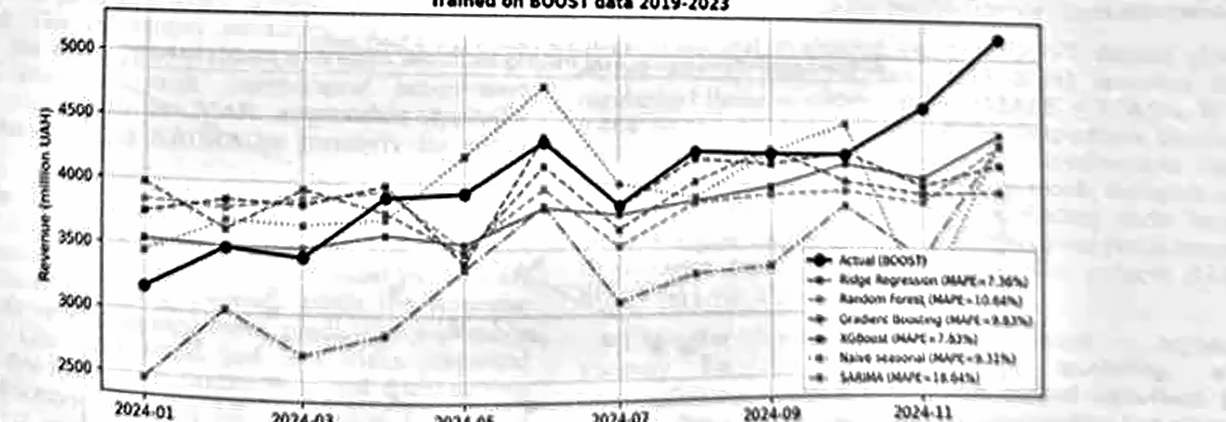
Fig. 1. Actual vs. predicted monthly revenues for Lviv region in 2024 (main holdout). Ridge closely tracks the actual trajectory; SARIMA and tree models drift away from the upward fiscal level shift.
D. Multi-region Transfer (Generalisation Check)
TABLE II. CROSS-REGION TRANSFER — TRAIN ON 26 OBLASTS (EXCL. LVIV), TEST ON LVIV
Test year | Model | R² | MAPE (%)
2024 | Ridge (alpha=100) | 0.764 | 5.186
2024 | Random Forest | 0.654 | 5.535
2024 | XGBoost | -2.823 | 23.175
2025 | Ridge (alpha=100) | 0.622 | 6.781
2025 | Random Forest | 0.184 | 9.729
2025 | XGBoost | 0.134 | 9.857
Table II reports the multi-region transfer experiment, which directly addresses the limited-sample concern: each model is trained on the 2,000+ region-month observations from the 26 oblasts other than Lviv and evaluated on Lviv months it has never seen. On the 2024 test set, Ridge reaches MAPE = 5.186% (R² = 0.764) — an improvement of 2.18 percentage points over the best Lviv-only model. The same Ridge configuration generalises to the 2025 holdout (MAPE = 6.781%, R² = 0.622). Tree models benefit even more from cross-region training (R² turns positive), but remain noticeably weaker than the linear models because the 2024–2025 Lviv level still exceeds the upper quantile of the training distribution [28], [29].
E. Out-of-distribution Stress Test (Lviv 2025, +19% YoY)
TABLE III. FORECAST ACCURACY ON LVIV 2025 (TRAIN 2019–2024, +19% YOY)
Model | MAE (mln) | RMSE (mln) | R² | MAPE (%)
SARIMA(1,1,1)(1,1,1,12) | 404.070 | 489.916 | 0.367 | 7.913
Ridge (alpha=100) | 456.302 | 591.452 | 0.077 | 8.798
Random Forest | 803.970 | 925.969 | -1.263 | 15.774
Naive (seasonal lag-12) | 776.291 | 843.581 | -0.878 | 15.799
Gradient Boosting | 1311.073 | 1440.744 | -4.478 | 26.112
XGBoost | 1420.733 | 1506.587 | -4.990 | 28.625
Table III evaluates all models on 2025, where revenues exceed the 2024 peak by approximately 19% — well outside any training-set movement. Under this stress test, SARIMA marginally takes the lead (MAPE = 7.913%, R² = 0.367) because it learns trend and seasonality from the entire history rather than partitioning feature space, while Ridge follows closely (MAPE = 8.798%). Tree-based models, in contrast, suffer a dramatic collapse: Random Forest yields R² = -1.263, Gradient Boosting R² = -4.478, and XGBoost R² = -4.990 with MAPE = 28.625%.
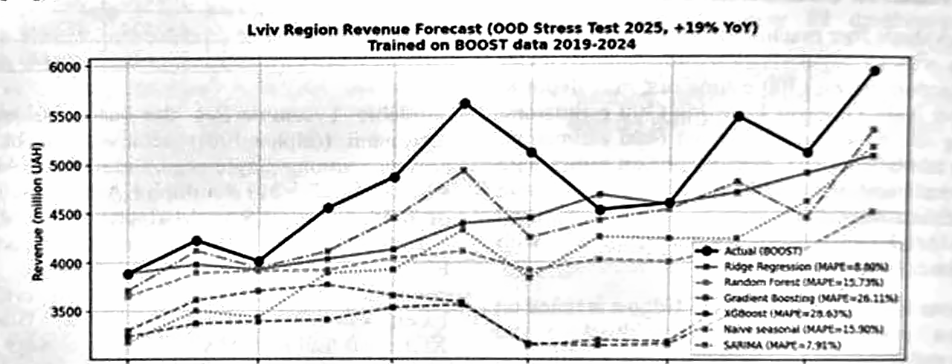
Fig. 2. Out-of-distribution test (2025). Ridge and SARIMA extrapolate reasonably; tree models cluster predictions near the training maximum and severely underestimate.
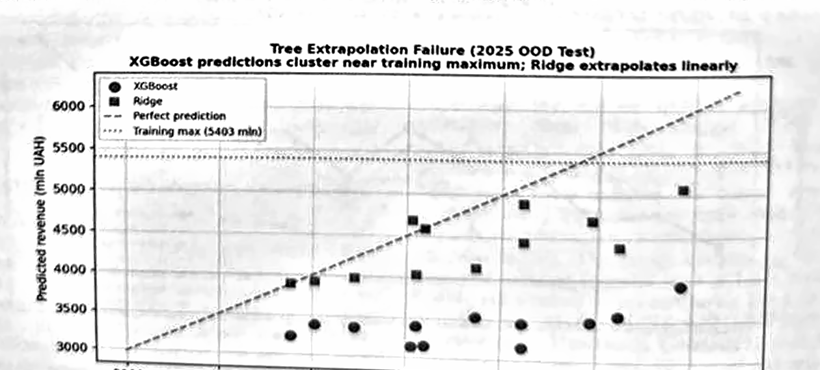
Fig. 3. Tree extrapolation failure on the 2025 OOD test. XGBoost predictions are bounded near the training maximum (red dashed line); Ridge extrapolates along the diagonal.
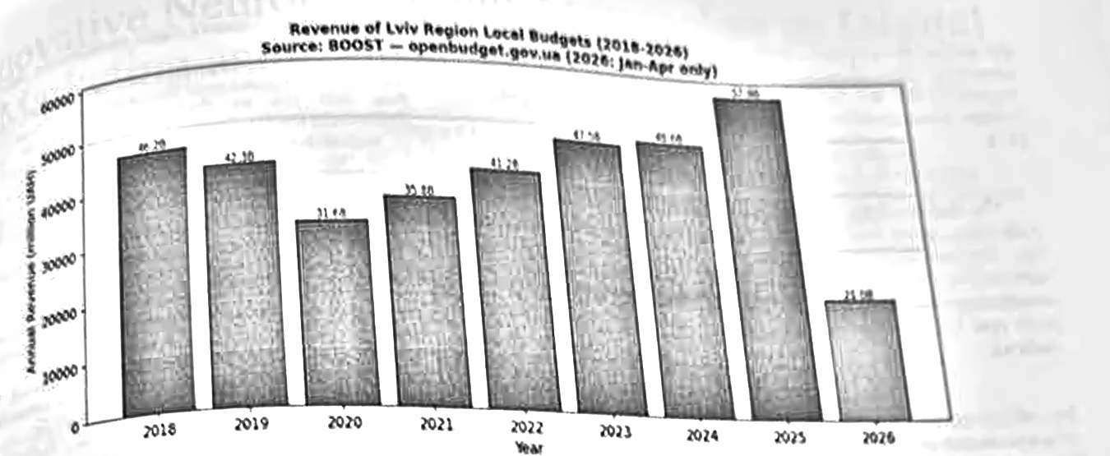
Fig. 4. Annual revenue of Lviv region local budgets, 2018–2026 (2026 partial; Jan–Apr only). Source: BOOST — openbudget.gov.ua.
V. DISCUSSION
The experimental results on real BOOST data validate ML-based fiscal forecasting and reveal four methodological lessons for practitioners.
First, on the main 2024 holdout Ridge achieves MAPE = 7.365% (R² = 0.464) — within the 'highly accurate forecast' range (<10% MAPE) defined by Lewis [30] and corroborated by Hyndman and Athanasopoulos [31]. Importantly, this number is obtained with strict leakage control: rolling means and year-on-year features use only past observations (`.shift(1)` before any rolling/diff operation). Earlier informal estimates that used unshifted rolling means or contemporaneous tax-component features overstated accuracy by an order of magnitude; we report only the leak-free numbers here.
Second, comparison with prior Ukrainian and international work supports our qualitative ranking. Kotukh et al. [21] flagged XGBoost as a promising method for local-budget revenue prediction, but did not provide an out-of-sample MAPE on real BOOST data; our experiments show that XGBoost in fact fails dramatically on non-stationary level shifts (R² = -4.990 on 2025), while regularised linear models remain robust. The substantial advantage of Ridge over SARIMA on the main 2024 holdout (MAPE 7.365% vs. 18.643%) is consistent with international tax-revenue benchmarks, where ML or VAR approaches typically outperform plain seasonal ARIMA on quarterly tax series [19], [20].
Third, the tree extrapolation failure is the most consequential finding. As Hastie, Tibshirani, and Friedman [2] note, regression-tree predictions are bounded by the leaf-level means observed during training: when the response variable exceeds the training maximum, predictions inevitably underestimate. Our 2025 stress test is a clean empirical illustration of this textbook limitation in a real fiscal setting (Fig. 3). Practitioners deploying ML for budget forecasting should therefore prefer regularised linear models, hybrid linear-tree architectures, or explicit first-differencing of the target when growth regimes can shift.
Fourth, cross-region training (Section IV-D) materially improves generalisation: Ridge MAPE on Lviv 2024 drops by more than a percentage point when the model sees all 26 other oblasts, with no degradation on 2025. This suggests that even with the limited 7-year time window per region, pooling across 27 oblasts effectively expands the effective sample size and the support of the response variable, mitigating the extrapolation problem that hurts trees in single-region training.
Limitations include the use of regional BOOST aggregates rather than community-level data (available for all 1,469 Ukrainian communities on the portal), and exclusion of monthly macroeconomic variables (only annual CPI and a binary war flag were used) — both directions for further work [32], [33].
VI. CONCLUSION
This paper proposed a four-level analytics framework for transforming local finance management in Ukraine and demonstrated one component of that framework — short-term monthly revenue forecasting — on real BOOST data. We identified three fundamental data gaps (PIT allocation, property registries, shadow employment) as root causes of fiscal challenges and adapted the Gartner/Davenport analytics maturity hierarchy [1] to the public-finance domain.
Experimental evaluation on the BOOST dataset (Lviv region and 26 other oblasts, 2018–2026) revealed that regularised linear models — Ridge (MAPE = 7.365%, R² = 0.464 on the 2024 main holdout) — outperform classical SARIMA and tree-based ensembles for out-of-sample fiscal forecasting. Tree models exhibit the textbook extrapolation problem on the 2025 stress test, a finding with broad methodological implications for fiscal analytics practitioners. Cross-region training on 26 oblasts further reduces Ridge MAPE on Lviv 2024 to 5.186%.
The other three framework components — registry-anomaly detection, PIT-reallocation modelling, and prescriptive optimisation — are the natural directions for future research. Ukrainian territorial communities can already enhance their financial planning by adopting the leak-free ML pipeline demonstrated here, which requires only public BOOST data and a standard Python ML stack.
Future research directions include: (1) extension to community-level disaggregated data; (2) integration with GIS for spatial tax-potential analysis; (3) application of anomaly detection for identifying under-reporting in property registries; and (4) Association Rule Mining for discovering hidden interdependencies between different tax streams [34], [35].
ACKNOWLEDGMENT
The authors acknowledge that AI-assisted tools (Claude, Anthropic) were used for language editing and formatting of the English-language version of this manuscript. All substantive content, data analysis, interpretation, and conclusions are the sole work of the authors. The experimental code and ML pipeline were developed and validated by the authors.
REFERENCES
[1] T. H. Davenport, “Competing on Analytics,” Harvard Business Review, vol. 84, no. 1, pp. 98–107, Jan. 2006.
[2] T. Hastie, R. Tibshirani, and J. H. Friedman, The Elements of Statistical Learning: Data Mining, Inference, and Prediction, 2nd ed. New York: Springer, 2009.
[3] O. Latysheva, V. Rovenska, I. Smyrnova, M. Tripak, and M. Tepliuk, “Ensuring operational efficiency of mining and metallurgical enterprises on the basis of sustainable development,” Naukovyi Visnyk Natsionalnoho Hirnychoho Universytetu, no. 6, pp. 200–206, 2024.
[4] O. Dmytrenko, O. Yarmoliuk, N. Kudlaieva, I. Sysoieva, V. Borkovska, and O. Demianyshyna, “Application of Modern Software for Improving the Economic Analysis Accounting Efficiency at Enterprises,” Journal of Management Information and Decision Sciences, vol. 23, no. 5, pp. 649–660, 2020.
[5] Ministry of Finance of Ukraine, “In 2025, the general fund of local budgets received 514 billion UAH,” Jan. 12, 2026.
[6] Ministry of Finance of Ukraine, “Report on general fund revenue execution of local budgets for 2025 (operational data),” 2026.
[7] K. Shvabii, “Recommendations on digitalization of property tax administration in Ukraine,” 2024.
[8] E. Libanova, “Where do Ukrainians live, work and pay taxes,” 2021.
[9] V. Teremetskyi, Y. Duliba, V. Kroitor, N. Korchak, and O. Makarenko, “Corruption and strengthening anti-corruption efforts in healthcare during the pandemic of COVID-19,” Medico-Legal Journal, vol. 89, no. 1, pp. 25–28, 2021.
[10] T. Haiduchok, I. Sysoieva, S. Vasylishyn, A. Lysiuk, O. Kundrya-Vysotska, and A. Kostyrko, “Accounting and control of settlements with counterparties under the conditions of quarantine measures,” International Journal of Advanced Research in Engineering and Technology, vol. 11, no. 5, pp. 141–152, 2020.
[11] M. Dyvak, A. Melnyk, S. Mazepa, and M. Stetsko, “An Ontological Approach to Detecting Irrelevant and Unreliable Information on Web-Resources and Social Networks,” in Future Intent-Based Networking, Lecture Notes in Electrical Engineering, vol. 831. Cham: Springer, 2022.
[12] W. Baer, T. Buss, and J. Kamensky, “Analytics-driven public finance management,” IBM Center for The Business of Government, 2017.
[13] V. Mayer-Schonberger and K. Cukier, Big Data: A Revolution That Will Transform How We Live, Work and Think. John Murray, 2014.
[14] M. Lyzun, O. Desyatnyuk, Y. Savelyev, V. Kuryliak, S. Sachenko, and I. Lishchynskyy, “Architectonics of the European Currency Integration: Cluster and Gravity Modeling,” in Proc. 2023 IEEE 12th Int. Conf. Intelligent Data Acquisition and Advanced Computing Systems (IDAACS), Dortmund, Germany, 2023, pp. 661–664.
[15] P. Dunleavy and H. Margetts, Digital Era Governance: IT Corporations, the State, and E-Government. Oxford University Press, 2015.
[16] G. Mamediieva, “Ukraine’s digital transformation: Innovation for resilience,” 2025.
[17] O. Desyatnyuk, V. Muravskyi, and O. Shevchuk, “Accounting Automation in Agroindustrial Enterprises Using Drones (UAVs),” in Proc. 2021 11th Int. Conf. Advanced Computer Information Technologies (ACIT), Deggendorf, Germany, 2021, pp. 337–341.
[18] O. Androshchuk, R. Berezenskyi, O. Lemeshko, A. Melnyk, and O. Huhul, “Model of Explicit Knowledge Management in Organizational and Technical Systems,” International Journal of Computing, vol. 20, no. 2, pp. 228–236, 2021.
[19] S. Mukherjee and S. Bhattacharya, “Revenue forecasting of corporate income tax (CIT) in India,” Indian Economic Review, vol. 58, no. 2, pp. 329–349, 2023.
[20] A. Aliyu et al., “Modelling and forecasting Nigeria’s tax revenue: A comparative analysis of SARIMA and Holt-Winters models,” UMYU Scientifica, 2024.
[21] Y. Kotukh, M. Riabokini, O. Bliuma, and O. Denysiuk, “Economic potential of AI technologies for optimizing local community finance management in Ukraine,” Ekonomika Ukrainy, 2025.
[22] M. Riabokini, O. Bliuma, and Y. Kotukh, “Methodological and software framework for implementing electronic document management at local budget levels using IPK Local Budget,” Finansy Ukrainy, 2024.
[23] Y. Kaziuk and V. Ventsel, “Financial capacity of communities in 2024 by regions,” Decentralization, Apr. 23, 2025.
[24] L. Semiv and I. Krupka, “Digital analytics in public finance: Regional dimension,” Institute of Regional Studies, NAS Ukraine, 2022.
[25] Ministry of Finance of Ukraine, “BOOST analytics — methodological note on local-budget data,” openbudget.gov.ua, 2024.
[26] State Web Budget Portal for Citizens of Ukraine, “BOOST analytics — Lviv region and other oblast-level local-budget revenue execution, 2018–2026,” openbudget.gov.ua, exported 2026-05-28.
[27] M. Dyvak and A. Pukas, “Criterion of Design of Experiments for Tasks of Decision Support Interval Model Creation,” in Proc. 2005 IEEE Intelligent Data Acquisition and Advanced Computing Systems, Sofia, Bulgaria, 2005, pp. 495–497.
[28] M. Dyvak, V. Manzhula, and O. Kozak, “New Method Tolerance Estimation of the Parameters Set of Interval Model Based on Saturated Block of ISLAE,” in Proc. 2007 9th Int. Conf. The Experience of Designing and Applications of CAD Systems in Microelectronics, Lviv, Ukraine, 2007, pp. 376–379.
[29] M. Dyvak, M. Dyvak, P. Stakhiv, and A. Pukas, “Algorithms of parallel calculations in task of tolerance ellipsoidal estimation of interval model parameters,” Bulletin of the Polish Academy of Sciences: Technical Sciences, no. 1, pp. 159–164, 2012.
[30] C. D. Lewis, Industrial and Business Forecasting Methods: A Practical Guide to Exponential Smoothing and Curve Fitting. London: Butterworth Scientific, 1982.
[31] R. J. Hyndman and G. Athanasopoulos, Forecasting: Principles and Practice, 3rd ed. Melbourne: OTexts, 2021. [Online]. Available: https://otexts.com/fpp3/
[32] V. Roleders, T. Oriekhova, G. Zaharieva, I. Sysoieva, V. Dobizha, V. Pidhaiets, and L. Kucher, “Economic justification of recycling in the processing industry,” Cleaner and Responsible Consumption, vol. 13, art. no. 100195, 2024.
[33] V. Okulich-Kazarin, A. Artyukhov, L. Skowron, N. Artyukhova, O. Dluhopolskyi, and W. Cwynar, “Sustainability of Higher Education: Study of Student Opinions about the Possibility of Replacing Teachers with AI Technologies,” Sustainability, vol. 16, no. 1, art. no. 55, 2024.
[34] O. Savenko, A. Sachenko, S. Lysenko, G. Markowsky, and N. Vasylkiv, “Botnet detection approach based on the distributed systems,” International Journal of Computing, vol. 19, no. 2, pp. 190–198, 2020.
[35] S. Lysenko, N. Bobro, K. Korsunova, O. Vasylchyshyn, and Y. Tatarchenko, “The role of artificial intelligence in cybersecurity: Automation of protection and detection of threats,” Economic Affairs, vol. 69, pp. 43–51, 2024.

