## the ministry of education and science of ukraine

## Ternopil Ivan Pul'uj National Technical University

## The department of management

## in manufacturing sphere

## Lectures on discipline

## managerial decision modeling

## Ternopil 2016

## Kuzhda T. I. Lectures on discipline “Managerial decision modeling” for the students of the speciality 6.030601 “Management” (full-time study bachelors). – Ternopil: TNTU, 2016. – 99 p.

## Made by: Ph.D. Kuzhda Tetiana

## Reviewer: Ph.D. Mosiy Olga

## The lectures on discipline “Managerial decision modeling” have been discussed and approved at the meeting of the department of management in manufacturing sphere of the Ternopil Ivan Pul'uj National Technical University on September 7-th, 2016, minutes №2.

## Content

## Introduction

Topic 1. Introduction to managerial decision modeling

Topic 2. Decision modeling under risk and uncertainty

Topic 3. Decision modeling based on time series analysis

Topic 4. Decision making with econometric modeling

Topic 5. Inventory decisions modeling in supply chain

Topic 6. Decision making with simulation modeling

## Introduction

Managerial decision modeling provides a spreadsheet-based, example-driven approach to management science. Throughout the lectures, students will find many new models that are based upon real managerial problems, and a student will find a much clearer presentation of the modeling, solution, and interpretation of the examples. This course integrates modeling into all functional areas of business. The purpose of this course is to expose student to a variety of problems that have been solved successfully with management science methods and to give the student experience in modeling these problems in the Excel spreadsheet package.

## The main tasks of the course are:

- to acquaint the students with the steps in decision modeling and types of decision models;

- to provide an introduction to the underlying components of managerial decision modeling, such input data, decision variable and problem parameter;

- to establish a sense of the managerial decision making process, decision making under risk and uncertainty, and decision tree approach;

- to acquaint the students with decision modeling based on time series, time series components and time series analysis;

- to establish a sense of the decision modeling with econometric modeling, and decision making with linear and non-linear econometric model;

- to provide students with understanding of inventory decisions modeling in supply chain and decision modeling with queuing models;

- to acquaint the students with decisions modeling with simulation models.

As a result student must be able:

- to determine the dependent and independent variables and explore the relationship between them by using different types of decision models;

- to conduct the Break-Even Analyses and compute the Break-even units and Break-even sales using Excel spreadsheet;

- to build the decision tree, calculate the expected monetary value and make decision based on decision tree approach Excel spreadsheet;

- to evaluate the decision under risk and uncertainty and compute the expected value of outcome, and other measures for risk level using Excel spreadsheet;

- to model the decisions with time series analysis indicators, such as average absolute increase and growth rate, seasonality index and so on;

- to make decisions with linear regression and non linear regression using Excel spreadsheet;

- to develop the inventory decision models with application of different economic order quantity models using Excel spreadsheet;

- to conduct decision modeling with simulation management models using Excel spreadsheet.

**Topic 1. INTRODUCTION TO MANAGERIAL DECISION MODELING**

**Content**

1. What is decision modeling?

2. Data sources for decision modeling

3. Steps in decision modeling

4. Types of decision models

5. Managerial decision modeling with spreadsheets

**1.** **What is decision modeling?**

*Decision management* is used to improve the decision making process by using all available information to increase the precision, consistency and agility of decisions and making good choices taking known risks and time constraints into consideration.

*Decision modeling* is the scientific approach to managerial decision-making. This type of analysis is a logical and rational approach to making decisions.

*Decision modeling* focuses on the high volume, operational decisions that must be made every day in any organization: the decisions in the operational, financial, and other processes.

*Decision modeling* is based on three components:

*1. Input data* can come from company reports and documents, interviews with employees and other personnel, direct measurement, and sampling procedures. For many managerial problems, a number of different sources are required to obtain data, and in some cases it is necessary to obtain the same data from different sources in order to check the accuracy and consistency of the input data. If the input data are not accurate, the results can be misleading and very costly to the organization.

Input data needed for managerial decision modeling should be reliable, accurate, timely, meaningful, interrelated, written and easy to use. Further details of these characteristics related to organizational information for decision-making follows:

- *Availability / accessibility* means that the input information should be easy to obtain or access. Businesses used to keep customers, suppliers, staff details on a computer in the operational databases. For business premises, say for a hotels, the data would probably get from the Internet.

- *Accuracy* – the input information needs to be accurate enough for the use to which it is going to be put. To obtain information that is 100% accurate is usually unrealistic as it is likely to be too expensive to produce on time. The degree of accuracy depends upon the circumstances. At operational levels information may need to be accurate to the nearest penny – on a supermarket till receipt, for example. At tactical level department heads may see weekly summaries correct to the nearest £100, whereas at strategic level directors may look at comparing stores’ performances over several months to the nearest £100,000 per month. Accuracy is important. As an *example*, if government statistics based on the last census wrongly show an increase in births within an area, plans may be made to build schools and construction companies may invest in new housing developments. In these cases any investment may not be recouped.

*- Reliability or objectivity* – reliability deals with the truth of information or the objectivity with which it is presented. Managers can only really use information confidently if they are sure of its reliability and objectivity. *For example*, the accounting reliability refers to whether financial information can be verified and used consistently by investors and creditors with the same results. Basically, reliability refers to the trustworthiness of the financial statements. Can the end users trust what is on the financial statements? If decision makers cannot trust what is on the financial statements, financial reporting in general is useless.

*- Relevance / appropriateness* – input information should be relevant to the purpose for which it is required. It must be suitable. What is relevant for one manager may not be relevant for another. The user will become frustrated if information contains data irrelevant to the task in hand. *For example*, a market research company may give information on users’ perceptions of the quality of a product. This is not relevant for the manager who wants to know opinions on relative prices of the product and its rivals. The information gained would not be relevant to the purpose.

*- Completeness* – input data should contain all the details required by the user. Otherwise, it may not be useful as the basis for making a decision. *For example*, if an organization is supplied with information regarding the costs of supplying a fleet of cars for the sales force, and servicing and maintenance costs are not included, then a costing based on the information supplied will be considerably underestimated. Ideally all the information needed for a particular decision should be available. However, this rarely happens; good information is often incomplete. To meet all the needs of the situation, manager often have to collect it from a variety of sources.

*- Level of detail / conciseness* – input information should be in a form that is short enough to allow its examination and use. There should be no extraneous information. For example, it is very common practice to summarize financial data and present this information, both in the form of figures and by using a chart or graph.

*- Presentation* – the presentation of information is important to the user. Information can be more easily assimilated if it is aesthetically pleasing. For example, a marketing report that includes graphs of statistics will be more concise as well as more aesthetically pleasing to the users within the organization. Many organizations use presentation software and show summary information via a data projector. These presentations have usually been well thought out to be visually attractive and to convey the correct amount of detail.

*- Timing* – the input information must be on time for the purpose for which it is required. Information received too late will be irrelevant. Users of accounting information must be provided with financial statements on a timely basis to ensure that their financial decisions are based on up to date information. This can be achieved by reporting the financial performance of companies with sufficient regularity (e.g. quarterly, half yearly or annual) depending on the size and complexity of the business operations. Unreasonable delay in reporting accounting information to users must also be avoided.

*- Value of information* – the relative importance of information for decision-making can increase or decrease its value to an organization. For example, an organization requires information on a competitor’s performance that is critical to their own decision on whether to invest in new machinery for their factory. The value of this information would be high. Always keep in mind that information should be available on time, within cost constraints and be legally obtained.

*- Cost of information* – the input data should be available within set cost levels that may vary depending on situation. If costs are too high to obtain information an organization may decide to seek slightly less comprehensive information elsewhere. *For example*, an organization wants to commission a market survey on a new product. The survey could cost more than the forecast initial profit from the product. In that situation, the organization would probably decide that a less costly source of information should be used, even if it may give inferior information.

*2. Decision variable* is an unknown quantity which value can be controlled by the decision maker. *Examples* include how many inventory items to order, how many courses to take this semester, how much money to invest in retirement plans this year, etc.

*3. Problem parameter* is a measurable (usually known) quantity that is inherent in the problem. *Examples* include the cost of placing an order for more inventory items, the tuition payable for taking a course, the annual fees payable for establishing a retirement plan, etc.

**2. Data sources for decision modeling**

*Input data needed for decision modeling* can be obtained from different sources. There are primary and secondary data.

*Primary data* include the internal company information (*for example*, data on the costs of raw materials, costs of production, prices, income, net profit, sales and etc.) and external information obtained from consumers, suppliers, distributors or economists-experts resulting personal interviews.

*Secondary data* is the data collected by government statistics, private organizations, specialized on collecting statistical data (*for example*, consulting agencies) and obtained resulting censuses, statistical surveys, and organizational records. Secondary data are computer data bases.

*Input data is* classified as follows:

* *Quantitative data* are the numeric values that indicate how much or how many. It is used to describe a type of information that can be counted or expressed numerically. *For example*, quantity of products, profit, income, costs, etc. This type of data is often collected in experiments, manipulated and statistically analyzed. Quantitative data can be represented visually in graphs, histograms, tables and charts.
* *Qualitative data* are the labels or names used to identify an attribute. Qualitative data can be arranged into categories that are not numerical. These categories can be physical traits, gender, colors, pass/fail or the presence or lack of a characteristic or anything that does not have a number associated to it. The other examples include the outcome of an upcoming election, new technological breakthrough, etc.

*Input data for* *decision modeling are divided into 4 types:*

*1. Financial* *data* include the information from company accounting and finance departments. Accounting provides information relating to a *company’s expenditures, cost allocation methods for products and statements indicating the company’s profitability*. Owners and managers can also use this information to compare against the industry standard to ensure their company is at least on par with other companies. The finance department contains information on how the company pays for operations, whether it is debt or equity financing. Owners and managers can get the financial information from such financial documents as *balance sheet, income statement,* etc.

*2. Operational* *data* provide owners and managers with documents and figures relating to how well a company produces consumers goods and services. Information can relate to types of *economic resources needed, quantity of products, employee productivity, waste from operations and other information*. Owners and managers typically conduct a performance review to ensure their company is operating efficiently and effectively. Owners and managers can get the operational information from *production efficiency report, sales repot, labor productivity report, etc.*

*3. Economic data* typically include external figures that owners and managers need to understand current economic conditions. *Consumer demand, available credit, resource availability, exchange rate, potential for international sales and active competitors in the market* are a few types of economic information needed by businesses. Owners and managers can use this information to create forecasts or other estimates on the potential sales based on these conditions.

*4. Governmental data* typically relate to *regulations and taxes*. Owners and managers need this information to ensure they understand the additional liabilities they must accept in relation to their business operations. *Profit tax, income tax, value-added tax, excise duty, tariffs, customs duty, customs payments* are a few types of governmental information needed for a manager.

**3. Steps in decision modeling**

*Decision modeling* is a step-by-step process that allows decision makers to investigate managerial problems using quantitative techniques. The decision modeling process includes three phases that are broken into several steps:

*I phase: Formulation* is translating a managerial problem scenario from words to an economic and mathematical model. This phrase covers the following steps:

- *1 step: Defining the problem, its scope and time horizon*. In every case, the decision analysis begins with defining the problem. The problem could be too many stockouts, too many bad debts, or determining the products to produce that will result in the maximum profit or minimum costs for the organization.

*- 2 step: Developing a model*. After the managerial problems have been defined, the next step is to develop one or more models. These models could be inventory control models, models that describe the debt situation in the organization, and so on.

*- 3 step: Acquiring input data.* Once the models have been developed, the next step is to acquire input data. In the inventory problem, *for example*, such factors as the annual demand, the ordering cost, and the carrying cost would be input data that are used by the model developed in the preceding step. In determining the products to produce in order to maximize profits, the input data could be such things as the profitability for all the different products, the amount of time that is available at the various production departments that produce the products and the amount of time it takes for each product to be produced in each production department.

*II phrase: Solution* means solving the model to obtain the optimal solution (result). This phrase covers the following steps:

*4 step: Developing a solution*. This requires manipulation of the model in order to determine the best solution.

*5. step: Testing the solution*. The results must be tested.

*III phrase: Interpretation and Sensitivity Analysis* mean analyzing results and implementing a solution:

*6 step: Analyzing the results*. The results must be analyzed, and implemented. In the inventory control problem, this might result in determining and implementing a policy to order a certain amount of inventory at specified intervals. For the problem of determining the best products to produce, this might mean testing, analyzing, and implementing a decision to produce a certain quantity of given products.

*7 step: Implementing the results*. Implementation is the process of taking the solution and incorporating it into the company or organization. This is the final step in the decision modeling approach, and if a good job is not done with implementation, all of the effort expended on the previous steps can be wasted.

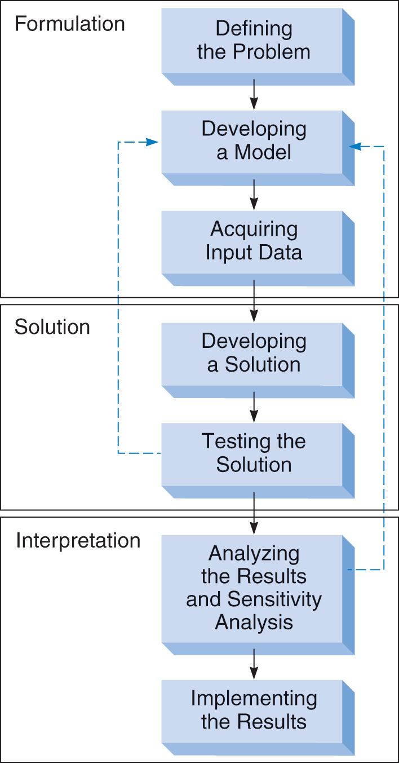

*Figure 1* – Steps in decision modeling

**4.** **Types of decision models**

*Decision model* is an intellectual template for perceiving, organizing, and managing the business operations behind a business decision. Decision models are classified as follows:

*- Quantitative models* are logical, mathematical display of the important components of an organization and linkages between them. Quantitative model requires numerical definition of the managerial problem and works with two kinds of variable: dependent and independent. *For example*, the relationship between company output and production costs, demand for products can be described numerically. In this case, company output is a dependent variable. Production costs and demand for products are factors or independent variables.

*- Qualitative models* are based on the subjective judgment based on quantifiable information, such as management expertise, industry cycles, strength of research and development, and labour relations. They treat only qualities of managerial problem.

*- Optimization models* seek to maximize a quantity (e.g. profit, income, return) or minimize a quantity (e.g. cost, time, expenses) that may be restricted by a set of constraints (limitations on the availability of capital, workers, supplies, machines, etc.).

*- Predictive models* seek tomake forecast of economic processes, activities and data given certain conditions. They aim at calculating the quantitative forecast after looking at the information that is available. Predictive models used to predict GDP, inflation, unemployment, sales, demand, revenue and so on.

*- Deterministic models* assume that all the relevant input data are known with certainty. That is, these models assume that all the information needed for modeling the decision-making problem environment is available, with fixed and known values. Students should be able to find several examples from the manufacturing and service sectors. *For example*, deciding how many sections of a course to offer during a semester can be modeled as a deterministic model since the costs and benefits of offering each section are known.

*- Probabilistic (also called stochastic) models* assume that some input data are not known with certainty. That is, these models assume that the values of some important variables will not be known before decisions are made. Here again, students should be able to find several examples from the manufacturing and service sectors*. For example*, their own career based on their choice of a major for their undergraduate study can be modeled as a probabilistic model.

*- Static models* are concerned with determining an answer for particular set of fixed conditions that will probably not change significantly in the short run. *The example* of static model is that if we supplement the demand equation with a static supply equation, we obtain the static market equilibrium model.

*- Dynamic models* are used to represent the variables interaction during time intervals. *For example*, the interactions between company sales and demand for product through April to August can be modeled as the dynamic model.

**5. Managerial decision modeling with spreadsheets**

Managers create and store all types of above information using *Excel spreadsheet*. *Excel Spreadsheet* is an interactive computer application program for organizing, modeling and analyzing input data in tabular form. There are several reasons for the popularity of spreadsheets:

- data are submitted to the modeler in spreadsheets,

- data can be analyzed easily using statistical and mathematical tools readily available in the spreadsheet,

- data and information can easily be displayed using graphical tools.

Some advantages of using spreadsheets for decision modeling are:

1) spreadsheets are capable of quickly calculating results for a given set of input values,

2) spreadsheets are effective tools for sorting and manipulating data,

3) spreadsheets have several built-in functions for performing complex calculations;

4) spreadsheets have several built-in procedures (such as Goal Seek, Data Table, and Chart Wizard) and add-ins (such as Solver) that make it easy to set up and solve most of the decision modeling techniques commonly used in practical situations.

## Let’s take a look at managerial decision modeling with spreadsheets based on calculation of break-even units and break-even sales for a company.

## *Break-Even Analysis* is a calculation of the approximate sales volume required to just cover costs, below which production would be unprofitable and above which it would be profitable. Break-even analysis focuses on the relationship between fixed cost, variable cost, and profit.

## *Fixed costs* are those which are assumed to be constant during the specified payback period and which do not depend on the number of units produced. Advertising, insurance, real estate taxes, rent, accounting fees, and supplies would all be examples of fixed costs. *Fixed costs* also include salaries and payroll taxes for non-direct labour such as administrative assistants and managers, or in other words, the payroll not included as variable costs.

## *Variable costs* include the production, direct labour, materials, and other expenses which depend on the number of units produced and sold.

## *Example* of *Break-Even Analyses* and calculation procedures is given below.

## *Table 1* – Statistical data for Break-Even Analyses

|  |  |
| --- | --- |
| Input data | Dollars |
| **Selling Price (P):** | **12** |
| *Fixed costs (FC):* |  |
| Advertising | 320 |
| Accounting, legal | 30 |
| Depreciation | 120 |
| Insurance | 40 |
| Manufacturing | 80 |
| Payroll | 450 |
| Rent | - |
| Supplies | 35 |
| Taxes (real estate, etc.) | - |
| Utilities | 25 |
| Other (specify) | - |
| **Total Fixed Costs (TFC):** | *320+30+120+40+80+450+35+25=*1100 |
| *Variables Costs based on Dollar Amount per Unit:* |  |
| Cost of Goods Sold | 1,5 |
| Direct labour | 0,5 |
| Overhead | 0,4 |
| Other (specify) | - |
| **Total Variable Cost per Unit (V):** | *1,5+0,5+0,4=*2,4 |

## *Break-Even Point* is for calculating the “Break-Even Units” and “Break-Even Sales”.

## *Break-even units* are the number of units that a company has to sell to cover costs. The following formula is for calculating the number of units (X) the company will have to sell over the specified period of time.

## *X = TFC / ( P – V) ,*

## where *TFC* is the total fixed costs,

## *P* is the selling price per unit;

## *V* is the variable cost per unit.

## *X = 1100 / ( 12 – 2,4 ) =115 units.*

## *Conclusion* is that the company has to sell 115 units to cover its costs.

## *Break-even sales amount* (S) is just the total revenue (TR) at the break-even point. The following formula is for calculating the break-even sales amount.

## *S = TFC / (1 - V / P)*

## *S = 1100 / (1 – 2,4/12)=$1375*

## *Conclusion* is that the total revenue at the break-even point for a company is $1375.

## Let’s have a look how to calculate the break-even units and break-even sales using Spreadsheet. To fill the “Break-Even Analyses” document you need to enter input data into Spreadsheet.

## To compute the total fixed costs click cell B15 and type the formula (*figure 1*)

## =SUM(B4:B14)

## To compute the variable costs based on dollar amount per unit click cell B21 and type the formula

## =SUM(B17:B20)

## To compute the break-even units (X) click cell B22 and type the formula

## =B15/(B2-B21)

## To compute the break-even sales (S) click cell B23 and type the formula

## =B15/(1-B21/B2)

## To compute the share of advertising costs to total fixed costs click cell D4 and type the formula (*figure 2*)

## =B4/B15*100

## To compute the share of accounting and legal costs to total fixed costs click cell D5 and type the formula

## =B5/B15*100

## To compute the share of each other costs to total fixed costs you should apply the same formula for each cell.

## Total percentage of shares gives a 100. The formula is given below (click cell D14 and enter the formula):

## =SUM(D4:D13)

## *Figure 1*

## 

To compute the share of costs of goods sold to total variable costs click cell D17 and type the formula

=B17/B21*100

To compute the share of each other costs to total variable costs you should apply the same formula for each cell.

Total percentage of shares gives a 100. The formula is given below (click cell D21 and enter the formula):

=SUM(D17:D20)

## *Figure 2*

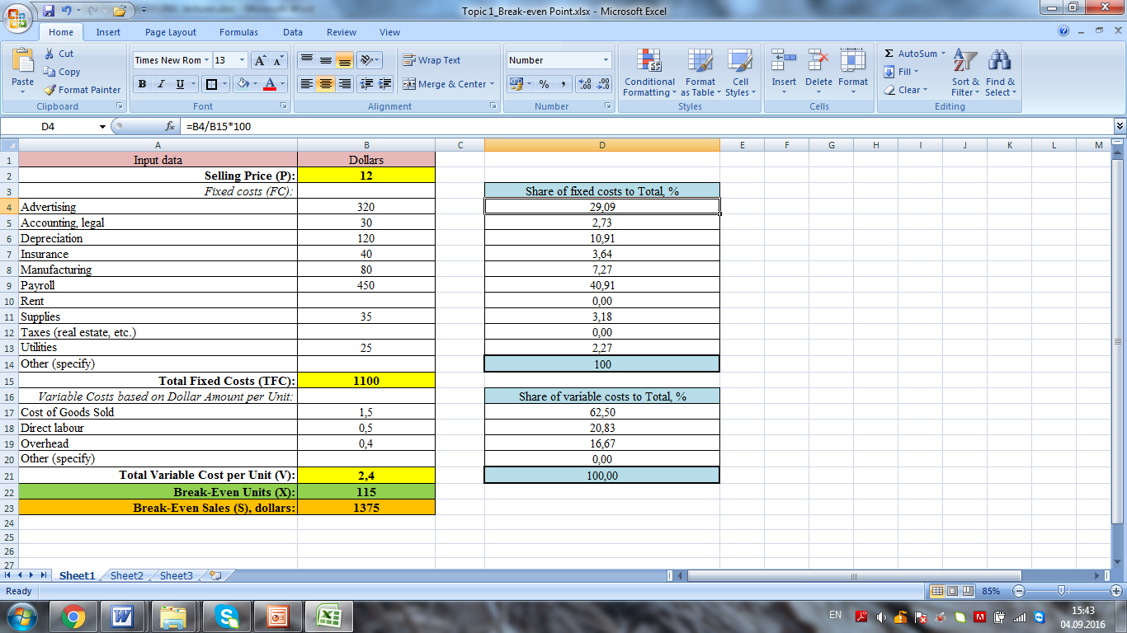

**Topic 2. DECISION MODELING under risk and uncertainty**

**Content**

1. Managerial decision making process

2. Decision making under risk and uncertainty

3. Decision tree approach

4. Evaluating decision under risk and uncertainty

5. Evaluating decision under risk and uncertainty with spreadsheets

**1.** **Managerial decision making process**

*Decision* is a choice whereby a manager comes to a conclusion about given circumstances/situation in the organization. It represents a course of behaviour or action about what one is expected to do or not to do. *Decision-making* may, therefore, be defined as a selection of one course of action from two or more alternative courses of action. Thus, it involves a choice-making activity and the choice determines our action or inaction.

The five steps involved in managerial decision making process are explained below:

*1. Establishing the objective*: the first step in the decision making process is to establish the objective of the business enterprise. The important objective of a private business enterprise is to maximize profits. However, a business firm may have some other objectives such as maximization of sales or growth of the company. But the objective of a public enterprise is normally not of maximization of profits but to follow benefit-cost criterion. According to this criterion, a public enterprise should evaluate all social costs and benefits when making a decision whether to build an airport, a power plant, a steel plant, etc.

*2. Defining the problem*: the second step in decision making process is one of defining or identifying the problem. Defining the nature of the problem is important because decision making is after all meant the solution of the problem. *For instance*, a cotton textile company may find that its profits are declining. It needs to be investigated what are the causes of the problem of decreasing profits: whether it is the wrong pricing policy, bad labour-management relations or the use of outdated technology which is causing the problem of declining profits. Once the source or reason for falling profits has been found, the problem has been identified and defined.

*3. Identifying possible alternative solutions (alternative courses of action)*: once the problem has been identified, the next step is to find out alternative solutions to the problem. This will require considering the variables that have an impact on the problem. In this way, relationship among the variables and with the problems has to be established. In regard to this, various assumptions can be developed which will become alternative courses for the solution of the problem. *For example*, in case of the problem mentioned above, if it is identified that the problem of declining profits is due to use of technologically inefficient and outdated machinery in production, then there are two possible solutions of the problem:

- updating and replacing only the old machinery;

- building entirely a new plant equipped with latest machinery.

The choice between these alternative courses of action depends on which will bring larger increase in profits.

*4. Evaluating alternative courses of action*: the next step in business decision making is to evaluate the alternative courses of action. This requires the collection and analysis of the relevant data. Some data will be available within the various departments of the firm itself, the other may be obtained from the industry and government. The data and information so obtained can be used to evaluate the outcome or results expected from each possible course of action. Methods such as sales analysis, break-even analysis, and cost-benefit analysis are used to arrive at the optimal course. The optimum solution will be one that helps to achieve the established objective of the firm. The course of action which is optimum will be actually chosen. It may be further noted that for the choice of an optimal solution to the problem, a manager works under certain constraints.

The constraints may be legal such as laws regarding pollution and disposal of harmful wastes; they may be financial (i.e. limited financial resources); they may relate to the availability of physical infrastructure and raw materials, and they may be technological in nature which set limits to the possible output to be produced per unit of time. The crucial role of a business manager is to determine optimal course of action and he has to make a decision under these constraints.

*5. Implementing the decision*: after the alternative courses of action have been evaluated and optimal course of action selected, the final step is to implement the decision. The implementation of the decision requires constant monitoring so that expected results from the optimal course of action are obtained. Thus, if it is found that expected results are not forthcoming due to the wrong implementation of the decision, then corrective measures should be taken.

*Establishing Objective*

*Defining the Problem*

*Identifying Possible Alternative Courses of Action*

*Evaluating Alternative Courses of Action ad Choosing the Best*

*Considering Legal and Social Constraints*

*Considering financial, technological, infrastructural and input constraints*

*Implementing and Monitoring the Decision*

*Figure 1* – Managerial decision making process

However, it should be noted that once a course of action is implemented to achieve the established objective, changes in it may become necessary from time to time in response to changes to conditions or firm’s operating environment on the basis of which decisions were taken.

**2. Decision making under risk and uncertainty**

*Decision making* is a process of identifying problems and opportunities and choosing the best option among alternative courses of action for resolving them successfully. Usually, there are three different conditions under which decisions are made:

*1. Certainty*: Complete and accurate knowledge of outcome of each alternative. There is only one outcome for each alternative.

*2. Risk*: Multiple possible outcomes of each alternative can be identified and a probability of occurrence can be attached to each.

*3. Uncertainty*: Multiple outcomes for each alternative can be identified but there is no knowledge of the probability to be attached to each.

Let’s take a look at these conditions in details:

*- Conditions under certainty* are which a decision maker has full and needed information to make a decision. The manager knows exactly what the outcome will be, as he/she has enough clarity about the situation and knows the resources, time available for decision-making, the nature of the problem itself, possible alternatives to resolve the problem, and undoubtedly clarify or certain with the result of alternatives. In most situations, the solutions are already available from the past experience and are appropriate for the problem at hand. The decision for restock food supply, *for example*, when the goods in stock fall below a determined level, is a decision making under circumstance of certainty.

*Other example*: if the optimization criterion is least cost and you are considering two different brands of a product, which appear to be equal in value to you, one costs 20% less than the other, then, all other things being equal, you will choose the less expensive brand.

- *Conditions under risk* provide probabilities regarding expected results for decision making alternatives, it is due to the nature of the future conditions that are not always know in advance and the managers face this condition more often in reality compared to conditions under certainty. Although some good information may be available, it is not enough to answer all questions about the outcomes. The manager could define the nature of the problem, possible alternatives, and the probability of each alternative leading to the desired results, but could not guarantee how each alternative may work. Decision has clear-cut goals, but future outcomes associated with each alternative are subject to chance. Testing a nuclear leakage in Japan is a risky decision by Japanese Government, as the government didn’t know how wide the range of effecting area and the nuclear substance itself is a life threatening factor.

*Other example*: if you are faced with a choice between two actions one offering a 1% probability of a gain of $10000 and the other a 50% probability of a gain of $400, you as a rational decision maker will choose the second alternative because it has the higher expected value of $200 (400*0,5) as against $100 (10000*0,01) from the first alternative.

- *Conditions under uncertainty* provide no or incomplete information, many unknowns and possibilities to predict expected results for decision making alternatives. Uncertainty is a situation where the current state of knowledge is such that the order or nature of things is unknown, the consequences, extent, or magnitude of circumstances, conditions, or events are unpredictable, and credible probabilities to possible outcomes cannot be assigned. The manager cannot even assign subjective probabilities to the likely outcomes of alternatives. The manager cannot predict with confidence what the outcomes of his actions will be. Managers may have to come up with creative approaches and alternatives to solve the problem. *Decision making under uncertainty* means that the alternatives are evaluated for different scenarios. *For example*, one could assess the benefit of a public transportation system for the four scenarios: 1) high demand and strong economy; 2) low demand and strong economy; 3) high demand and weak economy; 4) low demand and weak economy.

Uncertainty also can be classified as:

*Complete uncertainty* means that a manager don’t have enough data to quantify the chance of occurrence of the different states and resulting scenarios.

*Informed uncertainty* refers to situations where the managers do have enough data to quantify the chance of occurrence of the different states and resulting scenarios.

**3. Decision tree approach**

*Decision tree* is a very specific type of probability tree that enables a manager to make a decision about some kind of process. There are three broad areas usually displayed in a tree:

*- Decision*: displayed as a square node (box) with two or more arcs (called “decision branches”) pointing to the options. A box is used to show a choice that the manager has to make.

*- Event sequence*: displayed as a circle node with two or more arcs pointing out the events. Probabilities may be displayed with the circle nodes, which are sometimes called “chance nodes”. A circle is used to show that a probability outcome will occur.

*- Consequences*: the costs or utilities associated with different pathways of the decision tree. The end point is called a “Terminal” and is represented by a triangle or bar on a computer. Lines connect outcomes to their choice or probability outcome.

The main *advantages of decision tree* are the following:

*-* Easy to understand: Decision tree output is very easy to understand even for people from non-analytical background. It does not require any statistical knowledge to read and interpret them.

- Useful in data exploration: Decision tree is one of the fastest ways to identify most significant variables and relation between two or more variables. With the help of decision trees, we can create new variables / features that have better power to predict target variable.

- Less data cleaning required: It requires less data cleaning compared to some other modeling techniques.

- Data type is not a constraint: It can handle both numerical and categorical variables.

- Decision tree can be used with other decision techniques.

- Risks are not ignored because decision trees consider negative outcomes as well.

- The probability of each outcome occurring is an advantage and makes calculations easier.

- Decision trees take into consideration the costs of the decision as well.

The main *disadvantages of decision tree* are the following:

- the external business environment is not taken into consideration when drawing decision trees;

- the diagram only helps in calculation but not reduction of risks in decision making;

- the estimated probabilities might not always be meaningful since forecasting errors may occur;

- decision trees are numerical/quantitative in nature and ignore qualitative data.

*Decision Trees Example*: suppose an organization is using a legacy software. Some influential stakeholders believe that by upgrading this software your organization can save millions, while others feel that staying with the legacy software is the safest option, even though it is not meeting the current company needs. The stakeholders supporting the upgrade of the software are further split into two factions: those that support buying the new software and those that support building the new software. By exploring all possibilities and consequences, a manager can quantify the decisions and convince stakeholders. This is known as Decision Tree Analysis.

In this scenario, you can either:

*- Build the new software:* To build the new software, the associated cost is $500000.

*- Buy the new software:* To buy the new software, the associated cost is $750000.

*- Stay with the legacy software:* If the company decides to stay with the legacy software, the associated cost is mainly maintenance and will amount to $100 000.

Looking at the options listed above, you can start building the decision trees as shown in the diagram (*figure 2*). By looking at this information, the lobby for staying with the legacy software would have the strongest case. But, let’s see how it pans out.

The Buy the New Software and Build the New Software options will lead to either a successful deployment or an unsuccessful one. If the deployment is successful then the impact is $2 million. However, if the deployment is unsuccessful, then the impact is zero. The Stay with the Legacy Software option will lead to only one impact, which is $0,8 million, because the legacy software is not currently meeting the needs of the company. Nor, will it meet the needs should there be growth. In this example, we have assumed that the company will have growth.

In this example, Decision Trees analysis will be used to make the project risk management decision. The next step is to compute the Expected Monetary Value for each path in the Decision Trees. Let's see how this helps in this Decision Trees example.

Decision

Build Buy

Stay

Successful

Deployment

**Impact: $2 million**

Unsuccessful

Deployment

**Impact: $0**

Successful

Deployment

**Impact: $2 million**

Unsuccessful

Deployment

**Impact: $0**

Growth in business

**Impact: $0,8 million**

45%

Stay with legacy software

**Cost:**

**$200 000**

Buy the new software

**Cost:**

**$600 000**

Build the new software

**Cost:**

**$500 000**

40%

35%

*Figure 2* – Decision tree

The diagram depicts the decision tree. Now, the manager can calculate the Expected Monetary Value for each decision.

The Expected Monetary Value associated with each risk is calculated by multiplying the probability of the success with the impact. By doing this, we get the following:

*- Build the new software:* $ 2 000 000 * 0,4 = $ 800 000

*- Buy the new software:* $ 2 000 000 * 0,35 = $ 700 000

*- Staying with the legacy software:* $ 800 000 * 0,45 = $ 360 000

Now, subtract the setup costs from each Expected Monetary Value:

*- Build the new software:* $ 800 000 – $ 500 000 = $ 300 000

*- Buy the new software:* $ 700 000 – $ 600 000 = $ 100 000

*- Staying with the legacy software:* $ 360 000 – $ 200 000 = $ 160 000

*Conclusion*: looking at the Expected Monetary Values computed in this Decision Trees example, you can see that building the new software is actually the most cost efficient option, even though it requires significant initial setup cost. The Expected Monetary Values from building the new software exceeds the initial setup cost by $300 000.

**4. Evaluating decision under risk and uncertainty**

When managers implement decision and make choices under risk or uncertainty, they must somehow incorporate this risk into their decision-making process.

*Evaluating decision under risk and uncertainty* covers the set of methods and techniques designed to detect and measure risk during decision making process.

*Conditions of risk* occur when a manager must make a decision for which the outcome is not known with certainty. Under conditions of risk, the manager can make a list of all possible outcomes and assign probabilities to the various outcomes.

*Uncertainty* exists when a decision maker cannot list all possible outcomes and/or cannot assign probabilities to the various outcomes. To measure the risk associated with a decision, the manager can examine several characteristics of the probability distribution of outcomes for the decision.

*Outcomes* are the changes, benefits or other effects (*for example*, increased revenue or profit, decreased costs and expenses, increased productivity) that happen as a result of managerial decisions.

The various rules for making and implementing decisions under risk require information about several different characteristics of the probability distribution of outcomes:

*1) Expected value of outcome* is defined as a value found by multiplying the value of the outcome by the probability for each value. The following formula is used to compute the expected value of outcome.

*Expected value of outcome = ∑ Outcome value * Probability* (1)

*2) Variance* is used to measure the risk level during decision implementation and calculated by the formula:

*Variance =∑* (*Outcome value - Expected value of outcome*)***2*** *\* Probability* (2)

A small variance indicates that the risk level during decision implementation is low and acceptable, while a high variance indicates that the risk level during decision implementation is high.

*3) Standard deviation* is the square root of the variance:

 (3)

A small standard deviation indicates that the risk level during change implementation is low and acceptable, while a high standard deviation indicates that the risk level during change implementation is high.

*4) Coefficient of variation* is defined by dividing the standard deviation by the expected value of outcome:

*Coefficient of variation = (Standard Deviation / Expected value of*

*outcome)*100%* (4)

The lower the coefficient of variation, the risk is low and acceptable. On the other hand, the higher the coefficient of variation, the risk is high and unacceptable.

The risk level ranges from 0 to 100%:

0-10% – low risk level;

10-25% – moderate risk level;

25% and ˃ – high risk level.

*For example*: An automobile company explores the possibility to produce the crossovers, mid-size cars, full-size cars and luxury cars. Make the decision and determine the riskiness of each car production.

*Table 1* – Input data

|  |  |  |  |  |
| --- | --- | --- | --- | --- |
| Cars | *Revenue, thousand dollars per unit* | | | |
| Crossovers | 8,2 | 8,5 | 9,4 | 9,5 |
| Mid-size cars | 15 | 15,5 | 16 | 14 |
| Full-size cars | 25 | 28 | 29 | 30 |
| Luxury cars | 45 | 50 | 35 | 40 |
| *Probability,* *р* | *0,3* | *0,2* | *0,25* | *0,25* |

*Solution*: The expected values of revenue for each kind of cars are calculated below:

*Expected revenue _ Crossovers*  *= 8,2*0,3+8,5*0,2+9,4*0,25+9,5*0,25=*

*$ 8,89 thousand*

*Expected revenue _ Mid-size cars* *=15*0,3+15,5*0,2+16*0,25+14*0,25=*

*$ 15,1 thousand*

*Expected revenue _ Full-size cars* *=25*0,3+28*0,2+29*0,25+30*0,25=*

*$ 27,9 thousand*

*Expected revenue _ Luxury cars =45*0,3+50*0,2+35*0,25+40*0,25=*

*$ 42,3 thousand*

*Conclusion* is that production of luxury cars brings to the automobile company the highest expected revenue.

The riskiness of each kind of cars is determined by using following indicators:

- The variance of each kind of cars:

*Variance _ Crossovers =* (*8,2–8,89*)*2*0,3* +(*8,5–8,89*)*2*0,2+*(9*,4–8,89*)*2*0,25+*(*9,5–8,89*)*2*0,25=0,33*

*Variance _ Mid-size cars =* (*15–15,1)2*0,3+(15,5–15,1)2*0,2+(16-15,1)2*0,25+(14–15,1*)*2*0,25=0,54*

*Variance _ Full-size cars =* (*25–27,9)2*0,3+(28–27,9)2*0,2+(29–27,9)2*0,25+(30–27,9*)*2*0,25=3,93*

*Variance _ Luxury cars =* (*45–42,3)2*0,3+(50–42,3)2*0,2+(35–42,3)2*0,25+(40–42,3*)*2*0,25=28,69*

*Conclusion* is that production of crossovers is characterized by the lowest risk level, despite on the fact that production of luxury cars brings the highest expected revenue.

- The standard deviation of each kind of cars:









- The coefficient of variation of each kind of cars:

*Coefficient of variation_ Crossovers = (0,576 / 8,89)*100%=* 6,5%

*Coefficient of variation_ Mid-size cars = (0,735 / 15,1)*100%=* 4,9%

*Coefficient of variation_ Full-size cars = (1,982 / 27,9)*100%=* 7,1%

*Coefficient of variation_ Luxury cars = (5,356 / 42,3)*100%=* 12,7%

*Conclusion* is that production of mid-size car is characterized by the lowest risk level (4,9%), although production of crossovers and full-size cars is characterized by low risk level (6,5%) as well. The decision of luxury car production is characterized by moderate risk level. The automobile company has to produce the second kind of cars (i.e. mid-size cars), because its riskiness is lowest.

**5. Evaluating decision under risk and uncertainty with spreadsheets**

To create spreadsheet model, proceed through the following steps:

1) headings and range names – you need to name appropriate columns by using the example or your task;

2) enter the input data and format them appropriately (*figure 1*);

3) enter the name of decision variable and compute them in the following way (*figure 1*):

- To compute the expected values of revenue for Crossovers, click cell F3 and type the formula

=B3*B7+C3*C7+D3*D7+E3*E7

To compute the expected values of revenue for Mid-size cars, click cell F4 and type the formula

=B4*B7+C4*C7+D4*D7+E4*E7

To compute the expected values of revenue for Full-size cars, click cell F5 and type the formula

=B5*B7+C5*C7+D5*D7+E5*E7

To compute the expected values of revenue for Luxury cars, click cell F6 and type the formula

=B6*B7+C6*C7+D6*D7+E6*E7

- To compute the variance of the first kind of cars (Crossovers), click cell G3 and type the formula

=(B3-F3)^2*B7+(C3-F3)^2*C7+(D3-F3)^2*D7+(E3-F3)^2*E7

To compute the variance of the second kind of cars (Mid-size cars), click cell G4 and type the formula

=(B4-F4)^2*B7+(C4-F4)^2*C7+(D4-F4)^2*D7+(E4-F4)^2*E7

To compute the variance of the third kind of cars (Full-size cars), click cell G5 and type the formula

=(B5-F5)^2*B7+(C5-F5)^2*C7+(D5-F5)^2*D7+(E5-F5)^2*E7

To compute the variance of the fourth kind of cars (Luxury cars), click cell G6 and type the formula

=(B6-F6)^2*B7+(C6-F6)^2*C7+(D6-F6)^2*D7+(E6-F6)^2*E7

To compute the standard deviation for Crossovers, click cell H3 and type the formula =SQRT(G3)

To compute the standard deviation for Mid-size cars, click cell H4 and type the formula =SQRT(G4)

To compute the standard deviation for Full-size cars, click cell H5 and type the formula =SQRT(G5)

To compute the standard deviation for Luxury cars, click cell H6 and type the formula =SQRT(G6)

To compute the coefficient of variation for Crossovers, click I3 and type the formula =H3/F3*100

To compute the coefficient of variation for Mid-size cars, click I4 and type the formula =H4/F4*100

To compute the coefficient of variation for Full-size cars, click I5 and type the formula =H5/F5*100

To compute the coefficient of variation for Luxury cars, click I4 and type the formula =H6/F6*100

*Figure 1*

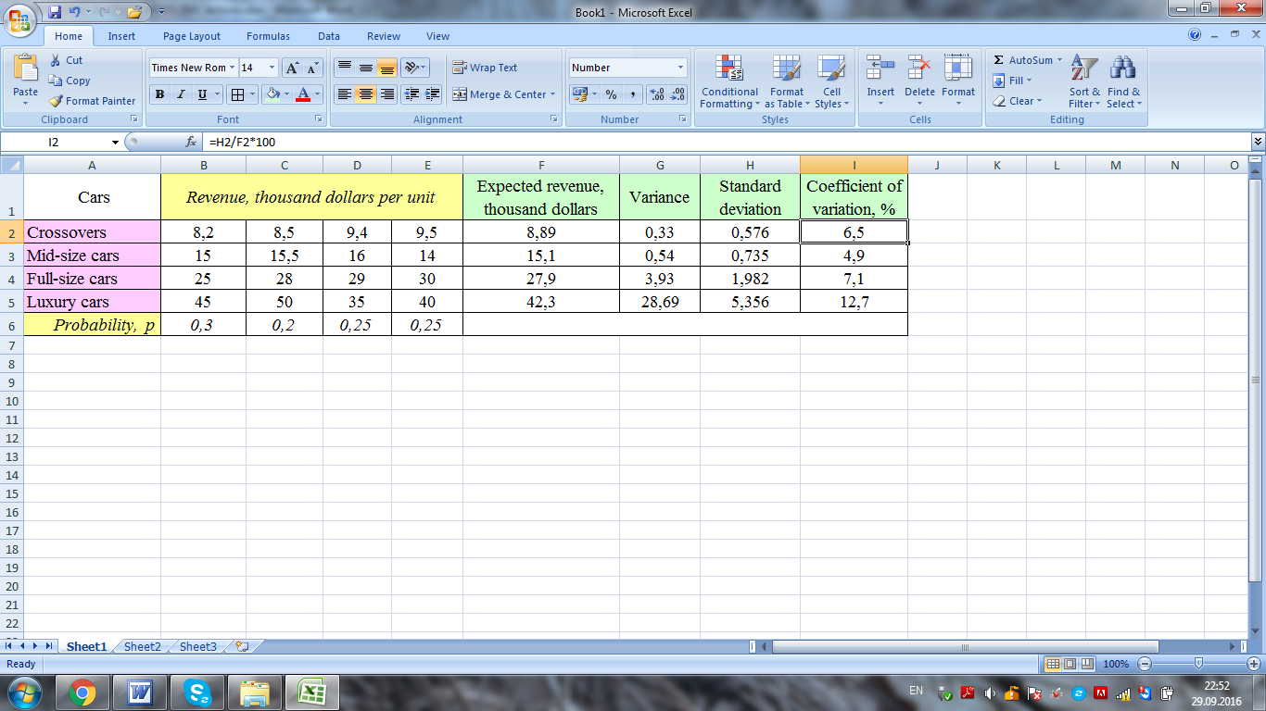

**Topic 3. DECISION MODELING based on TIME SERIES ANALYSIS**

**Content**

1. Time series analysis

2. Time series components

3. Decision modeling with time series analysis indicators

4. Decision modeling based on time series analysis with spreadsheets

**1.** **Time series analysis**

*Time series* is a set of statistics, usually collected at regular intervals. Time series data occur naturally in many application areas:

• *economics* – e.g., monthly data for unemployment, gross domestic product, exports and imports, external debt, etc.

• *finance* – e.g., daily exchange rate, a share price, dividend per share, etc.

• *environmental –* e.g., daily rainfall, air quality readings.

*Time series* is a collection of observations of well-defined data items obtained through repeated measurements over time. Separate data of time series is called data points.

*Time series* is the sequence of data points describing the change of the events, objects or processes at uniform time intervals. In plain English, a *time series* is simply a sequence of numbers collected at regular intervals over a period of time.

*For example*, measuring the level of unemployment each month of the year would comprise a time series. This is because employment and unemployment are well defined, and consistently measured at equally spaced intervals. Data collected irregularly or only once are not time series.

Time series are divided into stock series and flow series.

*Stock time series* are themeasure of certain attributes at a point in time.Stock time series illustrate the data points at every instant of time. *For example:* the remnants of the finished product at the first of each month, the value of fixed assets at the beginning or end of the year and etc.

*Flow time series* are series which are a measure of activity over a given period. Flow time series illustrate the data points within time interval, such as production for month, quarter and year. *For example*: the company’s profit for May is 52 thousand dollars, for first quarter is 208 thousand dollars and for the year is 940 thousand dollars.

The main difference between a stock and a flow series is that flow series can contain effects related to the calendar (trading day effects). Both types of series can still be seasonally adjusted using the same seasonal adjustment process.

*Time series analysis* is the analysis of past statistical data, recorded at successive time intervals. *Time series analysis* is an assessment of relationships between two or among more variables over periods of time. Time series analysis can be useful to see how a given asset, security or economic variable changes over time. It can also be used to examine how the changes associated with the chosen data point compare to shifts in other variables over the same time period.

It is assumed that a time series data set has at least one systematic pattern. The most common patterns are trends and seasonality.

*For example*, suppose you wanted to analyze a time series of daily closing stock prices for a given stock over a period of one year. You would obtain a list of all the closing prices for the stock from each day for the past year and list them in chronological order. This would be a one-year daily closing price time series for the stock.

Delving a bit deeper, you might be interested to know whether the stock's time series shows any seasonality to determine if it goes through peaks and valleys at regular times each year. Analysis in this area would require taking the observed prices and correlating them to a chosen season. This can include traditional calendar seasons, such as summer and winter, or retail seasons, such as holiday seasons.

Alternatively, you can record a stock's share price changes as it relates to an economic variable, such as the unemployment rate. By correlating the data points with information relating to the selected economic variable, you can observe patterns in situations exhibiting dependency between the data points and the chosen variable.

*Time series analysis* aims to achieve various objectives and the tools and models used vary accordingly. The various types of time series analysis include:

- *descriptive analysis* is used to determine the trend or pattern in a time series using graphs or other tools. This helps us identify cyclic patterns, overall trends, turning points and outliers;

*- spectral analysis* is also referred to as frequency domain and aims to separate periodic or cyclical components in a time series. *For example*, identifying cyclical changes in sales of a product;

*- forecasting* is used extensively in business forecasting, budgeting, etc based on historical trends;

*- intervention analysis* is used to determine if an event can lead to a change in the time series, for example, an employee’s level of performance has improved or not after an intervention in the form of training – to determine the effectiveness of the training program;

*- explanative analysis* studies the cross correlation or relationship between two time series and the dependence of one on another. *For example,* the study of employee turnover data and employee training data to determine if there is any dependence of employee training programs on employee turnover rates over time.

**2. Time series components**

The *main components of time series* are trend, seasonality, economic cycles and random variations.

*1. Trend* is a general tendency of a series of data points to move in a certain direction over time. Trend covers short-term changes of time series. It can be growing trend and declining trend. Time series are very frequently plotted via line charts.

*For example:* Figure 1 illustrates the dynamics of demand at uniform time intervals. Figure 2 illustrates the dynamics of supply at uniform time intervals.

Line on figure 1 is called a trend. This trend represents demand change at uniform time intervals (months). Figure 1 illustrates the upward trend in demand.

*Figure 1*



Growing trend

Line on figure 2 illustrates supply change at uniform time intervals (months). Figure 2 represents the downward trend in supply.

*Figure 2*



Decreasing

trend

*2. Seasonality* is a periodic variation or periodic data fluctuations in the limits of small time intervals: days, weeks, months or quarters (often the term “seasonality” refers to the onset of winter, spring, summer or autumn). The major factors that are responsible for the repetitive pattern of seasonal variations are weather conditions and customs of people.

*For example*, more woollen clothes are sold in winter than in the season of summer. Regardless of the trend we can observe that in each year more ice creams are sold in summer and very little in winter season. Another example*:* retail sales tend to peak for the Christmas season and then decline after the holidays. So time series of retail sales will typically show increasing sales from September through December and declining sales in January and February.

*3. Cycles* are the series of wavelike (undulating) data fluctuations over several years. Economic cycles involve shifts over time between periods of relatively rapid economic growth and ups, and periods of relative stagnation or decline (downs). Therefore, *cyclical variations* show upward or downward movements in a time series but the period of cycle is greater than a year. A business has to pass through four cycles – prosperity, recession, depression and recovery.

*For example:* Figure 3 illustrates the dynamics of national produce for 2000-2014 years.

*Figure 3*



Cycles illustrate the economic ups

Cycle illustrates the economic down

*4. Random variations or irregular events* are the fluctuations and variations caused by unexpected and unusual situations such as introduction of legislation, one-off major cultural or sporting event, strikes, emergencies, civil wars and etc. that cannot be anticipated, detected, identified, or eliminated.

**3. Decision modelling with time series analysis indicators**

*Time series analysis* requires data for the selected socioeconomic indicator (including employment, gross domestic product (GDP), expenses, income, profit and population size) over several years.

*Time series analysis indicators* are the analytical indicators used to analyze the time series data over time. How can a time series be analyzed? An original time series shows the actual movements in the data over time. An original series includes any movements due to cyclical, seasonal and irregular events.

A cyclical effect is any regular fluctuation in daily, weekly, monthly or annual data. *For example*, the number of commuters using public transport has regular peaks and troughs during each day of the week, depending on the time of day.

A seasonal effect is any variation in data due to calendar related effects which occur systematically at specific seasonal frequencies every year. *For example*, in Australia employment increases over the Christmas or New Year period, or fruit and vegetable prices can vary depending on whether or not they are “in-season”.

An irregular effect is any movement that occurred at a specific point in time, but is unrelated to a season or cycle. *For example*, a natural disaster, the introduction of legislation, and so on.

Timeseries consists of separate data points: *у1, у2, у3, у4, ... , уп.*

*For example*: Statistics on income for several months is presented in the table*1*.

*Table 1* – Statistics on income

|  |  |
| --- | --- |
| Months | Income, thousand $ |
| May | 120 |
| June | 134 |
| July | 142 |
| August | 140 |
| September | 158 |

where *у1* – is the first data point;

*уп* – is the last data point;

*уі* – is the any data point;

*п* – is the number of periods (months, years).

*The main analytical indicators used to analyze the time series data* are the following:

1) *Absolute chain increase* is the difference between each next data point and previous data point (1):

**;(1)

where *уі-1* – is the previous data point.

2) *Absolute basis increase* is the difference between each next data point and first data point (2):

; (2)

3) *Average absolute increase* is defined as the last data point minus the first data point divided by number of period minus one (formula 3):

**; (3)

4) *Chain growth rate* can be calculated by dividing each next data point by previous data point (4):

; (4)

5) *Basis growth rate* can be calculated by dividing each next data point by first data point (5):

; (5)

5) *Average growth rate* is defined as the last data point divided by the first data point and this fraction raised to power of 1/n-1 (formula 6):

**. (6)

*Example 1:* Calculate the following analytical indicators:

1) the basis and chain absolute increases;

2) the basis and chain growth rates;

3) the average absolute increase;

4) the average growth rate.

*Table 2* – Statistical data on demand

|  |  |
| --- | --- |
| Months | Revenue (*y*), thousand $ |
| March | 520  *уп*  *у1* |
| April | 432 |
| May | 320 |
| June | 450 |
| July | 550 |
| August | 506 |
| September | 487 |
| October | 465 |

1) Firstly, calculate the absolute chain and basis increases in revenue by the formulas (1) and (2).

*Table 3* – Calculation results

|  |  |  |  |
| --- | --- | --- | --- |
| Months | Revenue, thousand $ | Absolute chain increase, thousand $ | Absolute basis increase, thousand $ |
| March | 520 | - | - |
| April | 432 | 432-520= – 88 | 432-520= – 88 |
| May | 320 | 320-432= – 112 | 320-520= – 200 |
| June | 450 | 450-320= 130 | 450-520= – 70 |
| July | 550 | 550-450= 100 | 550-520= 30 |
| August | 506 | 506-550= – 44 | 506-520= – 14 |
| September | 487 | 487-506= – 19 | 487-520= – 33 |
| October | 465 | 465-487= – 22 | 465-520= – 55 |

2) Second, calculate the chain and basis growth rates in revenue by the formulas (4) and (5).

*Table 4* – Calculation results

|  |  |  |  |
| --- | --- | --- | --- |
| Months | Revenue, thousand dollars | Chain growth rate, % | Basis growth rate, % |
| March | 520 | - | - |
| April | 432 |  |  |
| May | 320 |  |  |
| June | 450 |  |  |
| July | 550 |  |  |
| August | 506 |  |  |
| September | 487 |  |  |
| October | 465 |  |  |

3) Average absolute increase in revenue by the formula (3) equals:

**.

The *conclusion* is that the revenue decreased by an average to 7,86 thousand dollars.

4) Average growth rate in revenue by the formula (6) equals:

**.

The *conclusion* is that the revenue decreased by an average by 2% (because 0,98*100%-100%).

Many time series display seasonality. *Seasonality* is any cyclical or periodic fluctuation in a time-series that repeatsitself at the same phase of the cycle or period. *Seasonal variation* is a component of a time series which is defined as the repetitive and predictable movement around the trend line in one year or less. *Seasonal variation* is detected by measuring the quantity of interest for small time intervals, such as days, weeks, months or quarters. The major factors that are responsible for the repetitive pattern of seasonal variations are weather conditions and customs of people. *For example*: toy sales at Christmas, ice cream sales in the summer.

Seasonal variation is measured in terms of an index, called a *seasonal index*. *Seasonal index* is an average that can be used to compare an actual observation relative to what it would be if there was no seasonal variation.

*Seasonal index* is the ratio of data for each period (day, week, month or quarter) to average annual data. *Seasonal index* measures how much the actual data for a particular period tends to be above (or below) the average value.

, (7)

where  is the seasonal index;

 is the statistical data for each period (day, week, month, quarter);

 is the average annual data.

*Average annual data* is defined as a value found by adding available numerical data and then dividing this total by the number of time periods. The average annual data is given by the formula (8):

, (8)

where is the average annual data;

*yi –* is the statistical data for *n*-periods;

*n* – is the number of periods (number of months, quarters, days).

*Example 2:* a company has collected statistical data on ice cream sales for 12 months (*table 5*). Calculate the seasonal index for each month for the next year.

*Table 5* – Statistics on ice cream sales

|  |  |
| --- | --- |
| Month | Ice cream sales, thousand dollars |
| March | 70 |
| April | 85 |
| May | 96 |
| June | 125 |
| July | 135 |
| August | 140 |
| September | 137 |
| October | 110 |
| November | 93 |
| December | 42 |
| January | 40 |
| February | 38 |

*Solution*: Firstly, calculate *the average annual ice cream sales* by the formula (8):

 thousand dollars.

The *seasonal index* for each month is calculated in the table *6* by the formula (7).

*Table 6* – Calculation results

|  |  |  |
| --- | --- | --- |
| Month | Ice cream sales, thousand dollars | Seasonal index |
| March | 70 | *Is1*=70÷92,6=0,856 |
| April | 85 | *Is2*=85÷92,6=0,918 |
| May | 96 | *Is3*=96÷92,6=1,037 |
| June | 125 | *Is4*=125÷92,6=1,35 |
| July | 135 | *Is5*=135÷92,6=1,458 |
| August | 140 | *Is6*=140÷92,6=1,512 |
| September | 137 | *Is7*=137÷92,6=1,48 |
| October | 110 | *Is8*=110÷92,6=1,188 |
| November | 93 | *Is9*=93÷92,6=1,005 |
| December | 42 | *Is10*=42÷92,6=0,453 |
| January | 40 | *Is11*=40÷92,6=0,432 |
| February | 38 | *Is12*=38÷92,6=0,41 |

*Conclusion*: the seasonal index of 0,756 for March means that the ice cream sales is 24,4% (because 0,756*100%-100%) lower than the average ice cream sales; …; the seasonal index of 1,458 for July means the ice cream sales is 45,8% (because 1,458*100%-100%) higher than the average ice cream sales; …; the seasonal index of 1,188 for October means the ice cream sales is 18,8% (because 1,188*100%-100%) higher than the average ice cream sales; …; the seasonal index of 0,41 (because 0,41*100%-100%) for February means the ice cream sales is 59% lower than the average ice cream sales.

**4. Decision modeling based on time series analysis with spreadsheets**

To create spreadsheet model for decision modeling based on time series analysis, proceed through the following steps:

1) headings and range names – you need to name appropriate columns by using the example 1;

2) enter the input data and format them appropriately (*figure 1*);

3) enter the name of decision variable and compute them in the following way (*figure 1*):

To compute the absolute chain increase in revenue for April click cell C3 and type the formula

=B3-B2

and stretch down.

To compute the absolute basis increase in revenue for April click cell D3 and type the formula

=B3-B2

To compute the absolute basis increase in revenue for May click cell D4 and type the formula

=B4-B2

To compute the absolute basis increase in revenue for June click cell D5 and type the formula

=B5-B2

To compute the absolute basis increase in revenue for July click cell D6 and type the formula

=B6-B2

To compute the absolute basis increase in revenue for August click cell D7 and type the formula

=B7-B2

To compute the absolute basis increase in revenue for September click cell D8 and type the formula

=B8-B2

To compute the absolute basis increase in revenue for October click cell D9 and type the formula

=B9-B2

To compute the chain growth rate in revenue for April click cell E3 and type the formula

=B3/B2*100

and stretch down.

To compute the basis growth rate in revenue for April click cell F3 and type the formula

=B3/B2*100

To compute the basis growth rate in revenue for May click cell F4 and type the formula

=B4/B2*100

To compute the basis growth rate in revenue for June click cell F5 and type the formula

=B5/B2*100

To compute the basis growth rate in revenue for July click cell F6 and type the formula

=B6/B2*100

To compute the basis growth rate in revenue for August click cell F7 and type the formula

=B7/B2*100

To compute the basis growth rate in revenue for September click cell F8 and type the formula

=B8/B2*100

To compute the basis growth rate in revenue for October click cell F9 and type the formula

=B9/B2*100

To compute the average absolute increase in revenue cell C11 and type the formula

=(B9-B2)/7

To compute the average growth rate in revenue cell C12 and type the formula

=(B9/B2)^(1/7)

*Figure 1*

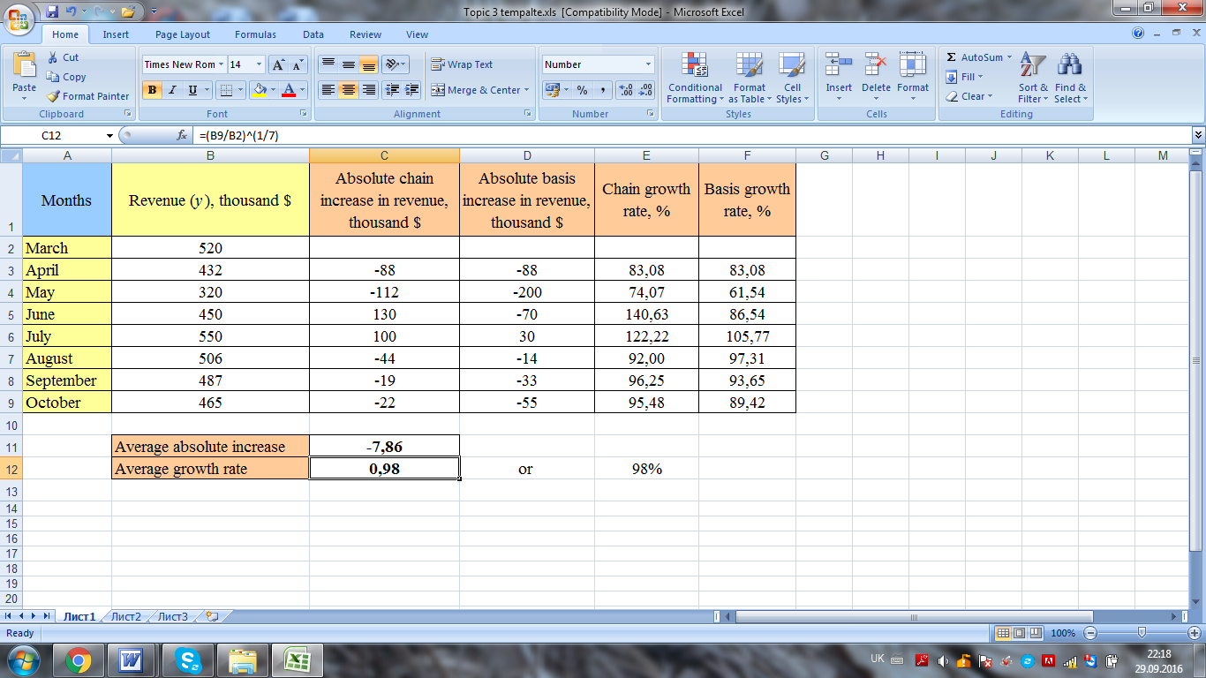

To create spreadsheet model for decision modeling based on analysis of seasonality, proceed through the following steps:

1) headings and range names – you need to name appropriate columns by using the example 2;

2) enter the input data and format them appropriately (*figure 2*);

3) enter the name of decision variable and compute them in the following way (*figure 2*):

To compute the average annual ice cream sales click cell B15 and type the formula

=AVERAGE(B2:B13)

To compute the seasonal index for March click cell C2 and type the formula

=B2/B15

To compute the seasonal index for April click cell C3 and type the formula

=B3/B15

To compute the seasonal index for May click cell C4 and type the formula

=B4/B15

To compute the seasonal index for June click cell C5 and type the formula

=B5/B15

To compute the seasonal index for July click cell C6 and type the formula

=B6/B15

To compute the seasonal index for August click cell C7 and type the formula

=B7/B15

To compute the seasonal index for September click cell C8 and type the formula

=B8/B15

To compute the seasonal index for October click cell C9 and type the formula

=B9/B15

To compute the seasonal index for November click cell C10 and type the formula

=B10/B15

To compute the seasonal index for December click cell C11 and type the formula

=B11/B15

To compute the seasonal index for January click cell C12 and type the formula

=B12/B15

To compute the seasonal index for February click cell C13 and type the formula

=B13/B15

*Figure 2*

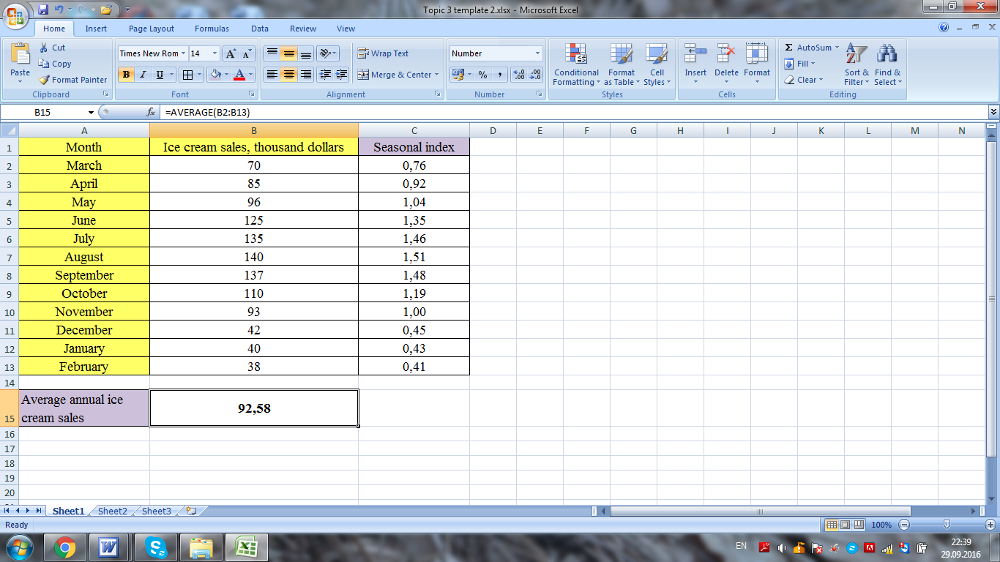

**topic 4. Decision making with Econometric modeling**

**content**

1. Steps in econometric modeling

2. Decision making with linear econometric model

3. Decision making with non-linear econometric model

4. Decision making based on econometric modeling using spreadsheets

**1. Steps in econometric modeling**

*Econometric modeling* is a technique that uses computer processed mathematical equations (that are based on historical data and certain assumptions) to predict economic conditions. These models are employed commonly in determining the economic aspects of changes in government policies, regulatory conditions, interest rates, demographic changes, tax laws, wage levels, etc.

*Econometric modeling* is a set of equations that have been estimated by econometric methods and that are then used, together, to forecast the economy or to calculate effects of changes in the economy.

There are three main steps in developing an econometric model: specification, estimation and validation.

*1. Specification* – in this first step, the model or models used must be defined, as well as data to be used in the estimation stage. In the specification step, we will refer to four elements: *the economic model, the econometric model, the statistical assumptions of the model and the data*. In this section we will refer to the first three elements; in the following section we will examine different types of data used in econometric analysis. The first element we need is an economic model. In some cases, a formal economic model is constructed entirely using economic theory. In other cases, economic theory is used less formally in constructing an economic model. After we have an economic model, we must convert it into an econometric model. We are going to see that with two examples.

*Example 1:* the amount of revenue earned depends on two things – the number of items sold and their selling price. An increase (or decrease) in goods sold or selling price causes an increase (decrease) in company sales. These two components constitute an economic model. To estimate and test this model we must convert it into an econometric model. The linear function can been used to describe the econometric model. The number of items sold or selling price are not the only factors in the determination of company revenue. In real life there are many other factors, which have an influence on revenue, for example demand for product or company costs. In general, all the relevant factors must be introduced explicitly in the econometric model; all the other factors are taken into account in a unique variable: the error or the random disturbance.

*Example 2:* Human capital theory says that education, experience and training are factors that affect productivity and hence the wage. Therefore, an economic model for wage determination includes three factors (independent variables). The linear function can been used to describe the econometric model. To convert an economic model into an econometric model we need to take into account the following:

a) the form of the function has been specified;

b) a disturbance variable has been included to reflect the effect of other variables affecting wage, but not appearing in the model.

*2. Estimation* – in the estimation process we obtain numerical values of the coefficients of an econometric model. To complete this stage, data are required on all observable variables that appear in the specified econometric model, while it is also necessary to select the appropriate estimation method, taking into account the implications of this choice on the statistical properties of estimators of the coefficients. The distinction between estimator and estimate should be made clear. An estimator is the result of applying an estimation method to an econometric specification. On the other hand, an estimate consists of obtaining a numerical value of an estimator.

In general, it is possible to obtain analytical expressions of the estimators, particularly in the case of estimating linear relationships. But in non-linear procedures of estimation it is often difficult to establish their analytical expression.

*3. Validation* – the results are assessed in the validation stage, where we assess whether the estimates obtained in the previous stage are acceptable, both theoretically and from the statistical point of view. On the one hand, we analyze, whether estimates of model parameters have the expected signs and magnitudes: that is to say, whether they satisfy the constraints established by economic theory.

From the statistical point of view, on the other hand, statistical tests are performed on the significance of the parameters of the model, using the statistical assumptions made in the specification step. In turn, it is important to test whether the statistical assumptions of the econometric model are fulfilled, although it should be noted that not all assumptions are testable. The violation of any of these assumptions implies, in general, the application of another estimation method that allows us to obtain estimators whose statistical properties are as good as possible.

One way to establish the ability of a model to make predictions is to use the model to forecast outside the sample period, and then to compare the predicted values of the dependent variable with the values actually observed.

Now, we are going to see three types of data which can be used in the estimation of an econometric model: time series, cross sectional data, and panel data.

*- Time series* – in time series, data are observations on a variable over time. *For example:* magnitudes from national accounts such as consumption, imports, income, etc. The chronological ordering of observations provides potentially important information. Consequently, ordering matters. Time series data cannot be assumed to be independent across time. Most economic series are related to their recent histories. Typical examples include macroeconomic aggregates such as prices and interest rates. This type of data is characterized by serial dependence. Given that most aggregated economic data are only available at a low frequency (annual, quarterly or perhaps monthly), the sample size can be much smaller than in typical cross sectional studies. The exception is financial data where data are available at a high frequency (weekly, daily, hourly, etc.) and so sample sizes can be quite large.

*- Cross sectional data* sets have one observation per individual and data are referred to a determined point in time. In most studies, the individuals surveyed are individuals (for example, in the labour force survey more than 100000 individuals are interviewed every quarter), households (for example, the household budget survey), companies (for example, industrial company survey) or other economic agents.

Surveys are a typical source for cross-sectional data. In many contemporary econometric cross sectional studies the sample size is quite large. In cross sectional data, observations must be obtained by random sampling. Thus, cross sectional observations are mutually independent. The ordering of observations in cross sectional data does not matter for econometric analysis. If the data are not obtained with a random sample, we have a sample selection problem. So far we have referred to micro data type, but there may also be cross sectional data relating to aggregate units such as countries, regions, etc. Of course, data of this type are not obtained by random sampling.

*- Panel data* are time series for each cross sectional member in a data set. The key feature is that the same cross sectional units are followed over a given time period. Panel data combines elements of cross sectional and time series data. These data sets consist of a set of individuals (typically people, households, or corporations) surveyed repeatedly over time. The common modeling assumption is that the individuals are mutually independent of one another, but for a given individual, observations are mutually dependent. Thus, the ordering in the cross section of a panel data set does not matter, but the ordering in the time dimension matters a great deal. If we do not take into account the time in panel data, we say that we are using pooled cross sectional data.

**2. Decision making with linear econometric model**

The term “model” is broadly used to represent any economic relationships in a mathematical frame work. A model or relationship is termed as linear if it is linear in parameters and nonlinear, if it is not linear in parameters.

The basic tool for decision making is the linear regression model. Estimating a linear regression on two variables can be visualized as fitting a line through data points representing values of the independent and dependent variables.

*Linear econometric model (linear regression)* describes the process when the economic data increase or decrease by more or less constant value. The independent variable (x) and the dependent variable (y) is the actual observed value in the time series. A simple linear regression model has only one independent variable, while a multiple linear regression model has two or more independent variables.

*Simple linear regression* looks like (1):

, (1)

where  is the dependent variable;

*a* and *b –* are the designate coefficients;

*x –* is the independent variable;

*e –* is the error in regression model.

Coefficient *b* is calculated by the formula (2):

, (2)

where *n* – is the number of periods;

– is the average value of independent variable;

 – is the average value of dependent variable.

Average value of variable “*x*” is calculated by the formula (3):

, (3)

where *n* - is the number of periods; - is the sum of independent variables;

Average value of variable“*у*”is calculated by the formula (4):

; (4)

where *n* - is the number of periods;

- is the sum of dependent variable.

Coefficient *a* is calculated by the formula (5):

. (5)

*Example 1:* statistical data on sales volume and advertising costs for 5 months are given in the table*1*. Build a linear econometric model and make decision based on it.

*Table 1* – Statistics on sales volume and advertising costs

|  |  |  |
| --- | --- | --- |
| Months | Sales volume, million dollars | Advertising costs, million dollars |
| March | 1,2 | 2,5 |
| April | 1,5 | 2,8 |
| May | 1,9 | 3,0 |
| June | 2,2 | 3,6 |
| July | 2,8 | 3,9 |

*Solution*: in this example the sales volume is dependent variable and the advertising costs are independent variable.

Firstly, write down the linear regression  and calculate the coefficients “*b*” and“*a*” by the formulas (2, 5). To do this, find: “x*2*”,“y*\*x*” in the table 2.

*Table 2* – Calculation results

|  |  |  |  |  |  |
| --- | --- | --- | --- | --- | --- |
| Months | Sales volume (*y*), million dollars | Advertising costs (*x*), million dollars | *y*x* | *x2* | *y2* |
| March | 2,5 | 1,2 | 2,5*1,2=3 | 1,22=1,44 | 2,52=6,25 |
| April | 2,8 | 1,5 | 2,8*1,5=4,2 | 1,52=2,25 | 2,82=7,84 |
| May | 3,0 | 1,9 | 3*1,9=5,7 | 1,92=3,61 | 32=9 |
| June | 3,6 | 2,2 | 3,6*2,2=7,92 | 2,22=4,84 | 3,62=12,96 |
| July | 3,9 | 2,8 | 3,9*2,8=10,92 | 2,82=7,84 | 3,92=15,21 |
| **∑** | ***15,8*** | ***9,6*** | ***31,74*** | ***19,98*** | ***51,26*** |

Last row in the table 2 shows the calculation results of sums: “*t*”, “ *y*”, “ *t2*”, “*y*t*”.

*Average sales volume* (average dependent variable)by the formula (2):

.

*Average value of advertising costs* (average independent variable)by the formula (4):

.

Coefficient *b* by the formula (2) equals:

.

Coefficient *a* by the formula (5) equals:

.

*Linear regression* looks like:

.

The coefficient of determination and correlation coefficient are used as a guideline to measure the linear relationship between variables.

*Coefficient of determination* (R2) – is a measure used in econometric analysis to assess how well a linear regression explains the relationship between variables. The coefficient, also commonly known as “*R-square*”, and it is expressed as a value between 0 and 1. The following points are accepted guidelines for interpreting the coefficient of determination:

1) values between 0 and 0,3 indicate a weak positive linear relationship;

2) values between 0,3 and 0,7 indicate a moderate positive linear relationship;

3) values between 0,7 and 1 indicate a strong positive linear relationship.

*Coefficient of determination* is defined as follows:

 (6)

*The correlation coefficient*, denoted by “r”, is a measure of the strength of the straight-line or linear relationship between two or more variables. *Correlation coefficient* is the square root of the coefficient of determination. The correlation coefficient takes on values ranging between +1 and -1. The following points are accepted guidelines for interpreting the correlation coefficient:

1) 0 indicates no linear relationship;

2) +1 indicates a perfect positive linear relationship: as one variable increases in its values, the other variable also increases in its values;

3) -1 indicates a perfect negative linear relationship: as one variable increases in its values, the other variable decreases in its values;

4) values between 0 and 0,3 (0 and -0,3) indicate a weak positive (negative) linear relationship;

5) values between 0,3 and 0,7 (-0,3 and -0,7) indicate a moderate positive (negative) linear relationship;

6) values between 0,7 and 1 (-0,7 and -1) indicate a strong positive (negative) linear relationship.

*Absolute error* (*AE*) is the difference between actual statistical data (data on dependent variable) and calculated values:

*AE = уi -* (7)

*Dispersion* (*D*) is a calculated as the sum of absolute errors divided by number of periods (*n*):

** (8)

Low value of dispersion means the linear regression is reliable to make future forecast and decisions.

Calculated values by linear regression and absolute errors are found in the table*4*.

*Table 4* – Calculation results

|  |  |  |  |  |
| --- | --- | --- | --- | --- |
| Months | Sales volume (*y*), million dollars | Advertising costs (*x*), million dollars | Calculated values  by linear regression | Absolute error |
| March | 2,5 | 1,2 | 1,42+0,91*1,2=2,51 | 2,5-2,51 = – 0,01 |
| April | 2,8 | 1,5 | 1,42+0,91*1,5=2,78 | 2,8-2,78 = 0,01 |
| May | 3,0 | 1,9 | 1,42+0,91*1,9=3,15 | 3-3,15 = – 0,15 |
| June | 3,6 | 2,2 | 1,42+0,91*2,2=3,42 | 3,6-3,42 = 0,18 |
| July | 3,9 | 2,8 | 1,42+0,91*2,8=3,97 | 3,9-3,97 = – 0,07 |

*Dispersion* by the formula (8):

**.

*Conclusion*: the linear econometric model is reliable to make decision and forecast, because dispersion is close to 0.

*Coefficient of determination* by the formula (6):



Correlation coefficient (*r*) is a square root of the coefficient of determination (R2). R2=0,98 may be interpreted as follows: approximately 98% (0,98*100%) of the variation in the dependent variable (sales volume) can be explained by the independent variable (advertising costs).

The correlation coefficient equals:

**

*Conclusion*: *r=*0,99 may be interpreted as follows: approximately 99% (0,99*100%) of the variation in the dependent variable (sales volume) can be explained by the linear regression.

**3. Decision making with non-linear econometric model**

Non-linear econometric model (non-linear regression) is a form of mathematical model that reflects results in a curve between two dependent and independent variables rather than a straight-line relationship as in the case of a linear regression. Nonlinear regression uses logarithmic functions, trigonometric functions and exponential functions, among other fitting methods.

Nonlinear relationship between dependent and independent variables can be described by using following equations:

- quadratic equation: ;

- power equation: ;

- logarithmic equation: ;

- exponential equation:  and so on.

Absolute error, dispersion and pair correlation ratio are used as a guideline to measure the nonlinear relationship between variables.

*Pair correlation ratio* is a measure used in econometric analysis to assess how well a nonlinear regression explains the relationship between variables.

 (9)

It is expressed as a value between 0 and 1. If the value of pair correlation ratio is close to 1, it means that the non-linear regression is reliable in describing the relationship between dependent and independent variables. The following points are accepted guidelines for interpreting the pair correlation ratio:

1) values between 0 and 0,3 indicate a weak positive linear relationship;

2) values between 0,3 and 0,7 indicate a moderate positive linear relationship;

3) values between 0,7 and 1 indicate a strong positive linear relationship.

*Example 2:* the nonlinear econometric model is used to describe the relationship between sales volume and consumer income. Estimate how well a nonlinear model explains the relationship between variables.

*Table 5* – Statistics on sales volume and consumer income

|  |  |  |
| --- | --- | --- |
| Months | Sales volume, million dollars | Consumer income, million dollars |
| March | 5,4 | 5,8 |
| April | 5,8 | 6,4 |
| May | 6,9 | 7,3 |
| June | 7,3 | 7,4 |
| July | 8,1 | 8,2 |

*Solution*: in this example the sales volume is dependent variable and the consumer income is independent variable. Calculated values by non-linear regression and absolute errors are shown in the table *6*.

*Table 6* – Calculation results

|  |  |  |  |  |
| --- | --- | --- | --- | --- |
| Months | Sales volume (*y*), million dollars | Consumer income (*x*), million dollars | Calculated values  by non-linear regression | Absolute error |
| March | 5,4 | 5,8 | -0,81+1,51*5,8-0,05*5,82=6,27 | 5,4-6,27= – 0,87 |
| April | 5,8 | 6,4 | -0,81+1,51*6,4-0,05*6,42=6,81 | 5,8-6,81= – 1,01 |
| May | 6,9 | 7,3 | -0,81+1,51*7,3-0,05*7,32=7,55 | 6,9-7,55= – 0,65 |
| June | 7,3 | 7,4 | -0,81+1,51*7,4-0,05*7,42=7,63 | 7,3-7,63= – 0,33 |
| July | 8,1 | 8,2 | -0,81+1,51*8,2-0,05*8,22=8,21 | 8,1-8,21= – 0,11 |

Average sales volume equals: 

*Table 7* – Calculation results

|  |  |  |
| --- | --- | --- |
| Months | Sales volume (*y*), million dollars | (Sales volume – Average sales)2 |
| March | 5,4 | (5,4 – 6,7)2=1,69 |
| April | 5,8 | (5,8 – 6,7)2=0,81 |
| May | 6,9 | (6,9 – 6,7)2=0,04 |
| June | 7,3 | (7,3 – 6,7)2=0,36 |
| July | 8,1 | (8,1 – 6,7)2=1,96 |
| **∑** |  | ***4,86*** |

*Pair correlation ratio* by the formula 9 equals:



The pair correlation ratio of 0,73 means strong positive linear relationship between sales volume and consumer income. Therefore, a manager who will make a business decision has to take into consideration the customer income as a factor which has an impact on sales volume.

*Dispersion* by the formula (8):

**.

*Conclusion*: the non-linear econometric model is sufficiently reliable to make decision and forecast, because dispersion is close to 0.

**4. Decision making based on econometric modeling using spreadsheets**

To create spreadsheet for linear econometric model, proceed through the following steps:

1) headings and range names – you need to name appropriate columns by using the example 1;

2) enter the input data and format them appropriately (*figure 1*);

Let’s assume that the linear regression model is already known: . Then enter the name of other decision variables and compute them in the following way (*figure 1*).

To compute the calculated value for March by linear regression click cell D2 and type the formula:

=1,42+0,91*C2

To compute the calculated value for April by linear regression click cell D3 and type the formula:

=1,42+0,91*C3

To compute the calculated value for May by linear regression click cell D4 and type the formula:

=1,42+0,91*C4

To compute the calculated value for June by linear regression click cell D5 and type the formula:

=1,42+0,91*C5

To compute the calculated value for July by linear regression click cell D6 and type the formula:

=1,42+0,91*C6

To compute the absolute error click cell E2 and type the formula

=B2-D2

and stretch down.

To compute the dispersion click cell C8 and type the formula

=(E2^2+E3^2+E4^2+E5^2+E6^2)/5

To compute the correlation coefficient click cell C10 and type the formula

=SQRT(C9)

*Figure 1*

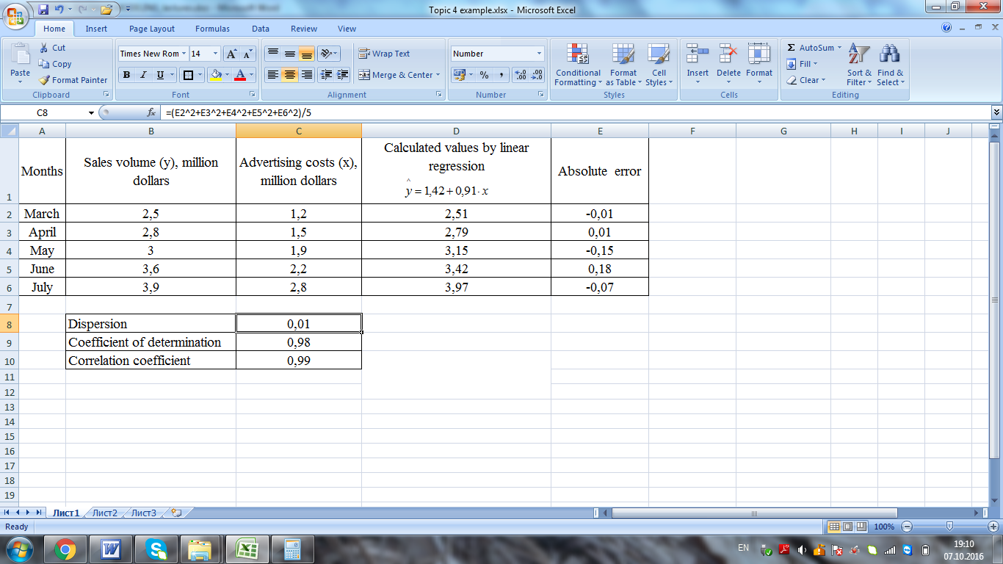

To create spreadsheet for non-linear econometric model, proceed through the following steps:

1) headings and range names – you need to name appropriate columns by using the example 2;

2) enter the input data and format them appropriately (*figure 2*);

Let’s assume that the nonlinear regression model is already known: . Then enter the name of other decision variables and compute them in the following way (*figure 1*).

To compute the calculated value for March by nonlinear regression click cell D2 and type the formula:

=-0,81+1,51*C2-0,05*C2^2

To compute the calculated value for April by nonlinear regression click cell D3 and type the formula:

=-0,81+1,51*C3-0,05*C3^2

To compute the calculated value for May by nonlinear regression click cell D4 and type the formula:

=-0,81+1,51*C4-0,05*C4^2

To compute the calculated value for June by nonlinear regression click cell D5 and type the formula:

=-0,81+1,51*C5-0,05*C5^2

To compute the calculated value for July by nonlinear regression click cell D6 and type the formula:

=-0,81+1,51*C6-0,05*C6^2

To compute the absolute error click cell E2 and type the formula

=B2-D2

and stretch down.

To compute the absolute error in square click cell F2 and type the formula

=E2^2

and stretch down.

To compute the average sales volume, click C8 and type the formula

=AVERAGE(B2:B6)

To compute the (Sales volume – Average sales) in square click cell G2 and type the formula

=(B2-C$8)^2

To compute the total absolute errors in square click cell F7 and type the formula

=SUM(F2:F6)

To compute the total the (Sales volume – Average sales) in square click cell G7 and type the formula

=SUM(G2:G6)

To compute the pair correlation ratio click cell C9 and type the formula

=SQRT(1-F7/G7)

To compute the dispersion click cell C10 and type the formula

=F7/5

Figure 2

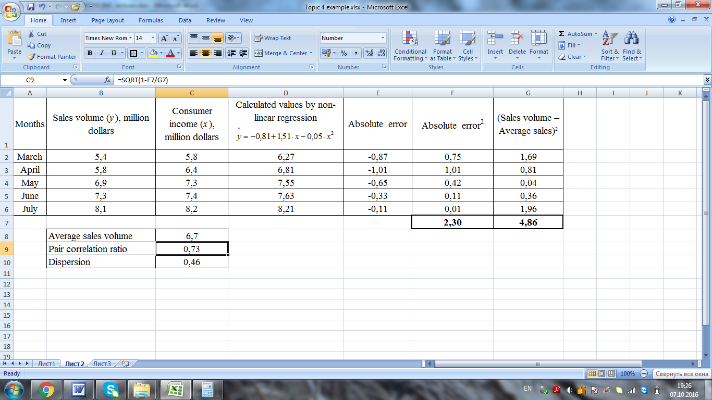

**topic 5.** **INVENTORY DECISIONS Modeling in SUPPLY CHAIN**

**content**

1. Categories of inventory models

2. Types of costs in inventory models

3. Economic order quantity models

4. Developing inventory models using spreadsheet

**1. Categories of inventory models**

*Inventory management* is the practice overseeing and controlling of the ordering, storage and use of components that a company uses in the production of the items it sells. It’s one of the most important decisions faced by many companies. These companies include not only retailers that stock products for sale to customers, but also companies that supply other companies. They all face two competing pressures.

*The first is the pressure* to have enough inventories on hand. The most obvious reason for this is that they do not want to run out of products that customers demand. Another prominent reason, however, is the fixed cost of ordering or producing. If a fixed cost is incurred each time the company orders from its supplier, or a fixed cost is incurred each time a manufacturer produces a batch, where this cost does not depend on the order or batch size, then the company has an incentive to place large orders or produce large batches to minimize its annual fixed costs.

*The second pressure* related to inventory management is the pressure to carry as little inventory as possible. The most obvious reasons for this are the cost of storing items and the interest costs involved in tying up money in inventory. If the company has to pay cash for items that end up sitting on the shelf for long periods of time, it loses potential interest on this money that could be invested elsewhere. Storage space is sometimes an issue as well. Some companies simply do not have the space to store as much inventory as they might like. For example, there is fierce competition for shelf space in supermarkets.

These two competing pressures are at the heart of most inventory models. Companies want to order enough, but they do not want to order too much. The balance is typically not easy to find, so we need models to determine the best ordering (or production) policy. An inventory problem can usually be broken up into two parts: (1) how much to order on each ordering opportunity and (2) when to order.

We discuss only the most basic of these models, which have been used extensively in real applications.

*- Deterministic inventory models* assume that all inputs to the problem, particularly customer demand, are known when the decisions are made. In reality, a company must always forecast future demands with some type of forecasting model. The outputs of this forecasting model might include a mean demand and a standard deviation of demand. In deterministic models, however, we use only the mean and discard any information about the uncertainty, such as the standard deviation. This makes the resulting models simpler, but usually less realistic.

*- Probabilistic inventory models* assume that all inputs to the problem, particularly customer demand, are known with some degree of probability. They are typically more difficult to analyze, but they tend to produce better decisions, especially when the level of uncertainty is high.

A second factor in inventory modeling is whether demand for the product is generated externally or internally.

*- External demand (or independent demand)* occurs when the company that sells the product cannot directly control the extent or the timing of customer demand. For example, a retailer who orders products from a supplier and then waits to see how many customers request these products faces external demand. In these situations, we usually assume that ordering decisions are influenced by, but do not affect, customer demand.

*- Internal demand (or dependent demand)* occurs in most assembly and manufacturing processes. Consider, for example, a company that manufactures laptop computers. The external demand is for the finished product, but the internal demand is for the components that go into the finished product. After the company forecasts the number of laptops its customers will demand, say, in the next month, it must then determine an appropriate production schedule for producing them. This production schedule will necessitate having inventories of the laptop’s component parts and subassemblies on hand at the right time. In short, the production schedule determines, in large part, the inventory required for all of the individual parts and subassemblies. The supply chain needs to ensure that the parts and subassemblies are available at the right time and the right place (and at the cheapest cost) for manufacturers to compete in today’s business environment.

A third factor in inventory modeling is whether the company orders the products from a supplier or produces them internally.

*- If the products are ordered*, then there is typically an order lead time, the time elapsed from when the order is placed until it arrives. In ordering models, there is also usually a fixed cost (also called a setup or ordering cost) each time an order is placed, where this cost is independent of the order quantity.

*- If products are produced internally*, there is also a lead time, the time it takes to produce a batch of items. This time is determined by a production rate, such as 10 units per hour, and possibly by a setup time, the fixed time necessary to set up any machinery to produce a specific type of product. As in ordering models, there can also be a setup cost each time a batch is produced, where this cost is independent of the batch size.

A fourth factor in inventory modeling is whether inventory is reviewed continuously or periodically.

*- In continuous review models*, the inventory is monitored continually and orders can be placed at any time. Typically, there is a reorder point – a specific inventory level – so that when the inventory on hand reaches this reorder point, an order is placed immediately. This could happen Wednesday afternoon, Friday morning, or any other time.

*- In periodic review models*, there is some standard time, such as every Monday morning, when the inventory is reviewed and ordering decisions are made. Except possibly for emergency orders; these are the only times, when orders are placed. Continuous review models can certainly be implemented, given today’s computerized access to inventory levels in real time, and these models can result in lower annual costs than periodic review models. However, when a company stocks many products (hundreds or even thousands), it is often more convenient to order these, say, only on Monday mornings.

A final factor in inventory modeling concerns the number of products involved.

*Single product models*: models that consider only a single product are conceptually and mathematically simpler, so we initially analyze *single-product models*.

*Multiple-product models:* However, most companies have many different products that must be considered simultaneously. If the company orders these items from a supplier, then it may be wise to synchronize the orders in some way to minimize ordering costs.

**2. Types of costs in inventory models**

Companies face a number of costs when they manage inventories. Although the types of costs vary depending on the company and the situation, the following costs are typical.

*- Ordering (or setup) cost* is the fixed cost incurred every time an order is placed or a batch is produced. The ordering cost is independent of the amount ordered or produced. This ordering cost includes the cost of paperwork and billing each time an order is placed and could include other costs as well, such as paying a truck driver to deliver the order to the company’s warehouse. If the product is produced rather than ordered, this cost can include the cost to set up equipment.

*- Unit purchasing (or production) cost* is the cost for each additional unit purchased or produced (often referred to as the variable cost). *For example*, to order 100 units, the company might have to pay a setup cost of $500 plus $3 per unit, for a total of $800. Here, $3 is the unit purchasing cost. If the company produces the product, then the unit production cost includes the cost of raw materials and the labor cost for each unit produced. Sometimes the unit purchasing cost is not constant but changes according to a quantity discount schedule.

*- Holding (or carrying) cost* is the cost that motivates the company to keep less inventory on hand. This cost generally has two components, the financial holding cost and the nonfinancial holding cost. The nonfinancial holding cost is usually the cost of storing the product. *For example*, this might be the cost of renting warehouse space. The financial holding cost is the opportunity cost of having money tied up in inventory when that money could instead be earning interest in other investments. There can be other holding costs, such as spoilage, insurance, and overhead, which vary according to the amount and type of inventory on hand.

*- Shortage (or penalty) cost* is the cost of running out of inventory. This is often the most difficult cost to measure. For one thing, it depends on how the company handles shortages. At one extreme, there are lost sales models, where any demands that occur when inventory is zero are lost; these customers take their business elsewhere. At the other extreme, there are complete backlogging models, where demands that occur when inventory is zero are satisfied as soon as a new order arrives. Both of these models – or any in between, called partial backlogging models – have negative effects for the company. There is lost revenue, loss of goodwill, and possibly expedited shipments with higher costs. Unfortunately, it can be difficult to put a dollar value on the “cost” of running out of inventory. An alternative is to specify a service level, such as meeting at least 95% of the demand on time.

**3. Economic order quantity models**

*Economic order quantity models* make the following assumptions:

- a company orders a single product from a supplier and sells this product to its customers;

- orders can be placed at any time (continuous review);

- there is a constant, known demand rate for the product, usually expressed in units per year (annual demand);

- there is a constant, known lead time for delivery of the product from the supplier;

- there is a fixed ordering cost each time the product is ordered, independent of the size of the order;

- the price the company charges for the product is fixed;

- the annual holding cost is proportional to the average amount of inventory on hand.

*1. Economic order quantity* *model* is a model where the order quantity that minimizes total inventory holding costs and ordering costs. Two most important categories of inventory costs are ordering costs and carrying costs. *Ordering costs* are costs that are incurred on obtaining additional inventories. They include costs incurred on communicating the order, transportation cost, etc. *Carrying costs* represent the costs incurred on holding inventory in hand. They include the opportunity cost of money held up in inventories, storage costs, spoilage costs, etc.

The formula for an *economic order quantity* is:

**, (1)

where *D* – are the units of annual demand;

*OC* – is the cost per order;

*C* – is the carrying cost per order.

*Example 1*: ABC Ltd. is engaged in sale of footballs. Its cost per order is $400 and its carrying cost unit is $10 per unit per annum. The company has a demand for 20000 units per year. Calculate the order size, total orders required during a year, total carrying cost and total ordering cost for the year.

*Solution*: the order size by the formula (1) equals:

*units.*

*Total orders* are calculated by dividing the annual demand by the order size.

** (2)

Annual demand is 20000 units so the company will have to place 16 orders, because

*orders.*

*Total ordering cost* is calculated by multiplying the cost per order by the total orders.

*TOC=OC ×TO* (3)

The total ordering cost by the formula (3) equals:

*TOC=400 × 16=$6400*

*Total carrying cost* iscalculated by multiplying the average inventory held by the carrying cost per unit.

*TCC=AIH ×C* (4)

where *AIH* – is the average inventory held (is calculated by dividing the sum of the inventory at the beginning and at the end of the period by 2).

The average inventory held equals:

*AIH=1265 / 2 = 632*

The total carrying cost by the formula (4) equals:

*TCC=632 ×10 =$6320*

*Conclusion:* the order size is 1265 footballs, the total ordering cost is $6400 and the total carrying cost is $6320.

*2. Economic order quantity model with quantity discounts* is a model, where the company placing the order can obtain quantity discounts from its supplier. The order quantity is defined by the formula:

**, (5)

where *D* – are the units of annual demand;

*OC* – is the cost per order;

*Sc* – is the storage cost per order expressed as percentage;

*P* – is the price.

*Example 2*: The accounting company of AJ Taylor buys USB thumb drives from a distributor of PC supplies. The company uses approximately 5000 drives per year at a fairly constant rate. The distributor offers the following quantity discount. If 500 drives are ordered, the cost per drive is $30. If 650 drives are ordered, the cost per drive is $28. If 800 drives are ordered, the cost per drive is $26. The fixed cost of placing an order is $100. The company’s storage cost is 10% per year. The company wants to find the order quantity.

*Solution*: if 500 drives are ordered, then the order size equals:

* units*.

If 650 drives are ordered, then the order size equals:

* units*.

If 800 drives are ordered, then the order size equals:

* units*.

*Conclusion:* the order size is 183 units, if 500 drives are ordered; the order size is 215 units, if 650 drives are ordered; and the order size is 248 units, if 800 drives are ordered;

*3. Economic order quantity model with shortages allowed* is a model, where the shortages and back ordering are allowed. It will be assumed that all demand not met because of inventory shortage can be back ordered and delivered to the customer later. The order size is defined by the formula:

, (6)

where *D* – are the units of annual demand;

*OC* – is the cost per order;

*C* – is the carrying cost per order.

*SC* – is the shortage cost.

*Example 3*: Carpet Discount Store allows shortages and the shortage cost. Its cost per order is $30 and its carrying cost unit is $3 per unit per annum. The company has a demand for 8000 units per year. Also, the company allows shortages and the shortage cost $7 per unit per annum. Calculate the order size and number of orders.

*Solution*: the order size by the formula (1) equals:

 *units.*

Number of orders is defined by dividing the demand by the order size:

 orders per year.

*Conclusion:* the order size is 478 units and number of orders is 17 per year.

**4. Developing inventory models using spreadsheet**

To create spreadsheet for economic order quantity model (*example 1*), proceed through the following steps:

1) headings and range names – you need to name appropriate columns by using the example 1;

2) enter the input data and format them appropriately (*figure 1*);

3) enter the name of other decision variables and compute them in the following way (*figure 1*).

To compute the order size click cell B8 and type the formula=SQRT((2*B5*B3)/B4)

To compute the total orders click cell B9 and type the formula

=B5/B8

To compute the average inventory held click cell B10 and type the formula

=B8/2

To compute the total ordering cost click cell B11 and type the formula

=B3*B9

To compute the total carrying cost click cell B12 and type the formula

=B4*B10

*Figure 1*

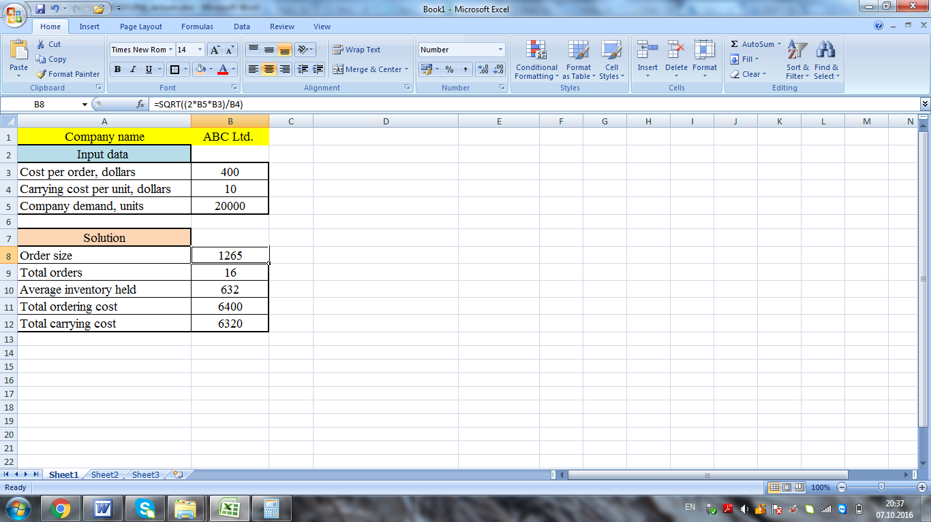

To create spreadsheet for economic order quantity model with quantity discounts(*example 2*), proceed through the following steps (*figure 2*).

To compute the order size if distributor offers 500 units click cell E3 and type the formula

=SQRT((2*B4*B10)/(B5*B11))

To compute the order size if distributor offers 650 units click cell E4 and type the formula

= =SQRT((2*B6*B10)/(B7*B11))

To compute the order size if distributor offers 800 units click cell E5 and type the formula

=SQRT((2*B8*B10)/(B9*B11))

*Figure 2*

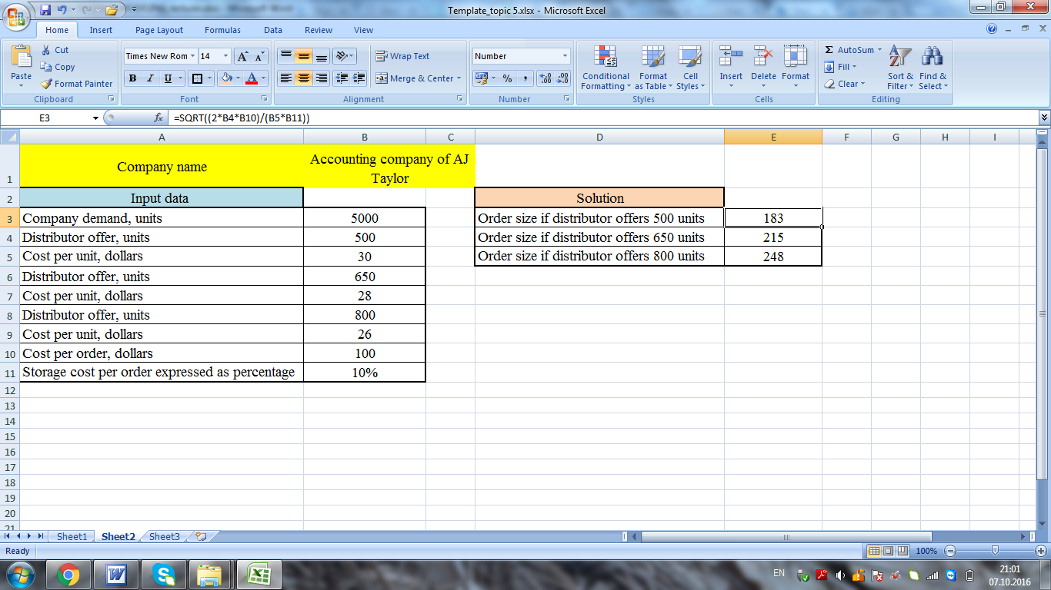

To create spreadsheet for economic order quantity model with shortages allowed(*example 3*), proceed through the following steps (*figure 3*).

To compute the order quantity with shortages allowed click cell B9 and type the formula

=SQRT((2*B5*B3)/B4*(B4+B6)/B6)

To compute the number of orders, click cell B10 and type the formula

=B5/B9

*Figure 3*

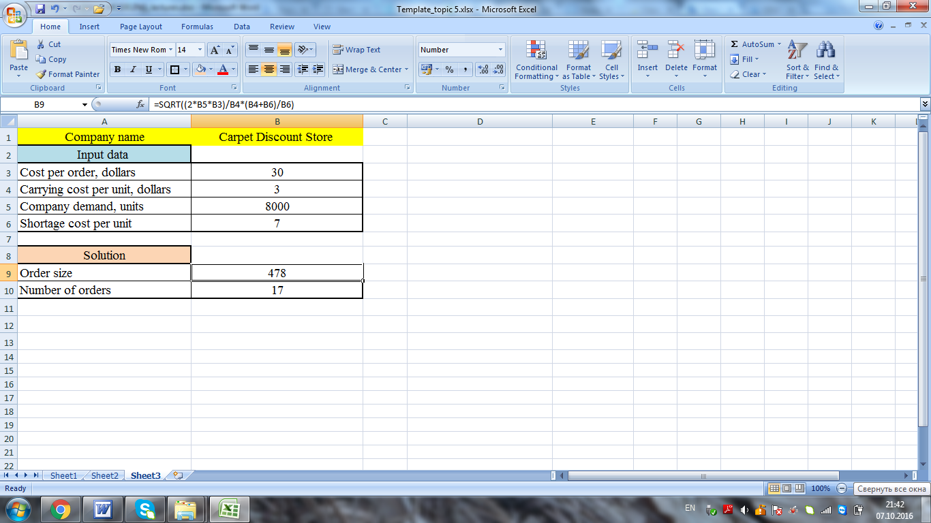

**topic 6. Decision making with simulation modeling**

**content**

1. Introduction to simulation modeling

2. Operational simulation models

3. Financial simulation models

4. Simulation models with spreadsheets

**1. Introduction to simulation modeling**

*Simulation model* is a model that calculates the impact of uncertain inputs and decisions a manager makes on outcomes, such as profit and loss, investment returns. The main advantages of simulation modeling are given below.

*- Simulation model* is a model that imitates a real-life situation and shows the best-case and worst-case scenarios. This model is like other mathematical models, but it explicitly incorporates uncertainty in one or more input variables. When we run a simulation, we allow these random input variables to take on various values, and we keep track of any resulting output variables of interest. In this way, we are able to see how the outputs vary as a function of the varying inputs.

- *The fundamental advantage of a simulation model* is that it shows an *entire distribution of results*, not simply a single bottom-line result. As an example, suppose an automobile manufacturer is planning to develop and market a new model car. The company is ultimately interested in the expected profits from this car over the next 10 years. However, many uncertainties surround this car, including the yearly customer demands, the cost of development, and others. It is better to treat the uncertainty explicitly with a simulation model. This involves entering probability distributions for the uncertain quantities and seeing how the expected profit varies as the uncertain quantities vary.

Each different set of values for the uncertain quantities can be considered a scenario. Simulation allows us to generate many scenarios, each leading to a particular expected profit. In the end, we see a whole distribution of expected profits, not just a single best guess. We can see what the expected profit will be on average, and we can also see worst-case and best-case results.

*- Simulation models are also useful* for determining *how sensitive a system is to changes in operating conditions. For example*, we might simulate the operations of a supermarket. After the simulation model has been developed, we can then run it (with suitable modifications) to ask a number of what-if questions. *For example,* if the supermarket experiences a 20% increase in business, what will happen to the average time, when customers must wait for service?

*- A great benefit of simulation modeling* is that it enables us to answer these types of what-if questions *without actually changing (or building) a physical system*. *For example*, the supermarket might want to experiment with the number of open registers to see the effect on customer waiting times. The only way the supermarket can physically experiment with more registers than it currently owns is to purchase more equipment. Then if it determines that this equipment is not a good investment – customer waiting times do not decrease appreciably – the company is stuck with expensive equipment it doesn’t need. Computer simulation is a much less expensive alternative because it provides the company with an electronic replica of what would happen if the new equipment were purchased. Then, if the simulation indicates that the new equipment is worth the cost, the company can be confident that purchasing it is the right decision. Otherwise, the company can abandon the idea of the new equipment before the equipment has been purchased.

There are the following types of business simulation models:

*- Strategic Management Business Simulations* – these simulations cover the strategic management of business. Since the simulation is concerned with strategic management it covers the general management of a “total enterprise”. Decisions cover marketing, finance, operations, business research and information and product design and development.

*- Tactical Management Business Simulations* – these simulations cover the tactical management of a business. Just as strategic simulations tend to focus on the external environment these concentrate on the internal aspects of the business. The simulation model concerns on factory and financial operations. Marketing aspects may be quite simple with emphasis on the efficient use of resources, budgetary control and cash flow;

*- Functional Simulations* – these involves participants running a functional area of a business with strategic, tactical and operational decisions. Functional simulations take a vertical slice through the organization. As a result some decisions are of strategic importance, some of tactical importance and some are operational necessities. Functional simulations refer to production (operational) management simulation, sales and marketing simulation. Marketing departments have plenty of opportunities to use simulation. They face uncertainty in the brand-switching behavior of customers, the entry of new brands into the market, customer preferences for different attributes of products, the effects of advertising on sales, and so on. Also, a production management simulation might involve making decisions to set-up the factory and those to run it. The factory set-up decisions are made once, at the start of the simulation. The factory scheduling decisions are made, repetitively, each month.

*- Concepts Simulations* – these are simulations that address one or a very limited range of business concepts such as: product life cycle, team behaviour, and budgetary control. These simulations focus on specific business issues and concepts. *For example*, this might be the launch of a new product or the operation of a simple factory unit. To be a viable learning tool these simulations must be simple and involve making only three or four decisions each period.

*- Planning Simulations* – these involve creating a plan based on a series of “What-if” analyses such as: investment analysis, financial analysis. These involve the preparation of a business plan using a “What-If” model. *For example*, this might be long range market diversification plan or the development of an annual budget. Planning simulations are of particular use where managers need to understand the business implications of the topic. For instance, a manager may have learned about the composition of the Profit & Loss and Balance Sheet and how various Financial Ratios are calculated. For this knowledge to be of practical use, the manager must understand how managerial actions impact these and the business implication of the results of these actions.

*- Process Simulations* – these involve the practical exploration of a business process such as sales forecasting, inventory planning, analysis of sales performance, contract bidding. Practicalities must be considered, the results are interpreted and quantitative and qualitative issues balanced. The process simulation involves teams working on different sets of data or situations to find patterns, discussing implications and explore the process.

**2. Operational simulation models**

*Operational simulation models* are the simulations covering such things as productivity control, quality control, bidding for a contract, estimating the number of replacements under warranty. *Operational simulation models* can offer significant capabilities for operating personnel to analyze and troubleshoot current performance and to develop optimum responses in a proactive manner. This can increase agility in decision making, improve reliability and lower operating cost. The following examples relate to the operational simulation models:

*- bidding for a contract* (uncertainty in the bids by competitors) – In situation where a company must bid against competitors, simulation can often be used to determine the company’s optimal bid. Usually the company does not know what its competitors will bid, but it might have an idea about the range of the bids its competitors will choose. Simulation model can be used to determine a bid that maximizes the company’s expected profit;

*- warranty costs* (uncertainty in the time until failure of an appliance) – When you buy a new product, it usually carries warranty. A typical warranty might state that if the product fails within a certain period such as 1 year, you will receive a new product at no cost, and it will carry the same warranty. However, if the product fails after the warranty period, you have to bear the cost of replacing the product. Due to random life-times of products, we need a way to estimate the warranty costs (to the company) of a product. Simulation model is used to estimate the number of replacements under warranty and the total expected profit from a given sale;

*- quality control* (uncertainty in the quality of manufactured parts); is used to ensure that a process is meeting specified standards by measuring its performance. If the process is to produce quality products, its capabilities must be periodically measured to check that it is performing as planned. The quality of the process can be affected by natural variations that occur in almost every production process. As long as these variations remain within specified limits, the process is ‘in control’ and quality will not be affected. However, if the variations go outside the specified limits, the process is ‘out of control’ and the causes must be determined. Control charts are used to separate random causes of variation from non-random causes such as operator error, faulty setup, poor materials, and so forth.

*- productivity control* (uncertainty in the bottleneck in a process or operation, reducing inventory and work-in-process, and reducing cycle time). Productivity is formally defined as the ratio of output per unit of input. In real life situations, however, the diversity and complexity of inputs and outputs make productivity computation and analysis rather difficult and intractable. Depending on the situation, productivity can be measured by the ratio of revenue per employee, the return on assets, and at a more specific level, the number of products produced per hour at a given plant running with a given level of staffing, equipment, energy and other inputs. Productivity growth depends on finding better ways to produce goods and services. Given the diversity and complexity of inputs and outputs as well as the inherent computational difficulty, simulation becomes a more practical tool as compared to the traditional analytical approaches to productivity improvement studies. The superiority of simulation stems from the fact that simulation models are designed to mimic the process (or system) under study. Thus, the analyst has access to all variables and their values at any instant of time during the simulation. Some common approaches to productivity improvement are identification and removal of bottleneck in a process or operation, reducing inventory and work-in-process, and reducing cycle time.

*Example 1:* the company explores the best-case and worst-case scenarios for improving the manufacturing process and sales management. Find the labour productivity as output per hour worked, labour productivity as output per employee and labour productivity as revenue per employee if the company considers three scenarios for expected output and sales revenue: scenario “minimum success” with 70% probability, scenario “most likely success” with 50% probability, and scenario “maximum success” with 30% probability.

*Table 1* – Input data

|  |  |  |  |
| --- | --- | --- | --- |
| *Indicators* | *Minimum* | *Most likely* | *Maximum* |
| Expected output, units | 428000 | 460000 | 540000 |
| Total labour hours | 16640 | 17200 | 17820 |
| Employees | 150 | 158 | 162 |
| Sales revenue, dollars | 624000 | 684000 | 732000 |

*Labour productivity* is the value of goods and services produced in a period of time, divided by the hours of labour used to produce them. In other words labour productivity measures output produced per unit of labour, usually reported as *output per hour worked or output per employed person*.

The formula for measuring *labour productivity as output per hour worked* is the number of products manufactured or produced divided by the number of labour hours (1).

**,(1)

where *O* – is the company output;

*L* – is the labour hours.

The formula for measuring *labour productivity as output per employee* is the total output divided by the quantity of labour employed. So, o*utput per employee* is the ratio of the company output to the number of employees (2).

**,(2)

where *O* – is the company output;

*E* – is the number of employees.

*Labour productivity* can be measured as sales revenue per employee. In this case, *revenue per employee* is an important ratio that looks at an company’s sales in relation to the number of employees they have (3).

**,(3)

where *S* – is the sales revenue;

*E* – is the number of employees.

*Solution*: the labour productivity as output per hour worked, labour productivity as output per employee and labour productivity as revenue per employee are calculated in the table 2.

*Table 2* – Labour Productivity control

|  |  |  |  |
| --- | --- | --- | --- |
| *Indicators* | *Minimum* | *Most likely* | *Maximum* |
| Expected output, units | 428000 | 460000 | 540000 |
| Total labour hours | 16640 | 17200 | 17820 |
| Employees | 150 | 158 | 162 |
| Sales revenue, dollars | 624000 | 684000 | 732000 |
| *Labour Productivity Measurement* | | | |
| 1. Output per hour worked, units | *(428000*0,7) / 16640=*  *18* | *(460000*0,5) / 17820=*  *13* | *(540000*0,3) / 17820=*  *9* |
| 2. Output per employee, units | *(428000*0,7) / 150=*  *1997* | *(460000*0,5) / 162=*  *1456* | *(540000*0,3) / 162=*  *1000* |
| 3. Revenue per employee, dollars | *(624000*0,7) / 150=*  *2912* | *(684000*0,5) /162=*  *2164,8* | *(732000*0,3) /162=*  *1355,6* |

*Conclusion* is that the output per hour worked, the output per employee and the revenue per employee are higher for the scenario “minimum success”, respectively 18 units per hour, 1997 units per employee and 2912 dollars per employee. Despite on the less expected output and revenue, the manager should accept the scenario “minimum success”.

**3. Financial models**

*Financial simulation models* are used by the companies for capital budgeting and financial planning processes. Future cash flows, future stock prices, and future interest rates are some of the many uncertain variables a manager must deal with it. In particular financial simulation models are based on the calculation of the present value of future cash flows and net present value, and used the response sensitivity-to-risk simulation model.

The present value of cash flows is calculated by the formula (4):

*,* (4)

where **is the future value of cash flows;

*t* - is the number of payment periods (*t=1,…, n*);

** is the discount rate.

Net present value (NPV) – is the difference between the present value of the cash flows and the initial investment (5). If the net present value of cash flows is more than zero (*NPV>0*), the investment will be paid off. If the net present value of cash flows is less than zero (*NPV<0*), the investment will not be paid off.

**, (5)

where **is the present value of cash flow;

*I* – is the initial investment.

*Response sensitivity-to-risk simulation model* is the model used to estimate the investment with risk. The calculation steps for the response sensitivity-to-risk model include:

1) finding the present value of cash flows (by the formula 4) by using various discount rates.

2) finding the net present value of cash flows (by the formula 5).

3) computing the percentage change in net present value under an impact of various discount rates.

*Example 2:* An investor plans to invest $16000 in the project. There are two possible projects. The first project will bring the following expected cash flows: for the first year – $10000, for the second year – $15000. The second project will bring the following expected cash flows: for the first year – $18000, for the second year – $7000. The discount rate will increase from 10% to 12%. Find the percentage change in the net present value for both projects and make decision in which project the investor should invest money.

*Solution:* the present value of cash flows (by the formula 4) for both projects with discount rate of 10%.

*Project 1*: **;

*Project 2*: **.

The present value of cash flows (by the formula 4) for both projects with discount rate of 12%:

*Project 1: *;

*Project 2: *.

The net present value of cash flows (by the formula 5) for both projects:

*Project 1 (if the discount rate is 10%):* **;

*Project 2 (if the discount rate is 10%):* **.

*Project 1 (if the discount rate is 12%):* **;

*Project 2 (if the discount rate is 12%):* **.

The percentage change in net present value under an impact of various discount rates for both projects:

*Project 1:*

**.

*Project 2:*

**.

*Conclusion* is that the project 1 is more sensitive to risk, because the percentage change in net present value is 12,3%. Project 2 is less sensitive to risk, because the percentage change in net present value is 8,8%. The investor should accept the second project, because it’s less sensitive to risk.

**5. Simulation models with spreadsheets**

To create spreadsheet for productivity simulation model (*example 1*), proceed through the following steps:

1) headings and range names – you need to name appropriate columns by using the example 1;

2) enter the input data and format them appropriately (*figure 1*);

3) enter the name of other decision variables and compute them in the following way (*figure 1*).

To compute the output per hour worked for the scenario “minimum success” click cell B8 and type the formula

=(B2*B6)/B3

To compute the output per hour worked for the scenario “most likely success” click cell C8 and type the formula

=(C2*C6)/C3

To compute the output per hour worked for the scenario “maximum success” click cell D8 and type the formula

=(D2*D6)/D3

To compute the output per employee for the scenario “minimum success” click cell B9 and type the formula

=(B2*B6)/B4

To compute the output per employee for the scenario “most likely success” click cell C9 and type the formula

=(C2*C6)/C4

To compute the output per employee for the scenario “maximum success” click cell D9 and type the formula

=(D2*D6)/D4

To compute the revenue per employee for the scenario “minimum success” click cell B10 and type the formula

=(B5*B6)/B4

To compute the revenue per employee for the scenario “most likely success” click cell C10 and type the formula

=(C5*C6)/C4

To compute the revenue per employee for the scenario “maximum success” click cell D10 and type the formula

=(D5*D6)/D4

*Figure 1*

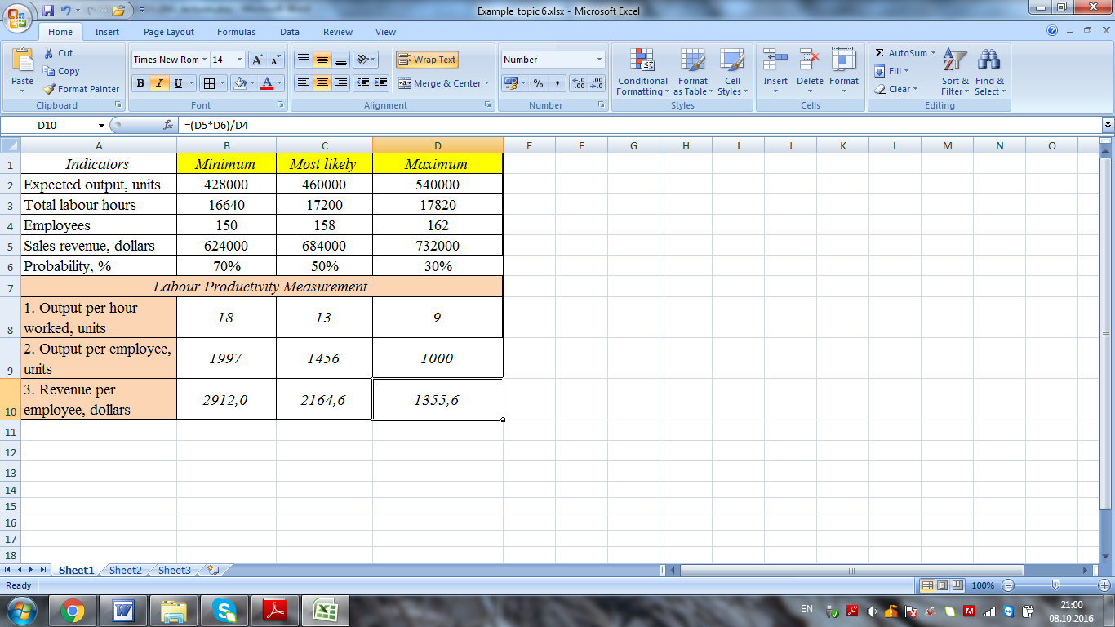

To create spreadsheet for response sensitivity-to-risk simulation model (*example 2*), proceed through the following steps:

1) headings and range names – you need to name appropriate columns by using the example 2;

2) enter the input data and format them appropriately (*figure 2*);

3) enter the name of other decision variables and compute them in the following way (*figure 2*).

To compute the present value of cash flows for project 1 with discount rate of 10% click cell B9 and type the formula

=B2/(1+B5)^1+B3/(1+B5)^2

To compute the present value of cash flows for project 2 with discount rate of 10% click cell C9 and type the formula

=C2/(1+B5)^1+C3/(1+B5)^2

To compute the present value of cash flows for project 1 with discount rate of 12% click cell B10 and type the formula

=B2/(1+B6)^1+B3/(1+B6)^2

To compute the present value of cash flows for project 2 with discount rate of 12% click cell C10 and type the formula

=C2/(1+B6)^1+C3/(1+B6)^2

To compute the net present value for project 1 with discount rate of 10% click cell B11 and type the formula

=B9-B4

To compute the net present value for project 2 with discount rate of 10% click cell C11 and type the formula

=C9-C4

To compute the net present value for project 1 with discount rate of 12% click cell B12 and type the formula

=B10-B4

To compute the net present value for project 2 with discount rate of 12% click cell C12 and type the formula

=C10-C4

To compute the percentage change in net present value for project 1 click cell B13 and type the formula

=B11/B12*100-100

To compute the percentage change in net present value for project 2 click cell C13 and type the formula

=C11/C12*100-100

*Figure 2*

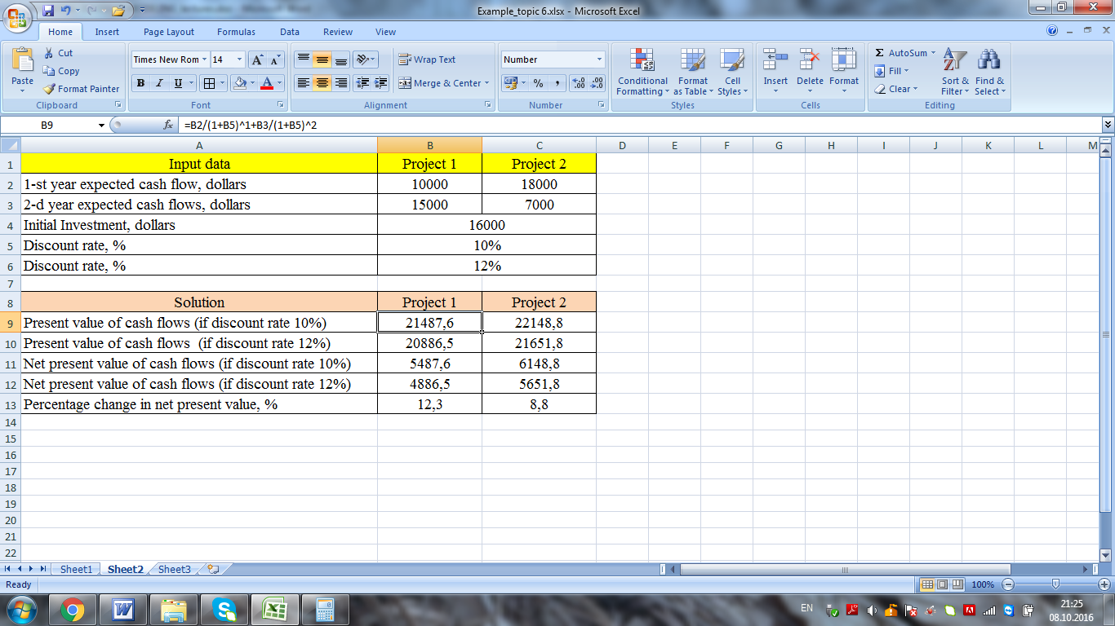

**References**

1. Wayne L. Winston, S. Christian Albright Practical Management Science: Spreadsheet Modeling and Applications. – 2012. – 936 p.
2. [S. Christian Albright](https://www.google.com.ua/search?tbo=p&tbm=bks&q=inauthor:%22S.+Christian+Albright%22), [Wayne L. Winston](https://www.google.com.ua/search?tbo=p&tbm=bks&q=inauthor:%22Wayne+L.+Winston%22), [Christopher James Zappe](https://www.google.com.ua/search?tbo=p&tbm=bks&q=inauthor:%22Christopher+James+Zappe%22) Managerial Statistics. – 2000. – 937 p.
3. S. Christian Albright, Wayne Winston, Christopher Zappe Data Analysis and Decision Making with Microsoft Excel. – Cengage Learning. – 2008. – 1104 p.
4. S. Christian Albright, Wayne L. Winston Business Analytics: Data Analysis & Decision Making. – Cengage Learning. – 2014. – 1008 p.
5. S. Christian Albright, Wayne L. Winston, Christopher James Zappe Data Analysis for Managers with Microsoft Excel. – Thomson/Brooks/Cole. – 2004. – 952 p.
6. S. Christian Albright, Wayne L. Winston Spreadsheet modeling and applications: essentials of practical management science. – Duxbur. – 2005. – 672 p.
7. Jeffrey Hillsman Moore, Lawrence R. Weatherford Decision modeling with Microsoft Excel. – Prentice Hall. – 2001. – 704 p.
8. Barry Render, Ralph M. Stair, Nagraj Balakrishnan Managerial Decision Modeling with Spreadsheets. – Prentice Hall. – 2003. – 616 p.
9. [Michael Pidd](https://www.google.com.ua/search?tbo=p&tbm=bks&q=inauthor:%22Michael+Pidd%22) Computer simulation in management science. – Wiley. – 2007. – 307 p.
10. Michael Pidd Systems Modelling: Theory and Practice. – Wiley. – 2004. – 236 p.
11. S. Christian Albright Statistics for business and economics. – Maxwell Macmillan Canada, Incorporated. – 2002. – 1017 p.
12. Helmut Lütkepohl Introduction to Multiple Time Series Analysis. – 2003. – 545 p.
13. Helmut Lütkepohl New Introduction to Multiple Time Series Analysis. – Springer Berlin Heidelberg. – 2007. – 764 p.
14. Helmut Lütkepohl, Markus Krätzig Applied Time Series Econometrics. – Cambridge University Press. – 2004. – 764 p.
15. Dimitrios Asteriou, Stephen G. Hall Applied Econometrics. – Palgrave Macmillan. – 2015. – 552 p.