
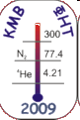
2-а Всеукраїнська наукова конференція молодих вчених
ФІЗИКА НИЗЬКИХ ТЕМПЕРАТУР (КМВ–ФНТ–2009)

TRANSPORT PROPERTIES OF MOTT-HUBBARD FERROMAGNET
WITH CORRELATED HOPPING AT LOW TEMPERATURE
O.Kramar, Yu. Skorenkyy
Ternopil State Technical Unіversity, 46001 Ternopil, 56, Rus’ka St.
e-mail: kramar@tu.edu.te.ua

Abstract
Peculiarities of the electronic conductivity and effective masses of current carriers in Mott-Hubbard material have been studied in the framework of generalized model [L. Didukh, Yu. Skorenky, O. Kramar Condens. Matter Phys., 11 , 443 (2008)] of narrow energy band. Single-particle Green function has been obtained using the projection procedure [L. Didukh Acta Physica Polonica B, 31, 3097 (2000)]. On this basis the correlation narrowing factors, shifts of energy subband centers, ground state energy, magnetization of the system have been found at various density of states forms and correlated hopping parameters.
The static conductivity σ has been calculated using the approach proposed in works [R.H. Bari, D. Adler, R.V. Lange Phys. Rev. B., 2, 2898 (1970); L. Didukh, O. Kramar, Yu. Skorenky and Yu. Dovhopyaty Condens. Matter Phys., 8, 825 (2005) ]. At low temperatures and partial fillings n of Hubbard subbands the system is unstable toward the transition to ferromagnetically ordered state. The numerical calculation of the static conductivity in the upper and lower energy bands was performed in the regime of a doped Mott-Hubbard system with strong intra-atomic correlation.

The Hamiltonian of generalized narrow-band model
$\begin{aligned}H=−μ\sum_{iσ}{a_{iσ}^{+}a_{iσ}}+μ_{B}h\sum_{i}{(n_{i↑}−n_{i↓})}+U\sum_{i}{n_{i↑}n_{i↓}}+\sum_{\text{ij}σ}{'t_{\text{ij}}a_{iσ}^{+}a_{jσ}} \\ +\sum_{\text{ij}σ}{'\left(T\left(\text{ij}\right)a_{iσ}^{+}a_{jσ}n_{\bar{σ}}+e\text{.}c\text{.}\right)}+\frac{1}{2}\sum_{\text{ij}σσ^{'}}{'J\left(\text{ij}\right)a_{iσ}^{+}a_{jσ^{'}}^{+}a_{iσ^{'}}a_{jσ}},\end{aligned}$

The above Hamiltonian properly describes magnetic, conducting and insulating states of electronic subsystem of oxides, sulphides and selenides of transition metals
⇓⇓⇓⇓
$\begin{aligned}U=5÷\text{15} \text{еV,} \\ T\left(\text{ij}\right)<t(\text{ij})\text{\sim }\frac{1}{2} \text{еV,} \\ J\left(\text{ijkj}\right)\text{\sim }\frac{1}{\text{10}} \text{еV,} \\ J\left(\text{ij}\right)\text{\sim }\frac{1}{\text{40}} \text{еV,}\end{aligned}$

Methods
Effective Hamiltonian method
[L. Didukh // Acta Phys. Polonica B, 31, 31, 2000.]
[L.Didukh and O.Kramar // Condens. Matter Phys., 8, 547, 2005]

Canonical transformation
$\tilde{H}=e^{S}{\text{He}}^{−S}$$S=\sum_{\text{ij}}{L\left(\text{ij}\right)\left(\left(X_{i}^{↑0}X_{j}^{↓2}−X_{i}^{↓0}X_{j}^{↑2}\right)−h\text{.}c\text{.}\right)}$
$$\tilde{H}=H_{0}+\sum_{\text{ij}}{'t_{\text{ij}}\left(n\right)X_{i}^{σ0}X_{j}^{0σ}}+\sum_{\text{ij}σ}{'{\tilde{t}}_{\text{ij}}\left(n\right)X_{i}^{2σ}X_{j}^{σ2}}+H_{\text{ех}}+{\tilde{H}}_{\text{ех}}+{\tilde{H}}_{t}$$
$$\begin{aligned}H_{0}=−μ\sum_{i}{\left(X_{i}^{↑}+X_{i}^{↓}+2X_{i}^{2}\right)}+U\sum_{i}{X_{i}^{2}}+ \\ +μ_{B}h\sum_{i}{(X_{i}^{↑}−X_{i}^{↓})}\end{aligned}$$
Indirect exchange integral
$$\tilde{J}\left(\text{ij}\right)=\frac{2{\left(t_{\text{ij}}^{'}\left(n\right)\right)}^{2}}{U}$$
$$H_{\text{ех}}=−\frac{1}{2}\sum_{\text{ij}σ}{J\left(\text{ij}\right)\left(X_{i}^{σ}X_{j}^{\bar{σ}}+X_{i}^{σ\bar{σ}}X_{j}^{\bar{σ}σ}\right)}$$
$${\tilde{H}}_{\text{ех}}=−\frac{1}{2}\sum_{\text{ij}σ}{\tilde{J}\left(\text{ij}\right)\left(X_{i}^{σ}X_{j}^{\bar{σ}}−X_{i}^{σ\bar{σ}}X_{j}^{\bar{σ}σ}−X_{i}^{2}X_{j}^{0}\right)}$$
$$\begin{aligned}{\tilde{H}}_{t}=−\frac{1}{2}\sum_{\text{ijk}σ}{J\left(\text{ijk}\right)\left(X_{i}^{σ0}X_{j}^{\bar{σ}}X_{k}^{0σ}−X_{i}^{σ0}X_{j}^{\bar{σ}σ}X_{k}^{0\bar{σ}}\right)}− \\ −\frac{1}{2}\sum_{\text{ijk}σ}{J\left(\text{ijk}\right)\left(X_{i}^{2σ}X_{j}^{σ\bar{σ}}X_{k}^{\bar{σ}2}−X_{i}^{2σ}X_{j}^{\bar{σ}}X_{k}^{σ2}\right)}\text{.}\end{aligned}$$
U
Indirect hopping integral
$$J\left(\text{ijk}\right)=\frac{2t_{\text{ij}}^{'}\left(n\right)t_{\text{jk}}^{'}\left(n\right)}{U}$$

N.B. : Mathematical treatment is greatly simplified!

Projection procedure within the Green function method
[Л.Дідух // Журн. фіз. досл., 1, 241, 1997]
$G_{pp^{'}}^{σ}(E)=\left\langle \left\langle X_{p}^{0σ}|X_{p^{'}}^{σ0}\right\rangle \right\rangle$
n<1 case:
Equation of motion:$\begin{aligned}(E+μ+{\text{zJ}}_{\text{eff}}n_{σ}−η_{σ}{\text{hn}}_{σ})G_{pp^{'}}(E)=\frac{δ_{pp^{'}}}{2π}\left\langle X_{p}^{σ}+X_{p}^{0}\right\rangle \\ +\left\langle \left\langle \left[X_{p}^{0σ},\sum_{{\text{ij \{}σ}^{'}}{}t_{\text{ij}}(n)X_{i}^{σ^{'}0}X_{j}^{0σ^{'}}\right]|X_{p^{'}}^{σ0}\right\rangle \right\rangle \end{aligned}$
Projection procedure: $\left[X_{p}^{0σ},\sum_{{\text{ij \{}σ}^{'}}{}t_{\text{ij}}(n)X_{i}^{σ^{'}0}X_{j}^{0σ^{'}}\right]=\sum_{j}{ε^{σ}(\text{pj})X_{j}^{0σ}}$
Analogous procedure is performed for n>1 case with ${\tilde{G}}_{pp^{'}}^{σ}(E)=\left\langle \left\langle X_{p}^{σ2}|X_{p^{'}}^{2σ}\right\rangle \right\rangle$
- The mean values of quasi-bose operators are substituted by c-numbers.
- The mean values of quasi-fermi operators are calculated self-consistantly.

Quasi-particle energy spectrum

$E_{\vec{k}}^{σ}=−μ+α_{σ}t_{\vec{k}}\left(n\right)+β_{σ}−{\text{zJn}}_{σ}−η_{σ}h$n<1

${\tilde{E}}_{\vec{k}}^{σ}=−μ+U+{\tilde{α}}_{σ}{\tilde{t}}_{\vec{k}}\left(n\right)+{\tilde{β}}_{σ}−{\text{zJn}}_{σ}−η_{σ}h$n>1

Factors of correlation narrowing of the bands:
$α_{σ}=\frac{2−n+η_{σ}m}{2}+\frac{n^{2}−m^{2}}{2\left(2−n+η_{σ}m\right)}$${\tilde{α}}_{σ}=\frac{n+η_{σ}m}{2}+\frac{n^{2}−m^{2}}{2\left(n+η_{σ}m\right)}$

Spin-dependent shifts of the band centers:
$β_{σ}=−\frac{2}{\left(2−n+η_{σ}m\right)}\sum_{\vec{k}}{t_{\vec{k}}\left(n\right){\left\langle X_{i}^{\bar{σ}0}X_{j}^{0\bar{σ}}\right\rangle }_{\vec{k}}}$${\tilde{β}}_{s}=−\frac{2}{\left(n+η_{s}m\right)}\sum_{\vec{k}}{{\tilde{t}}_{\vec{k}}\left(n\right){\left\langle X_{i}^{s2}X_{j}^{2s}\right\rangle }_{\vec{k}}}$

The form of unperturbed density of states (DOS)
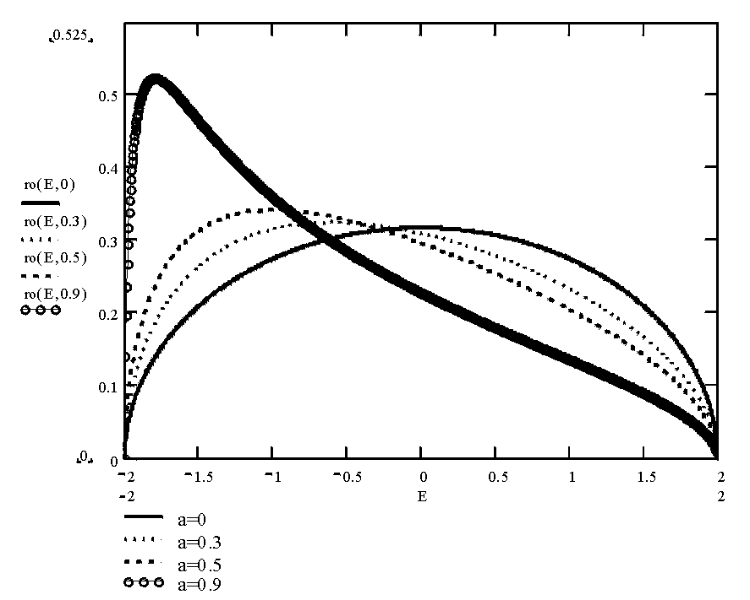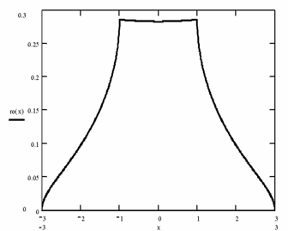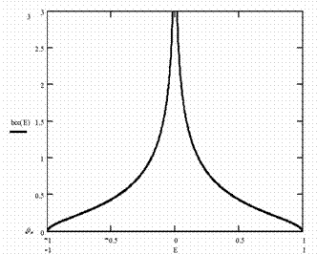
rectangular model DOS
semi-elliptical model DOS
-w
w
sc lattice

bcc lattice

The method of electronic conductivity calculation

[Bari R.H., Adler D., Lange R.V. // Phys. Rev. B, 2, 2898, 1970]
[Дидух Л.Д. // Препринт ИФКС АН Украины; ИФКС-92-9P]
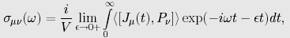
$P_{ν}$
- the current operator, component,
- the polarization operator. component.
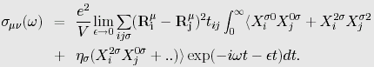
h.c

In the Mott-Hubbard regime (U>>w)
xx-component of the conductivity tensor
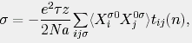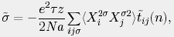
For arbitrary temperature one should carry out
- the chemical potential calculation,
- self-consistent calculation of the mean values,
- taking into account the possibility of the ferromagnetic ordering (spontaneous or field-induced) realization.

Generalization of the method for the case of arbitrary DOS form:
the conductivity of lower subband
$σ=−σ_{0}\left(\frac{1}{1−n_{↓}}\int_{−w(n)}^{w(n)}{\frac{ρ(t)\text{tdt}}{\text{exp}\left(\frac{E_{↑}(t)}{Θ}\right)+1}}+\frac{1}{1−n_{↑}}\int_{−w(n)}^{w(n)}{\frac{ρ(t)\text{tdt}}{\text{exp}\left(\frac{E_{↓}(t)}{Θ}\right)+1}}\right)$

the conductivity of upper subband
$\tilde{σ}=−σ_{0}\left(\frac{1}{1−n_{↓}}\int_{−w(n)}^{w(n)}{\frac{ρ(t)\text{tdt}}{\text{exp}\left(\frac{{\tilde{E}}_{↑}(t)}{Θ}\right)+1}}+\frac{1}{1−n_{↑}}\int_{−w(n)}^{w(n)}{\frac{ρ(t)\text{tdt}}{\text{exp}\left(\frac{{\tilde{E}}_{↓}(t)}{Θ}\right)+1}}\right)$

The peculiarities of conductivity

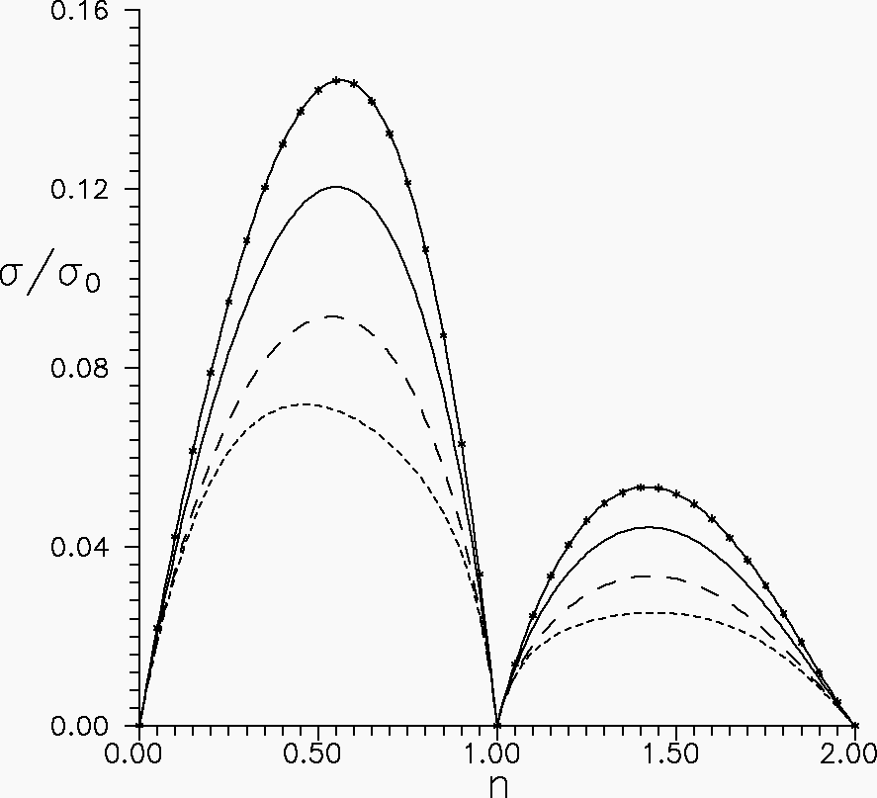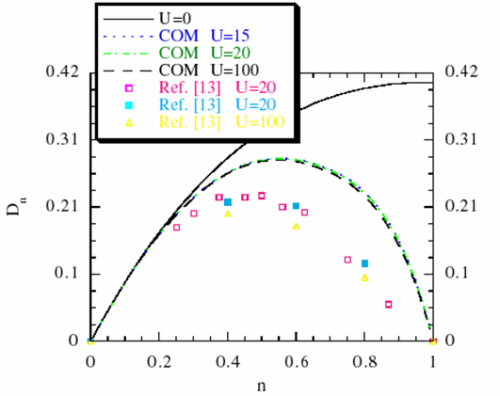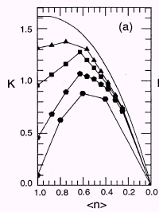
Concentration dependence of the conductivity,
at τ1= τ2=0.2, kT/w=0.1
dots - rectangular DOS
solid line - semi-elliptic DOS
long dashed line -sc-lattice
short dashed line - bcc-lattice

Mancini W. and Villiani D.
// cond-mat/9910463
(E-print.- Los Alamos 1999)
Dagotto E. // Rev. of Mod.
Phys. 66, 763, 1994
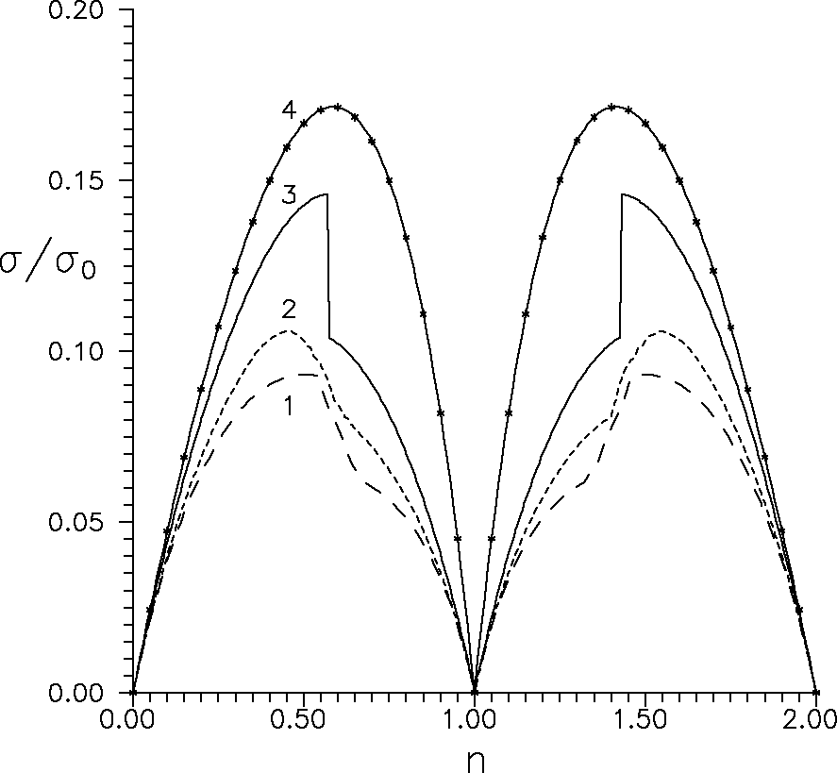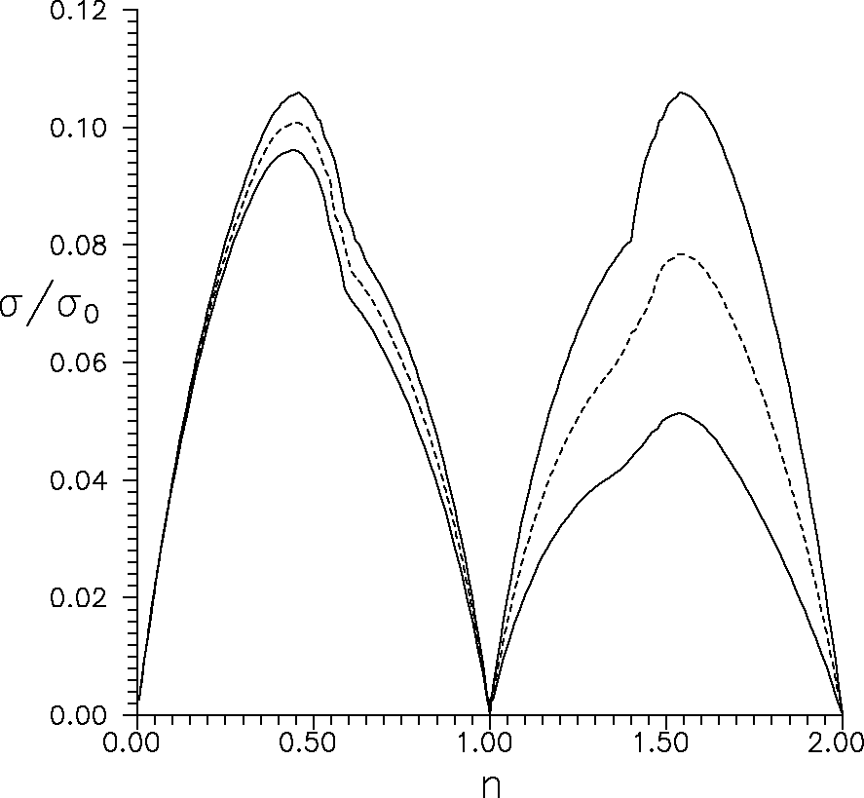
The stepwise transition to the saturated ferromagnetic state, which occurs in system with semielliptic DOS, leads to a sharp decrease of the conductivity at n=0.59. In the region of saturated ferromagnetic ordering, which is realized in the systems with body-centered cubic (bcc) and simple cubic (sc) lattices, the σ(n) dependencies are more smooth. Due to correlated hopping the substantial decrease of the conductivity of the more than half-filled band is observed. It is worth to note, that for sc lattice the concentration interval in which the magnetization exists is much more wide than for bcc-lattice. This fact has two important consequences. First, changes of the conductivity for sc-lattice and is more smooth than for bcc-lattice; the second, the difference between the maximum values of the conductivity is small, because the maximum of the dependence for sc-lattice lies within ferromagnetic region, and maximum of the curve for bcc-lattice is in paramagnetic region.
Influence of the spontaneous ferromagnetic ordering on the system conductivity
dots - rectangular DOS
solid line - semi-elliptic DOS
long dashed line -sc-lattice
short dashed line - bcc-lattice
The correlated hopping effect on the conductivity value for the system with bcc-lattice

Behavior of the concentration dependence of the conductivity is determined by:
- peculiarities of electronic kinetic energy (DOS form influence)
- realization of ferromagnetic ordering (spontaneous or field-induced)
- occupation of cites involved in the hopping process (the correlated hopping)

In the absence of correlated hopping:
- the conductivity has two symmetrical maxima at band-filling values, dependent on the DOS form
correlated hopping:
- shifts the maxima
- $(\tilde{w}<w)$ reduces the conductivity value in (↑↓-σ)- subband with respect to (σ-0)- subband

The effective masses of current carriers
$m_{\text{eff}}^{s}=\frac{m_{0}}{(1−τ_{1}n)α_{s}}$${\tilde{m}}_{\text{eff}}^{s}=\frac{m_{0}}{(1−τ_{1}n−2τ_{2}){\tilde{α}}_{s}}$

- Effective mass renormalization is determined by correlated hopping and correlation effects.
- Spin-splitting of the effective masses of carriers with opposite spin projections is due to spin-dependence of correlation narrowing factors.
- System magnetization, having essential effect on the effective masses, is controlled by DOS form.
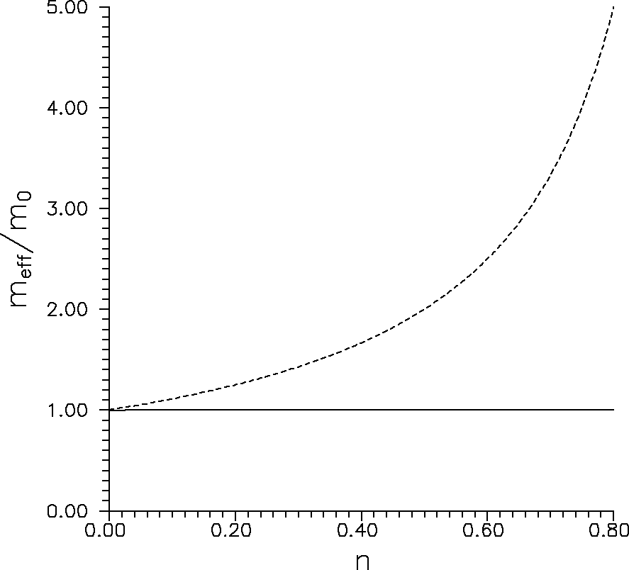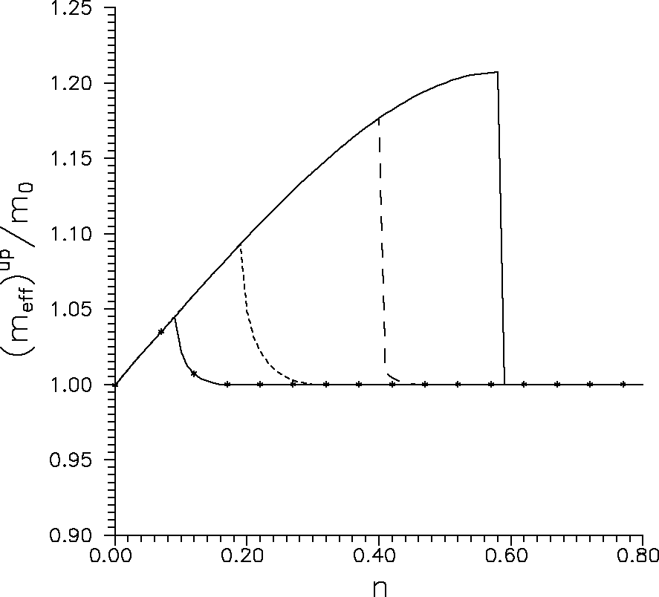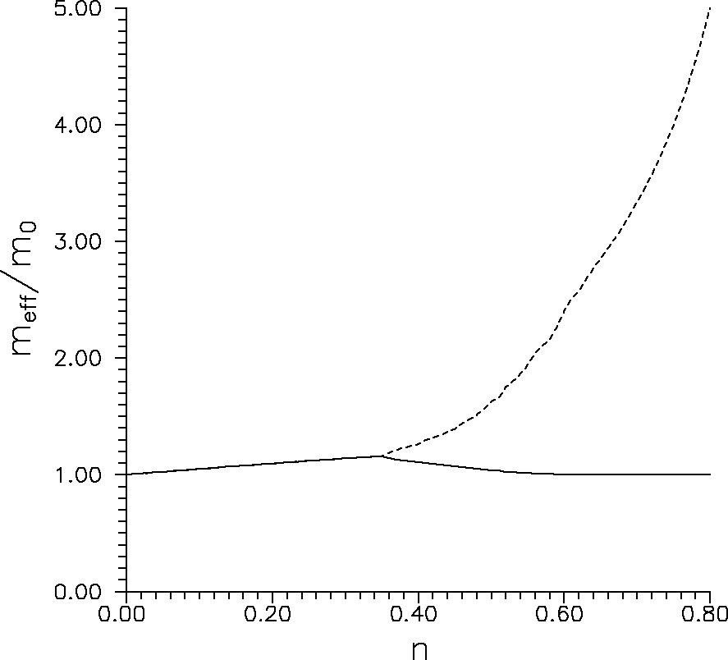
rectangular model DOS asymmetrical DOS sc lattice

Ferromagnetically ordered state
Θ/w=0.02; zJ/w=0.05
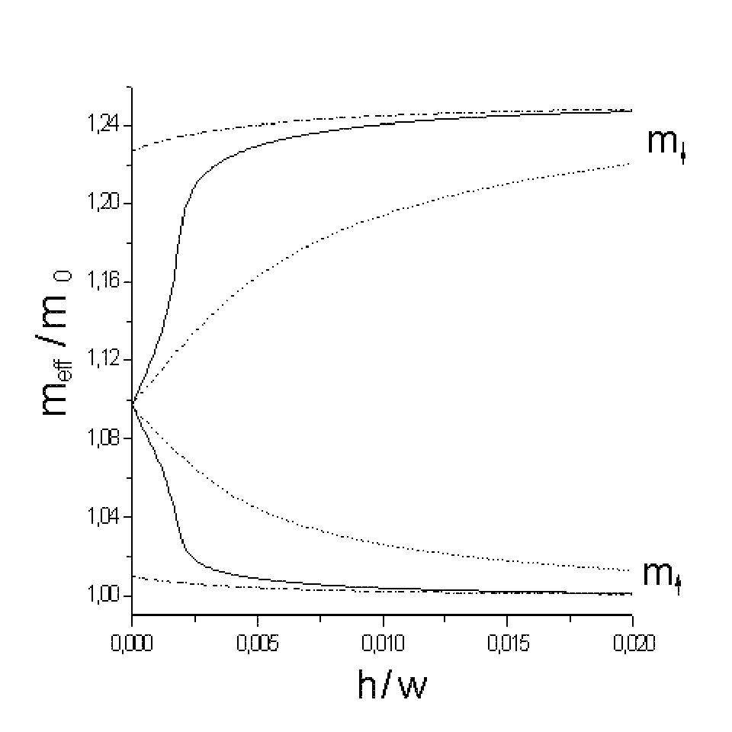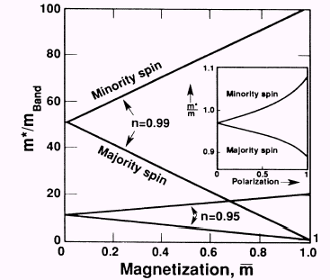
Θ/w=0.02; zJ/w=0
Θ/w=0.02; zJ/w=0
Dependence of current carrier effective mass m_{eff} / m₀ on the external magnetic field
In agreement with
[Spalek J., Gopalan P. // Phys. Rev. Lett., 64, 2823, 1990]
the magnetization increase leads to the larger splitting of spin-dependent effective masses

Conclusions

- The choice of the unperturbed DOS form modifies substantially the conditions of paramagnet-ferromagnet phase transition, critical values of electron concentration,the system magnetization.
- The concentration dependence of the conductivity is determined by the corresponding dependence of the system magnetization, influenced by peculiarities of DOS form and electron correlation.
- The effective mass in the studied system is determined by correlated hopping of electrons and correlation narrowing of subband.
- Effective masses appear to be spin-dependent, what is the reason for the conductivity changes in magnetic field.
- Ferromagnetic ordering modifies essentially effective mass behavior.
- Conditions of ferromagnetic ordering realization in the considered system depends on the bare DOS form and effective exchange interaction type.

