Ministry of Education and Science of Ukraine

Ternopil Ivan Puluj National Technical University

Department of building mechanics

Study guide on

“Technology of Structural materials and Material Science”

Part 3

“Material Science”

for students of “Engineering mechanics” field of study 6.050502

Student ____________________________________________________

Faculty __________________________________________________

Course ______________________ Group ________________________

Ternopil

2016

Kramar H.M. Study guide on “Technology of Structural materials and Material Science” Part 3 “Material science” for students of “Engineering mechanics” field of study 6.050502 (full-time study bachelors) // H.M.Kramar, L.H. Bodrova. – Ternopil, TNTU, 2016. – 160 p.

Authors: H.M. Kramar

L.H. Bodrova

Reviewer: Ya.O.Kovalchuk

Study guide on have been approved at the meeting of building mechanics department (minutes № 1 from 25 August 2016)

The Study guide on have been approved by the Mechanical Engineering Faculty methodological committee (minutes № 1 from 29 August 2016)

**Contents**

|  |  |  |
| --- | --- | --- |
| № Labs | Part 3 | Pages |
|  | Safety during lab activities |  |
|  | Practical 2. Iron – Carbon equilibrium diagram |  |
| LW5 | Plain carbon steels | 16 |
| LW6 | Cast iron | 30 |
| LW7 | Heat treatment of steel | 36 |
| LW8 | Chemical heat treatment of steel | 52 |
| LW9 | Alloy steels (low alloy steels and stainless steels) | 62 |
| LW10 | Tool steel and hard alloys | 80 |
| LW11 | Aluminium, copper and their alloys | 89 |
| LW12 | Ceramics | 107 |
| LW13 | Polymers | 123 |
|  | Glossary | 136 |
|  | Appendixs | 145 |
|  | Reference | 160 |

**Introduction**

###### “Technology of Structural materials and Material Science” is one of the basic technical disciplines in the syllabus for “Engineering mechanics” field of study.

During the implementation of laboratory work considerable attention is given to the educational and experimental work for the study of materials that are used in different branches of an industry; methods of treatment and external environments The study of the theory and practice of different methods of materials strengthening is to provide a high reliability and longevity of the machine’s details, devices, tools etc.

After every practical class and lab activities in the laboratory, students will fill the laboratory report. The content of the laboratory class corresponds with the syllabus of the course “Technology of Structural materials and Material Science” for students of the “Engineering mechanics” field of study.

The purpose of this manual is to provide guidelines for the students in preparation for independent laboratory work and to project its results in the laboratory reports.

Safety during lab activities

The laboratory classes for “Material Science” will take place in the education-research laboratories of the department of building mechanics. The observation of the safety requirements is necessary during labs activities.

Students who are not taking part in the lab activities, must seat at their desks. Students can’t:

- store any unnecessary things, which are not used during the lab on the work place;

- whirl adjustment knob of microscope, machine for tensile strength and hardness testing and other devices, if it is not used during labs activities.

- turn on machine-tools, weld transformer, presses etc.

Students can do labs only when they are supervised by a teacher.

Labs equipment has high voltage (220 or 380 V).

To prevent danger by electrical current, it is prohibited to:

turn on equipment that is not used during labs;

open the doors of the electrical wardrobe and furnace;

transfer equipment and devices.

Before turning on an equipment student must see that it is safe to do so. When a student observes that equipment has defects, it is prohibited to turn on voltage. The student must report such to the teacher immediately.

During some lab classes, students will use chemical substances. When chemical substance comes in contact with the student’s skin or eyes, it is necessary to wash with water immediately.

During the lab classes that require equipment with heating, beware of catching fire with your clothes and skin burn.

Violation of these safety rules may lead to unhappy accidents.

Follow these safety rules strictly!

Practical 2. IRON-CARBON EQUILIBRIUM DIAGRAM

***Objectives***

1. To learn the process Fe – Fe3C diagram analysis.

2.To learn how to apply the phase rule and inverse level rule.

***Scientific principles***

Fe and C are the main components of Fe – Fe3C diagram. Fe has polymorphic modification; it’s marked by the initial letters of the Greek alphabet, beginning from low temperatures (Feα, Feγ Feδ).

When iron crystallizes at 1539 oС it is B.C.C. (δ -iron), at 1392 oС its structure changes to F.C.C. (γ-iron or austenite), and at 911 oС it again becomes B.C.C. (α -iron or ferrite) (Fig2.1).

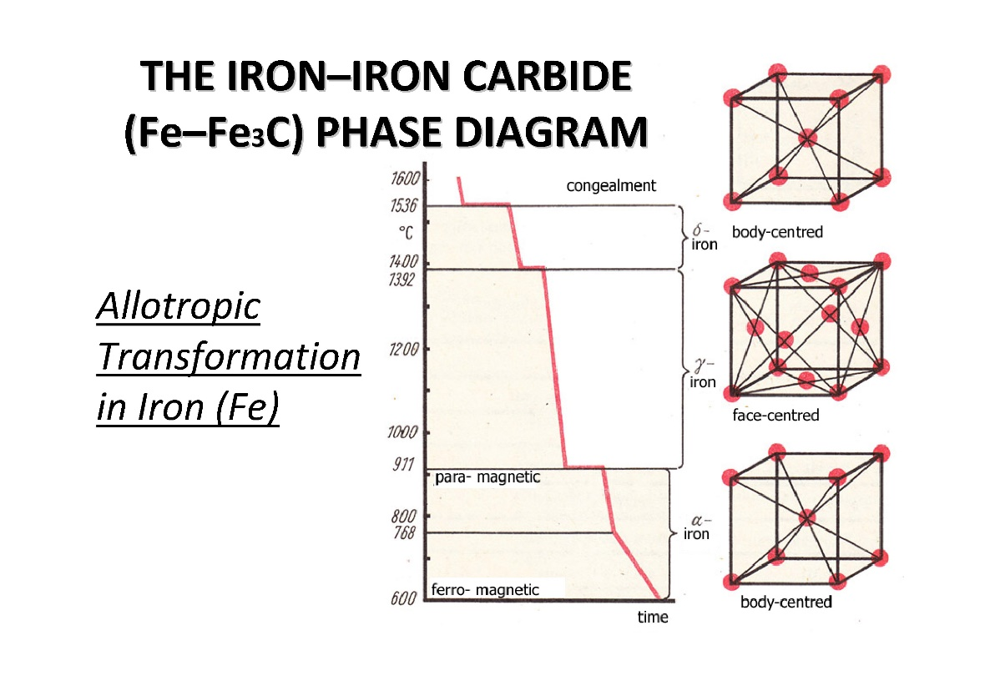

Fig.2.1. Allotropic Transformation in Iron.

Fig. 2.2. shows, the Fe-C equilibrium diagram in which various structure (obtained during heating and cooling), phases and microscopic constituents of various kinds of steel and cast iron are depicted.

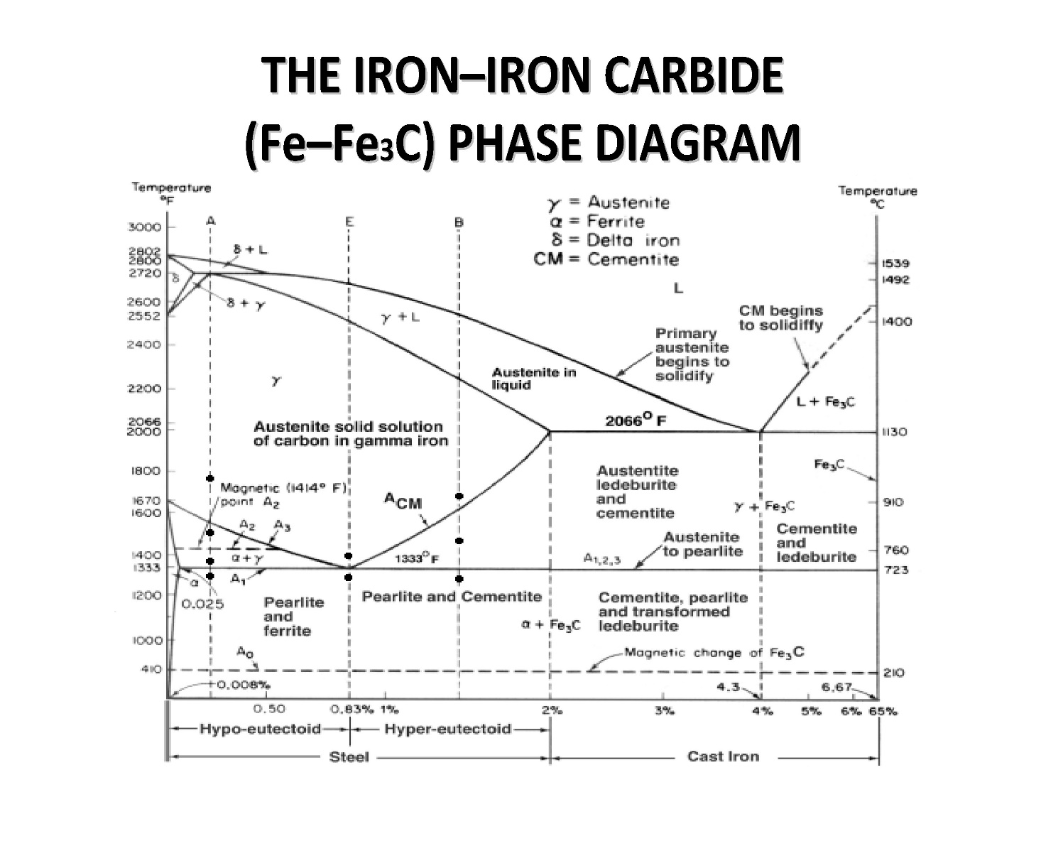

Fig. 2.2. Fe-C equilibrium diagram

The main structures, significance of various lines and critical points are discussed as under.

**Structures in Fe-C-diagram**

There are following phathes and structure of Fe – Fe3C diagram:

***CEMENTITE***  is a chemical compound of carbon with iron and is known as iron carbide (Fe3C). It contains 6.67 % carbon by weight. It is a typical hard and brittle interstitial compound of low tensile strength but high compressive strength. Its crystal structure is orthorhombic.

Cementite is Cast iron having 6.67% carbon is possessing complete structure of cementite. Free cementite is found in all steel containing more than 0.83% carbon. It increases with increase in carbon % as reflected in Fe-C Equilibrium diagram. It is extremely hard. The hardness and brittleness of cast iron is believed to be due to the presence of the cementite. It decreases tensile strength. This is formed when the carbon forms definite combinations with iron in form of iron carbides which are extremely hard in nature. The brittleness and hardness of cast iron is mainly controlled by the presence of cementite in it. It is magnetic below 200°C.

***AUSTENITE ( γ - iron):***

Austenite is a solid solution of free carbon and iron in gamma iron. It is also known as (γ -) gamma-iron, which is an interstitial solid solution of carbon dissolved in iron with a face centered cubic crystal (F.C.C) structure.

Austenite is normally unstable at room temperature. Under certain conditions it is possible to obtain austenite at room temperature.

On heating the steel, after upper critical temperature, the formation of structure completes into austenite which is hard, ductile and non-magnetic. It is able to dissolve large amount of carbon. It is in between the critical or transfer ranges during heating and cooling of steel. It is formed when steel contains carbon up to 1.8% at 1130°C. On cooling below 723°C, it starts transforming into pearlite and ferrite. Austenitic steels cannot be hardened by usual heat treatment methods and are non-magnetic.

***FERRITE (α - iron):***

It is (α - ) alpha -iron, which is an interstitial solid solution of a small amount of carbon dissolved in iron with a Body Centered Cubic (B.C.C.) crystal structure. It is the softest structure on the iron-iron carbide diagram.



Fig. 2.3. BCC iron showing the location of interstitial carbon atoms

Ferrite contains very little or no carbon in iron. It is the name given to pure iron crystals which are soft and ductile. The slow cooling of low carbon steel below the critical temperature produces ferrite structure. Ferrite does not harden when cooled rapidly. It is very soft and highly magnetic.

***PEARLITE (α - Fe + Fe3C)***

Pearlite is a eutectoid alloy of ferrite and cementite. It occurs particularly in medium and low carbon steels in the form of mechanical mixture of ferrite and cementite in the ratio of 87:13. It is the eutectoid mixture containing 0.8 % carbon and is formed at 723oC on very slow cooling. It is very fine platelike or lamellar mixture of ferrite and cementite. The structure of pearlite includes a white matrix (ferritic background) which includes thin plates of cementite.

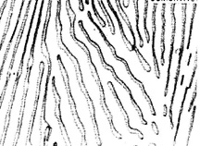

Fig. 2.4. Pearlite microstructure (Light background is the ferrite matrix, dark lines are the cementite network)

Its hardness increases with the proportional of pearlite in ferrous material. Pearlite is relatively strong, hard and ductile, whilst ferrite is weak, soft and ductile. It is built up of alternate light and dark plates. These layers are alternately ferrite and cementite. When seen with the help of a microscope, the surface has appearance like pearl, hence it is called pearlite. Hard steels are mixtures of pearlite and cementite while soft steels are mixtures of ferrite and pearlite.

As the carbon content increases beyond 0.2% in the temperature at which the ferrite is first rejected from austenite drop until, at or above 0.8% carbon, no free ferrite is rejected from the austenite. This steel is called eutectoid steel, and it is the pearlite structure in composition.

***LEDEBURITE (γ - Fe + Fe3C)***

It is the eutectic mixture of austenite and cementite. It contains 4.3% carbon and represents the eutectic of cast iron. Ledeburite exists when the carbon content is greater than 2.14%, which represents the dividing line on the equilibrium diagram between steel and cast iron.

As iron having various % of carbon (up to 6%) is heated and cooled, the following phases representing the lines will tell the about the structure of iron, how it charges.

**Significance of Transformations Lines**

**Line ABCD – liquidus line**

The line ABCD tells that above this line melting has been completed during heating the iron. The molten metal is purely in the liquidus form. Below this line and above line AHJECF the metal is partially solid and partially liquid. The solid metal is known as austenite. Thus the line ABCD represents temperatures at which melting is considered as completed. Beyond this line metal is totally in molten state. It is not a horizontal line the melting temperature will vary with carbon content.

**Line AHJECF – solidus line**

This line tells us that metal starts melting at this temperature. This line is not horizontal and hence the melting temperatures will change with carbon content. Below this line and above line GSEC, the metal is in solid form and having austenite structure.

**Line PSK – eutectoid reaction**

This line occurs near 723°C and is a horizontal line and is known as **lower critical temperature** line because transformation of steels starts at, this line. Carbon % has not effect on it that means steel having different % of carbon will transforms at the same temperature. The range above the line up to GSE is known as transformation range. This line tells us the steel having carbon up to 0.8% up to 0.8% will starts transforming from ferrite and pearlite to austenite during heating.

**Line ECF** – **eutectic reaction**

It is a line at temperature 1130°C which tells that for cast iron having % of C from 2% to 4.3%. Below this line and above line SK, Cast iron will have austenite + ledeburite and cementite + ledeburite.

**Critical Temperatures**

The temperatures at which changes in structure takes place is known as critical temperatures, these are as follows:

The temperature along GSE is known as **upper critical temperature**. The temperature along GS during heating as (upper critical temperature) where austenite + alpha iron changes into austenite and vice versa. The temperature along GS during cooling as A3 where austenite changes into austenite + alpha iron and vice versa during heating. The temperature along line SE during heating as Acm changes into austenite from austenite + cementite and vice versa.

The temperature along PSK is known as **lower critical temperature** when pearlite changes into austenite on heating as denoted, by A1.

When a steel specimen is heated, its temperature rises unless there is change of state or a change in structure. Fig. 2.5 shows heating and cooling curve of steel bearing different structures. Similarly, if heat is extracted, the temperature falls unless there is change in state or a change in structure. This change of structure does not occur at a constant temperature. It takes a sufficient time a range of temperature is required for the transformation. This range is known as transformation range. For example, the portion between the lower critical temperature line and the upper critical temperature line with hypo and hyper eutectoid steels, in iron carbon equilibrium diagram. This range is also known as critical range. Over heating for too long at a high temperature may lead to excessive oxidation or decarburization of the surface. Oxidation may manifest itself in the form of piece of scale which may be driven into the surface at the work piece if it is going to be forged. If steel is heated, well above the upper critical temperature, large austenite grains form. In other words steel develops undesirable coarse grains structure if cooled slowly to room temperature and it lacks both in ductility and resistance to shock

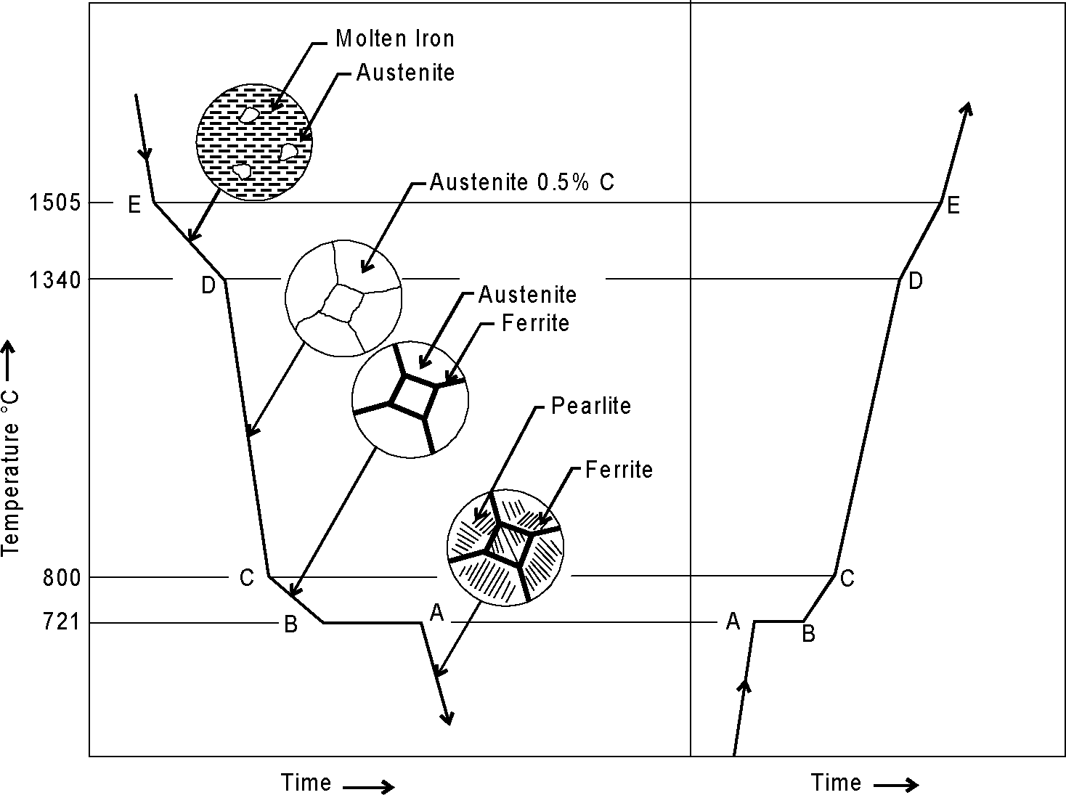

Fig. 2.5 Heating and cooling curve of steel

There are **three phase reaction** at different constant temperature:

At the eutectic point, the phase reaction, on cooling, is ***eutectic***:

Liquid => austenite ( γ-iron) +cementite

or

Liquid => ledeburite.

But the diagram shows another feature which looks like a eutectic: it is the at the bottom of the austenite field. The transformation which occurs there is very like the eutectic transformation, but this time it is a solid, austenite, which transforms on cooling to two other solids. The point is called a eutectoid point. The compositions of the two new phases are given by the ends of the tie line through the eutectoid point.

At the eutectoid point, the phase reaction, on cooling, is ***eutectoid:***

Austenite => ferrite ( α-iron) + cementite

or

Austenite => pearlite.

At the peritectic point, the phase reaction, on cooling, is ***peritectic:***

Liquid + ferrite (δ –iron) => austenite .

***Activity***

1. To analyse the Fe – Fe3C diagram mark at all critical points of the Fe – Fe3C diagram with letters.
2. Describe the lines of Fe – Fe3C diagram (liquidus, solidus, phase reactions, lines of the solubility).
3. Identify components of alloys. List allotropic forms of the components.
4. What kinds of initial elements interaction take place there? Identify all phases and structure which occur in the chosen alloy.
5. Describe phase reactions and write down their formula.
6. To analyse the alloy, choose it carbon contant and temperature.

Note! Your variant is your number in the group list or your number in the group list minus 10 (20).

1. Draw alloy’s vertical, mark the point of chosen temperature and all points of where alloy’s vertical crosses the lines of phase diagram.
2. Construct the general shape of cooling curve for chosen alloy.
3. Mark phases at every temperature period on the cooling curve.
4. Application of the phase rule. How many degrees of freedom are there at constant ***p*** in all fields.
5. How many phases can coexist in equilibrium at constant ***p***? Define them.
6. Describe what happens if alloy is cooled to room temperature. At which temperatures do changes in the number or type of phases occur?
7. Application of the inverse level rule. Calculate the approximate composition and proportions by weight of each phase that is present at chosen temperature.

Table. Carbon contant in the alloy and temperature to Fe – Fe3C diagram analyse

|  |  |  |  |  |  |  |  |  |  |  |
| --- | --- | --- | --- | --- | --- | --- | --- | --- | --- | --- |
|  | **V1** | **V2** | **V3** | **V4** | **V5** | **V6** | **V7** | **V8** | **V9** | **V10** |
| Carbon contant  % (wt.) | 0.25 | 0.4 | 0.6 | 0.8 | 1.0 | 1.2 | 2.3 | 3.5 | 4.3 | 5.0 |
| Temperature,  0C | 800 | 600 | 1450 | 1400 | 760 | 800 | 1000 | 1200 | 900 | 1200 |

|  |  |
| --- | --- |
| 1. Fe – Fe3C diagram | 2. Cooling curve |
|  |  |

3. Lines of the Fe – Fe3C diagram: liquidus___________________________, solidus____________________________, phase reactions ______________________

______________________________________________________________________,

lines of the solubility ___________________________________________________

4. Components of the alloys. _________.

Allotropic forms in the components _______________________________________.

5. Kinds of initial elements interaction_____________________________________

6. Phases, which occur in the alloys_______________________________-___________________________________.

7. Structure, which occur in the alloys

_____________________________________________________________________.

8. Chemical composition of chosen alloy__________________________________

9. Phase reactions in chosen alloy and their formulas

____________________________________________________________________________________________________________________________________________

10. Application of the phase rule. Calculate degrees of freedom in all fields at constant ***p***.

____________________________________________________________________________________________________________________________________________

1. How many phases can coexist in equilibrium at constant ***p***? Define them.

___________________________________________________________________________________________________________________________________________

1. Describe what happens if the alloy is cooled to room temperature. At which temperatures do changes in the number or type of phases occur?

__________________________________________________________________________________________________________________________________________________________________________________________________________________

1. Application of the inverse level rule. Calculate the approximate composition and the proportions by weight of each phase that is present at chosen temperature.

The composition of phase 1 is ______________________________________________.

The composition of phase 2 is

What (roughly) are the proportions by weight of each phase?

**Conclusion***___________________________________________________________________________________________________________________________________*

_______________________ _________________________

Studen tsignature Teacher’s signature

“____”___________20__y. “____”____________20___ y.

LABORATORY WORK 5

**PLAIN CARBON STEELS**

***Objectives***

1. To learn the microstructures of the steels.

2. To learn the effect of carbon and impuritieson the properties of steel.

3. To learn classification of Plain Carbon Steels.

4. To learn to determine of the steel chemical composition by its SAE-AISI number.

***Scientific principles***

There are two types of iron-carbon alloys- steel and cast iron.

Plain carbon steel is an alloy of iron and carbon. It has good machineability and malleability. It is different from cast iron as regards the percentage of carbon. It contains carbon from 0.06 to 2% whereas cast iron possesses carbon from 2 to 4.2%.

***Steels***  are an iron-carbon alloys, which contains less than 2 % carbon, impurities Mn, Si, Al, S, P, O, H, N and alloying elements, such as Cr, Ni, Ti, W and etc..

***Cast irons*** are an iron-carbon alloys which contains more than 2 % carbon (carbon may be presented as carbide (connected) and as graphite (free)) and impurities S, P, Mn, Si. The microstructure of steels and cast irons are described by Fe – Fe3C diagram (Fig.5.1).

***Plain Carbon* *Steels***  are an iron-carbon alloys, which contains less than 2.14% carbon and impurities Mn, Si, Al, S, P, O, H, N.

As the term ‘‘plain carbon steel’’ implies, these are alloys of iron and carbon. These steels were the first developed, are the least expensive, and have the widest range of applications. Steel is used for making camshafts, sheets and srips for fan blades, welded tubing, forgings, chains, stamping, rivets, nails, pipes, angle, channels, case hardening steel, rods, tubes, valves, gears, crankshafts, connecting rods, railway axles, fish plates, etc

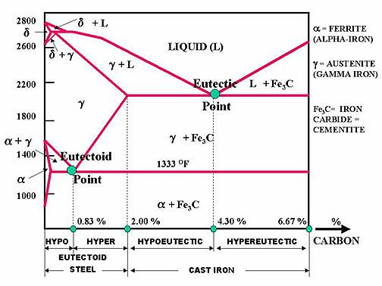

Fig.5.1.Fe – Fe3C diagram

**The effect of Carbon on the Properties of Steel**

In general, as the carbon content increases the hardness of the steel also increases. The tensile strenth and the yield strength also increase to about 0.8% carbon. Thereafter, they level out. This is shown in Figure 5.3.

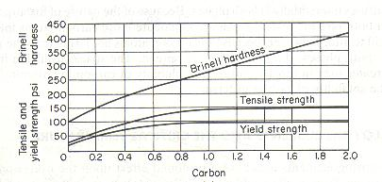

Fig. 5.3. The effect of carbon on the hardness, tensile strength and yield strength of steels.

The tensile strength and hardness are affected as the ratio of ferrite to cementite in the structure of steel changes. As the percentage of pearlite increases in the hypoeutectoid steels, the tensile strength increases. The hypereutectoid steels show only a slight increase in strength as the cementite-to-ferrite ratio increases.

The elongation and the reduction in area represent how ductile or brittle a material is. Fig.5.4. indicates the effect of carbon on the ductility and impact resistance (toughness) of steels. The elongation and the reduction in area drop sharply with increase in carbon content, going almost to zero at about 1.5 % carbon. This indicates that the carbon content of 1.5 % or more will cause high brittleness.

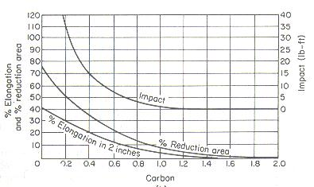

Fig. 5.4. The effect of carbon on the impact resistance and ductility of steels.

**The effect of impurities on steel**

The effects of impurities like silicon, sulphur, manganese and phosphorus, on steel as discussed under.

**Silicon.** Silicon content in the finished steel usually ranges from 0.05 to 0.30%. It is added in low carbon steels for preventing them from becoming porous. It helps in removing the gases and oxides. It prevents blow holes there by making steel tougher and harder.

**Manganese.** It serves as a valuable deoxidizing and purifying agent, in steel. Manganese also combines with sulphur and thereby decreases the harmful effect of this element remaining in the steel. It increases wear resistance, hardness and strength and decreases machineability. When used in ordinary low carbon steels, manganese makes the metal ductile and of good bending quantities. In high speed steels, it is used to tougher the metal and to increase its critical temperature.

**Sulphur.** It renders free cutting properties in steel. It is found in steel either as iron sulphide or manganese sulphide. Iron sulphide due to its low melting point, produces brittleness whereas manganese sulphide does not affect so much. Therefore, manganese sulphide is less objectionable in steel than iron sulphide.

**Phosphorus.** It induces brittleness in steel. It also produces cold shortness in steel. In low carbon steels, it raises the yield point and improves the resistance to atmospheric corrosion. The sum of carbon and phosphorus usually does not exceed 0.25%.

***Hot-shortness:*** Brittleness at high temperatures is called hot-shortness which is usually caused by sulfur. When sulfur is present, iron and sulfur form iron sulfide (FeS) that is usually concentrated at the grain boundaries and melts at temperatures below the melting point of steel. Due to the melting of iron sulfide, the cohesion between the grains is destroyed, allowing cracks to develop. This occurs when the steel is forged or rolled at elevated temperatures. In the presence of manganese, sulfur tends to form manganese sulfide (MnS) which prevents hot-shortness.

***Cold-shortness:*** Large quantities of phosphorus (in excess of 0.12% P) reduces the ductility, thereby increasing the tendency of the steel to crack when cold worked. This brittle condition at temperatures below the recrystallization temperature is called cold-shortness.

**Classification of Plain Carbon Steels**

The steel may be of various kinds and few important types are explained as under.

**Classification by structure**

There are three kinds of plain carbon steels: hypoeutectoid, eutectoid and hypereutectoid steels.

**Eutectoid steel**. In the abbreviated iron–iron carbide diagram of Fig. 5.1 the eutectoid point is the lowest temperature and composition at which the austenite phase can exist. It is that point corresponding to a composition of 99.2 wt% Fe 0.8 wt% C. This is the eutectoid point of the iron–iron carbide system.

Euctectoid deals with a solid-to-solid transformation, while the eutectic region begins with a liquid. At the eutectoid point, the eutectoid reaction takes place on cooling a 0.8 wt% C alloy composition slowly through the eutectoid temperature. At this temperature the reaction is

Austenite → Ferrite + Fe3C

This is a reaction of a solid transforming to two different solids forming a parallel-plate microstructure of the two phases called **pearlite.**

A plain carbon steel of eutectoid composition is 1080 steel, which has a tensile strength of about 112,0 psi ( pound-force per square inch, lbf/in?) or about 772 MPa.

***\*Note 1psi = 6.89 MPa; 1 MPa = 0,145 psi***

If the austenite contains less than 0.80% carbon **(hypoeutectoid steel**), free ferrite will first be rejected on slow cooling through the critical temperature until the composition of the remaining austenite reaches 0.80% carbon, when the simultaneous rejection of both ferrite and carbide will again occur, producing pearlite. So a hypoeutectoid steel at room temperature will be composed of areas of free ferrite and areas of pearlite; the higher the carbon percentage, the more pearlite present in the steel. A 1040 steel is typical of a hypoeutectoid steel. It will be somewhat softer than a 1080 steel and have a tensile strength of about 75,0 psi (517 Mpa).

When austenite that contains more than 0.80% carbon **(hypereutectoid steel**) is slowly cooled, cementite is thrown out at the austenite grain boundaries, forming a cementite network, until the austenite again contains 0.80% carbon, at which time pearlite is again formed. Thus a hypereutectoid steel, when slowly cooled, will have areas of pearlite surrounded by a thin carbide network

|  |  |  |
| --- | --- | --- |
|  |  |  |
| a) | b) | c) |
| Fig.5.2. Microstructure of mild steel (a), pearlitic eutectoid steel (b),  high carbon steel (c) | | |

**Classification of steel by carbon content**

Depending upon the carbon content, a plain carbon steels can divided to the following types:

**Table 5.1.** Classification of steel by carbon content

|  |  |
| --- | --- |
| Dead carbon steel | Up to 0.05% carbon |
| Low carbon or mild steel | 0.15% to 0.45% carbon |
| Medium carbon steel | 0.45% to 0.8% carbon |
| High carbon steel | 0.8% to 1.5% carbon |

**Dead Carbon Steel**

It possesses very low percentage of carbon varying from 0.05 to 0.15%. It has a tensile strength of 390 MPa and a hardness of about 115 BHN. Steel wire, sheets, rivets, screws, pipe, nail and chain are made from this steel. This steel is used for making camshafts, sheets and strips for fan blades, welded tubing, forgings, chains, stamping, rivets, nails, pipes, automobile body etc.

**Low Carbon Or Mild Steel**

Low carbon steel is sometimes known as mild steel also. It contains 0.20 to 0.30% C which has tensile strength of 555 MPa and hardness of 140 BHN. It possesses bright fibrous structure. It is tough, malleable, ductile and more elastic than wrought iron. It can be easily forged and welded. It can absorb shocks. It rusts easily. Its melting point is about 1410°C. It is used for making angle, channels, case hardening steel, rods, tubes, valves, gears, crankshafts, connecting rods, railway axles, fish plates, small forgings, free cutting steel shaft and forged components etc.

Applications

Mild steel containing 0.15 to 0.20% carbon

It is used in structure steels, universal beams, screws, drop forgings, case hardening steel, bars, rods, tubes, angles and channels etc.

Mild steel containing 0.20-0.30% carbon

It is used in making machine structure, gears, free cutting steels, shafts and forged components etc.

**Medium Carbon Steels**

Medium carbon steel contains carbon from 0.30 to 0.8%. It possesses having bright fibrous structure when fractured. It is tough and more elastic in comparison to wrought iron. It can be easily forged, welded, elongated due to ductility and beaten into sheets due to its good malleability. It can easily absorb sudden shocks. It is usually produced as killed or semi killed steels and is harden able by treatment. Hardenability is limited to thin sections or to the thin outer layer on thick parts. Its tensile strength is better than cast iron and wrought iron but compressive strength is better than wrought iron but lesser than cast iron. It rusts readily. Its melting point is 1400°C. It can be easily hardened and it possesses good balance of strength and ductility.

It is generally used for making railway coach axles, bolts, connecting rods, key stock, wires and rods, shift and break levers, spring clips, gear shafts, small and medium forgings, railway coach axles, crank pins on heavy machines, spline shafts, crankshafts, forging dies, set screws, die blocks, self tapping screws, clutch discs, valve springs, plate punches, thrust washers etc. The applications of different kinds of medium carbon steel are given as under.

Applications

Plain carbon steels having carbon % 0.30 to 0.45. Axles, special duty shafts, connecting rods, forgings, machinery steel, spring clips, turbine, rotors, gear shafts, key stock, forks and bolts.

Plain carbon steels having carbon % 0.45 to 0.60. Railway coach axles, crank pins, crankshafts, axles, spline shafts, loco tyres.

Plain carbon steels having carbon % 0.60 to 0.80. Drop forging dies, die blocks, bolt heading dies, self-tapping screws, valve spring, lock washers, hammers, cold chisels, hacksaws, jaws for vices etc.

**High Carbon Steels**

High carbon steels (HCS) contain carbon from 0.8 to 1.5%. Because of their high hardness, these are suitable for wear resistant parts. Spring steel is also high carbon steel. It is available in annealed and pre-tempered strips and wires. High carbon steel loses their hardness at temperature from 200°C to 250°C. They may only be used in the manufacture of cutting tools operating at low cutting speeds. These steels are easy to forge and simple to harden. These steels are of various types which are identified by the carbon percentage, hardness and applications.

**Classification by Applications**

**Free cutting steel**

The important features of free cutting steels are their high machinability and high quality surface finish after finishing. These properties are due to higher sulphur and phosphorus. Sulphur exists in the form of manganese sulphide (MnS) which forms inclusions in steel. These inclusions promote the formation of discontinuous chips and also reduce friction on the surface being machined so produces good surface finish easily. Phosphorus is dissolved in the ferrite and increases hardness and brittleness. Lead up to 0.35% can be added to improve the machinability of steel. These have high sulphur content present in form of manganese sulphide inclusions causing the chips to break short on machining. Mn and P make steel hardened and brittle. Lead (0.2% to 0.35%) is sometimes added to steel improving machinability properties of steel. This consists of three Bessemer grades B1111, B1112, B1113 which differ in sulphur content and the sulphurised steels from C1108 to C1151.

The tool life achieved in machining free cutting steels is from 2 to 2.5 times higher than when carbon steels of the same carbon content. However, it must be noted that free cutting steels have lower dynamic strength characteristics and are more susceptible to corrosion. Free cutting steels are frequently supplied in the cold drawn or work hardened form. These cold drawn steels have a high tensile strength and hardness but less ductile when compared to other kind of steels.

Applications of free cutting steel

These steels are used for manufacturing axles, bolts, screws, nuts, special duty shafts, connecting rods, small and medium forgings, cold upset wires and rods, solid turbine rotors, rotor and gear shaft, armature, key stock, forks and anchor bolts screw stock, spring clips, tubing, pipes, light weight rails, concrete reinforcing etc.

**Structural steels**

Structural steels possess high strength and toughness, resistance to softening at elevated temperatures and enough resistance to corrosion. In addition, they should possess weldability, workability and high hardenability. The principal alloying elements in structural steels are chromium, nickel and manganese.

These steels has various applications. They are used for structural members of bridges, buildings, rail road, cars etc. They are also used for manufacturing components subjected to static and dynamic loads. These components include valves, pins, studs, gears, clutches, bushes, shafts etc.

**The Marking of Steel**

According to Indian standard ISO 1570-1961, plain carbon steels are designated by the alphabet ‘C’ followed by numerals which indicate the average percentage of carbon in it. For example C40 means a plain carbon steel containing 0.35% to 0.45% C (0.40% on average), although other elements like manganese may be present. In addition to the percentage of carbon, some other specification may include e.g. C55Mn75 means the carbon content lies between 0.50% to 0.60% and the manganese content lies between 0.60 to 0.90%. It may be noted that only average contents are specified in such designation of steelSteel, because of its strength, formability, abundance, and low cost, is the primary metal used for structural applications.

The Society of Automotive Engineers (SAE) has established standards for specific analysis of steels. In the 10XX series, the first digit indicates a plain carbon steel. The second digit indicates a modification in the alloys. 10XX means that it is a plain carbon steel where the second digit (zero) indicates that there is no modification in the alloys. The last two digits denote the carbon content in points. For example SAE 1040 is a carbon steel where 40 points represent 0.40 % Carbon content.

The American Iron and Steel Institute (AISI) numbering system for plain carbon steels also includes 11XX, 12XX, and 15XX. A brief description of each type of alloy is as follows:

10XX Plain carbon, Mn 1.00% max.

11XX Plain carbon, resulfurized

12XX Plain carbon, resulfurized and rephosphorized

15XX Plain carbon, Mn range 1.00–1.65% max.

General representation of steels:

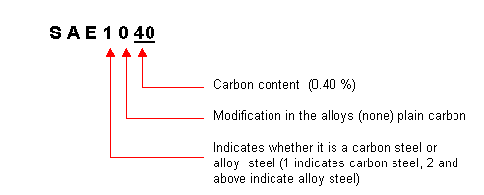

Mechanical and Physical Properties several kinds of steel are in the tables 5.2 –5.4

**TABLE 5.2.** Average Mechanical Properties of Cold-Drawn Steel

|  |  |  |  |  |  |
| --- | --- | --- | --- | --- | --- |
| AISI  no. | Tensile  strength  (psi) | Yield  strength  (psi) | Elongation  (%) | Brinell  hardness | Reduction  of area  (%) |
| 1010 | 67,000 | 55,000 | 25.0 | 137 | 57 |
| 1015 | 71,000 | 60,300 | 22.0 | 149 | 55 |
| 1020 | 75,000 | 63,700 | 20.0 | 156 | 52 |
| 1025 | 80,000 | 68,000 | 18.5 | 163 | 50 |
| 1030 | 87,000 | 73,900 | 17.5 | 179 | 48 |
| 1035 | 92,000 | 78,200 | 17.0 | 187 | 45 |
| 1040 | 97,000 | 82,400 | 16.0 | 197 | 40 |
| 1045 | 102,000 | 86,200 | 15.0 | 207 | 35 |
| 1120 | 78,000 | 66,300 | 19.5 | 159 | 49 |
| 1137 | 105,000 | 89,200 | 16.0 | 217 | 35 |

**TABLE 5.3.** Mechanical and Physical Properties of AISI 1020 Steel (Hot Worked)

|  |  |
| --- | --- |
| Modulus of elasticity (psi) | 29–30 |
| Tensile strength (psi) | 75 |
| Yield strength (psi) | 65.7 |
| Elongation (%) | 36 |
| Brinell hardness | 156 |
| Density (g/cm3) | 7.85 |
| Thermal conductivity (Btu/hr ft2 F) | 27 |
| Specific heat (Btu/lb F) | 0.1 |
| Thermal expansion 10 6 (in./in. F) | 8.4 |

**TABLE 5.4.** Mechanical Properties of Selected Carbon Steels inNormalized and Annealed Condition

|  |  |  |  |  |  |
| --- | --- | --- | --- | --- | --- |
|  |  |  | Yield |  |  |
| AISI | Treatment | | strength | Elongation | Hardness |
| no. |  | ( C/ F) | (psi) | (%) | (RB) |
|  |  |  |  |  |  |
| 1020 | N | 870/1600 | 50,000 | 35.8 | 131 |
|  | A | 870/1600 | 43,000 | 36.5 | 111 |
| 1040 | N | 900/1650 | 54,000 | 28.0 | 170 |
|  | A | 790/1450 | 51,000 | 30.2 | 149 |
| 1060 | N | 900/1650 | 61,000 | 18.0 | 229 |
|  | A | 790/1450 | 54,000 | 22.5 | 179 |
| 1080 | N | 900/1650 | 76,000 | 11.0 | 293 |
|  | A | 790/1450 | 56,000 | 24.7 | 174 |
| 1095 | N | 900/1650 | 73,000 | 9.5 | 293 |
|  | A | 790/1450 | 55,000 | 13.0 | 192 |
| 1137 | N | 900/1650 | 58,000 | 22.5 | 197 |
|  | A | 790/1450 | 50,000 | 26.8 | 174 |

aN = normalized; A = annealed; temperature is that to which the piece was heated.

***\*Notes F = (C x 9/5) + 32; C = (F – 32) x 5/9***

**Materials and Equipment:**

1. Specimen of the hypoeutectoid and hypereutectoid steels.
2. Microscope MM – 4.

**Procedure**

1. For checking microstructure of steel, its specimen is prepared by preparing a flat mirror surface on small piece of metal through rubbing by sand papers, polishing and buffing etc. This surface is then followed by etching with a chemical solution. The chemical solution reacts with various constituents in varying degree to reveal crystal structure clearly. The revealed structure is then viewed through powerful microscope.

2. Set specimen of the hypoeutectoid and hypereutectoid steels on a microscope and look at their microstructure.

3. Draw the microstructure of the hypoeutectoid and hypereutectoid steels.

4. Determine the critical temperatures (UCT and LCT) for hypoeutectoid steel with 0.3 %C and hypereutectoid steel with 1.2%C.

5. Determine the chemical composition of the steels by its SAE-AISI number.

**Questions:**

1. What are the types of iron- carbon alloys?
2. What is steel?
3. What is cast iron?
4. Which polymorphic modifications does the iron have and at what temperatures interval is it stable?
5. List fathes and structure of the Fe-Fe3C diagram.
6. What is cementite and what properties does it have?
7. What is austenite and what properties does it have?
8. What is ferrite and what properties does it have?
9. What is perlite and what properties does it have?
10. What is ledeburite?
11. What carbon content does the hypoeutectoid steel have?
12. What carbon content does hyperutectoid steel have?
13. What carbon content does hypoeutectic cast iron have?
14. What carbon content does hypereutectic cast iron have?
15. Discribe the effect of carbon on hardness and tensile strength of steels.
16. Discribe the effect of carbon on toughness (impact resistance) and ductility of steels.
17. Discribethe effect of impurities on steel.
18. What is hot-shortness and cold shortness?
19. Classification of Plain Carbon Steels by structure.
20. Classification of steel by carbon content.
21. Classification of steel by by applications.
22. What does number SAE 1020 mean?

LABORATORY WORK № 5

**PLAIN CARBON STEELS**

PROTOCOL №1

Hypoeutectoid steel Hypereutectoid steel

Carbon content___________% Carbon contain___________%

Critical temperature, ?C

UCT = _________ UCT = _________

LCT = __________ LCT = _________

PROTOCOL № 2

|  |  |  |  |  |  |  |  |
| --- | --- | --- | --- | --- | --- | --- | --- |
| Steel | Carbon content, %  C | Mechanical properties | | | | | |
| Tensile  strength  (psi/MPa) | Yield  strength  (psi/MPa) | Elongation  (%) | Brinell  hardness | Reduction  of area  (%) |
| SAE 1010 |  |  |  |  |  |  |
| SAE 1025 |  |  |  |  |  |  |
| SAE 1030 |  |  |  |  |  |  |
| SAE 1045 |  |  |  |  |  |  |

Conclusions:

____________________________________________________________

______________________________________________________________________

______________________________________________________________________

_____________________ ___________________

Student’s signature Teacher’s signature

“____”___________20___ y. “____”____________20___ y.

LABORATORY WORK 6

**CAST IRONS**

***Objectives***

1. To learn the microstructures of the cast iron.

2. To learn the advantages and disadvantages of the cast iron.

3. To learn the applications of the cast iron.

***Scientific principles***

***Types of cast iron***

Cast irons may often be used in place of steel at considerable cost savings. The design and production advantages of cast iron include:

Low tooling and production cost

Good machinability without burring

Ability to cast into complex shapes

Excellent wear resistance and high hardness (particularly white cats irons)

High inherent damping capabilities

The properties of the cast iron are affected by the following factors:

Chemical composition of the iron

Rate of cooling of the casting in the mold (which depends on the section thickness in the casting)

Type of graphite formed (if any)

Major types of cast iron are shown in Figure 6.1.

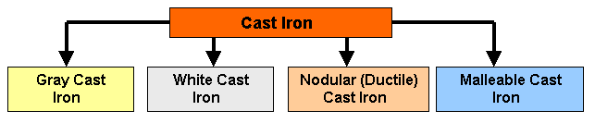

***Fig.6.1. Types of Cast Iron***

***Gray cast iron***

Gray iron, named so because of its fracture has a gray appearance. It contains carbon in the form of ***flake graphite*** in a matrix which consists of ferrite, pearlite or a mixture of the two. The fluidity of liquid gray iron, and its expansion during solidification due to the formation of graphite, has made this metal ideal for the economical production of shrinkage-free, intricate castings such as motor blocks.

The flake-like shape of graphite in Gray iron, see Fig.6.2 and 6.3, exerts a dominant influence on its mechanical properties. The graphite flakes act as stress raisers which may prematurely cause localized plastic flow at low stresses, and initiate fracture in the matrix at higher stresses. As a result, Gray iron exhibits no elastic behavior but excellent damping characteristics, and fails in tension without significant plastic deformation. The presence of graphite flakes also gives Gray Iron excellent machinability and self-lubricating properties.

|  |  |
| --- | --- |
|  |  |
| ***Fig.6.2. Graphite Flakes in Gray***  ***Cast iron*** | ***Fig.6.3. Photomicrograph of Gray***  ***Cast iron*** |

***Advantages of Gray Cast Iron:***

- Graphite acts a s a chip breaker and a tool lubricant.

- Very high damping capacity.

- Good dry bearing qualities due to graphite.

- After formation of protective scales, it resists corrosion in many common engineering environments.

***Disadvantages:***

- Brittle (low impact strength) which severely limits use for critical applications.

- Graphite acts as a void and reduces strength.

- Changes in section size will cause variations in machining characteristics due to variation in microstructure.

- Higher strength gray cast irons are more expensive to produce.

***White cast iron***

***White cast iron*** is unique in that it is the only member of the cast iron family in which ***carbon is present only as carbide***. Due to the absence of graphite, it has a light appearance. The presence of different carbides, depending on the alloy content, makes white cast irons extremely hard and abrasion resistant but very brittle. An improved form of white cast iron is the chilled cast iron.



***Fig.6.4. Photomicrograph of White Cast Iron***

***Ductile Cast iron (nodular cast)***

This structure is developed from the melt. The carbon forms into ***spheres*** when cerium, magnesium, sodium, or other elements are added to a melt of iron with very low sulfur content that will inhibit carbon from forming. The control of the heat-treatment process can be pearlitic, ferritic, martensitic matrices into which the carbon spheres are embedded.

|  |  |
| --- | --- |
|  |  |
| ***Fig.6.5. Nodular (Ductile) Cast Iron and***  ***the spherical carbon embedded into***  ***the matrix.*** | ***Fig.6.6. Photomicrograph***  ***of Nodular Cast iron*** |

Ductile cast iron is used for many structural applications, particularly those requiring strength and toughness combined with good machinability and low cost. The automotive and agricultural industries are the major users of ductile iron castings. Because of economic advantage and high reliability, ductile iron is used for such critical automotive parts as crankshafts, engine connecting rods, idler arms, wheel hubs, truck axles, front wheel spindle supports, disk brake calipers, suspension system parts, power transmission yokes, high temperature applications for turbo housing and manifolds, and high security valves for many applications. The cast iron pipe industry is another major user of ductile iron.

***Malleable Cast Iron***

If cast iron is cooled rapidly, the graphite flakes needed for gray cast iron do not get a chance to form. Instead, white cast iron forms. This white cast iron is reheated to about 950oC for long periods of time and at the elevated temperatures cementite (Fe3C) decomposes into ferrite and free carbon. Upon cooling, the combined carbon further decomposes to small compact particles of graphite (instead of flake -like graphite seen in gray cast iron). If the cooling is very slow, more free carbon is released. This free carbon is referred to as temper carbon, and the process is called ***malleableizing.***

|  |  |
| --- | --- |
|  |  |
| ***Fig. 6.7. Malleable Cast Iron*** | ***Fig.6.8. Ferritic Malleable Cast iron*** |

Malleable cast iron is used for connecting rods and universal joint yokes, transmission gears, differential cases and certain gears, compressor crankshafts and hubs, flanges, pipe fittings and valve parts for railroad, marine and other heavy-duty applications.

***Advantages:***

- Excellent machinability

- Significant ductility

- Good shock resistance properties

***Disadvantages:***

The major disadvantage is shrinkage. Malleable cast iron decreases in volume during solidification, and as a result, requires attached reservoirs (feeders and risers) of liquid metal to offset the shrinkage and prevent the formation of internal or external shrinkage defect.

***Materials and Equipment:***

1. Specimens of the gray cast iron, nodular cast iron and malleable cast iron.

2. Microscope MM – 4.

***Procedure:***

1. Set specimen of the gray cast iron, nodular cast iron and malleable cast iron on a microscope and look at their microstructure.

2. Draw the microstructure of the gray cast iron, nodular cast iron and malleable cast iron.

***Questions:***

1. What are the advantages of cast iron?
2. What are the major types of cast iron?
3. List forms of the graphite and write what types of cast iron have those forms of graphite.
4. What form of graphite does the gray cast iron have?
5. What are the advantages of gray cast iron?
6. Write an example of ductile cast iron applications.
7. Explain the malleable cast iron?
8. What are the advantages and disadvantages of malleable cast iron?

Laboratory work № 6

**CAST IRONS**

PROTOCOL №1

Gray cast iron nodular cast iron malleable cast iron Graphite form

______________ ______________ _______________

The type of the metallic matrix

______________ ______________ _______________

Conclusions:

__________________________________________________________________

__________________________________________________________________

__________________________________________________________________

_______________________ _________________________

Student’s signature Teacher’s signature

“____”___________20___ y. “____”____________20___ y.

LABORATORY WORK 7

**HEAT TREATMENT OF STELL**

***Objectives***

1. To learn the major objectives of heat treatment.

2. To learn the advantages and disadvantages major types of heat treatment processes.

3. To learn how to choose temperature of different types of steel heat treatment.

4. To learn the applications of major types of heat treatment processes.

***Fundamental concept***

***Types of heat treatment processes***

**Heat treatment** is a heating and cooling process of a metal or an alloy in the solid state with the purpose of changing their properties.

It can also be said as a process of heating and cooling of ferrous metals especially various kinds of steels in which some special properties like softness, hardness, tensile-strength, toughness etc, are induced in these metals for achieving the special function objective.

It consists of three main phases namely heating of the metal soaking of the metal and cooling of the metal. The theory of heat treatment is based on the fact that a change takes place in the internal structure of metal by heating and cooling which induces desired properties in it. The ***rate of cooling*** is the major controlling factor. Rapid cooling the metal from above the critical range, results in hard structure. Whereas very slow cooling produces the opposite affect i.e. soft structure. In any heat treatment operation, the rate of heating and cooling is important. A hard material is difficult to shape by cutting, forming, etc. During machining in machine shop, one requires machineable properties in job piece hence the properties of the job piece may requires heat treatment such as annealing for inducing softness and machineability property in workpiece. Many types of furnaces are used for heating heat treatment purposes.

Various types of heat treatment processes are used to change the following properties or conditions of the steel:

The major objectives of heat treatment are given as under

It relieves internal stresses induced during hot or cold working.

It changes or refines grain size.

It increases resistance to heat and corrosion.

It improves mechanical properties such as ductility, strength, hardness, toughness, etc.

It helps to improve machinability.

It increases wear resistance

It removes gases.

It improves electrical and magnetic properties.

It helps to improve shock resistance.

It improves weldability.

Figure 7.1 shows major types of heat treatment processes.

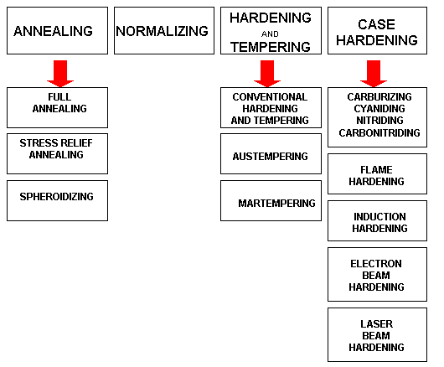

Fig.7.1. ***The Types of Heat Treatment Processes.***

***Time-Temperature-Transformation (TTT) Diagram***

T(Time) T(Temperature) T(Transformation) diagram is a plot of temperature versus the logarithm of time for a steel alloy of definite composition. It is used to determine when transformations begin and end for an isothermal (constant temperature) heat treatment of a previously austenitized alloy. When austenite is cooled slowly to a temperature below ***LCT (Lower Critical Temperature)***, the structure that is formed is Pearlite. As the cooling rate increases, the pearlite transformation temperature gets lower. The microstructure of the material is significantly altered as the cooling rate increases. By heating and cooling a series of samples, the history of the austenite transformation may be recorded. ***TTT diagram indicates*** when a specific transformation starts and ends and it also shows what percentage of transformation of austenite at a particular temperature is achieved.

Cooling rates in the order of increasing severity are achieved by quenching from elevated temperatures as follows: furnace cooling, air cooling, oil quenching, liquid salts, water quenching, and brine. If these cooling curves are superimposed on the TTT diagram, the end product structure and the time required to complete the transformation may be found.

In Fig.7.2 the area on the left of the transformation curve represents the austenite region. Austenite is stable at temperatures above LCT but unstable below LCT. Left curve indicates the start of a transformation and right curve represents the finish of a transformation. The area between the two curves indicates the transformation of austenite to different types of crystal structures. (Austenite to pearlite, austenite to martensite, austenite to bainite transformation.)

|  |  |
| --- | --- |
|  |  |
| a) | b) |
| ***Fig.7.2. TTT Diagram in general (a), in details (b)*** | |

If the cooling rate is very slow such as annealing process, the cooling curve passes through the entire transformation area and the end product of this the cooling process becomes 100% Pearlite.

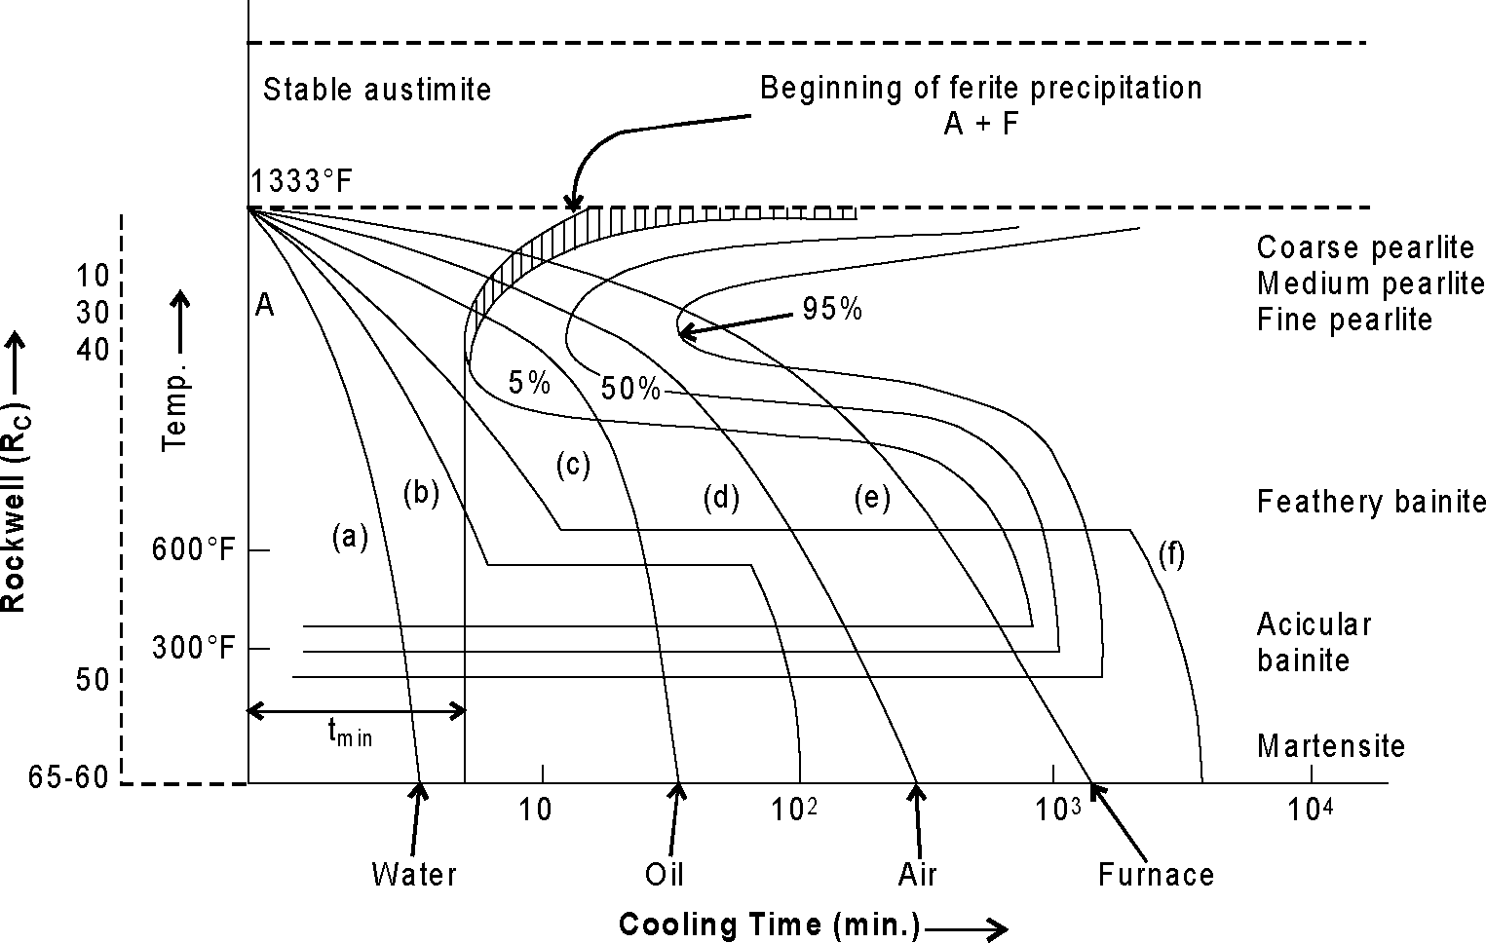

Fig. 7.3. Series of different cooling rates curves in TTT diagram

In Fig.7.4 the cooling rates A and B indicate two rapid cooling processes. In this case curve A will cause a higher distortion and a higher internal stresses than the cooling rate B. The end product of both cooling rates will be ***martensite.*** Cooling rate B is also known as the ***Critical Cooling Rate,*** which is represented by a cooling curve that is tangent to the nose of the TTT diagram. Critical Cooling Rate is defined as the lowest cooling rate which produces 100% Martensite while minimizing the internal stresses and distortions.

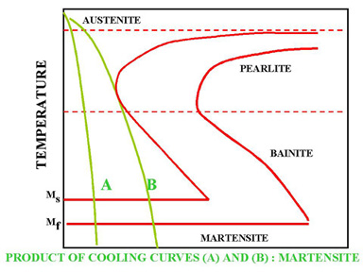

***Fig.7.4. Rapid Quench***

In Fig.7.5 a rapid quenching process is interrupted (horizontal line represents the interruption) by immersing the material in a molten salt bath and soaking at a constant temperature followed by another cooling process that passes through Bainite region of TTT diagram. The end product is Bainite, which is not as hard as Martensite. As a result of cooling rate D; more dimensional stability, less distortion and less internal stresses are created.

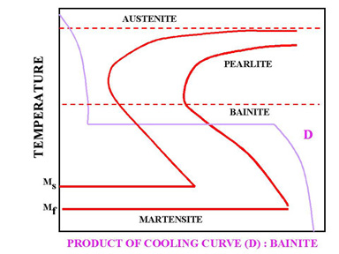

***Fig. 7.5. Interrupted Quench***

In Fig.7.6 cooling curve C represents a slow cooling process, such as furnace cooling. An example for this type of cooling is annealing process where all the Austenite is allowed to transform to Pearlite as a result of slow cooling.

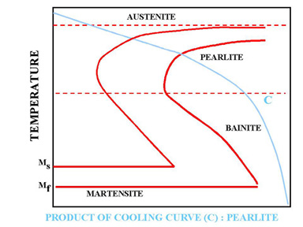

***Fig.7.6. Slow cooling process (Annealing)***

***Processes of Annealing and Spheroidizing***

There are two types of Critical Temperature according to the diagram iron- ironcarbide:

***LCT (Lower Critical Temperature) -*** line **PSK** (constant temperature 727 oC for all stell);

***UCT (Upper Critical Temperature)* -** line **GSE** (temperaturedepends of carbon contain).

Full annealing is accomplished by heating a hypoeutectoid steel to a temperature ***above the UCT*** (Upper Critical Temperature). In practice, the steel is heated to about 30-50 oC above the UCT. It is then cooled in the furnace very slowly to room temperature. The formation of austenite destroys all structures that have existed before heating. Slow cooling yields the original phases of ferrite and pearlite.

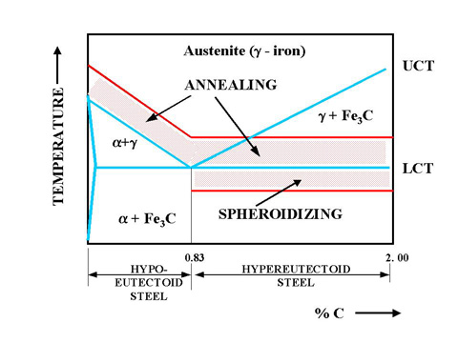

***Fig. 7.7. Annealing and Spheroidizing Temperatures***

Hypereutectoid steels consist of pearlite and cementite. The cementite forms a brittle network around the pearlite. This presents difficulty in machining the hypereutectoid steels. To improve the machinability of the annealed hypereutectoid steel spheroidize annealing is applied. This process will produce a spheroidal or globular form of a carbide in a ferritic matrix which makes the machining easy. Prolonged time at the elevated temperature will completely break up the pearlitic structure and cementite network. The structure is called spheroidite. This structure is desirable when minimum hardness, maximum ductility and maximum machinability are required.

***Stress-Relief Annealing*** is useful in removing residual stresses due to heavy machining or other cold-working processes. It is usually carried out at temperatures below the LCT, which is usually selected around 600?C.

***Full annealing*** consists of (1) recovery (stress-relief), (2) recrystallization, (3) grain growth stages. Annealing reduces the hardness, yield strength and tensile strength of the steel.

***Process of Normalizing***

The ***normalizing*** of steel is carried out by heating approximately 30-50 oC above the UCT (Upper Critical Temperature) followed by cooling in air to room temperature. Normalizing can be applied above the UCT for both hypoeutectoid and hypereutectoid steels. Fig.7.8 shows the normalizing temperatures.

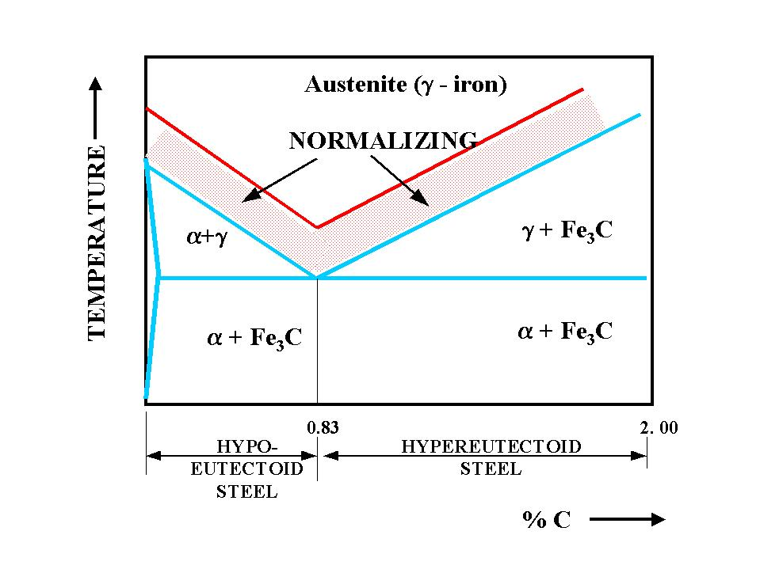

***Fig.7.8. Normalizing temperatures for hypoeutectoid and hypereutectoid steels.***

The following is the list of the reasons for normalizing the steel :

- To produce a harder and stronger steel than full annealing

- To improve the machinability

- To modify and refine the grain structure

- To obtain a relatively good ductility without reducing the hardness and strength

Annealing and normalizing do not present a significant difference on the ductility of low carbon steels. As the carbon content increases, annealing maintains the % elongation around 20%. On the other hand, the ductility of the normalized high carbon steels drop to 1 to 2 % level.

The tensile strength and the yield point of the normalized steels are higher than the annealed steels. Normalizing and annealing do not show a significant difference on the tensile strength and yield point of the low carbon steels. However, normalized high carbon steels present much higher tensile strength and yield point than those that are annealed. Comparison between Annealing and Normalising are given in Table 7.1.

Table 7.1 Comparison between Annealing and Normalising

|  |  |  |
| --- | --- | --- |
| S.No. | Annealing | Normalising |
| 1 | In this hypoeutectoid steel is heated to a temperature approximately 20 to 30°C above temperature the higher critical temperature and for hypereutectoid steel is heated 20 to 30°C above the lower critical temperature. | In this metal is heated 30 to 50°C above higher critical temperature. |
| 2 | It gives good results for low and medium carbon steel. | It also gives very good results for low and medium carbon steel |
| 3 | It gives high ductility. | It induces gives higher ultimate strength, yield point and impact strength in ferrous material. |
| 4 | It is basically required to soften the metal, to improve machinability, to increase ductility, improve, to refine grain size. | It is basically required to refine grain size, improve structure of weld, to relieve internal stresses. |

The medium carbon steels can maintain similar hardness levels when normalized or annealed. However, when high carbon steels are normalized they maintain higher levels of hardness than those that are annealed.

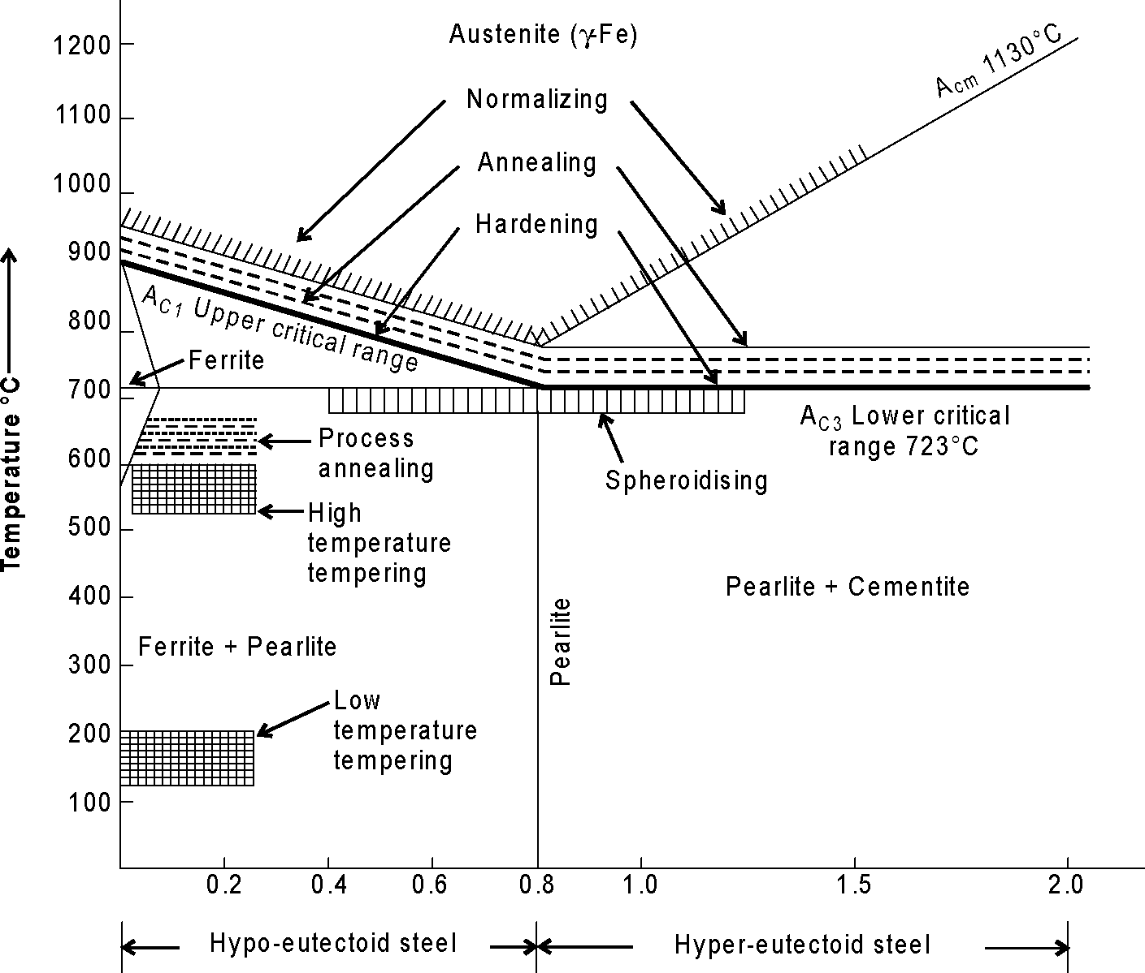

***Fig. 7.9. Heating temperature ranges for various heat treatment processes***

***Processes of Hardening and Tempering***

Steels can be heat treated to high hardness and strength levels. Structural components subjected to high operating stress need the high strength of a hardened structure. Similarly, tools such as dies, knives, cutting devices, and forming devices need a hardened structure to resist wear and deformation.

**Hardenability:** This property determines the depth and distribution of hardness induced by quenching.

Quenched hardened steels are so brittle that even slight impacts may cause fracture. All hardened steels must be tempered before use.

**Hardening** is a hardness inducing kind of heat treatment process in which steel is heated to a temperature above the critical point and held at that temperature for a definite time and then quenched rapidly in water, oil or molten salt bath.

Steel is hardened by heating 20-30°C above the upper critical point for hypoeutectoid steel and 20-30°C above the lower critical point for hypereutectoid steel and held at this temperature for some time and then quenched in water or oil or molten salt bath. Fig. 7.10 (a) shows the structure obtained on water quenching on hardening of medium carbon steel. Fig. 8.10 (b) shows the structure obtained on oil quenching on hardening of medium carbon steel. Fig. 8.10 (c) shows the structure obtained on water quenching on hardening of medium carbon steel and followed by tempering.

|  |  |
| --- | --- |
|  |  |
| a) b) | c) |
| ***Fig. 7.10 Structure of hardened carbon steel*** | |

Metal is heated up to austenite formation and is followed by fast and continuous cooling of austenite to temperature 205° to 315°C or even lower than that. Due to such rapid cooling, austenitic structure changes to new structure known as **martensite.** It is evident that faster the rate of cooling harder will be the metal due to formation of more martensitic structure. Martensite has a tetragonal crystal structure. Hardness of martensite varies from 500 to 1000 BHN depending upon the carbon content and fineness of the structure. Martensite is a body centered phase produced by entrapping carbon on decomposition of austenite when cooled rapidly. It is the main constituent of hardened steel. It is magnetic and is made of a needle like fibrous mass. It has carbon content up to 2%. It is extremely hard and brittle. The decomposition of austenite below 320°C starts the formation of martensite.

Sudden cooling of tool steel provides thermal stresses due to uneven cooling. It provides unequal specific volume of austenite and its decomposition product. The structural transformations are progressing at different rates in outer layers and central portion of the article. When martensitic transformation takes place in the central portion of the article, due to tension stress produces cracks. The harness depends upon essentially on the cooling rate. The effect of cooling on austenite transformation is given in Fig. 7.11.

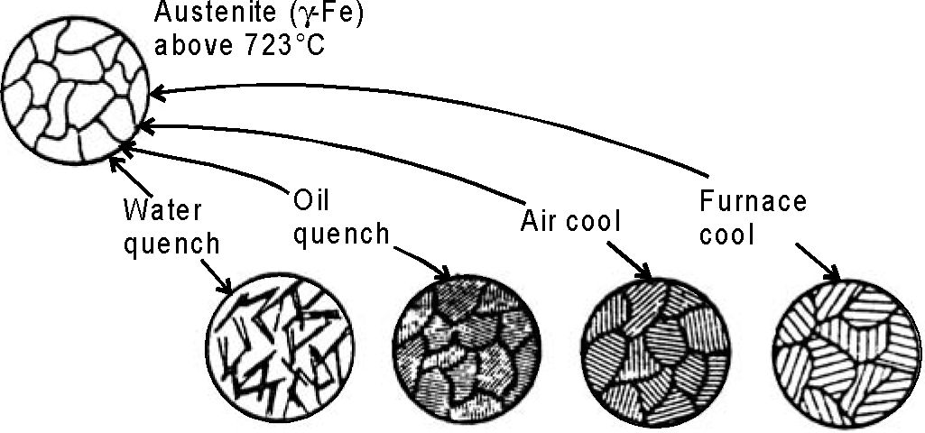

Martensite Very fine Fine Coarse

pearlite pearlite pearlite

Fig. 7.11. Effects of coooling of austenite transformation

**Tempering** is a heat treatment that reduces the brittleness of a steel without significantly lowering its hardness and strength.

**Low Temperature Tempering**

Hardened steel parts requiring tempering are heated up to 200°C and then quenched in oil. Tempering is used to retain hard micro-structure of martensite which increases brittleness. Fig 7.12 a represents the microstructure of martensite.

**Medium Temperature Tempering**

Hardened steel parts requiring tempering are heated in the temperature range of 200-350°C. This process gives troosite structure. Troosite structure is another constituent of steel obtained by quenching tempering martensite. It is composed of the cementite phase in a ferrite matrix that cannot be resolved by light microscope. It is less hard and brittle than martensite. It is also produced by cooling the metal slowly until transformation begins and then cooling rapidly to prevent its completion. It has a dark appearance on etching. It is weaker than martensite. Fig 7.12b represents the microstructure of troosite.

**High Temperature Tempring**

Hardened steel parts requiring tempering are heated in the temperature range of 350-550°C. This process gives sorbite structure. Sorbite structure is produced by the, transformation of tempered martensite. It is produced when steel is heated at a fairly rapid rate from the temperature of the solid solution to normal room temperature. It has good strength and is practically pearlite. Its properties are intermediate between those of pearlite and troosite. Parts requiring tempering are heated in the temperature range of 550-750°C. This process gives spheriodite structure. Fig 7.12(c) represents the micro structure of sorbite. However there are other special kinds of tempering also which are discussed as under.

|  |
| --- |
|  |
| a) b) c) |
| ***Fig.7.12. Structures obtained tempering of hardened steel*** |

**QUENCH AND TEMPERING PROCESSES:**

(1) Conventional Heat, Quench and Temper process

(2) Martempering

(3) Austempering

***Conventional Heat, Quench and Temper Process:***

Quench begins by conventional heating of a hypoeutectoid steel to a temperature to about 30-50oC ***above the UCT*** (Upper Critical Temperature). Quench begins by heating of a hyperoeutectoid steel to a temperature ***above the LCT*** (Lower Critical Temperature). Then all steels are soaked and rapidly cooled. In this process, Austenite is transformed to Martensite as a result of rapid quench from furnace to room temperature. Then, martensite is heated to a temperature which gives the desired hardness. As the metal cools, it also contracts and its microstructure occupies less volume. Extreme variations in size of metal parts complicate the work of the heat treater and should be avoided in the designing of metal parts. This means there is a limit to the overall size of parts that can be subjected to such thermal processing. Figure 7.13. shows the conventional hardening, tempering process.

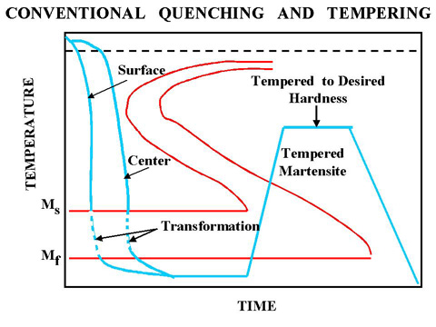

***Fig.7.13. Conventional quenching and tempering process.***

***Martempering (Marquenching):***

To overcome the restrictions of conventional quenching and tempering, Martempering process can be used. Martempering or marquenching permits the transformation of Austenite to Martensite to take place at the same time throughout the structure of the metal part. Then cooling is continued through the martensite region, followed by the usual tempering.

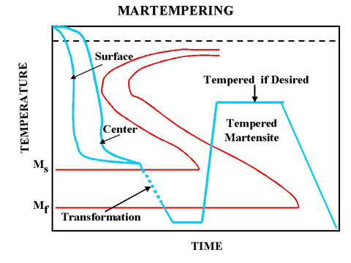

***Fig.7.14. Martempering process***

***Austempering:***

This is the second method that can be used to overcome the restrictions of conventional quench and tempering. The quench is interrupted at a higher temperature than for Martempering to allow the metal at the center of the part to reach the same temperature as the surface. By maintaining that temperature, both the center and the surface are allowed to transform to Bainite and are then cooled to room temperature.

***Advantages of Austempering:***

(1) Less distortion and cracking than martempering,

(2) No need for final tempering (less time consuming and more energy efficient)

(3) Improvement of toughness (impact resistance is higher than the conventional quench and tempering)

(4) Improved ductility

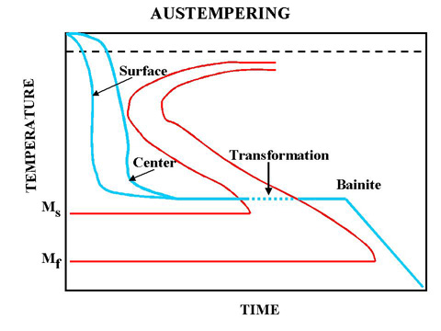

***Fig.7.15. Austempering process***.

In Austempering process, the end product is 100% bainite. The part is left in the bath until the transformation to bainite is complete. The steel is caused to go directly from austenite to bainite.

**Limitations of Aus-Tempering**

1. The process is very costly.

2. The process is time consuming.

***Materials and Equipment:***

1. Specimen of the hypoeutectoid steel SAE 1040.
2. Microscope MM – 4.

***Procedure:***

1. Determine the carbon content of the steel SAE 1040.
2. Choose the temperature of the annealing, normalizing and quanch of this steel.
3. Define the major types of heat treatment processes.
4. Write conclusions about the difference between these processes.

***Questions:***

1. What properties or conditions of the steel change during the various types of heat treatment?

2. What are the major types of heat treatment processes?

3. Plot the TTT diagram.

4.What does the TTT diagram indicate?

1. What is the critical cooling rate?
2. What structure is formed during the slow cooling (annealing process)?
3. Show the upper and lower critical temperature on the Fe-Fe3C diagram.
4. What is the purpose of the spheroidizing process?
5. List of the reasons for normalizing the steel.
6. How to choose the normalizing temperature for hypo- and hypereutectoid steel? Show temperature ranges on the Fe-Fe3C diagram.
7. Comparison between Annealing and Normalising.
8. What is the martensite and what properties does it have?
9. What is Hardenability?
10. What transformation takes place during quench process?
11. How to choose the quench temperature for hypo- and hypereutectoid steel? Show temperature ranges on the Fe-Fe3C diagram.
12. What is the purpose of the tempering process?
13. What is the tempering?
14. Describe types of tempering.

19. What is Martempering and Austempering.

20. List the Advantages of Austempering.

LABORATORY WORK № 7

**HEAT TREATMENT OF STELL**

PROTOCOL №1

**Define:**

Annealing______________________________________________________________________________________________________________________________________________________________________________________________

Normalizing____________________________________________________________________________________________________________________________________________________________________________________________

Quenching______________________________________________________________________________________________________________________________________________________________________________________________

Tempering______________________________________________________________________________________________________________________________________________________________________________________________

PROTOCOL №2

|  |  |  |  |  |  |  |
| --- | --- | --- | --- | --- | --- | --- |
| Steel | Carbon content, % | Critical temperature,?C | | Temperature of the processes, ?C | | |
| SAE 1030 |  | UCT |  | annealing | normalizing | quanch |
| LCT |  |  |  |  |

Conclusions:

_______________________________________________________________

_______________________________________________________________

_______________________________________________________________

_______________________ _________________________

Student’s signature Teacher’s signature

“____”___________20___ y. “____”____________20___ y.

LABORATORY WORK № 8

**CHEMICAL HEAT TREATMENT OF STEEL**

***Objectives***

1. To learn the major types of chemical heat treatment processes.

2. To learn the technological parameters of the Carburization and Nitriding processes.

2. To learn the applications of the types of chemical heat treatment processes.

***Scientific principles***

***Carburization process***

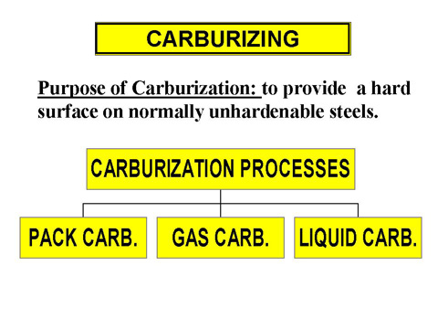

***Fig.8.1. Major types of the Carburization process.***

***Technological parameters of carburization:***

* Depth of Hardening:

there is no technical limit to the depth of hardening with carburizing techniques, but it is not common to carburize to depths in excess of 1.2 mm.

- Carburizing Time:

4 to 10 hours

- Carburizing Temperature:

950 °C (above the upper critical temperature-Austenite area)

***Quenching:***

All of the carburizing processes (pack, gas, liquid) require quenching from the carburizing temperature or a lower temperature or reheating and quenching. Parts are then tempered to the desired hardness.

***Pack Carburizing:***

In this process, the part that is to be carburized is packed in a steel container so that it is completely surrounded by granules of charcoal. The charcoal is treated with an activating chemical such as Barium Carbonate (BaBO3) that promotes the formation of Carbon Dioxide (CO2). This gas in turn reacts with the excess carbon in the charcoal to produce carbon monoxide; CO.Carbon Monoxide reacts with the low-carbon steel surface to form atomic carbon which diffuses into the steel. Carbon Monoxide supplies the carbon gradient that is necessary for diffusion. The carburizing process does not harden the steel. It only increases the carbon content to some predetermined depth below the surface to a sufficient level to allow subsequent quench hardening.

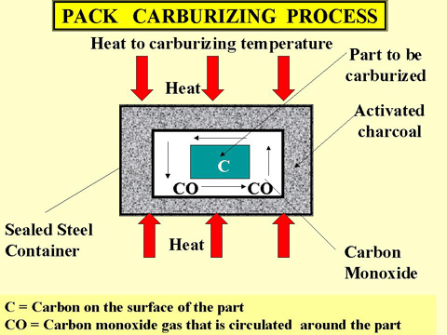

***Fig.8.2. Pack carburizing process***

***Quenching Process:***

It is difficult to quench the part immediately, as the sealed pack has to be opened and the part must be removed from the pack. One technique that is used often is to slow cool the entire pack and subsequently harden and temper the part after it is removed from the sealed pack.

***Gas Carburizing:***

Can be done with any carbonaceous gas, such as methane, ethane, propane, or natural gas. Most carburizing gases are flammable and controls are needed to keep carburizing gas at 930 °C from contacting air (oxygen). The advantage of this process over pack carburizing is an improved ability to quench from the carburizing temperature. Conveyor hearth furnaces make quenching in a controlled atmosphere possible.

***Liquid Carburizing:***

Can be performed in internally or externally heated molten salt pots. Carburizing salt contains cyanide compounds such as sodium cyanide (NaCN). Cycle times for liquid cyaniding is much shorter (1 to 4 hours) than gas and pack carburizing processes. Disadvantage is the disposal of salt. (environmental problems) and cost (safe disposal is very expensive).

There are some advantages of the liquid bath carburizing which are given as under.

Advantages

1. Greater depth of penetration possible in this process.
2. Selective carburizing is possible if needed.
3. Uniform heating will occur in this process.
4. Little deformation or distortion of articles occur in this process.
5. Ease of carburizing for a wider range of products.
6. It is time saving process.
7. Parts leave the bath with a clean and bright finish.

There is no scale in this process as occur in pack hardening

***Nitriding Process:***

In this process, nitrogen is diffused into the surface of the steel being treated. The reaction of nitrogen with the steel causes the formation of very hard iron and alloy nitrogen compounds. The resulting nitride case is harder than tool steels or carburized steels. The advantage of this process is that hardness is achieved without the oil, water or air quench. As an added advantage, hardening is accomplished in a nitrogen atmosphere that prevents scaling and discoloration. Nitriding temperature is below the lower critical temperature of the steel and it is set between 500°C and 600 °C. The nitrogen source is usually Ammonia (NH3). At the nitriding temperature the ammonia dissociates into Nitrogen and Hydrogen.

2NH3 ---> 2N + 3H2

The nitrogen diffuses into the steel and hydrogen is exhausted. A typical nitriding setup is illustrated in Fig.8.3.

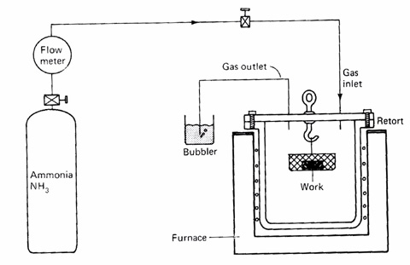

***Fig.8.3. Nitriding process***

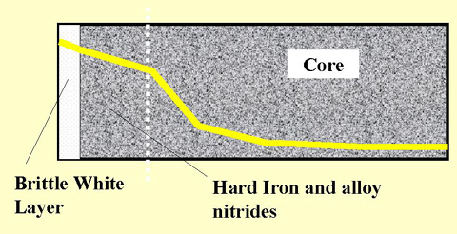

***Fig.8.4. Nitriding microstructure.***

The white layer shown in Fig.8. 4 has a detrimental effect on the fatigue life of nitrided parts, and it is normally removed from parts subjected to severe service. Two stage gas-nitriding processes can be used to prevent the formation of white layer. White layer thickness may vary between 0.2 and 0.4 mm, which depends on nitriding time. The most commonly nitrided steels are chromium-molybdenum alloy steels and Nitralloys(fig.8.5). Surface hardness of 55 HRC to 70 HRC can be achieved with case depths varying from 0.1 in to 0.5 mm. Nitrided steels are very hard and grinding operations should not be performed after nitriding. White layer is removed by lapping.

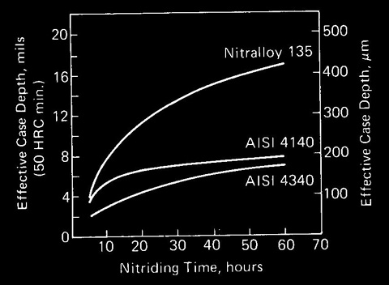

***Fig.8.5. Nitriding time for various types of alloy steels***

Application

Many automobile, diesel engines parts, pumps, shafts, gears, clutches, etc. are treated with the nitriding process. This process is used for the parts which require high wear resistance at elevated temperatures such as automobile and air plane valve’s and valve parts, piston pins, crankshafts, cylinder liners etc. It is also used in ball and roller bearing parts die casting dies, wire drawing dies etc.

***Carbonitriding*** ***and Cyaniding processes:***

This process involves with the diffusion of both carbon and nitrogen into the steel surface. The process is performed in a gas atmosphere furnace using a carburizing gas such as propane or methane mixed with several percent (by volume) of ammonia. Methane or propane serve as the source of carbon, the ammonia serves as the source of nitrogen. Quenching is done in a gas which is not as severe as water quench. As a result of les severe quench, there is less distortion on the material to be treated. Case hardness of HRC 60 to 65 is achieved at the surface. (Not as high as nitrided surfaces.) Case depths of 0.5 to 0.7 mm can be accomplished by carbonitriding. One of the advantages of this process is that it can be applied to plain carbon steels which give significant case depths. Carbonitriding gives less distortion than carburizing. Carbonitriding is performed at temperatures above the transformation temperature of the steels (840 to 860°C).

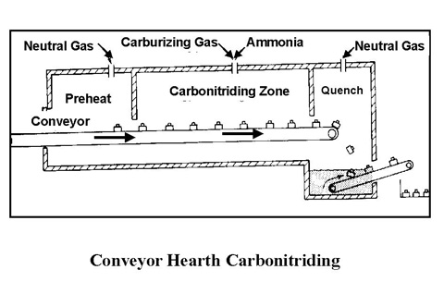

***Fig.8.6. Carbonitriding process.***

***Cyaniding***

It is similar to carbonitriding, and involves the diffusion of both carbon and nitrogen into the surface of the steel. The source of the diffusing element in this method is a molten cyanide salt such as sodium cyanide. It is a supercritical treatment involving temperatures in the range of 840 to 860°C. Case depths are between 0.2 and 0.6 mm. Diffusion times are less than one hour. Water or oil quench is required. This type of cases presents a significant distortion. Advantage of this method is the short time it requires to complete the diffusion, otherwise it should be avoided because of high distortion.

Application

Cyaniding is generally applied to the low carbon steel parts of automobiles (sleeves, brake cam, speed box gears, drive worm screws, oil pump gears etc), motor cycle parts (gears, shaft, pins etc.) and agriculture machinery.

**Comparison Between Full Hardening And Case Hardening**

The comparison between full hardening and case hardening is under in Table 8.

Table 8. Comparison between Full Hardening and Case Hardening

|  |  |  |
| --- | --- | --- |
| S.No. | Full Hardening | Case Hardening |
| 1 | It is process carried out on steel parts to resist wear or abrasion and in case of cutting tools to improve their cutting ability. | The main objective of case- hardening of steel parts is to have a hard surface and tough core. The various methods are, carburizing, cyaniding, nitriding, flame hardening and induction hardening. |
| 2 | In this process, the structure formed of materials and whole of the part is effected. | In this process, the only outer surface (up to some depth) is saturated by carbon, nitrogen or both. Where core is not affected (remains tough). |
| 3 | Its main purpose is to resist wear and increase the cutting ability. | Its main purpose is get outer surface hard where inner core is kept tough. It is used to obtain close tolerances on machine parts, higher fatigue limit and high mechanical properties in core of the metal part. |
| 4 | Hardening is always followed by tempering to increase its usefulness. | Case hardening is not always followed by tempering. |
| 5 | In hardening the metals are heated above critical temperature and then cooled rapidly. | In case hardening, the metals are heated obut it not necessary to cool them rapidly. always. |
| 6 | It is a cheap and fast process. | It is costly and time consuming process. |

***Materials and Equipment:***

1. Specimen of the hypoeutectoid steel SAE 1010.
2. Microscope MM – 4.

***Procedure:***

1. Define the major types of chemical heat treatment processes.
2. Determine the carbon content of the steel SAE 1010.
3. Choose the temperature of the carburizing, quanch and tempering of this steel.
4. Draw the microstructure of this steel after chemical heat treatment.

***Questions:***

1. What properties of the steel change during the various types of chemical heat treatment?

2. What are the major types of chemical heat treatment processes?

3. What is carburizing and write it technological parameters?

4. Explain Pack Carburizing process.

5. Explain Gas Carburizing process.

6. Explain Liquid Carburizing process.

7. What the reasons for using Quenching Process after Carburizing process?

8. List the Advantages of Liquid Carburizing process.

9. What is Nitriding Process and write it technological parameters.

10.Draw and explain the Nitriding microstructure.

11. Describe Carbonitriding and Cyaniding processes.

12. Write the application of the major types of chemical heat treatment processes.

13. Describe the comparison between Full Hardening and Case Hardening.

LABORATORY WORK № 7

**CHEMICAL HEAT TREATMENT OF STELL**

PROTOCOL №1

**Define:** Carburizing process ____________________________________________________________________________________________________________________________________

Nitriding Process ____________________________________________________________________________________________________________________________________

Carbonitriding ____________________________________________________________________________________________________________________________________

Cyaniding processes ____________________________________________________________________________________________________________________________________

PROTOCOL №2

|  |  |  |  |  |  |  |
| --- | --- | --- | --- | --- | --- | --- |
| Steel | Carbon content, % | Depth,  mm | Time,  hours | Temperature of the processes, ?C | | |
| carburizing | quanch | tempering |
| SAE 1010 |  |  |  |  |  |  |

PROTOCOL №3

Microstructure steel SAE 1010 after chemical heat treatment

Conclusions:

_______________________________________________________________

_______________________________________________________________

_______________________________________________________________

_______________________ _________________________

Student’s signature Teacher’s signature

“____”___________20___ y. “____”____________20___ y.

LABORATORY WORK № 9

**ALLOY STEELS. LOW-ALLOY STEELS AND STAINLESS STEELS**

***Objectives***

1. To learn the effect of alloying elements in steel.

2. To learn to determine of the alloy steel chemical composition by its SAE-AISI number.

3. To learn the chemical composition, microstructure and applications low-carbon steels.

4. To learn the chemical composition, microstructure and applications stainless steels.

***Scientific principles***

To produce needed improvement in properties of plain carbon steel, certain elements in steel are alloyed for specific purposes to increase wearing resistance, electrical and mechanical properties which cannot be obtained in plain carbon steels.

The properties of steel can be tailored for special uses by the addition of other metals to the alloy. For improving the properties of ordinary steel, certain alloying elements are added in it in sufficient amounts. The most common alloying elements added to steel are chromium, nickel, manganese, silicon, vanadium, molybdenum, tungsten, copper, titanium, zirconium, cobalt, and aluminium.

Each of these elements induces certain qualities in steels to which it is added. They may be used separately or in combination to produce desired characteristics in the steel. The **main purpose of alloying element** in steel is to improve machinability, elasticity, hardness, case hardening, cutting ability, toughness, wear resistance, tensile strength, corrosion resistance, and ability to retain shape at high temperature, ability to resist distortion at elevated temperature and to impart a fine grain size to steel. Like carbon, a number of alloying elements are soluble to produce alloys with improved strength, ductility, and toughness. Also carbon, besides forming an inter-metallic compound with iron, combines with many alloying elements and form alloy carbides. These alloy carbides as well as iron-alloy carbides are usually hard and lack in toughness. Some alloying elements are added to prevent or restrict grain growth. Aluminium is considered the most effective in this respect. Others are zirconium, vanadium, chromium, and titanium. The addition of alloying elements almost always affects the austenite-ferrite transformation mechanism. Some alloying elements lower and some raise the critical temperature. The compositional and structural changes produced by alloying elements change and improve the physical, mechanical and processing properties of steel.

**Effect of alloying elements in steel**

The chief alloying elements used in steel are nickel, chromium, molybdenum, cobalt, vanadium, manganese, silicon and tungsten. Each of these elements possesses certain qualities upon the steel to which it is added. These elements may be used separately or in combination to produce the desired characteristic in steel. Following are the effects of alloying elements on steel.

**Nickel.** Steels contain 2 to 5% nickel and from 0.1 to 0.5% carbon increase its strength and toughness. In this range, nickel contributes great tensile strength, yield strength, toughness and forming properties and hardness with high elastic limit, good ductility and good resistance to corrosion. An alloy containing 25% nickel possesses maximum toughness and offers the greatest resistance to rusting, corrosion and burning at high temperature. It has proved beneficial in the manufacture of boiler tubes, valves for use with superheated steam, valves for engines and sparking plugs for petrol engines. A nickel steel alloy containing 36% of nickel is known as **invar.** It has nearly zero coefficient of expansion. Therefore, it is in great demand for making measuring instruments for everyday use.

**Chromium.** It improves corrosion resistance (about 12 to 18% addition). It increases tensile strength, hardness, wear resistance and heat resistance. It provides stainless property in steel. It decreases malleability of steel. It is used in steels as an alloying element to combine hardness with high strength and high elastic limit. It also imparts corrosion resisting properties to steel. The most common chrome steels contain from 0.5 to 2% chromium and 0.1 to 1.5% carbon. The chrome steel is used for balls, rollers and races for bearings. A Nickel-Chrome steel containing 3.25% nickel, 1.5% chromium and 0.25% carbon is much used for armour plates. Chrome nickel steel is extensively used for motor car crank shafts, axles and gears requiring great strength and hardness.

**Tungsten.** It increases hardness, wear resistance, shocks resistance and magnetic reluctance. It increases ability to retain hardness and toughness at high temperature. It prohibits grain growth and the depth of hardening of quenched steel. The principal uses of tungsten steels are for cutting tools, dies, valves, taps and permanent magnets.

**Vanadium.** It improves tensile strength, elastic limit, ductility, fatigue resistance, shock resistance and response to heat treatment. It aids in obtaining a fine grain structure in tool steel. The addition of a very small amount of vanadium (less than 0.2%) produces a marked increase in tensile strength and elastic limit in low and medium carbon steels without a loss of ductility. The chrome- vanadium steel containing about 0.5 to 1.5% chromium, 15 to 0.3% vanadium and 0.13 to 1.1% carbon have extremely good tensile strength, elastic limit, endurance limit and ductility. These steels are frequently used for parts such as springs, shafts, gears, pins and many drop forged parts.

**Molybdenum.** A very small quantity (0.15 to 0.30%) of molybdenum is generally used with chromium and manganese (0.5 to 0.8%) to make molybdenum steel. It increases hardness, wear resistance, thermal resistance. When added with nickel, it improves corrosion resistance. It counteracts tendency towards temper brittleness. It makes steel tough at various hardness levels. It acts as a grain growth inhibitor when steels are heated to high temperatures. Molybdenum steels possesses hardness, wear resistance, thermal resistance and extra tensile strength. It is used for air­plane fuselage and automobile parts. It can replace tungsten in high speed steels.

**Cobalt.** When added to steel, it refines the graphite and pearlite and acts as a grain refiner. It improves hardness, toughness, tensile strength and thermal resistance.

**Titanium.** It acts as a good deoxidizer and promotes grain growth. It prevents formation of austenite in high chromium steels. It is the strongest carbide former. It is used to fix carbon in stainless steels and thus prevents the precipitation of chromium carbide.

**Aluminium.** It is used as a deoxidizer. If present in an amount of about 1 %, it helps promoting nitriding.

**Copper.** It improves resistance to corrosion. It increases strength. More than 0.6 % copper for precipitation.

**Silicon.** It improves magnetic permeability and decreases hysteresis losses. It decreases weldability and forgeability. It is also added as a deoxidizer during casting of ingots. It takes care of oxygen present in steel by forming SiO2. Silicon steels behave like nickel steels. These steels have a high elastic limit as compared to ordinary carbon steel. Silicon steels containing from 1 to 2% silicon and 0.1 to 0.4% carbon and other alloying elements are used for electrical machinery, valves in engines, springs and corrosion resisting materials.

**Manganese.** It improves the strength of the steel in both the hot rolled and heat treated condition. The manganese alloy steels containing over 1.5% manganese with a carbon range of 0.40 to 0.55% are used extensively in gears, axles, shafts and other parts where high strength combined with fair ductility is required. The principal use of manganese steel is in machinery parts subjected to severe wear. These steels are all cast and ground to finish.

The effect of alloying elements on the microstructure and properties of steel are given in Table 9.1.

**Table 9.1.** The effect of alloying elements on the properties of steel

|  |  |
| --- | --- |
| Element | Effect |
| Aluminum | Ferrite hardener  Graphite former  Deoxidizer |
| Chromium | Mild ferrite hardener  Moderate effect on hardenability  Graphite former  Resists corrosion  Resists abrasion |
| Cobalt | High effect on ferrite as a hardener  High red hardness |
| Molybdenum | Strong effect on hardenability  Strong carbide former  High red hardness  Increases abrasion resistance |
| Manganese | Strong ferrite hardener |
| Nickel | Ferrite strengthener  Increases toughness of the hypoeutectoid steel  With chromium, retains austenite  Graphite former |
| Copper | Austenite stabilizer  Improves resistance to corrosion |
| Silicon | Ferrite hardener  Increases magnetic properties in steel |
| Phosphorus | Ferrite hardener  Improves machinability  Increases hardenability |

The Marking of Alloy Steel

Alloy steels are indicated by 2XXX, 3XXX, 4XXX, etc. The American Iron and Steel Institute (AISI) in cooperation with the Society of Automotive Engineers (SAE) revised the percentages of the alloys to be used in the making of steel, retained the numbering system (fig. 9.1).

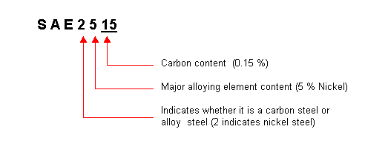

Fig. 9.1. General representation of alloy steels

Table 9.2. Marking and classification of alloy steels.

|  |  |
| --- | --- |
| SAE - AISI Number | Classification |
| 2XXX | Nickel steels  5 % Nickel increases the tensile strength without reducing ductility.  8 to 12 % Nickel increases the resistance to low temperature impact  15 to 25 % Nickel (along with Al, Cu and Co) develop high magnetic properties. (Alnicometals)  25 to 35 % Nickel create resistance to corrosion at elevated temperatures. |
| 3XXX | Nickel-chromium steels  These steels are tough and ductile and exhibit high wear resistance, hardenability and high resistance to corrosion. |
| 4XXX | Molybdenum steels  Molybdenum is a strong carbide former. It has a strong effect on hardenability and high temperature hardness. Molybdenum also increases the tensile strength of low carbon steels. |
| 5XXX | Chromium steels  Chromium is a ferrite strengthener in low carbon steels. It increases the core toughness and the wear resistnace of the case in carburized steels. |
| 86XX  87XX  93XX  94XX  97XX  98XX | Triple Alloy steels which include Nickel (Ni), Chromium (Cr), and Molybdenum (Mo).These steels exhibit high strength and also high strength to weight ratio, good corrosion resistance. |

LOW-ALLOY STEELS

Low-alloy carbon steels are those steels containing about 2–8% total alloying element content and manganese, silicon, and copper content greater than that for the carbon steels, which are 1.65% Mn, 0.6% Si, and 0.6% Cu.

It is possible to subdivide these hardenable steels as follows:

Low-carbon quenched and tempered steels having yield strengths in the 50–150 ksi range and total Ni-Cr-Mo content to approximately 4%.

Medium-carbon ultrahigh-strength steels having strengths in the range of 200 ksi. AISI 4130 and 4340 steels are typical examples.

Bearing steels, such as 8620 and 2100.

Chrome-molybdenum heat-resisting steels containing up to 1% Mo and 9% Cr in the AISI 9XXX series.

When relatively large amounts of alloying elements are added to steel, the characteristic behavior of carbon steel is obliterated. Most alloy steel is medium- or high-carbon steel to which various elements have been added to modify its properties to an appreciable extent, but it still owes its distinctive characteristics to the carbon that it contains. The percentage of alloy element required for a given purpose ranges from a few hundredths of 1% to possibly as high as 5%.

When ready for service these steels will usually contain only two constituents, ferrite and carbide. The only way that any alloying element can affect the properties of steel is to change the dispersion of carbide in the ferrite or change the properties of the carbide. The effect on the distribution of carbide is the most important factor. In large sections when carbon steels fail to harden throughout the section, even under a water quench, the har-denability of the steel can be increased by the addition of any alloying element (except possibly cobalt). The elements most effective in increasing the hardenability of steel are manganese, silicon, and chromium.

Elements such as molybdenum, tungsten, and vanadium are effective in increasing the hardenability when dissolved in the austenite, but they are usually present in the austenite in the form of carbides. The main advantage of these carbide-forming elements is that they prevent the agglomeration of carbides in tempered martensite. Tempering relieves the internal stresses in the hardened steel and causes spheroidization of the carbide particles, with resultant loss in hardness and strength. With these stable carbide-forming elements present, higher tempering temperatures may be employed without sacrificing strength. This permits these alloy steels to have a greater ductility for a given strength, or a greater strength for a given ductility, than plain carbon steels.

The third factor that contributes to the strength of alloy steel is the presence of the alloying element in the ferrite. Any element present in solid solution in a metal will increase the strength of the metal. The elements most effective in increasing the strength of the ferrite are phosphorus, sili-con, manganese, nickel, molybdenum, tungsten, and chromium.

A final effect of alloying elements is their influence on the austenitic grain size. Martensite, when formed from coarse-grained austenite, has con-siderably less resistance to shock than that formed from a fine-grained aus-tenite. Aluminum is the most effective element for fine-grained growth inhibitors.

TABLE 9.3. Chemical Composition of Low-Alloy Carbon Steels

|  |  |  |
| --- | --- | --- |
|  | Alloy |  |
|  | no.a | Composition (%) |
| Manganese steel | 13XX | Mn 1.75 |
| Nickel steels | 23XX | Ni 3.5 |
|  | 25XX | Ni 5.00 |
| Nickel-chromium steels | 31XX | Ni 1.25; Cr 0.65, 0.08 |
|  | 32XX | Ni 1.75; Cr 1.07 |
|  | 33XX | Ni 3.50; Cr 1.50, 1.57 |
|  | 34XX | Ni 3.00; Cr 0.77 |
| Molybdenum steels | 40XX | Mo 0.20, 0.25 |
|  | 44XX | Mo 0.40, 0.52 |
| Chromium-molybdenum | 41XX | Cr 0.50, 0.80, 0.95; Mo 0.12, |
| steel |  | 0.20, 0.25, 0.30 |
| Nickel-chromium- | 43XX | Ni 1.82; Cr 0.50, Mo 0.25 |
| molybdenum steels |  | Ni 1.82; Cr 0.50; Mo 0.12 |
|  | 47XX | Ni 1.05; Cr 0.45; Mo 0.20, |
|  | 81XX | Ni 0.30; Cr 0.40; Mo 0.12 |
|  | 86XX | Ni 0.55; Cr 0.50; Mo 0.20 |
|  | 87XX | Ni 0.55; Cr 0.50; Mo 0.25 |
|  | 88XX | Ni 0.55; Cr 0.50; Mo 0.35 |
|  | 93XX | Ni 3.25; Cr 1.20; Mo 0.12 |
|  | 94XX | Ni 0.45; Cr 0.40; Mo 0.12 |
|  | 97XX | Ni 1.00; Cr 0.20; Mo 0.20 |
|  | 98XX | Ni 1.00; Cr 0.80; Mo 0.25 |
| Nickel-molybdenum steels | 46XX | Ni 0.85, 1.82; Mo 0.20, 0.25 |
|  | 48XX | Ni 3.50; Mo 0.25 |
| Chromium steels | 50XX | Cr 0.27, 0.40, 0.50, 0.65 |
|  | 51XX | Cr 0.80, 0.87, 0.92, 0.95, 1.00, 1.05 |
|  | 50XXX | Cr 0.50; C 1.00 min. |
|  | 51XXX | Cr 1.02; C 1.00 min. |
|  | 52XXX | Cr 1.45; C 1.00 min. |
| Chromium-vanadium steel | 61XX | Cr 0.60, 0.80, 0.95; V 0.10, 0.15 |
| Tungsten-chromium steel | 72XX | W 1.75; Cr 0.75 |
| Silicon-manganese steel | 92XX | Si 1.40, 2.00; Mn 0.65, 0.82, 0.85; Cr 0.00, 0.65 |

aXX or XXX indicates the carbon content in hundredths of a percent

**STAINLESS STEEL**

**TYPES OF CORROSION**

**Stress Corrosion Cracking**

Stress corrosion cracking occurs at points of stress. Usually the metal or alloy is virtually free of corrosion over most of its surface, yet fine cracks penetrate through the surface at the points of stress.

**Sulfide Stress Cracking**

Many corrosion processes produce hydrogen ions, which combine with electrons from the base metal to form hydrogen atoms. Two such formed hydrogen atoms may combine to form a hydrogen molecule. The majority of such molecules will form hydrogen bubbles and float away harmlessly. However, a percentage of the hydrogen atoms will diffuse into the base metal and embrittle the crystalline structure. Sulfide stress cracking will occur when a critical concentration of hydrogen is reached while a tensile stress exceeding a threshold level is present. Although H2S does not actively participate in the SSC reaction, sulfides act to promote the entry of the hydrogen atoms into the base metal.

The susceptibility of carbon steels to SSC is directly related to their strength or hardness levels. As carbon or low-alloy carbon steel is heat treated to progressively higher levels of hardness, the time to failure de-creases rapidly for a given stress level.

Temperature is also a factor. Below 7۫ ˚C the diffusion rate is so slow that the crucial concentration is not reached. By carefully monitoring the processing of carbon and low-alloy carbon steels, and keeping the hardness level below 22HRC, these steels will have acceptable resistance to SSC.

**Pitting**

Carbon and low-alloy carbon steels may pit under low flow or stagnant conditions. The pits are generally shallow.

**Corrosion Fatigue**

Fatigue failures are the results of prolonged cyclic loading. If corrodents are present, the fatigue problem is worse, sometimes involving corrosion deposits accumulating in the cracks to concentrate the cycling stresses.

**Uniform Corrosion**

Carbon and low-alloy carbon steels are primarily affected by uniform, or general, corrosion. The most common current corrosive solvent is water, in everything from dilute solutions to concentrated acids and salt solutions. Some organic systems are also capable of causing serious corrosion.

**Microbiologically Influenced Corrosion**

Stagnant hydrotest water is frequently the cause of this type of corrosion. In water systems there are many bacteria that accumulate and grow on metal surfaces in colonies, changing the localized chemistry to highly corrosive conditions.

**Stainless steel** contains chromium together with nickel as alloy and rest is iron. Stainless steel contains a minimum of 12% chromium, which stops further oxidation by forming a protective oxide on the surface.

It has been defined as that steel which when correctly heat treated and finished, resists oxidation and corrosive attack from most corrosive media. Stainless steel surface is responsible for corrosion resistance. Minimum chromium content of 12% is required for the film’s formation, and 18% is sufficient to resist the most severe atmospheric corrosive conditions. Their principal alloying element is chromium while some other elements like nickel, manganese etc. can also be present in small amounts. Addition of nickel improves ductility and imparts strength. Corrosion resistance to stainless steels increases with increase in nickel content against neutral chloride solution and weakly oxidizing acids. Addition of molybdenum improves its resistance to sulphuric, sulphurous and organic acids. Addition of manganese increases hot workability of these steels.

Steels having 15 to 20% Ni and about 0.1 % carbon possesses great strength and toughness and extremely good resistance to corrosion. Such steels are called stainless steels. Another type of stainless steel containing 11 to 14% chromium and about 0.35% carbon is used for cutlery, surgical and dental instruments and other purposes where hard edges are required. Maximum resistance to corrosion is obtained when this steel is ground and polished after heat-treating.

A steel containing 18% chromium and 8% nickel is widely used and is commonly referred to as 18/8 steel. Stainless steel is highly resistance to corrosion and oxidation. It can be classified into three major categories according to the type of micro structures.

**General Properties of Stainless Steels**

It possesses wide range of strength and hardness, high ductility, formability, high corrosion resistance, good creep resistance, good thermal conductivity, good machinability, good weldability, high hot, cold workability, high resistance to scaling and oxidation at elevated temperatures, excellent surface appearance and finish.

**Classification of Stainless Steel**

On basis of their structure, stainless steels are classified as follow:

– Martensitic stainless steels

– Ferritic stainless steels

– Austenitic stainless steels.

These types of stainless steel are discussed as under.

**Martensitic Stainless Steels**

These steels contain 12 to 16% chromium and 0.1 to 1.2 % carbon. The structure consists of hard martensite phase after hardening. The general utility chromium stainless steel with 12% chromium and 0.15% carbon are ferromagnetic and air hardening. It is very hard and possesses high strain and high corrosion resistance properties.

Applications

Stainless steels containing 12 to 14% chromium and 0.3% carbon are extensively used for table cutlery, tools and equipments etc. Stainless steels containing 16-18% chromium and 0.2% carbon are used as springs, ball bearing, valves, knife blades and instruments under high temperature and corrosive conditions. These steels are generally used for making utensils, surgical and dental instruments, and springs of high temperature operations, ball valves and toilet seats.

**Ferritic Stainless Steels**

Ferritic stainless steels are non hardenable and contain 16 to 30% chromium and 0.08 to 0.2 per cent carbon. Structure of these steel consists of ferrite phase which cannot be hardened by heat treatment. They have very low carbon and possess considerable ductility, ability to be worked hot or cold, excellent corrosion resistance and are relatively in expensive. They are always magnetic and retain their basic microstructure up to the melting point.

Applications

These are extensively used for kitchen equipment, diary machinery interior decorative work, automobile trimmings, chemical engineering industry, stainless steel sinks, food containers, refrigerator parts, beer barrels, automobile trimming etc. These are also used as high temperature furnace parts when chromium content is high.

**Austenitic Stainless Steel**

Addition of substantial quantities of Ni to high Cr alloys gives rise to austenitic steel. It has good resistance to many acids (even hot or cold nitric acid). Slight amount of W and Mo are added in such steels to increase its strength at elevated temperatures. This steel contains 16 to 24% Cr, 8 to 22% Ni and less than 0.2% C. Addition of nickel stabilizes austenite, and hence the structure of these steels consists of austenite at room temperature.

A steel containing 18% Cr and 8% Ni is very widely used and is commonly referred to as 18/ 8 stainless steel. These steels do not harden by heat treatment but can be rolled hard. These steels possess a brilliant luster when polished. These are highly resistant to many acids even nitric acids. The heat conductivity of steel is low, about 5% that of copper. Tungsten and molybdenum are added to increase the strength at elevated temperatures, silicon and aluminium to improve the resistance to scaling and selenium and sulphur are added to improve machinability. This steel is easily weldable.

Applications

It is used for making heat exchangers, conveyors chains, furnaces, spokes, brewery, dairy and chemical industrial components, cutlery parts, surgical and dental instruments, household appliances such as kitchen utensils, sinks and saucepans. These are also used in making components in power stations, especially in nuclear power stations, steam pipes, boiler tubes, radiator and super heater tubes.

## **Marking of Stainless steel**

100 Series—austenitic chromium-nickel-manganese alloys

Type 101—austenitic that is hardenable through cold working for furniture

Type 102—austenitic general purpose stainless steel working for furniture

200 Series—austenitic chromium-nickel-manganese alloys

Type 201—austenitic that is hardenable through cold working

Type 202—austenitic general purpose stainless steel

300 Series—austenitic chromium-nickel alloys

Type 301—highly ductile, for formed products. Also hardens rapidly during mechanical working. Good weldability. Better wear resistance and fatigue strength than 304.

Type 302—same corrosion resistance as 304, with slightly higher strength due to additional carbon.

Type 303—free machining version of 304 via addition of sulfur and phosphorus. Also referred to as "A1" in accordance with ISO 3506.

**Type 304—the most common grade; the classic 18/8 stainless steel. Also referred to as "A2" in accordance with ISO 3506.**

Type 304L—same as the 304 grade but contains less carbon to increase weldability. Is slightly weaker than 304.

Type 304LN—same as 304L, but also nitrogen is added to obtain a much higher yield and tensile strength than 304L.

Type 308—used as the filler metal when welding 304

Type 309—better temperature resistance than 304, also sometimes used as filler metal when welding dissimilar steels, along with inconel.

Type 316—the second most common grade (after 304); for food and surgical stainless steel uses; alloy addition of molybdenum prevents specific forms of corrosion. It is also known as marine grade stainless steel due to its increased resistance to chloride corrosion compared to type 304. 316 is often used for building nuclear reprocessing plants. 316L is an extra low carbon grade of 316, generally used in stainless steel watches and marine applications, as well exclusively in the fabrication of reactor pressure vessels for boiling water reactors, due to its high resistance to corrosion. Also referred    to as "A4" in accordance with ISO 3506. 316Ti includes titanium for heat resistance, therefore it is used in flexible chimney liners.

Type 321—similar to 304 but lower risk of weld decay due to addition of titanium. See also 347 with addition of niobium for desensitization during welding.

400 Series—ferritic and martensitic chromium alloys

Type 405—ferritic for welding applications

Type 408—heat-resistant; poor corrosion resistance; 11% chromium, 8% nickel.

Type 409—cheapest type; used for automobile exhausts; ferritic (iron/chromium only).

Type 410—martensitic (high-strength iron/chromium). Wear-resistant, but less corrosion-resistant.

Type 416—easy to machine due to additional sulfur

Type 420—Cutlery Grade martensitic; similar to the Brearley's original rustless steel. Excellent polishability.

Type 430—decorative, e.g., for automotive trim; ferritic. Good formability, but with reduced temperature and corrosion resistance.

Type 439—ferritic grade, a higher grade version of 409 used for catalytic converter exhaust sections. Increased chromium for improved high temperature corrosion/oxidation resistance.

Type 440—a higher grade of cutlery steel, with more carbon, allowing for much better edge retention when properly heat-treated. It can be hardened to approximately Rockwell 58 hardness, making it one of the hardest stainless steels. Due to its toughness and relatively low cost, most display-only and replica swords or knives are made of 440 stainless. Available in four grades: 440A, 440B, 440C, and the uncommon 440F (free machinable). 440A, having the least amount of carbon in it, is the most stain-resistant; 440C, having the most, is the strongest and is usually considered more desirable in knifemaking than 440A, except for diving or other salt-water applications.

Type 446—For elevated temperature service

500 Series—heat-resisting chromium alloys

600 Series—martensitic precipitation hardening alloys

601 through 604: Martensitic low-alloy steels.

610 through 613: Martensitic secondary hardening steels.

614 through 619: Martensitic chromium steels.

630 through 635: Semiaustenitic and martensitic precipitation-hardening stainless steels.

Type 630 is most common PH stainless, better known as 17-4; 17% chromium, 4% nickel.

650 through 653: Austenitic steels strengthened by hot/cold work.

660 through 665: Austenitic superalloys; all grades except alloy 661 are strengthened by second-phase precipitation.

Type 2205—the most widely used duplex (ferritic/austenitic) stainless steel grade. It has both excellent corrosion resistance and high strength.

**Materials and Equipment:**

1. Specimen of the low-carbon steel and stainless steel.
2. Microscope MM – 4.

**Procedure**

1. Set specimen of the low-carbon steel and stainless steel on a microscope and look at their microstructure.

2. Draw the microstructure of the low-carbon steel and stainless steel

3. Determine the chemical composition of the steels by its SAE-AISI number.

**Questions:**

1. What is alloy steel?
2. What is the purpose of the steel alloying?
3. List the alloying elements.
4. Discribe the effect of alloying elements chromium and nickel in steel.
5. Discribe the effect of alloying elements tungsten, vanadium, molybdenum and titanium in steel.
6. Discribe the effect of alloying elements cobalt and copperin steel.
7. Discribe the effect of alloying elements aluminium, silicon and manganese in steel.
8. What does number SAE 2520 mean?
9. What does number SAE 3108 mean?
10. What is low-alloy carbon steels?
11. Classification of is low-alloy carbon steels?
12. List types of corrosion.
13. Explain stress corrosion cracking and sulfide stress cracking.
14. Explain Pitting and Corrosion Fatigue.
15. Explain Uniform Corrosion and Microbiologically Influenced Corrosion.
16. What is stainless steel?
17. Classification of stainless steel by structure.
18. Write chemical composition of martensitic stainless steels and their applications.
19. Write chemical composition of ferritic stainless steels and their applications.
20. Write chemical composition of austenitic stainless steels and their applications.
21. Marking of Stainless steel.

LABORATORY WORK № 9

**ALLOY STEELS. LOW-ALLOY STEELS AND STAINLESS STEELS**

PROTOCOL №1

Low-carbon steel Stainless steel

SAE 3108 SAE 304

Carbon content___________% Carbon contain___________%

Alloying elements Cr___%, Ni___% Alloying elements Cr___%, Ni___%

PROTOCOL № 2

|  |  |  |  |  |  |
| --- | --- | --- | --- | --- | --- |
| Steel | Chemical composition, % | | | | |
| C | Ni | Mo | Cr | W |
| SAE 7240 |  |  |  |  |  |
| SAE 2412 |  |  |  |  |  |
| SAE 4240 |  |  |  |  |  |
| SAE 5215 |  |  |  |  |  |

Conclusions:

____________________________________________________________

______________________________________________________________________

______________________________________________________________________

_____________________ ___________________

Student’s signature Teacher’s signature

“____”___________20___ y. “____”____________20___ y.

LABORATORY WORK № 10

**TOOL STEELS AND HARD ALLOYS**

***Objectives***

1. To learn chemical composition, microstructure and application high carbon steel (HCS).

2. To learn chemical composition, microstructure and application high speed steels (HSS).

3. To learn heat treatment of tool steel.

4. To learn chemical composition, microstructure and application hard alloys.

***Scientific principles***

**TOOL STEELS**

**High carbon steel**

**High carbon steel** (HCS) is tool steel containing 0.7 to 1.3% carbon.

Steel containing 0.7 to 0.8% carbon possesses hardness of 450-500 BHN. It has application for making cold chisels, drill bits, wrenches, wheels for railway service, jaws for vises, structural wires, shear blades, automatic clutch discs, hacksaws etc.

Steel containing 0.8 to 0.9% C possesses hardness of 500 to 600 BHN. This steel is used for making rock drills, punches, dies, railway rails clutch discs, circular saws, leaf springs, machine chisels, music wires,

Steel containing 0.90 to 1.00% carbon is also known as high carbon tool steel and it possesses hardness of 550-600 BHN. Such steel is used for making punches, dies, springs keys and shear blades.

Steel containing 1.0 to 1.1 % C is used for making railway springs, mandrels, taps, balls, pins, tools, thread metal dies.

Steel containing 1.1 to 1.2% C is used for making taps, twist drills, thread dies, knives.

Steel containing 1.2 to 1.3% carbon is used for making files, reamers Files, dies for wire drawing, broaches, saws for cutting steel, tools for turning chilled iron.

Cutting tool materials imply the materials from which various lathe tools or other cutting tools are made. The best tool material to use for a certain job is the one that will produce the machined part at the lowest cost. To perform good during cutting, the tool material should possess the following properties for its proper functioning:

– a low coefficient of friction between tool material and chip material;

– ability to resist softening at high temperature;

– ability to absorb shocks without permanent deformation;

– sufficient toughness to resist fracture and bear cutting stresses;

– strength to resist disintegration of fine cutting edge and also to withstand the stresses developed, during cutting, in the weakest part of the tool;

– high hardness that means tool must be harder than the material being cut.

– red Hardness: this property (also called hot-hardness) is related to the resistance of the steel to the softening effect of heat. It is reflected to some extent in the resistance of the material to tempering.

**High speed steels**

**High Speed Steels** (HSS) have been given this name due to the fact that these steels may be operated as cutting tools at much higher speeds that are possible with plain carbon tool steel. High speed steels cutting tools operate at cutting speed 2 to 3 times higher than for High carbon steels. At higher cutting speeds, sufficient heat may be developed during the cutting process. This heat causes the cutting edge of the tool to reach a high heat (red heat). This heat softens the carbon tool steel and thus the tool will not work efficiently for a longer period. These steels have the property of retaining their hardness even when heated to red heat. High hardness at elevated temperatures is developed by addition of elements such as tungsten, chromium, vanadium to high carbon steels.

These steel are generally used for making lathe cutting tools, planner cutting tools, shaper cutting tools, slotting cutting tools, drills, reamers, broaches, milling cutter and punches.

There are four general types of high speed steels used in machine shop.

**High speed steel (18:4:1)**

It is the most common kind of cutting tool. It contains 18% tungsten, 4% chromium and 1 % vanadium, 0.8 carbon and remaining iron. It is considered to be one of the best of all purpose tool steels. This brand of high speed steel is used for machining operations on steel and non-ferrous materials. This is generally used for lathe, planer and shaper tools, drills, millings cutters, punches etc.

The microstructure high speed steels before and after heat treatment are showen on the fig.10.1.

|  |  |
| --- | --- |
|  |  |
| a) | b) |

***Fig.10.1. The microstructure high speed steels (18:4:1) before a) and after b) heat treatment***

**Molybdenum based high speed steel**

It contains 6% Mo, 6% W, 4% Cr, 2% V, 0.8% C and remaining Fe. It has excellent toughness and cutting ability. Molybdenum high speed steels are cheaper than other types of steels and are particularly used for drilling and tapping tools. These steels are also used for making rough cutting tools, lathe tools and various kinds of milling cutters.

**Cobalt based high speed steel**

It contains 1 to 12% Co, 20% W, 4% Cr, 2% V, 0.8 carbon and remaining iron. This is also known as super high speed steel, because cutting tool made of this steel can be operated at much higher speeds in comparison to high speed steel of 18:4:1 kind. In this steel, cobalt is added from 2 to 15 per cent in order to increase the cutting efficiency especially at high temperature. Since the cost of this steel is more, therefore, it is principally used for making cutting tools for heavy operations which impose high pressure and temperature on the tool. It is extensively used for making high production tools of heavy work for high production lathe, planer, shaper, milling and boring machine.

**Vanadium High Speed Steel**

Generally, this steel contains more than 1% V and 0.70% C. This steel possesses better abrasive resistance in comparison to normal HSS type steel. It is preferred for machining materials which are highly difficult to machine by conventional means. These steels cutting tools are close competitors of carbides cutting tools such as drills, reamers, milling cutters etc. In addition to having heat resistance properties of high speed steels possesses desirable properties of high hardness, high compressive strength and outstanding wear resistance.

**HEAT TREATMENT OF HIGH CARBON STEELS**

First of all, the purpose or functional requirements of the tool to be used should be understood clearly. Accordingly the heat-treatment will be carried on the tool to obtain the desired qua1ities in the tool steel to meet the needed objective. For example a cutting tool requires particularly sufficient strength, high hardness and high wear-resistance. Therefore, it is initially shaped by forging operation which should be carried out at temperature 850°- 950°C with the help of hammers.

Next normalizing is to be performed on it to relieve the stresses and strains developed during forging and to have a uniform grain structure. Next the tool steel is hardened by heating followed by sudden or rapid cooling depending upon the carbon percentage in tool steel. The various heating ranges of different tool steels are as follows in the table 10.1.

Table 10.1. Heating Range for high carbon steels

|  |  |
| --- | --- |
| C% in tool steel | Heating Range |
| 0.7- 0.8% | 780-850°C |
| 0.8- 0.95% | 765-790°C |
| 0.95-1.10% | 750-775°C |
| Above 1.10 % | 740-760°C |

The tool steel is heated to this temperature range and kept at that temperature for sufficient time to achieve uniform structure inside the metal. Then it is quenched by immersing it into a bath of fresh water (rapid cooling). For securing more homogenous cooling and reduce danger of cracking, brine solution (10% brine or caustic soda solution) may be used. After hardening, tempering is performed to remove extra hardness and brittleness induced during hardening. This is performed by reheating the hardened tool steel up to 150-300°C once again and same is cooled in oils to reduced internal stresses. Tempering is carried over to tool steel for the purpose of increasing its usefulness and to provide good results in its performance. The important point is to note that drills and milling cutters should be hardened through out. But certain tools like screw taps, screw dies, lathe, planer and shaping tools are not hardened throughout the surface of the cutting tools.

**HEAT TREATMENT OF HIGH SPEED STEEL**

First the HSS tool is heated to about 850°C and kept at this temperature for 4 to 5 hours. This is done to dissolve all the carbides or homogenization of WC, VC and Cr4C3. After it, tool is heated to 1200°C for 1-4 minutes. The purpose of heating to high temperature is that more the substance is cooled from high temperature to lower temperature difference, the more will be the hardness. Tool is not kept at such temperature for sufficient longer time. After this, it is quenched in salt bath to 650°C and kept at this temperature for 10-20 minutes. Direct quenching to room temperature is dangerous. Then the tool is oil quenched fig. (10.2). For increasing the life of HSS tool, surface treatment processes are also done like, liquid cyaniding, gas cyaniding and solid or dry cyaniding.

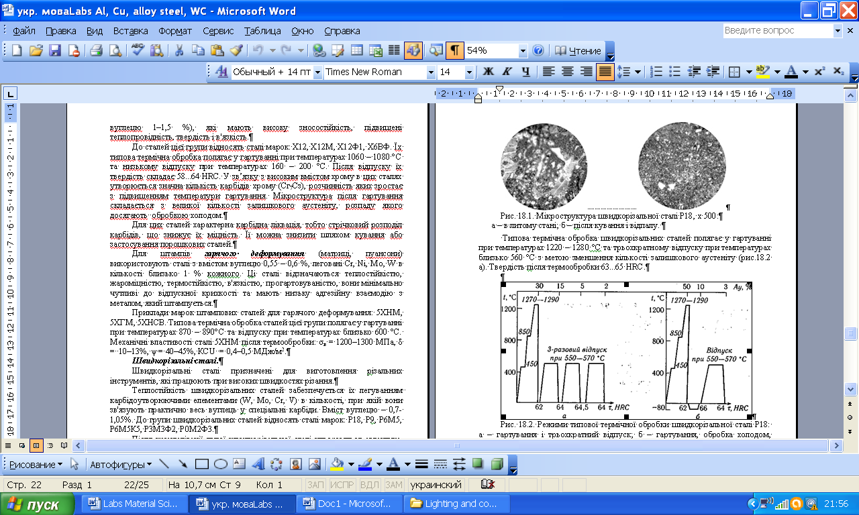

***Fig.10.2. Heat Treatment Of High Speed Steel***

**HARD ALLOYS**

The use of tungsten as an alloying elements gives steel the properly of retaining hardness at high temperature up to 900°C to 1000°C. Carbide is made by mixing tungsten metal powder with carbon and heating the mixture to the about 1600°C in the atmosphere of hydrogen until the two substance have under gone the chemical reaction to produce tungsten carbides.

Cemented carbide is a powder metallurgical product. The powder of several carbide compounds are pressed and bonded together in a matrix to from a cemented material. Today, the following three groups of cemented carbides are extensively applied for cutting elements of tools.

WC + Co + (WC-TiC-TaC) for use in the machining of steels.

WC + Co for use in the machining of cast irons and non ferrous metals.

TiC + Ni + Mo for use in the machining of high temperature high strength metals.

|  |  |
| --- | --- |
|  |  |
| a) | b) |

***Fig.10.3. The microstructure of the hard alloys (cemented carbide) WC + Co (a) and WC-TiC + Co (b).***

Cemented carbides have a very high hardness (second only to diamond) and high wear resistance to abrasion. They do not loose their cutting properties i.e., hardness over a wide range of temperature up to 900-1000°C. Therefore tools tipped with cemented carbides are capable of efficiently machining the hardest metals, including hardened steels at high cutting speeds. Such tools can operate at cutting speeds from 16 to 25 folds those permitted for tools made of carbon tool steels. One drawback of cemented carbides is their brittleness.

Very high stiffness (Young’s modulus is about three times that of steel) of the cemented carbides requires that they are well supported on a shank of sufficient thickness, for even a small amount of bonding deformation in a material of this stiffness may induce very high tensile stresses. Cemented carbides are weak in tension than in compression. They have a strong tendency to form pressure welds at low cutting speeds. In view of this they should be operated at speeds considerably in excess of those used with high speed steel tools. This caused for machine tools of increased power.

Carbides that obtain high cobalt percentage are tougher and stronger than that contain low cobalt. Hence they are used for rough cutting, interrupted cuts and for milling. The low cobalt variety is used for finished operations such as turning with a smooth chip cross-section and a continuous cut. It is recommended to keep the braze metal as thin as possible.

**Materials and Equipment:**

1. Specimen of the High carbon steel High speed steel.

2. Specimen of the hard alloy.

3. Microscope MM – 4.

**Procedure**

1. Set specimen of the High carbon steel, High speed steel and hard alloy on a microscope and look at their microstructure.

2. Draw the microstructure of the High carbon steel, High speed steel and hard alloy.

**Questions:**

1. What is red hardness?

2. What is high carbon steels? Describe their chemical composition and applications.

3.What properties should the tool material possess for its proper functioning?

4. What is High speed steels? Describe their chemical composition and applications.

5. What is the purpose of the High speed steels alloying?

6. List the alloying elements of the High speed steels.

7. Explain Heat Treatment of High Carbon Steels.

8. How does the heating range for high carbon steels depend on its chemical composition?

9. Explain Heat Treatment of High Speed Steels.

10. What is hard alloy?

11. Which technological method is used for hard alloys production?

12. Classification of hard alloys. Describe their chemical composition and applications.

13. Explain properties of hard alloys.

LABORATORY WORK № 10

**TOOL STEELS AND HARD ALLOYS**

PROTOCOL №1

high carbon steel high speed steel

SAE 1095 T11301

Carbon content___________% Carbon contain___________%

Alloying elements ___%, ___%,___%

Heat treatment________________ Heat treatment__________________

heating range ________________ heating range ___________________

___________________________ ______________________________

___________________________ ______________________________

Application ______________ Application ____________________

________________________ ______________________________

Conclusions:

____________________________________________________________

______________________________________________________________________

PROTOKOL № 2

Hard alloy

Chemical composition, %_______________________________________

Properties:____________________________________________________

__________________________________________________________________

Conclusions:

____________________________________________________________

______________________________________________________________________

______________________________________________________________________

_____________________ ___________________

Student’s signature Teacher’s signature

“____”___________20___ y. “____”____________20___ y.

LABORATORY WORK 11

**ALUMINIUM, COPPER AND THEIR ALLOYS**

***Objectives***

1. To learn applications and properties of the pure aluminium, pure cooper and their alloys.

2. To explore microstructure of the aluminium and cooper alloys and interrelation between their microstructure and phase diagrams.

***Fundamental concept***

Pure aluminium has silvery color. It is ductile, malleable and very good conductor of heat and electricity. It has a very high resistance to corrosion than the ordinary steel. Its specific gravity is 2.7 and melting point is 658°C. Its tensile strength varies from 95 to 157 MPa. In proportion to its weight it is quite strong. In its pure state the metal would be weak and soft for most purposes, but when mixed with small amounts of other alloys, it becomes hard and rigid. It may be blanked, formed, drawn, turned, cast, forged and die cast. Its good electrical conductivity is an important property and is broadly used for overhead cables. It forms useful alloys with iron, copper, zinc and other metals.

Applications

It is mainly used in aircraft and automobile parts where saving of weight is an advantage. The high resistance to corrosion and its non-toxicity make it a useful metal for cooking utensils under ordinary conditions. Aluminium metal of high purity has got high reflecting power in the form of sheets and is, therefore, widely used for reflectors, mirrors and telescopes. It is used in making furniture, doors and window components, rail road, trolley cars, automobile bodies and pistons, electrical cables, rivets, kitchen utensils and collapsible tubes for pastes. Aluminium foil is used as silver paper for food packing etc. In a finely divided flake form, aluminium is employed as a pigment in paint. It is a cheap and very important non ferrous metal used for making cooking utensils.

Aluminium alloys

The aluminium may be easily alloyed with other elements like copper, magnesium, zinc, manganese, silicon and nickel to improve various properties. The addition of small quantities of alloying elements into other metals helps to converts the soft and weak metal into hard and strong metal, while still retaining its light weight. Various aluminium alloys are

Duralumin, Y-alloy, Magnalium, Silumina.

Duralumin

It is an important wrought alloy. Its composition contains following chemical contents: Copper = 3.5-4.5%, Manganese = 0.4-0.7%, Magnesium = 0.4-0.7%, Aluminium = 94%.

Phase diagram Al – Cu and Duralumin microstructure are shown in the fig.11.1. and fig.11.2.

|  |  |
| --- | --- |
|  |  |
| Fig.6.1. Phase diagram Al – Cu | Fig.6.2. Duralumin microstructure, x 200. |

**Properties**

Duralumin can be very easily forged, casted and worked because it possesses low melting point. It has high tensile strength, comparable with mild steel combined with the characteristics lightness of Al. It however possesses low corrosion resistance and high electrical conductivity. This alloy possesses higher strength after heat treatment and age hardening. After working, if this alloy is age hardened for 3 or 4 days. This phenomenon is known as age hardening. It hardens spontaneously when exposed to room temperature. This alloy is soft enough for a workable period after it has been quenched. It is light in weight as compared to its strength in comparison to other metals. It can be easily hot worked at a temperature of 500°C. However after forging and annealing, it can also be cold worked.

Applications

Duralumin is used in the wrought conditions for forging, stamping, bars, sheets, tubes, bolts, and rivets. Due to its higher strength and lighter weight, this alloy is widely used in automobile and aircraft components. To improve the strength of duralumin sheet, a thin film of Al is rolled along with this sheet. Such combined sheets are widely used in air-craft industries. It is also employed in surgical and orthopedic work, non-magnetic work and measuring instrument parts constructing work.

Y -alloy

Y-Alloy is also called copper-aluminium alloy. The addition of copper to pure aluminium increases its strength and machinability. Its composition contains following chemical content: Copper = 3.5-4.5%, Manganese = 1.2-1.7%, Nickel = 1.8-2.3%, Silicon, magnesium, iron = 0.6% each, Aluminium = 92.5%.

Properties

The addition of copper in aluminium increases its strength and machinability. Y-alloy can be easily cast and hot worked. Like duralumin, this alloy is heat treated and age hardened. The age-hardening process of Y-alloy is carried out at room temperature for about five days.

Applications

Y-Alloy is mainly used for cast purposes, but it can also be used for forged components like duralumin. Since Y -alloy has better strength than duralumin at high temperatures, therefore it is much used in aircraft engines for cylinder heads, pistons, cylinder heads, crank cases of internal combustion engines die casting, pump rods etc.

Magnalium

Magnalium is an alloy of aluminium, magnesium, copper, nickel and tin etc. It contains

|  |  |  |  |  |  |
| --- | --- | --- | --- | --- | --- |
| Al = | 85 to 95%, | Cu = | 0 to 25%, | Mg = | 1 to 5%, |
| Ni = | 0 to 1.2%, | Sn = | 0 to 3%, | Fe = | 0 to 0.9%, |
| Mn = | 0 to 0.03%, | Si = | 0.2 to 0.6%. |  |  |

It is made by melting the aluminium with 2-10% magnesium in a vacuum and then cooling it in a vacuum or under a pressure of 100 to 200 atmospheres.

Properties

Magnalium is light in weight and brittle. This alloy possesses poor castability and good machinability. It can be easily welded.

Applications

Due to its light weight and good mechanical properties, it is mainly used for making aircraft and automobile components.

Silumina

Common casting aluminium alloys are alloys of the Al-Si system (6 ... 13% Si). Diagram of the system Al - Si is of eutectic type (fig.11.3). Adding mixture of 2/3 NaF and 1/3 NaCl or 2/3 KF і 1/3 KCl or 0,05 % Sr improves strength of these alloys. This process called *modification.*

Alloying Cu, Mg, Zn improves strength, especially after quenching and aging; Ti, Zr, B crush grain and increase the dispersion of the eutectic components; Mn improves corrosion resistance; Ni, Fe increase the heat resistance of casting aluminium alloys.

|  |  |
| --- | --- |
|  |  |
| Fig.11.3. Phase diagram Al – Si. | Fig. 11.4. Silumina microstructure, x 200. |

**Copper**

Copper is a very useful material. The remaining copper is approximately 99% pure. This is referred to as blister copper and is further refined to remove other impurities. The final ‘‘tough-pitch’’ copper has a purity of about 99.5%, which is suitable for many alloys. A higher purity of 99.9% can be obtained by electrolytic refinement of the tough-pitch copper.

It has excellent electrical and thermal conductivity properties, is malleable and machinable, but has low mechanical properties. Its tensile strength varies from 300 to 470 MPa and melting point is 1083°C. It is one of the best conductors of heat and it is highly resistant to corrosion. This non ferrous metal can withstand severe bending and forging without failure. If copper is heated to red heat and cooled slowly it becomes brittle, but if cooled rapidly it becomes soft, malleable and ductile. It can be welded at red heat.

The physical properties of copper which are of the most interest are the electrical and thermal conductivities. The recognized standard for metal electrical conductivity is the International Annealed Copper Standard (IACS). The conductivity is reduced by alloying. For example, alloy C71500 has a nickel content of 30% which reduces the conductivity to only 4% IACS.

Copper and its alloys are very easily fabricated; they can be shaped by the common forming processes. They can be cold-rolled, stamped, drawn, bent, and headed as well as being extruded, forged, and rolled at elevated temperatures. Annealing is required for some copper alloys that work-harden during cold working more rapidly than others.

All copper alloys are machinable using standard tooling. All but the hardest alloys can be machined using high-speed tool steels. Free-cutting copper alloys should be used for screw machine production.

A wide choice of means of joining copper alloys is available. They can be joined by soldering, brazing, welding, and mechanical means such as crimping, riveting, and bolting. During welding and brazing operations it is necessary to take into account the high thermal conductivities of copper

All copper alloys are machinable using standard tooling. All but the hardest alloys can be machined using high-speed tool steels. Free-cutting copper alloys should be used for screw machine production.

A wide choice of means of joining copper alloys is available. They can be joined by soldering, brazing, welding, and mechanical means such as crimping, riveting, and bolting. During welding and brazing operations it is necessary to take into account the high thermal conductivities of copper

Properties

The mechanical and physical properties of copper are shown in Table 11.1

|  |  |  |  |
| --- | --- | --- | --- |
| **TABLE 11.1** Mechanical and Physical Properties of Wrought Copper | | | |
| Property | Alloy | | |  |
| C11000  spring H08 | hard rod  H04 | C10800  tube H55 |
| Modulus of elasticity 106 (psi) | 17 | 17 | 17 |  |
| Yield strength 0.5% ext. (ksi) | 500 | 44 | 32 |  |
| Elongation (%) | 4 | 16 | 25 |  |
| Rockwell hardness | B-60 | B-47 | B-35 |
| Field strength 108 cycles (ksi) | 14 | — | — |
| Shear strength (ksi) | — | 27 | 26 |  |
| Density (lb/in.3) | 0.323 | 0.323 | 0.323 |  |
| Coefficient of thermal expansion at | 9.8 | 9.8 | 9.8 |  |
| 70–572 F, (10 6/ F) |  |  |  |  |
| Thermal conductivity (Btu/ft2/ft/hr/ F) | 226 | 202 | 202 |  |
| Specific heat | 0.092 | 0.092 | 0.092 |  |
| Electrical conductivity (% IACS) | 101 | 92 | 92 |  |

Applications

Applications such as heat exchangers, condensers, and other heat transfer devices take advantage of the high thermal conductivity of copper and its alloys. As temperatures increase, the thermal conductivity of many copper alloys increases, unlike most metals. Alloying reduces the thermal conductivity.

Copper alloys are used primarily for room temperature applications. Heat transfer apparatus applications are the exception. Most copper alloys can be used to 200 C.

Because of the good electrical properties of copper, it is used primarily in electrical or electronic applications such as bus bars, waveguides, wire, switches, and transfer components. Since copper is a noble metal it also finds many applications in corrosive environments.

**Copper Alloys**

In order to obtain strength the metal must be cold worked or alloyed. As a result there are hundreds of copper alloys. The Copper Development Association, together with the American Society of Testing and Materials and the Society of Automotive Engineers, has developed a five-digit system to identify these alloys. The system is part of the Unified Numbering System for Metals and Alloys. The numbers C-10000 through C79999 denote the wrought alloys, while the cast copper and copper alloys are numbered C80000 through C99999. This designation system is used throughout North America, Australia, and Brazil. Each number refers to a specific alloy composition. The UNS numbers for specific groups of wrought alloys are given in Table 6. along with applications for each specific group.

There are more than 100 temper designations for copper and copper alloys. These may be found in ASTM B601 ‘Standard Practice for Temper

**TABLE 11.2.** Unified Numbering System for Wrought Copper and Copper Alloys

|  |  |  |  |  |
| --- | --- | --- | --- | --- |
| UNS no. | Application | | | |
| ***Coppers*** |  | | | |
| C10100 to C15999 | General for group; high electrical conductivity requirements | | | |
| C10100 to C10700 | Highest conductivity coppers | | | |
| C11000 | Electrical wire and cable | | | |
| C12200 | Household water tube | | | |
| C12800 | Refrigerators, air conditioners, and gasoline | | | |
| C14200, C14300 | Contacts, terminals; resists softening when soldered | | | |
| C15215 to C16200 | Electrical components, lead frames, integrated circuits | | | |
| ***High copper alloys*** |  | | | |
| C16200 to C19199 | General for group; electrical and electronic connectors and contacts | | | |
| C17000 to C17300 | Highest strength copper-beryllium alloys; bellows, diaphragms, fasteners, relay parts - | | | |
| C18000 | Switches, circuit breakers, contacts | | | |
| C18200 to C18300 | Cable connectors, electrodes, arcing and bridging parts | | | |
| C19400 | Terminals, flexible hose, gaskets, fuse clips | | | |
| ***Copper-zinc brasses*** |  | | | |
| C21000 to C28000 | General; sheet for stamping, springs, electrical switches and sockets, plumbing | | | |
| C23000 | Red brass, condenser and heat exchanger tubes, plumbing, architectural trim - | | | |
| C26000 to C26200 | Cartridge brass, radiator cores, hardware, ammunition, plumbing accessories | | | |
| C26800 | Muntz metal, architectural sheet and trim, large nuts and bolts, brazing rod | | | |
| ***Copper-zinc-lead brasses*** |  | | | |
| C31200 to C38500 | General for group; leaded brasses, high machinability requirements | | | |
| C34500 | Clock parts, gears, wheels | | | |
| C36000 | Free-cutting brass, screw machine materials, gears, pinions | | | |
| C37700 | Forging brass | | | |
| ***Copper- zinc-tin brasses*** | |  | |  |
| C40400 to C48600 | | General; corrosion resistance and higher strength | |  |
|  | | requirements | |  |
| C42500 | | Supplied as strip for fabricating electrical connectors, springs, terminals | | |
| C46400 to C46700 | | Naval brass, marine hardware, propeller shafts, structural uses | | |
| C48200 to C48500 | | Free machining, marine hardware, valve stems, screw ma- chine products | | |
| ***Copper-aluminum bronzes*** | |  | | |
| C60800 to C64210 | | General; combine high strength and excellent corrosion resistance | | |
| C61000 | | Marine hardware, pumps, valves, nuts, bolts, shaft tie rods, machine parts, condenser tubing | | |
| C63000 | | Nuts, bolts, marine shafts, aircraft parts, forgings | | |
| ***Copper-silicone bronzes*** | |  |  | |
| C64700 to C66100 | | General; properties similar to aluminum bronzes; excellent weldability; hydraulic fluid lines, high strength fasteners, wear plates, marine hardware | | |
| ***Copper-nickel*** | |  |  | |
| C70100 to C72950 | | General; excellent corrosion resistance, strength retention at high temperatures, condenser tubes, marine products | | |
| ***Copper-zinc-nickel*** | |  |  | |
| C73500 to C79800 | | Good corrosion resistance with moderately high strength, silver luster; food and beverage handling equipment decorative hardware, hollow-ware | | |

Designations for Copper and Copper Alloys—Wrought and Cast. Wrought copper and copper alloys can be divided into the following groups:

***Coppers*** Metal which has a minimum copper content of 99.3%c opper.

***High copper alloys*** Alloys which contain 96.0 to 99.3% copper.

***Brasses***

**Brasses** are alloys which have zinc as the major alloying element.This group contains the copper-zinc alloys, the copper-zinc-lead alloys (leaded brass), and the copper-zinc-tin alloys (tin brasses).

Phase diagram Cu–Zn and properties brasses are in the fig. 11.6.

Alpha Phase. If the copper crystal structure is face centered cubic (FCC), there will be up to 39% of zinc. This solid solution is known as alpha brass. It has good mechanical properties, good corrosion resistance but it possesses lower electrical conductivity than copper.

Beta Phase. If the amount of zinc increases beyond 39%, beta brass will appear in the microstructure of the slowly cooled brass. This has body centered cubic structure (BCC). This phase is hard but quite tough at room temperature.

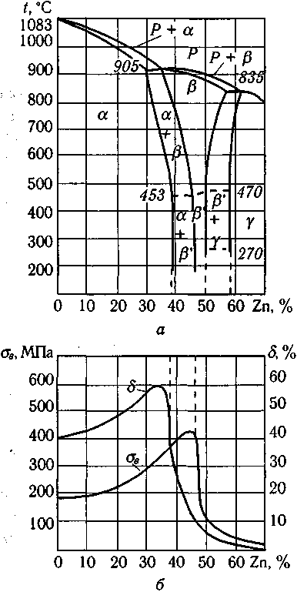

Fig.11.6. Phase diagrame Cu–Zn and properties brasses.

Microstructure of cast and wrought alpha brasses are shown in the fig.11.7.

|  |
| --- |
|  |
| Fig.11.7. Microstructure of cast (a) and wrought (b) alpha brasses brasses. |

***Bronzes***

**Bronze** is a common alloy of copper and tin. The alloys of copper and tin are generally termed as bronzes. The wide range of composition of these alloys comprise of 75 to 95% copper and 5 to 25% tin.

Four major families of bronze exist: copper-tin-phosphorus (phosphor bronzes), copper-tin-lead-phosphorus (leaded phosphor bronzes), copper-tin-nickel alloys (nickel-tin bronzes), and copper-aluminum alloys (aluminum bronzes).

For the most part copper alloys to a large extent attain their mechanical properties through different amounts of cold work. The main exceptions are the copper-beryllium alloys (the highest strength copper alloys), the aluminum bronzes, and some copper-chromium alloys. The aluminum bronzes are the second highest strength copper alloy group. Their high strengths are achieved by means of heat treatments that produce second phase particles.

Properties

Bronze has higher strength, better corrosion resistance than brasses. It is comparatively hard and resists surface wear and can be shaped or rolled into wire, rods and sheets very easily. It has antifriction or bearing properties. Bronze is costlier than brass. The tensile strength of bronze increases gradually with the amount of tin, reaching a maximum when tin is about 20%. However the percentage of tin content if increases beyond this amount, the tensile strength decreases very rapidly. Bronze is most ductile when it contains about 5% of tin. As the amount of tin increases about 5%, the ductility gradually decreases and practically disappears with about 20% of tin. Whereas presence of zinc in the bronze increases fluidity of molten metal, strength and ductility.

Applications

Phosphorus bronze is used making for bolts, electric contact springs, bearings, bushes, gears, ship sheathing, valve parts, propeller blades, worm wheels, gears, nuts for machine lead screws, pump parts, linings and for many other purposes. It is also suitable for making springs and corrosion resistance mine cables. Silicon bronze is widely used for making boilers, tanks, stoves or where high strength and good corrosion resistance is required. It is used also for making screws, tubing’s, pumps etc. Beryllium bronze is particularly suitable material for making springs, tubes, diaphragms and electrical contacts, heavy duty electrical switches, cams and bushings. This is used for springs, heavy duty electrical switches, cams and bushings. Aluminium bronze is generally used for making fluid connection fittings, gears, propellers, air pumps, bushings, tubes, slide and valves etc. Cams and rollers are commonly produced using this alloy.

Phase diagram Cu–Sn and properties bronze are in the fig. 11.8.

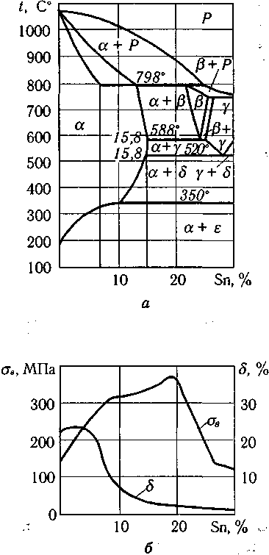

Fig. 11.8. Phase diagrame Cu–Sn and properties bronzes.

Microstructure of the Cu—4 wt.% Sn bronze after cast and anneling show in the fig.11.9.

|  |  |
| --- | --- |
|  |  |
| a) | b) |
| Fig.11.9. Microstructure of the Cu—4 wt.% Sn bronze after cast (a) and anneling (b) , x 200. | |

***Materials and Equipment:***

1. Specimen of the duralumin, silumina, brass and bronze
2. Microscope MM – 4.

***Procedure:***

1. Set specimen of the duralumin, silumina on a microscope and look at their microstructure.

2. Write chemical composition, according to the literature indicate mechanical properties and applications of the duralumin and silumina.

3. Draw the microstructure of the duralumin and silumina.

4. Draw phase diagrams of the Al - Cu, Al - Si. Describe the phase transformations in alloys.

5. Set specimen of the brass and bronze on a microscope and look at their microstructure.

6. Write chemical composition, according to the literature indicate mechanical properties and applications of the brass and bronze.

7. Draw the microstructure of the brass and bronze.

8. Draw phase state diagram Cu-Zn, Cu-Sn Describe the phase transformations in alloys.

9. Fill the protocol report.

***Questions:***

* 1. Describe properties of pure aluminium.

2. Applications of pure aluminium.

1. Classification of aluminium alloys.
2. Describe properties and applications of the duralumin.
3. Explain duralumin heat treatment.
4. Describe properties and applications of the silumin.
5. What is the silumin modification?
6. Describe properties of pure copper.
7. Applications of pure copper.
8. Classification of copper alloys.
9. Describe brasses, their applications, chemical composition and microstructure (using diagrams of Cu-Zn).
10. Describe bronzes, their applications, chemical composition and microstructure (using diagrams of (explain using a diagram Cu - Sn).

LABORATORY WORK 11

**ALUMINIUM, COPPER AND THEIR ALLOYS**

PROTOCOL №1

Wrought aluminium alloy __________duralumin_____________________________

Chemical composition, % wt.________________________________________

Manufacturing method____________________________________________________

Mechanical properties:

Tensile strength,σts, МPа _______________________________

Elongation,δ, % _______________________________________

Hadness, НВ, МПа _____________________________________

|  |  |
| --- | --- |
| **Temperature, oC** |  |

Phase diagram Al – Cu

Describe the phase transformations in alloys

____________________________________________________________________________________________________________________________________________

Duralumin microstructure, x____

Applications:_________________________________________________________________________________________________________________________________

PROTOCOL №2

Cast aluminium alloy __________silumina________________________________

Chemical composition, % wt.___________________________________________

Manufacturing method___________________________________________________

Mechanical properties:

Tensile strength,σts, МPа _______________________________

Elongation,δ, % _______________________________________

Hadness, НВ, МПа _____________________________________

|  |  |
| --- | --- |
| **Temperature, oC** |  |

Phase diagram Al–Si

Describe the phase transformations in alloys

____________________________________________________________________________________________________________________________________________

Silumina microstructure, x____

Applications:_________________________________________________________________________________________________________________________________

PROTOCOL №3

Wrought copper alloy __________ Alpha Brass _______________________

Chemical composition, % wt.______________________________________________

Manufacturing method____________________________________________________

Mechanical properties:

Tensile strength,σts, МPа _______________________________

Elongation,δ, % _______________________________________

Hadness, НВ, МПа _____________________________________

|  |  |
| --- | --- |
| **Temperature, oC** |  |
|  | Phase diagram Cu – Zn |

Describe the phase transformations in alloys

______________________________________________________________________________________________________________________________

Alpha brass microstructure, x____

Applications:_________________________________________________________________________________________________________________________________

PROTOCOL №4

Cast cooper alloy __________cooper– tin bronze_________________________

Chemical composition, % wt._________________________________________

Manufacturing method__________________________________________________

Mechanical properties:

Tensile strength,σts, МPа _______________________________

Elongation,δ, % _______________________________________

Hadness, НВ, МПа _____________________________________

|  |  |
| --- | --- |
| **Temperature, oC** |  |

Phase diagram Cu – Sn

Describe the phase transformations in alloys

______________________________________________________________________________________________________________________________

Cooper– tin bronze microstructure, x____

Applications:_________________________________________________________________________________________________________________________________

***Conclusion:*** __________________________________________________________________________________________________ _________________________

Student’ssignature Teacher’s signature

“____”___________20___ y. “____”____________20___ y.

LABORATORY WORK № 12

**CERAMICS**

***Objectives***

1. To explore the ceramic materials through applications, properties, and processing.

2. To learn ceramic bonding mechanisms and how they influence properties.

***Fundamental concept***

***Ceramics*** are materials that are composed of inorganic substances (usually a combination of metallic and nonmetallic elements). The electricity that kept that clock ticking all night was generated, stored, and traveled through a whole array of ceramic products such as transducers, resistors, and various **insulators**.

Ceramics can be divided into two classes: ***traditional and advanced***. Traditional ceramics include clay products, silicate glass and **cement**; while advanced ceramics consist of carbides (SiC), pure oxides (Al2O3), nitrides (Si3N4), non-silicate glasses and many others. Ceramics offer many advantages compared to other materials. They are harder and stiffer than steel; more heat and corrosion resistant than metals or polymers; less dense than most metals and their alloys; and their raw materials are both plentiful and inexpensive. Ceramic materials display a wide range of properties which facilitate their use in many different product areas.

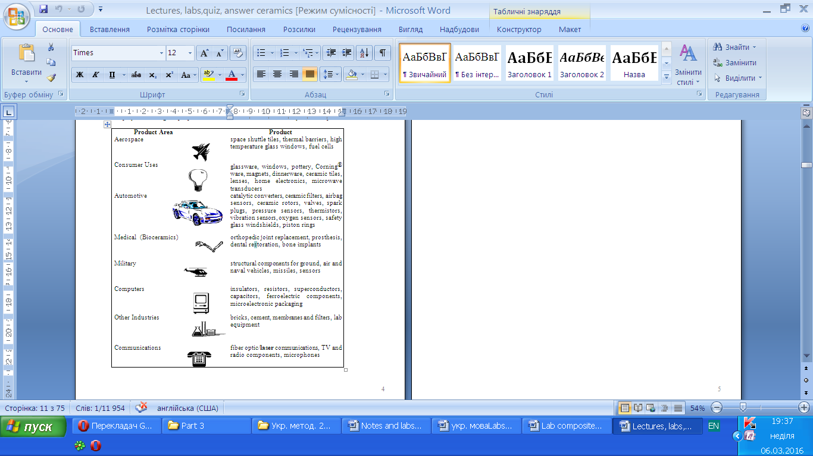

**Future Trends**

Structural applications of advanced ceramics include components of automobile engines, armor for military vehicles, and aircraft structures. For example, titanium carbide has about four times the strength of steel. Thus, a steel rod in an airplane structure can be replaced by a TiC rod that will support the same load at half the diameter and 31% of the weight.

Other applications that take advantage of the mechanical properties of ceramics include the use of clay and cement as structural materials. Both can be formed and molded when wet but produce a harder, stronger object when dry. Very hard materials such as alumina (Al2O3) and silicon carbide (SiC) are used as abrasives for grinding and polishing.

Ceramics of the past were mostly of artistic and domestic value. Ceramics of the present have many industrial applications.

|  |  |
| --- | --- |
| **Imagine** | **The Future with Ceramics** |
| Hand-held interactive videos that fit in your pocket | The electronic field looks ahead to microminiaturization of electronic devices. Ceramic engineers will turn nonfunctional packaging parts into functional components of the device. To accomplish this, new ceramic materials will be developed along with new methods to process them. |
| Phones that won’t ring; rings that will be phones with no dial pad | The communication industry was revolutionized with the development of fiber optics. Along with microminiaturization of components will come the incorporation of opto-electronic integrated circuits. |
| A 300 mph train ride into Fantasy Land | High temperature superconductors will open the doors to magnetic levitation vehicles, cheap electricity, and improved MRI (magnetic resonance imaging). With micro-applications of superconductors through thin film tapes in sensors and memory storage devices, the use of superconductors will take-off. |
| A high speed electric car powered with a fuel cell and full of high tech sensors that practically drive the car for you | The automobile industry, which already incorporates seventy pounds of ceramics into a car, is looking to the field of ceramics to provide improved sensors of motion, gas compositions, electrical and thermal changes; as well as light weight, high strength and high temperature components for the engines. For the conservation of energy and environmental protection, ceramics seem to be a viable possibility in the use of ceramic fuel cells, batteries, photovoltaic cells, and fiber optic transmission of energy. |
| A best friend that‘s bionic/andromic with microscopic hearing and seeing devices and a skeletal system all made from ceramics | Besides the ceramic applications in medical diagnostic instruments, the field of bioceramics for bone replacement and chemotherapy release capsules is here. As ceramic materials improve in terms of strength, nonreactivity, compatibility, longevity, porosity for tissue growth, and lower costs, more use of ceramic devices will be seen. |

Ceramics have characteristics that enable them to be used in a wide variety of applications including:

• high heat capacity and low heat conductance

• corrosion resistance

• electrically insulating, semiconducting, or superconducting

• nonmagnetic and magnetic

• hard and strong, but brittle

The diversity in their properties stems from their bonding and crystal structures.

**Atomic Bonding:**

Two types of bonding mechanisms occur in ceramic materials, **ionic** and **covalent**. Often these mechanisms co-exist in the same ceramic material. Each type of bond leads to different characteristics.

Ionic bonds most often occur between metallic and nonmetallic elements that have large differences in their **electronegativities**. Ionically-bonded **structures** tend to have rather high melting points, since the bonds are strong and non-directional.

The other major bonding mechanism in ceramic structures is the covalent bond. Unlike ionic bonds where electrons are transferred, atoms bonded covalently share electrons. Usually the elements involved are nonmetallic and have small electronegativity differences.

Many ceramic materials contain both ionic and covalent bonding. The overall properties of these materials depend on the dominant bonding mechanism. Compounds that are either mostly ionic or mostly covalent have higher melting points than compounds in which neither kind of bonding predominates.

**Table 12. 1:**  Comparison of % Covalent and Ionic character with several ceramic compound's melting points.

|  |  |  |  |
| --- | --- | --- | --- |
| **Ceramic Compound** | **Melting Point ˚C** | **% Covalent character** | **% Ionic character** |
| Magnesium Oxide | 2798 | 27% | 73% |
| Aluminum Oxide | 2050 | 37% | 63% |
| Silicon Dioxide | 1715 | 49% | 51% |
| Silicon Nitride | 1900 | 70% | 30% |
| Silicon Carbide | 2500 | 89% | 11% |

**Classification ceramic materials** **by structure**

Ceramic materials can be divided by structure into two classes: **crystalline** and **amorphous** (**noncrystalline**). In crystalline materials, a **lattice** point is occupied either by atoms or ions depending on the bonding mechanism. These atoms (or ions) are arranged in a regularly repeating pattern in three dimensions. In contrast, in amorphous materials, the atoms exhibit only short-range order. Some ceramic materials, like silicon dioxide (SiO2), can exist in either form. A crystalline form of SiO2 results when this material is slowly cooled from a temperature. Rapid cooling favors noncrystalline formation since time is not allowed for ordered arrangements to form.



Crystalline Silicon dioxide Amorphous Silicon dioxide

(regular pattern) (random pattern)

Fig. 12.1. Comparison in the physical strucuture of both crystalline and amorphous Silicon dioxide.

The type of bonding (ionic or covalent) and the internal structure (crystalline or amorphous) affects the properties of ceramic materials.

**Mechanical Properties**

Ceramics are strong, hard materials that are also resistant to corrosion (durable). These properties, along with their low densities and high melting points, make ceramics attractive structural materials.

The principal limitation of ceramics is their brittleness, i.e., the tendency to fail suddenly with little plastic deformation. This is of particular concern when the material is used in structural applications. In metals, the delocalized electrons allow the atoms to change neighbors without completely breaking the bond structure. This allows the metal to deform under stress. Work is done as the bonds shift during deformation. But, in ceramics, due to the combined ionic and covalent bonding mechanism, the particles cannot shift easily. The ceramic breaks when too much force is applied, and the work done in breaking the bonds creates new surfaces upon cracking.

Brittle fracture occurs by the formation and rapid propagation of cracks. In crystalline solids, cracks grow through the grains (transgranular) and along cleavage planes in the crystal. The resulting broken surface may have a grainy or rough texture. Amorphous materials do not contain grains and regular crystalline planes, so the broken surface is more likely to be smooth in appearance.

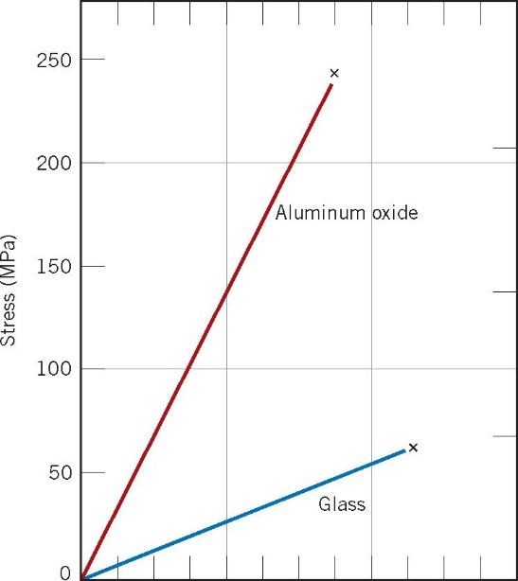

Fig. 12.2.Typical stress-strain behavior to fracture for aluminum oxide and glass.

The theoretical strength of a material is the tensile stress that would be needed to break the bonds between atoms in a perfect solid and pull the object apart. But all materials, including ceramics, contain minuscule structural and fabrication flaws that make them significantly weaker than the ideal strength. Any flaw, such as a pore, crack, or inclusion, results in stress concentration, which amplifies the applied stress. Pores also reduce the cross-sectional area over which a load is applied. Thus, denser, less porous materials are generally stronger. Similarly, the smaller grain size the better the mechanical properties.

In fact, ceramics are the strongest known monolithic materials, and they typically maintain a significant fraction of their strength at elevated temperatures. For example, silicon nitride (Si3N4, = 3.5 g/cm3) turbocharger rotors have a fracture strength of 830 MPa at 22 ° C and 560 MPa at 1200 ° C.

Compressive strength is important in ceramics used in structures such as buildings or refractory bricks. The compressive strength of a ceramic is usually much greater than their tensile strength. To make up for this, ceramics are sometimes prestressed in a compressed state. Thus, when a ceramic object is subjected to a tensile force, the applied load has to overcome the compressive stresses (within the object) before additional tensile stresses can increase and break the object.

Safety glass (thermal tempered glass) is one example of such a material. Ceramics are generally quite inelastic and do not bend like metals. The ability to deform reversibly is measured by the elastic modulus. Materials with strong bonding require large forces to increase space between particles and have high values for the modulus of elasticity. In amorphous materials, however, there is more free space for the atoms to shift to under an applied load. As a result, amorphous materials such as glass are more easily flexed than crystalline materials such as alumina or silicon nitride.

The fracture toughness is the ability to resist fracture when a crack is present. It depends on the geometry of both the object and the crack, the applied stress, and the length of the crack. Composites are being developed which retain the desirable properties of the ceramics while reducing their tendency to fracture. For example, the introduction of carbon fiber whiskers inhibits crack propagation through a ceramic and improves toughness.

Glass ceramics such as those that are used to make ovenware are composed of a matrix of glass in which tiny ceramic crystals grow, such that the final matrix is actually composed of fine crystalline grains (average size < 500 nm). Because their grain size is so small, these materials are transparent to light. The presence of the crystals improves the mechanical and thermal properties of the glass--the glass ceramics are strong, resistant to thermal shock, and good thermal conductors.

**Thermal Properties**

The most important thermal properties of ceramic materials are heat capacity, thermal expansion coefficient, and thermal conductivity. Many applications of ceramics, such as their use as insulating materials, are related to these properties.

Thermal energy can be either stored or transmitted by a solid. The ability of a material to absorb heat from its surrounding is its **heat capacity**. In solid materials at T > 0 K, atoms are constantly vibrating. The **atomic vibrations** are also affected by the vibrations of adjacent atoms through bonding. Hence, vibrations can be transmitted across the solid.

Ceramics generally have strong bonds and light atoms. Thus, they can have high frequency vibrations of the atoms with small disturbances in the crystal lattice. The result is that they typically have both high heat capacities and high melting temperatures.

Although the thermal conductivity is affected by faults or defects in the crystal structure, the insulating properties of ceramics essentially depend on microscopic imperfections. The transmission of either type of wave (phonon or photon) is interrupted by **grain** boundaries and pores, so that more porous materials are better insulators. The use of ceramic insulating materials to line kilns and industrial furnaces are one application of the insulating properties of ceramic materials.

The electron mechanism of heat transport is relatively unimportant in ceramics because charge is localized. This mechanism is very important, however, in metals which have large numbers of free (delocalized) electrons

**Table 12.2:**  Comparison of thermal properties of different ceramic materials.

|  |  |  |  |  |
| --- | --- | --- | --- | --- |
| **Material** | **Melting Temp.(oC)** | **Heat Capacity (J/kg.K)** | **Coefficient of Linear Expansion 1/oCx10-6** | **Thermal Conductivity (W/m.K)** |
| Aluminum metal | 660 | 900 | 23.6 | 247 |
| Copper metal | 1063 | 386 | 16.5 | 398 |
| Alumina | 2050 | 775 | 8.8 | 30.1 |
| Fused silica | 1650 | 740 | 0.5 | 2.0 |
| Soda-lime glass | 700 | 840 | 9.0 | 1.7 |
| Polyethylene | 120 | 2100 | 60-220 | 0.38 |
| Polystyrene | 65-75 | 1360 | 50-85 | 0.13 |

**Electrical Properties**

The electrical properties of ceramic materials vary greatly, with characteristic measures spanning over many orders of magnitude (see Table 3). Ceramics are probably best known as electrical insulators. Some ceramic insulators (such as BaTiO3) can be polarized and used as capacitors. Other ceramics conduct electrons when a threshold energy is reached, and are thus called **semiconductors.** In 1986, a new class of ceramics was discovered, the high Tc **superconductors.** These materials conduct electricity with essentially zero resistance. Finally, ceramics known as **piezoelectrics** can generate an electrical response to a mechanical force or vice versa.

**Table 7.3:** Electrical Resistivity of different materials.

|  |  |  |
| --- | --- | --- |
| Type | Material | Resistivity (Ω-cm) |
| Metallic conductors: | Copper | 1.7 x 10-6 |
|  | CuO2 | 3 x 10-5 |
| Semiconductors: | SiC | 10 |
|  | Germanium | 40 |
| Insulators: | Fire-clay brick | 108 |
|  | Si3N4 | >1014 |
|  | Polystyrene | 1018 |
| Superconductors: | YBa2Cu3O7-x | <10-22 (below Tc) |

Anyone who has used a portable cassette player, personal computer, or other electronic device is taking advantage of ceramic **dielectric** materials. A dielectric material is an insulator that can be polarized at the molecular level. Such materials are widely used in capacitors, devices which are used to store electrical charge.

Applications of superconductors which rely on their current carrying ability include electrical power generation, storage Some ceramics have the unusual property of piezoelectricity, or pressure electricity. These are part of a class known as "smart" materials which are often used as sensors. In a piezoelectric material, the application of a force or pressure on its surface induces polarization and establishes an electric field, i.e., it changes a mechanical pressure into an electrical impulse. Piezoelectric materials are used to make transducers, which are found in such common devices as phonograph pickups, depth finders, microphones, and various types of sensors.

In ceramic materials, electric charge can also be transported by ions. This property can be tailored by means of the chemical composition, and is the basis for many commercial applications. These range from chemical sensors to large scale electric power generators

**Ceramic Processing:**

Processing of ceramic materials describes the way in which ceramic objects (e.g., glass windows, turbocharger rotor blades, optical fibers, capacitors) are produced.

Processing begins with the raw materials needed to produce the finished components, and includes many individual steps that differ significantly depending on the type of ceramic material, crystalline versus glass.

**Processing of Crystalline Ceramics Glass Processing**

Raw Material Selection Raw Material Selection

Preparation Melting

Consolidation Pouring

**Sintering** **Annealing**

Raw material selection involves obtaining and preparing the right materials for the final product. Traditional ceramics use various forms of clay. Glass makers start with primarily silica.

**Material Uses**

Al2O3 (aluminum oxide) Spark-plug insulating bodies, substrates for microelectronic packaging

MgO (magnesium oxide) electrical insulators, refractory brick

SiO2 (Silicon dioxide) cookware, optical fibers

ZrO2 (zirconium oxide) cubic zirconia, oxygen sensors

SiC (silicon carbide) kiln parts, heating elements, abrasives

Si3N4 (silicon nitride) turbocharger rotors, piston valves

For crystalline ceramics, the characteristics of the raw materials (powders) such as their particle size and purity are very important as they affect the structure (e.g., grain size) and properties (e.g., strength) of the final component. Since strength increases with decreasing grain size, most starting powders are milled (or ground) to produce a fine powder (diameter < 1 µm). Since dry powders are difficult to shape, processing additives like water, polymers, etc. are added to improve their plasticity.

Consolidation involves forming the ceramic mixture into the specified shape. There are many techniques available for this step. Sintering is the final step in the process. Sintering at high temperatures (800˚ to 1800˚ C) causes densification that gives the ceramic product its strength and other properties. During this process, the individual ceramic particles coalesce to form a continuous solid network and pores are eliminated. Typically, the **mictrostructure** of the sintered product contains dense grains, where an individual grain is composed of many starting particles.



Fig. 7.3. Microstructure of raw, formed, and sintered ceramic products

Glass processing is different from crystalline processing. One of the considerations that must be examined is the solidifying behavior of glass. Glasses are most commonly made by rapidly quenching a melt. This means that the elements making up the glass material are unable to move into positions that allow them to form the crystalline regularity. The result is that the glass structure is disordered or amorphous.

One of the most notable characteristics of glasses is the way they change between solid and liquid states. Unlike crystals, which transform abruptly at a precise temperature (i.e., their melting point) glasses undergo a gradual transition. Between the melting temperature (Tm) of a substance and the so-called **glass transition temperature (Tg)**, the substance is considered a **supercooled** liquid. When glass is worked between Tg and Tm, one can achieve virtually any shape. The glass blowing technique is a demonstration of the ability to deform a glass.



Fig. 12.4. Temperature graph for a typical ceramic material

Glass processing does not require an optimum size particle (although smaller pieces melt faster). The selections of glass raw materials and chemical additives (which, for example, can alter the color of the glass) are heated up (700˚ - 1600˚ C), melted and finally poured onto or into a quick-cool form or plate. There are four different forming techniques used to fabricate glass.

**Technique Application**

Pressing Table ware

Blowing Jars

Drawing Windows

Fiber forming Fiber optics

During the glass formation, there may be stresses that have been introduced by rapid cooling or special treatments that the glass needs (such as layering or strengthening). Additional heat treatment is needed to “heal” the glass. Annealing, in which the glass is heated to the **annealing point** (a temperature just below the **softening point**) and then slowly cooled to room temperature, is one such process. Tempering is also a follow-up heat treatment in glass processing in which the glass is reheated and cooled in oil or a jet of air so that the internal and external parts have different properties. The tempering reduces the tendency of glass to fail. Tempered glass can then be used in conditions prone to stresses like car windows.

***Materials and Equipment:***

1. Simples of ceramic beams and glasses.
2. Ruler.
3. Weight.

***Procedure:***

1. Measure the ceramic beam‘s mass, length, width, and thickness. Record.
2. Calculate the ceramic beam’s density.
3. Write chemical composition, atomic bonding, structure, according to the literature indicate mechanical properties and applications of the ceramic.
4. Measure the glasses mass, length, width, and thickness. Record.
5. Calculate the glasses density.
6. Write chemical composition, atomic bonding, structure, according to the literature indicate mechanical properties and applications of the glasses.
7. Fill the protocol report.

***Questions:***

1. What is ceramic? Describe traditional and advanced ceramics.
2. Applications of ceramics.
3. Explain two types of bonding mechanisms occur in ceramic materials.
4. Classification ceramic materials by structure.
5. Describe mechanical properties of ceramic.
6. Describe thermal properties of ceramic.
7. Describe electrical properties of ceramic.
8. Processing of Crystalline Ceramics.
9. Why glass processing is different from crystalline processing?
10. List different forming techniques used to fabricate glass.
11. Which reasons of glass heat treatment?

LABORATORY WORK 12

**CERAMICS**

PROTOCOL №1

**Ceramic**

Chemical composition, % wt.______________________________________________

Atomic bonding___________________________________________________

Structure________________________________________________________

Processing ______________________________________________________

Mechanical properties:

Yield Strength, MPa ________________________________

Tensile strength, МPа _______________________________

Elongation, % _______________________________________

|  |  |  |  |  |  |  |  |  |  |  |  |  |  |
| --- | --- | --- | --- | --- | --- | --- | --- | --- | --- | --- | --- | --- | --- |
| |  |  |  |  |  |  | | --- | --- | --- | --- | --- | --- | | Mass,  g | Length,  mm | Width,  mm | Thickness,  mm | Volume,  mm3 | Density.  g/mm3 | |  |  |  |  |  |  | |  |

Applications:_________________________________________________________________________________________________________________________________

PROTOCOL №2

**Glass**

Chemical composition, % wt.______________________________________________

Atomic bonding___________________________________________________

Structure________________________________________________________

Processing ______________________________________________________

Mechanical properties:

Yield Strength, MPa ________________________________

Tensile strength, МPа _______________________________

Elongation, % _______________________________________

|  |  |  |  |  |  |  |  |  |  |  |  |  |  |
| --- | --- | --- | --- | --- | --- | --- | --- | --- | --- | --- | --- | --- | --- |
| |  |  |  |  |  |  | | --- | --- | --- | --- | --- | --- | | Mass,  g | Length,  mm | Width,  mm | Thickness,  mm | Volume,  mm3 | Density.  g/mm3 | |  |  |  |  |  |  | |  |

Applications:_________________________________________________________________________________________________________________________________

***Conclusion:*** ___________________________________________________________________________________________________________________________________________________________________________________________________________________________________________________________________________________________________________________________________ _________________________

Student’s signature Teacher’s signature

“____”___________20___ y. “____”____________20___ y.

LABORATORY WORK № 13

**POLYMERS**

***Objectives***

1. To learn classes of polymers, their applications and processing.
2. To compare mechanical properties of some thermoplastics

***Scientific principles***

**Plastics** are commonly known as synthetic resins or polymers. The term polymer comprises ‘poly’ means ‘many’ and ‘mers’ means ‘parts’. Thus, the term, polymer represents a substance built up of several repeating units, each unit being known as a monomer. Thousands of such units or monomers join together in a polymerization reaction to form a ‘polymer’.

**Polymers** are substances containing a large number of structural units joined by the same type of linkage. These substances often form into a chain-like structure. Polymers in the natural world have been around since the beginning of time. Starch, cellulose, and rubber all possess polymeric properties. Today, the polymer industry has grown to be larger than the aluminum, copper and steel industries combined.

**Applications of Polymers**

Polymers already have a range of applications that far exceeds that of any other class of material available to man. Current applications extend from adhesives, coatings, foams, and packaging materials to textile and industrial fibers, **elastomers,** and structural plastics. Polymers are also used for most **composites**, electronic devices, biomedical devices, optical devices, and precursors for many newly developed high-tech ceramics.

Agriculture and Agribusiness

Polymeric materials are used in and on soil to improve aeration, provide mulch, and promote plant growth and health.

Medicine

Many biomaterials, especially heart valve replacements and blood vessels, are made of polymers like Dacron, Teflon and polyurethane.

Consumer Science

Plastic containers of all shapes and sizes are light weight and economically less expensive than the more traditional containers. Clothing, floor coverings, garbage disposal bags, and packaging are other polymer applications.

Industry

Automobile parts, windshields for fighter planes, pipes, tanks, packing materials, insulation, wood substitutes, adhesives, matrix for composites, and elastomers are all polymer applications used in the industrial market.

Sports

Playground equipment, various balls, golf clubs, swimming pools, and protective helmets are often produced from polymers.

**Future Trends**

Just as nature has used biological polymers as the material of choice, mankind will chose polymeric materials as the choice material. An age of Polymers synthetic polymers are and will be the material of choice.

Polymer uses are being developed in such diverse areas as: conduction and storage of electricity, heat and light, molecular based information storage and processing, molecular composites, unique separation membranes, revolutionary new forms of food processing and packaging, health, housing, and transportation.

The field of polymers is so vast and the applications so varied, that it is important to understand how polymers are made and used. Since there are over 60,000 different plastics vying for a place in the market, knowledge of this important field can truly enrich our appreciation of this wonder material. Companies manufacture over 30 million tons of plastics each year, and spend large sums on research, development, and more efficient recycling methods.

Properties of plastics

1. Plastics are light in weight and at the same time they possess good toughness strength and rigidity.
2. They are less brittle than glass, yet they can be made equally transparent and smooth.
3. Their high dielectric strength makes them suitable for electric insulation.
4. They resist corrosion and the action of chemicals.
5. The ease with which they can be mass-produced contributes greatly to their popularity as wrappers and bags.
6. They possess the property of low moisture absorption.
7. They can be easily molded to desired shapes.
8. They can easily be made colored.
9. They are bad conductance of heat.
10. They are hard, rigid and heat resistance.
11. They possesses good deformability, good resiatance against weather conditions, good colorability, good damping characteristics and good resistance to peeling.

**Polymer Physical Structure**

Segments of polymer molecules can exist in two distinct physical structures. They can be found in either **crystalline** or **amorphous** forms. Crystalline polymers are only possible if there is a regular chemical structure (e.g., homopolymers or alternating copolymers), and the chains possess a highly ordered arrangement of their segments. Crystallinity in polymers is favored in symmetrical polymer chains, however, it is never 100%. These semi-crystalline polymers possess a rather typical liquefaction pathway, retaining their solid state until they reach their melting point at **Tm**.

Amorphous polymers do not show order. The molecular segments in amorphous polymers or the amorphous **domains** of semi-crystalline polymers are randomly arranged and entangled. Amorphous polymers do not have a definable **Tm** due to their randomness.At low temperatures, below their glass transition temperature **(Tg)**, the segments are immobile and the sample is often brittle. As temperatures increase close to **Tg**, the molecular segments can begin to move. Above **Tg**, the mobility is sufficient (if no crystals are present) that the polymer can flow as a highly viscous liquid. The **viscosity** decreases with increasing temperature and decreasing molecular weight. These effects can most easily be seen on a specific volume versus temperature graph.



**Fig.13.1.** Specific Volume versus Temperature graph.

**Classification of Plastics**

Plastics are broadly classified into **thermo plastics** and **thermo-setting plastics**.

Polymers can be separated into two different groups depending on their behavior when heated. Polymers with linear molecules are likely to be **thermoplastic**. These are substances that soften upon heating and can be remolded and recycled. They can be semi-crystalline or amorphous. The other group of polymers is known as **thermosets**. These are substances that do not soften under heat and pressure and cannot be remolded or recycled. They must be remachined, used as fillers, or incinerated to remove them from the environment.

Thermo Plastics

Those plastics which can be easily softened again and again by heating are called **thermoplastic**. They can be reprocessed safely. They retain their plasticity at high temperature, i.e. they preserve an ability to be repeatedly formed by heat and pressure. Therefore, they can be heated and reshaped by pressing many times. On cooling they become hard. They can be very easily shaped into tubes, sheets, films, and many other shapes as per the need.

Thermoplastics are generally carbon containing polymers synthesized by addition or condensation polymerization. This process forms strong **covalent bonds** within the chains and weaker secondary **Van der Waals** bonds between the chains. Usually, these secondary forces can be easily overcome by thermal energy, making thermoplastics moldable at high temperatures. Thermoplastics will also retain their newly reformed shape after cooling.

Types of Thermo Plastics

Amorphous: Polystyrene, Acrylonitrite-butadiene-styrene. Mrthacrylate. P.V.C (Polyvinyl chloride), Polychloroacetal, Polycarbonate etc.

Crystalline: Polyethylene, Polyamides, Polyacetal.Polypropylene

The reason for the re-softening of thermoplastic resins with heat is that they are composed of linear or long chain molecules. Application of heat weakens the intermolecular bonds by increasing thermal agitation of the molecules, and the material softens and thus plastic can be easily molded and remolded without damage

Thermo-Setting Plastics

Those plastics which are hardened by heat, effecting a non-reversible chemical change, are called **thermo-setting**. Alternatively these plastics materials acquire a permanent shape when heated and pressed and thus cannot be easily softened by reheating.

Thermosets have the same Van der Waals bonds that thermoplastics do. They also have a stronger linkage to other chains. Strong covalent bonds chemically hold different chains together in a thermoset material. The chains may be directly bonded to each other or be bonded through other molecules. This "cross-linking" between the chains allows the material to resist softening upon heating. Thus, thermosets must be machined into a new shape if they are to be reused or they can serve as powdered fillers. Although thermosets are difficult to reform, they have many distinct advantages in engineering design applications including:

1.High thermal stability and insulating properties.

2.High rigidity and dimensional stability.

3.Resistance to creep and deformation under load.

4.Light-weight.

Thermosetting resins: Phenol-formaldehyde resins, Polyester resins, Epoxy resins, Silicone resins

Thermosetting resins cannot be softened again by the application of heat. The reason for the above phenomenon is that the thermosetting plastics consist of linear, relatively low molecular weight thermoplastic polymer chains with cross-links which bond the chains together with primary valence bonds.

Other thermosetting compounds are phenol furfural, polysters, alkyds, and polyurethanes. The most common thermosetting compound is phenol formaldehyde. Phenol formaldehyde is called as bakelite due to the name of its inventor Bakelite. It is the most commonly and widely used plastic. It is made by the reaction of phenol with formaldehyde.

Comparison Between Thermo Plastic and Thermosetting Plastic

The comparison between thermo plastic and thermosetting plastic is given in Table 13.1.

Table 13.1. Comparison between Thermo Plastic and Thermosetting Plastic

|  |  |  |
| --- | --- | --- |
| S.No | Thermo Plastic | Thermosetting Plastic |
| 1 | They can be repeatedly softened by heat and hardened by cooling. | Once hardened and set, they do not soften with the application of heat. |
| 2 | They are comparatively softer and less strong. | They are more stronger and harder than thermoplastic resins |
| 3 | Objects made by thermoplastic resins can not be used at comparatively higher temperature as they will tend to soften under heat. | Objects made by thermosetting resins can be used at comparatively higher temperature without damage |
| 4 | They are usually supplied as granular material | They are usually supplied in monomeric or partially polymerized material form in which they are either liquids or partially thermoplastic solids. |
| 5 | Applications. Toys, combs, toilet goods, photographic films, insulating tapes, hoses, electric insulation, etc. | Applications. Telephone receivers, electric plugs, radio and T.V. cabinets, camera bodies, automobile parts, tapes, hoses, circuit breaker switch panels, etc. |

Additions in Polymer

To make polymer more for further processing of products, plastics, and some other material are added to the polymers before or during polymerization. These materials are

**Catalysts**

They are also known accelerator or hardener. They act as catalysts to accelerate the chemical reactions during polymerization of plastics.

**Fillers**

Fillers are added to synthetic resins for increasing strength, stiffness and thermal resistance of the plastics. These are clay, talc, alumina, carbon black, calcium carbonate, wood flour, mica, quartz, asbestos, glass fibres etc.

**Modifiers**

Modifiers are added to plastics for improving mechanical properties

**Plasticizers**

Plasticizers are fluids of high molecular weight. They are added for softening the resins at forming temperature and to improve their toughness at the finished stage and to impart flexibility to their finished products.

**Stabilizers**

The additions of stabilizers to plastics help in preventing deterioration due to the action of heat and light.

**Initiators**

Initiators help in starting the reaction i.e. polymerization.

**Dyes and pigments**

Dyes and pigments are the coloring agents, added to impart different colors and shades to plastic materials.

**Polymer Processing**

There are five basic processes to form polymer products or parts. These include; injection molding, compression molding, transfer molding, blow molding, and extrusion. Compression molding and transfer molding are used mainly for thermosetting plastics. Injection molding, extrusion and blow molding are used primarily with thermoplastics.

**Table 13.2:** Comparison of polymer processing techniques for thermoplastics and thermosets.

|  |  |  |  |
| --- | --- | --- | --- |
| Process | Thermoplastic  (TP) or  Thermoset  (TS) | Advantages | Disadvantages |
| Injection  Molding | TP, TS | It has the most precise control of shape and dimensions, is a highly automatic process, has fast cycle time, and the widest choice of materials. | It has high capital cost, is only good for large numbers of parts, and has large pressures in mold (20,000 psi). |
| Compression  Molding | TS | It has lower mold pressures  (1000 psi), does minimum damage to reinforcing fibers (in composites), and large parts are possible. | It requires more labor, longer cycle than injection molding, has less shape flexibility than injection molding, and each charge is loaded by hand. |
| Transfer  Molding | TS | It is good for encapsulating metal parts and electronic circuits. | There is some scrap with every part and each charge is loaded by hand. |
| Blow  Moldng | TP | It can make hollow parts (especially bottles), stretching action improves mechanical properties, has a fast cycle, and is low labor. | It has no direct control over wall thickness, cannot mold small details with high precision, and requires a polymer with high melt strength. |
| Extrusion | TP | It is used for films, wraps, or long continuos parts (ie. pipes). | It must be cooled below its glass transition temperature to maintain stability. |

**Table 13.3**. Major Plastic Resins and Their Uses

|  |  |  |  |
| --- | --- | --- | --- |
| Resin Code | Resin Name | Common Uses | Examples of Recycled Products |
|  | Polyethylene Terephthalate  (PET or PETE) | Soft drink bottles, peanut butter jars, salad dressing bottles, mouth wash jars | Liquid soap bottles, strapping, fiberfill for winter coats, surfboards, paint brushes, fuzz on tennis balls, soft drink bottles, film |
|  | High density Polyethylene (HDPE) | Milk, water, and juice containers, grocery bags, toys, liquid detergent bottles | Soft drink based cups, flower pots, drain pipes, signs, stadium seats, trash cans, re-cycling bins, traffic barrier cones, golf bag liners, toys |
|  | Polyvinyl Chloride  or Vinyl  (PVC-V) | Clear food packaging, shampoo bottles | Floor mats, pipes, hoses, mud flaps |
|  | Low density Polyethylene (LDPE) | Bread bags, frozen food bags, grocery bags | Garbage can liners, grocery bags, multi purpose bags |
|  | Polypropylene  (PP) | Ketchup bottles, yogurt containers, margarine, tubs, medicine bottles | Manhole steps, paint buckets, videocassette storage cases, ice scrapers, fast food trays, lawn mower wheels, automobile battery parts. |
|  | Polystyrene  (PS) | Video cassette cases, compact disk jackets, coffee cups, cutlery, cafeteria trays, grocery store meat trays, fast-food sandwich container | License plate holders, golf course and septic tank drainage systems, desk top accessories, hanging files, food service trays, flower pots, trash cans |

***Materials and Equipment:***

1. Samples of the Thermoplastic (TP) or Thermoset (TS).
2. Ruler.
3. Weight.
4. Brinell Testing Machine.

***Procedure:***

1. Measure the Thermoplastic mass, length, width, and thickness. Record.
2. Calculate the Thermoplastic density.
3. Write chemical composition, structure, according to the literature indicate mechanical properties and applications of the Thermoplastic.
4. Measure the Thermoset mass, length, width, and thickness. Record.
5. Calculate the Thermoset density.
6. Write chemical composition, structure, according to the literature indicate mechanical properties and applications of the Thermoset.
7. Find the hadness of the Thermoplastic and Thermoset by converting the diameter of

of the impression to Brinell Hardness Number (BHN).

1. Write the results of every measuring in the protocol.
2. Write to average of the three reading BHN values.
3. Fill in the protocol report.
4. Find the

***Questions:***

1.What is plastics?

2. What is polymers? List natural and synthetic polymers.

3.Applications of polymers.

4.Describe properties of plastics.

5.Explain polymer Physical Structure.

6.Classification of plastics.

7. What is Thermoplastics? Name any and describe their.

8.What is Thermosets? Name any and describe their.

9.Comparison Between Thermo Plastic and Thermosetting Plastic.

10.What will happen when we heating Thermoplastics?

11.What will happen when we heating Thermosets?

12.List the additions in polymer.

13.List polymer processing.

LABORATORY WORK 13

**POLYMERS**

PROTOCOL №1

Thermoplastic

Name

Structure_______________________________________________________________

Processing ______________________________________________________

Mechanical properties:

Yield Strength, MPa ________________________________

Tensile strength, МPа _______________________________

Elongation, % _______________________________________

|  |  |  |  |  |  |  |  |  |  |  |  |  |  |
| --- | --- | --- | --- | --- | --- | --- | --- | --- | --- | --- | --- | --- | --- |
| |  |  |  |  |  |  | | --- | --- | --- | --- | --- | --- | | Mass,  g | Length,  mm | Width,  mm | Thickness,  mm | Volume,  mm3 | Density.  g/mm3 | |  |  |  |  |  |  | |  |

Applications:_________________________________________________________________________________________________________________________________

PROTOCOL №2

Thermoset

Name

Structure_____________________________________________________________

Processing ______________________________________________________

Mechanical properties:

Yield Strength, MPa ________________________________

Tensile strength, МPа _______________________________

Elongation, % _______________________________________

|  |  |  |  |  |  |  |  |  |  |  |  |  |
| --- | --- | --- | --- | --- | --- | --- | --- | --- | --- | --- | --- | --- |
| |  |  |  |  |  |  | | --- | --- | --- | --- | --- | --- | | Mass,  g | Length,  mm | Width,  mm | Thickness,  mm | Volume,  mm3 | Density.  g/mm3 | |  |  |  |  |  |  | |

Applications:_____________________________________________________________________________________________________________________________

Protocol №3

***Hardness Brinell test***

|  |  |  |  |  |  |
| --- | --- | --- | --- | --- | --- |
| Plastic | *D*, mm | Load *Р*, N | d*i,* mm | BHN,  MPa | Average BHN, MPа |
|  |  |  |  |  |  |
|  |  |
|  |  |
|  |  |  |  |  |  |
|  |  |
|  |  |

***Conclusion:*** ___________________________________________________________________________________________________________________________________________________________________________________________________________________________________________________________________________________________________________________________________ _________________________

Student’ssignature Teacher’s signature

“____”___________20___ y. “____”____________20___ y.

**Glossary Metals**

**alloy:** a substance that has metallic properties and is made up of two or more chemical

elements, of which at least one is a metal.

**annealing:** a heat treatment of a metal designed to produce a soft, ductile condition.

Typically the metal is heated and allowed to cool slowly.

**anode:** electrode at which electrons are released during corrosion. The half reaction at the anode is called oxidation and the metal is said to be oxidized. The anode is the

electrode that disintegrates during corrosion.

**bronze:** An alloy composed of tin and copper.

**cathode:** electrode which accepts electrons during corrosion. The half reaction at the

cathode is called reduction and the metal is said to be reduced. The cathode is not destroyed during corrosion.

**cathodic protection:** a more active metal is placed next to a less active metal. The more

active metal will serve as an anode and will be corroded instead of the less active metal. The anode is then called a sacrificial anode.

**cold-working:** a permanent deformation of a metal below its crystallization temperature.

Deforming the metal creates more dislocations which entangle, pinning them and thereby strengthening the metal.

**corrosion:** oxidation-reduction reaction where electrons are released at the anode and

taken up at the cathode.

**dislocations:** linear defects in a crystal.

**ductile:** can be drawn or stretched into wire and other shapes.

**elastic deformation:** materials return to their original shape after a small load or stress

is applied.

**face-centered cubic:** crystal arrangement of close-packed layers of particles where three layers of particles alternate positions. This layering is known as ABCABC.

**failure:** ultimate separation of metal parts due to applied loads. i.e. it breaks.

**fatigue:** the application and release of stresses as metal is used which cause small cracks to grow, during many cycles of application, until they fracture.

**grain:** a crystal (ordered arrangement of atoms).

**grain boundary:** the interface between the grains or crystals.

**Hall Process:** an electrolytic technique to refine aluminum from its ore.

**hardening:** heating and rapidly cooling steel.

**heat treating:** modification of properties and structure of alloys by specific heating and cooling cycles.

**hexagon closest packing (HCP):** crystal arrangement of layers of particles where two layers alternate positions. The layering is known as ABAB.

**malleable:** can be hammered into a sheet.

**martensite:** a super-saturated solid solution of carbon in ferrite. The carbon atoms

distort the BCC ferrite into a BC-tetragonal structure.

**metallic bonding:** bond formed by positive ions surrounded by a cioud of valence electrons.

**ore:** a natural mineral deposit that contains enough valuable minerals to make it profitable to mine at the current technology.

**oxide:** a compound of oxygen with some other chemical element.

**oxidation:** the half of an electrochemical reaction where electrons are released. Oxidation occurs at the electrode called the anode.

**pinned:** the dislocations in a crystal get tangled or attached to atoms of an alloying agent.

**plastic deformation:** materials remain deformed after a load is added and then removed.

**quenched:** cooled rapidly.

**reduction:**  the half of an electrochemical reaction where electrons are taken up. Reduction occurs at the cathode.

**reduction of metals:** changing a metal ion to a neutral atom by the addition of electrons.

**steel:** an iron-carbon alloy, malleable in some temperature range as initially cast. Steel

usually contains some other alloying elements such as silicon, manganese, etc. as

well as impurities such as sulfur and phosphorus.

**strength:**  a measure of the ability of a material to support a load.

**stress:**  the internal forces produced by application of an external load, tending to displace component parts of the stressed material. It is defined as the force (load) divided by the area on which it acts.

**toughness:** the ability to aborb energy of deformation without breaking. High toughness requires both high strength and high ductility.

**unit cell:** The smallest repeating array of atoms in a crystal.

**GLOSSARY Ceramic**

**Abrasive:** A hard material used to grind, cut or wear.

**Absorption:** The inclusion of the energy of a photon within a substance.

**Amorphous:**  A noncrystalline substance, atoms lack long range order.

**Annealing:**  Heat treatment to alter properties.

**Annealing** **point** **(glass):** Temperature at which stresses are removed.

**Brittle** **fracture:**  A break that occurs by rapid crack propagation.

**Capacitance (C):** Charge storing capability.

**Cement:** A material that binds particles together in a mixture.

**Ceramic:** A compound of metallic and nonmetallic elements.

**Color:**  Wavelengths of light perceived by the eye.

**Component:** A part, or device.

**Conductivity:** The ability to carry an electric current (electricity) or thermal energy (heat).

**Covalent** **bond:** Bonding by sharing electrons.

**Crystalline:** A solid with a repeating three-dimensional unit cell.

**Crystal** **structure:** The orderly arrangement of the atoms or ions within a crystal.

**Diamagnetism:** Weakly repelled from a magnetic field.

**Dielectric:** An insulator.

**Dielectric** **constant:** Relative electrical permittivity of a material as compared to a perfect vacuum.

**Dielectric** **(breakdown)** **strength:** The amount of electricity needed to start an electric current flow in a dielectric material.

**Ductile** **fracture:** Break accompanied by large plastic deformation.

**Elastic** **deformation:**  Change in shape that returns when a stress is removed.

**Elastic Modulus:** Ratio of stress to strain in elastic deformation, measure of elasticity.

**Electric** **field:** The gradient of voltage.

**Electronegativity:** The attraction of an atom for shared electrons.

**Electron** **volt** **(eV):** Unit of energy equivalent to the energy gained by an electron when it falls through an electric potential of one volt.

**Excited** **state:** An energy state to which an electron may move by the absorption of energy.

**Fiber Optics:** The technology of transferring information as light pulses through long thin fibers, usually made of glass.

**Firing:** High temperature processing to increase densification in a product.

**Fluorescence:** Light that is emitted a short period of time after an electron has been excited.

**Fracture** **toughness (Kc):** Measure of a material's resistance to crack propagation.

**Glass:** An amorphous solid showing characteristic specific volume behavior over a certain temperature range.

**Glass** **-** **ceramic:** Crystalline ceramic material that was formed by heat treating glass.

**Glass** **transition** **temperature** **(Tg):** Temperature at which a glass changes from a

supercooled liquid into a solid.

**Grain:** Individual crystal in a **polycrystalline** material.

**Grain** **boundary:** The boundary between grains (or crystals) that are misoriented with respect to one another.

**Green** **ceramic** **body:** Ceramic object that is dried but not fired.

**Ground** **state:**  Lowest electron energy state.

**Hardness:** Resistance to deformation.

**Heat** **capacity:** Heat required to produce a unit increase in temperature per quantity of material.

**Imperfection:**  Flaw, any deviation from perfection, as in a crystal.

**Index** **of** **refraction:** Ratio of the speed of light in a vacuum to the speed of light in a medium.

**Insulator:** Material that does not conduct electricity (electrical) or heat (thermal).

**Ionic** **bond:** Electrostatic force between oppositely charged ions.

**Laser:** Source of coherent light (Light Amplification by Stimulated Emission of Radiation).

**Lattice:** The regular arrangement of points in a crystal.

**Magnetic** **field** **strength:** Intensity of an applied magnetic field.

**Microstructure:**  Structural features that can be observed with a microscope.

**Noncrystalline:** Amorphous, with no long-range atomic order.

**Piezoelectric:** Material that produces an electrical response to a mechanical force.

**Plastic** **deformation:** Permanent deformation, change of shape.

**Polycrystalline:** Composed of more than one crystal or grain.

**Porcelain:** A durable ceramic composite made by firing clay, feldspar and quartz together.

**Reflection:** Deflection of light at the interface between two materials.

**Refraction:** Bending of light as it passes from one medium into another.

**Refractory**: Material that can be exposed to high temperature without deterioration.

**Resistivity:** Measure of resistance to passage of electrical current (reciprocal of conductivity).

**Semiconductor:** Nonmetallic material that has a relatively narrow energy band gap.

**Sintering:** Coalescence of individual ceramic particles into a continuous solid phase at a high temperature.

**Slip:** Mixture of clay with water that can be poured into a mold.

**Slip** **casting:** Method of making ceramic objects by pouring slip into a mold.

**Softening** **point** **(glass)**: Maximum temperature a glass can be heated before it permanently deforms.

**Smart materials:** Materials able to detect a change in the environment and react to it.

**Specific** **volume:** Volume per unit mass, reciprocal of density.

**Strain:** Change in length of a sample in the direction of an applied stress.

**Stress:**  Force applied to a sample divided by its cross-sectional area.

**Structural** **clay products**: Ceramic objects made mainly of clay and used in structural applications.

**Structure:**  Arrangement of internal components.

**Superconductivity:** Disappearance of electrical resistivity at low temperatures.

**Supercooling:** Cooling below the normal temperature for a phase change, without the change occurring.

**Tensile** **strength:** Maximum stress without fracture.

**Thermal** **expansion** **coefficient,** **linear:** Fractional change in length divided by change in temperature, a measure of a materials tendency to expand when heated.

**Thermal** **stress:** Residual stress caused by a change in temperature.

**Thermal** **tempering:** The introduction of residual compressive stresses to increase the strength of glass.

**Toughness:** Energy absorbed by a material as it fractures, a measure of its resistance to fracture.

**Transgranular** **fracture:** Fracture by crack propagation through the grains.

**Translucent:** Transmits light diffusely.

**Transparent:** Transmits light clearly.

**Unit** **cell:**  The basic repeating unit in a crystal.

**Whiteware:** Clay-based ceramic that turns white after firing.

**Glossary Polymers**

**Abbreviations:**

HDPE:high density polyethylene

LDPE:low density polyethylene

PET: polyethylene terephthalate

PP:polypropylene

PS:polystyrene

PVA:polyvinyl alcohol

PVC:polyvinyl chloride

**addition polymerization:** a chemical reaction in which simple molecules are linked together to form long chain molecules.

**amorphous:** non-crystalline polymer or non-crystalline areas in a polymer.

**Bakelite:** a polymer produced by the condensation of phenol and formaldehyde.

**branched polymer:** polymer having smaller chains attached to the polymer backbone.

**cellulose:** a natural polymer found in wood and other plant material.

**composite polymer:** a filled or reinforced plastic.

**condensation polymer:** one in which two or more molecules combineresulting in elimination of water or other simple molecules, with the process being repeated to form a long chain molecule.

**configuration:** related chemical structure produced by the making and breaking of primary valence bonds.

**copolymer:** a macromolecule consisting of more than one type of building unit.

**creep:** cold flow of a polymer.

**cross-linking:** occurs when primary valence bonds are formed between separate polymer chain molecules.

**crystalline polymer:** polymer with a regular order or pattern of molecular arrangement and a sharp melting point.

**dimer:** a polymer containing two monomers.

**domains:** sequences or regions in block copolymers.

**elastomer:** a type of polymer that exhibits rubber-like qualities.

**Ekonol:**  a moldable, high temperature polymer.

**end group:** functional group at the end of a chain in polymers, e.g. carboxylic group.

**extrusion:** a fabrication process in which a heat-softened polymer is forced continually by a screw through a die.

**filler:** a relatively inert material used as the discontinuous phase of a polymer composite.

**free radical:** A chemical component that contains a free electron which covalently bonds with a free electron on another molecule.

**homopolymer:** a macromolecule consisting of only one type of building unit.

**initiation:** the start of a chain reaction with a source such as free radicals, peroxides, etc.

**kevlar:** a high strength polymer which can withstand high temperatures.

**linear:** polymers made up of one long continuous chain, without any excess

appendages or attachments.

**macromolecule:** a polymer.

**material:** a substance useful for structural purposes.

**monomer:** smallest repeating unit of a polymer.

**nylon:** a polymer used commonly in the textiles industry.

**oligomer:** a low molecular weight polymer in which the number of repeating units is approximately between two and ten.

**polyethylene:** the most extensively produced polymer.

**polyester:** a polymer with a COOR repeating unit.

**polymer:** a high molecular weight macromolecule made up of multiple repeating units.

**polymerization:** the chemical reaction in which high molecular mass molecules are formed from monomers.

**polystyrene:** a polymer commonly used in packaging.

**propagation:** the continuous successive chain extension in a polymer chain reaction.

**Tg:** glass transition temperature below which a polymer is a hard glassy material.

**thermoplastic:** a polymer which may be softened by heat and hardened by cooling in a reversible physical process.

**thermoset:** a network polymer obtained by cross-linking a linear polymer to make it infusible or insoluble.

**Tm:** melting temperature.

**Van der Waals forces:** intermolecular attractions.

**viscosity:** the resistance to flow as applied to a solution or a molten solid.

**vinyl chloride:** the monomer used in PVC production.

**vulcanization:** cross-linking with heat and sulfur to toughen a polymer.

***Appendix 1***

**Composition and Applications of Few Typical Materials**

|  |  |  |  |
| --- | --- | --- | --- |
| No | Alloy | Composition | Uses |
| 1 | Duralmin, | 95% Aluminium + 4% Copper+  0.5% Manganese + 0.5% Magnesium | Light structures, extruded sections and sheet |
| 2 | Gun metal | 90% copper + 10% zinc | Small valves, fittings for water services |
| 3 | Monel | 67% Ni + 28% Copper + remaining carbon, iron and Manganese | Valve parts for superheated steam turbine blades |
| 4 | Phosphor bronze | 90% Copper + 9.7% Tin + 0.3% Phosphorus | Bearings, worm wheels, rods sheets |
| 5 | High carbon steel | 0.8% to 1.5% Carbon + remaining iron | Files, dies for wire drawing, clutch disc |
| 6 | Spheroidal CI | 3.2%-4.5% carbon 1-4% Si 0.1-8% Mn 0.1% P 0-3.5% Ni 0.05-0.1% Mn | For high wear resistance |
| 7 | Wrought iron | 99% Pig Iron + 0.12% Carbon + 0.25% Phosphorus + 0.05 % Sulphur | Chains, crane hooks, railway couplings |

***Appendix 2***

**Room-Temperature Yield Strength and Plane Strain Fracture Toughness**

**Data for Selected Engineering Materials**

|  |  |  |  |  |
| --- | --- | --- | --- | --- |
|  | Yield Strength | | Klc | |
| Material | MPa | ksi | MPa | ksi |
| Aluminum alloy  (7075-T651) | Metals  495 | 72 | 24 | 22 |
| Aluminum alloya (2024-T3) | 345 | 50 | 44 | 40 |
| Titanium alloya (Ti-6Al-4V) | 910 | 132 | 55 | 50 |
| Alloy steela  (4340 tempered 260°C) | 1640 | 238 | 50.0 | 45.8 |
| Alloy steela (4340 tempered 425°C) | 1420 | 206 | 87.4 | 80.0 |
| Concrete | Ceramics |  | 0.2-1.4 | 0.18-1.27 |
| Soda-lime glass | — | — | 0.7-0.8 | 0.64-0.73 |
| Aluminum oxide | — | — | 2.7-5.0 | 2.5-4.6 |
| Polystyrene (PS) | Polymers  25.0-69.0 | 3.63-10.0 | 0.7-1.1 | 0.64-1.0 |
| Poly(methyl methacrylate) (PMMA) | 53.8-73.1 | 7.8-10.6 | 0.7-1.6 | 0.64-1.5 |
| Polycarbonate (PC) | 62.1 | 9.0 | 2.2 | 2.0 |

***Appendix 3***

**AISI/SAE and UNS Designation Systems and Composition Ranges for Plain Carbon Steel and Various Low-Alloy Steels**

|  |  |  |  |  |
| --- | --- | --- | --- | --- |
| AISI/SAE Designationa | UNS  Designation | Composition Ranges  (wt% of Alloying Elements in Addition to C)b | | |
| Ni | Cr | Mo | Other |
| 10xx, Plain carbon | G10xx0 |  |  |  |  |
| 11xx, Free machining | G11xx0 |  |  |  | 0.08-0.33 S |
| 12xx, Free machining | G12xx0 |  |  |  | 0.10-0.35 S, 0.04-0.12 P |
| 13xx | G13xx0 |  |  |  | 1.60-1.90 Mn |
| 40xx | G40xx0 |  |  | 0.20-0.30 |  |
| 41xx | G41xx0 |  | 0.80-1.10 | 0.15-0.25 |  |
| 43xx | G43xx0 | 1.65-2.00 | 0.40-0.90 | 0.20-0.30 |  |
| 46xx | G46xx0 | 0.70-2.00 |  | 0.15-0.30 |  |
| 48xx | G48xx0 | 3.25-3.75 |  | 0.20-0.30 |  |
| 51xx | G51xx0 |  | 0.70-1.10 |  |  |
| 61xx | G61xx0 |  | 0.50-1.10 |  | 0.10-0.15 V |
| 86xx | G86xx0 | 0.40-0.70 | 0.40-0.60 | 0.15-0.25 |  |
| 92xx | G92xx0 |  |  |  | 1.80-2.20 Si |

aThe carbon concentration, in weight percent times 100, is inserted in the place of “xx” for each specific steel.

b Except for 13xx alloys, manganese concentration is less than 1.00 wt%.

Except for 12xx alloys, phosphorus concentration is less than 0.35 wt%.

Except for 11xx and 12xx alloys, sulfur concentration is less than 0.04 wt%.

Except for 92xx alloys, silicon concentration varies between 0.15 and 0.35 wt%.

***Appendix 4***

**Mechanical Characteristics of Hot- Rolled Material and Typical Applications for Various Plain Low-Carbon and High-Strength, Low-Alloy Steels**

|  |  |  |  |  |  |
| --- | --- | --- | --- | --- | --- |
| AISI/SAE or ASTM Number | Tensile Strength [MPa (ksi)] | Yield Strength [MPa (ksi)] | Ductility [%EL in  50 mm (2 in. )] Typical Applications | | |
|  | Plain Low-Carbon Steels | | | |  |
| 1010 | 325 (47) | 180 (26) | | 28 | Automobile panels, nails, and wire |
| 1020 | 380 (55) | 210 (30) | | 25 | Pipe; structural and sheet steel |
| A36 | 400 (58) | 220 (32) | | 23 | Structural (bridges and buildings) |
| A516  Grade 70 | 485 (70) | 260 (38) | | 21 | Low-temperature pressure vessels |
|  | High-Strength, Low-Alloy Steels | | | |  |
| A440 | 435 (63) | 290 (42) | | 21 | Structures that are bolted or riveted |
| A633  Grade E | 520 (75) | 380 (55) | | 23 | Structures used at low ambient temperatures |
| A656  Grade 1 | 655 (95) | 552 (80) | | 15 | Truck frames and railway cars |

***Appendix 5***

**Typical App**lica**tions and Mechanical Pro**perty Ranges for Oil-Quenched and **Tempered Plain Carbon** and **Alloy Steels**

|  |  |  |  |  |  |  |
| --- | --- | --- | --- | --- | --- | --- |
| AISI  Number | UNS  Number | Tensile Strength [MPa (ksi)] | Yield Strength [MPa (ksi)] | Ductility [%EL in 50 mm (2 in.)] | | Typical Applications |
| Plain Carbon steels | | | | | | |
| 1040 | G10400 | 605-780  (88-113) | 430-585  (62-85) | 33-19 | Crankshafts, bolts | |
| 1080a | G10800 | 800-1310  (116-190) | 480-980  (70-142) | 24-13 | Chisels, hammers | |
| 1095a | G10950 | 760-1280  (110-186) | 510-830  (74-120) | 26-10 | Knives, hacksaw blades | |
| Alloy Steels | | | | | | |
| 4063 | G40630 | 786-2380  (114-345) | 710-1770  (103-257) | 24-4 | Springs, hand tools | |
| 4340 | G43400 | 980-1960  (142-284) | 895-1570  (130-228) | 21-11 | Bushings, aircraft tubing | |
| 6150 | G61500 | 815-2170  (118-315) | 745-1860  (108-270) | 22-7 | Shafts, pistons, gears | |

***Appendix 6***

**Designations, Compositions, and Applications for Tool Steels**

|  |  |  |  |  |  |  |  |  |
| --- | --- | --- | --- | --- | --- | --- | --- | --- |
| AIS  Number | UNS  Number |  |  | Composition (wt%)a | |  |  |  |
| C | Cr | Ni | Mo | W | V | Typical Applications |
| M1 | T11301 | 0.85 | 3.75 | 0.30 max | 8.70 | 1.75 | 1.20 | Drills, saws; lathe and planer tools |
| A2 | T30102 | 1.00 | 5.15 | 0.30 max | 1.15 | — | 0.35 | Punches, embossing dies |
| D2 | T30402 | 1.50 | 12 | 0.30 max | 0.95 | — | 1.10 max | Cutlery, drawing dies |
| O1 | T31501 | 0.95 | 0.50 | 0.30 max | — | 0.50 | 0.30 max | Shear blades, cutting tools |
| S1 | T41901 | 0.50 | 1.40 | 0.30 max | 0.50 max | 2.25 | 0.25 | Pipe cutters, concrete drills |
| W1 | T72301 | 1.10 | 0.15 max | 0.20 max | 0.10 max | 0.15 max | 0.10 max | Blacksmith tools, wood­working tools |

aThe balance of the composition is iron. Manganese concentrations range between 0.10 and 1.4 wt%, depending on the alloy; silicon concentrations between 0.20 and 1.2 wt%, depending on the alloy.

***Appendix 7***

**Designations, Compositions, Mechanical Properties, and Typical Applications for Austenitic, Ferritic, Martensitic, and Precipitation-Hardenable Stainless Steels**

|  |  |  |  |  |  |  |
| --- | --- | --- | --- | --- | --- | --- |
| URNS  Number | Composition (wt%)a | Conditions | Tensile  Strength  [MPa (ksi)] | Yield  Strengt  [MPa (ksi)] | Ductility  [%EL in mm (2 in.)] 50 | Typical  Applications |
| S40900 | 0.08 C,  11.0 Cr1.0 Mn, 0.50 Ni, 0.75 Ti, | Annealed | 380 (55) | 205 (30) | 20 | Automotive exhaust components, tanks for agricultural sprays |
| S44600 | 0.20 C, 25 Cr,1.5 Mn | Annealed | 515 (75) | 275 (40) | 20 | Valves (high temperature), glass molds, chambers combustion |
| S30400 | 0.08 C, 19 Cr, 9 Ni, 2.0 Mn | Annealed | 515 (75) | 205 (30) | 40 | Chemical and food processing equipment, cryogenic vessels |
| S31603 | 0.03 C, 17 Cr,12 Ni, 2.5 Mo, 2.0 Mn | Annealed | 485 (70) | 170 (25) | 40 | Welding construction |
| S41000 | 0.15 C, 12.5 Cr  1.0 Mn, | Annealed  Q & T | 485 (70) | 275 (40)  620 (90) | 20  12 | Rifle barrels, cutlery, jet engine parts |
| S44002 | 0.70 C, 17 Cr,0.75 Mo, 1.0 Mn | Anneal Q & T ed | 725 (105)  1790 (260) | 415 (60)  1650 (240) | 20  5 | Cutlery, bearings, surgical tools |

a The balance of the composition is iron. b Q & T denotes quenched and tempered.

Appendix 8

**Designations, Minimum Mechanical Properties, Approximate Compositions, and Typical Applications for Various Gray, Nodular, Malleable, and Compacted Graphite Cast Irons**

|  |  |  |  |  |  |  |  |  |
| --- | --- | --- | --- | --- | --- | --- | --- | --- |
| Grade | URNS Number | Composition  (wt%)a | Matrix Structure | Mechanical Properties | | |  | Typical Applications |
|  |  |  |  | Tensile  Strength  [MPa (ksi)] | Yield Strength  [MPa (ksi)] | Ductility  [%EL in mm (2 in.)] 50 | |  |
| Gray Iron | | | | | | | | |
| SAE G1800 | FI0004 | 3.40-3.7 C, | Ferrite + pearlite | 124 (18) | — | — |  | Miscellaneous soft iron |
|  |  | 2.55 Si, |  |  |  |  |  | castings in which strength is |
|  |  | 0.7 Mn |  |  |  |  |  | not a primary consideration |
| SAE G2500 | FI0005 | 3.2-3.5 C, | Ferrite + pearlite | 173(25) | — | — |  | Small cylinder blocks. |
|  |  | 2.20 Si, |  |  |  |  |  | cylinder heads, pistons, clutch |
|  |  | 0.8 Mn |  |  |  |  |  | plates, transmission cases |
| SAE G4000 | FI0008 | 3.0-3.3 C, | Pearlite | 276 (40) | — | — |  | Diesel engine castings, liners. |
|  |  | 2.0 Si, 0.8 Mn |  |  |  |  |  | cylinders, and pistons |
| Ductile (Nodular) Iron | | | | | | | | |
| ASTMA536 |  |  |  |  |  |  |  |  |
| 60-40-18 | F32800 s | 3.5-3.8 C, | Ferrite | 414 (60) | 276(40) | 18 |  | Pressure-containing parts such |
|  |  | 2.0-2.8 Si, |  |  |  |  |  | as valve and pump bodies |
| 100-70-03 | F34800 | \ 0.05 Mg, | Pearlite | 689 (100) | 483 (70) | 3 |  | High-strength gears and |
|  |  | <0.20 Ni, |  |  |  |  |  | machine components |
| 120-90-02 | F36200 J | 1 <0.10 Mo | Tempered  martensite | 827 (120) | 621 (90) | 2 |  | Pinions, gears, rollers, slides |
| Malleable Iron | | | | | | | | |
| 32510 | F22200 | 2.3-2.7 C, 1.0-1.75 Si, <0.55 Mn | Ferrite | 345 (50) | 224 (32) | 10 |  | General engineering service at normal and elevated temperatures |
| 45006 | F23131 | 24-2.7 C, 1.25-1.55 Si, | Ferrite + pearlite | 448 (65) | 310 (45) | 6 |  |
|  |
|  |  | <0.55 Mn |  |  |  |  |  |  |
| Compacted Graphite Iron | | | | | | | | |
| ASTMA842 |  |  |  |  |  |  |  |  |
| Grade 250 Л | l - | 3.1-4.0 C, 1.7-3.0 Si, | Ferrite | 250(36) | 175 (25) | 3 |  | Diesel engine blocks, exhaust manifolds. |
| Grade 450 1 | I - | 0.015-0.035 Mg,  0.06-0.13 Ті | Pearlite | 450(65) | 315 (46) |  |  | brake discs for high-speed trains |

“

The balance of the composition is iron.

***Appendix 9***

**Compositions, Mechanical properties and Applications for Copper Alloys**

|  |  |  |  |  |  |  |  |
| --- | --- | --- | --- | --- | --- | --- | --- |
| Alloy  Name | UNS  Number | Composition  (wt%)a | Condition | Mechanical Properties  Tensile Yield Ductility  Strength Strength [%EL in 50  [MPa (Asi)] [MPa (As/)] mm (2 in.)] | | | Typical  Applications |
| Wrought Alloys | | | | | | | |
| Electrolytictough  pitch | C11000 | 0.04 O | Annealed | 220 (32) | 69 (10) | 45 | Electrical wire, rivets, screening, gaskets, pans, nails, roofing |
| Beryllium  copper | C17200 | 1.9 Be, 0.20 Co | Precipitation  hardened | 1140-1310  (165-190) | 965-1205  (140-175) | 4-10 | Springs, bellows, firing pins, bushings, valves, diaphragms |
| Cartridge  brass | C26000 | 30 Zn | Annealed  Cold-  worked  (H04  hard) | 300 (44) 525 (76) | 75 (11) 435 (63) | 68  8 | Automotive radiator cores, ammunition components, lamp fixtures, flashlight shells, kickplates |
| Phosphor  bronze,  5%A | C51000 | 5 Sn, 0.2 P | Annealed Cold- worked (H04 hard) | 325 (47) 560 (81) | 130 (19) 515 (75) | 64  10 | Bellows, clutch disks, diaphragms, fuse clips, springs, welding rods |
| Copper-  nickel,  30% | C71500 | 30 Ni | Annealed Cold- worked (H02 hard) | 380 (55) 515 (75)  Cast Alloys | 125 (18) 485 (70) | 36  15 | Condenser and heat-exchanger components, saltwater piping |
| Leaded  yellow  brass | C85400 | 29 Zn, 3 Pb, 1 Sn | As cast | 234 (34) | 83(12) | 35 | Furniture hardware, radiator fittings, light fixtures, battery clamps |
| Tin bronze | C90500 | 10 Sn, 2 Zn | As cast | 310 (45) | 152 (22) | 25 | Bearings, bushings, piston rings, steam fittings, gears |
| Aluminum  bronze | C95400 | 4 Fe, 11 Al | As cast | 586 (85) | 241 (35) | 18 | Bearings, gears, worms, bushings, valve seats and guards, pickling hooks |

a The balance of the composition is copper.

***Appendix 10***

Compositions, Mechanical properties and Applications for Aluminum Alloys

|  |  |  |  |  |  |  |  |
| --- | --- | --- | --- | --- | --- | --- | --- |
| Aluminum |  |  | Condition | Tensile | Yield | [%EL in Typical | |
| Association Number | URNS Number | Compo-sition  (wt%)a | (Temper Desig-nation) | Strength[MPa (ksi)] | Strength[MPa (ksi)] | 50 mm(2 in.)] | Applications/ Characte-ristics |
| Wrought, Nonheat-Treatable Alloys | | | | | | | |
| 1100 | A91100 | 0.12 Cu | Annealed (O) | 90(13) | 35(5) | 35-45 | Food/chemical handling and storage equipment, heat exchangers, light reflectors |
|  |  |  |  |  |  |  |
|  |
| 3003 | A93003 | 0.12 Cu,  1.2 Mn  0.1 Zn | Annealed (O) | 110(16) | 40(6) | 30-40 | pressure vessels and piping |
| 5052 | A95052 | 2.5 Mg, 0.25 Cr | Strain Hardened  (H32) | 230(33) | 195(28) | 12-18 | Aircraft fuel and oil lines, appliances, rivets, and wire fuel tanks, |
| Wrought, Heat-Treatable Alloys | | | | | | | |
| 2024 | A92024 | 4.4 Cu, 0.6 Mn 1.5 Mg, | Heat-treated  (T4) | 470  (68) | 325  (47) | 20 | Aircraft structures, rivets, truck machine products screw wheels, |
| 6061 | A96061 | 1.0 Mg, 0.6 Si, 0.30 Cu,  0.20 Cr | Heat-treated  (T4) | 240  (35) | 145  (21) | 22-25 | Trucks, canoes, furniture, pipelines railroad car |
| 7075 | A97075 | 5.6 Zn, 2.5 Mg, 1.6 Cu  0.23 Cr | Heat-treated  (T6) | 570  (83) | 505  (73) | 11 | Aircraft structural applications |
| Cast, Heat-Treatable Alloys | | | | | | | |
| 295.0 | A02950 | 4.5 Cu, 1.1 Si | Heat-treated  (T4) | 221  (32) | 110  (16) | 8.5 | Flywheel and rear-axle housings, bus aircraft wheels, crankcases |
| 356.0 | A03560 | 7.0 Si,  0.3 Mg | Heat-treated  (T6) | 228  (33) | 164  (24) | 3.5 | Aircraft pump parts, automotive transmission cases, water-cooled cylinder blocks |

"

TThe balance of the composition is aluminum.

***Appendix 11***

**Room-Temperature Mechanical Properties (in Tension) for Various Materials**

|  |  |  |  |  |  |
| --- | --- | --- | --- | --- | --- |
|  | Yield Strength | | Tensile Strength Ductility, %EL | | |
| Material | MPa | ksi | MPa | ksi | [in **50** mm (2 in.)]a |
| Molybdenum | Metal Alloysb  565 82 | | 655 | 95 | 35 |
| Titanium | 450 | 65 | 520 | 75 | 25 |
| Steel (1020) | 180 | 26 | 380 | 55 | 25 |
| Nickel | 138 | 20 | 480 | 70 | 40 |
| Iron | 130 | 19 | 262 | 38 | 45 |
| Brass (70 Cu-30 Zn) | 75 | 11 | 300 | 44 | 68 |
| Copper | 69 | 10 | 200 | 29 | 45 |
| Aluminum | 35 | 5 | 90 | 13 | 40 |
| Zirconia (ZrO2)d | Ceramic Materialsc | | 800-1500 | 115-215 |  |
| Silicon nitride (Si3N4) | — | — | 250-1000 | 35-145 | — |
| Aluminum oxide (Al2O3) | — | — | 275-700 | 40-100 | — |
| Silicon carbide (SiC) | — | — | 100-820 | 15-120 | — |
| Glass-ceramic (Pyroceram) | — | — | 247 | 36 | — |
| Mullite (3Al2O3-2SiO2) | — | — | 185 | 27 | — |
| Spinel (MgAl2O4) | — | — | 110-245 | 16-36 | — |
| Fused silica (SiO2) | — | — | 110 | 16 | — |
| Magnesium oxide (MgO)“ | — | — | 105 | 15 | — |
| Soda-lime glass | — | — | 69 | 10 | — |
| Nylon 6,6 | Polymers  44.8-82.8 6.5-12 | | 75.9-94.5 | 11.0-13.7 | 15-300 |
| Polycarbonate (PC) | 62.1 | 9.0 | 62.8-72.4 | 9.1-10.5 | 110-150 |
| Poly(ethylene terephthalate) (PET) | 59.3 | 8.6 | 48.3-72.4 | 7.0-10.5 | 30-300 |
| Poly(methyl methacrylate) (PMMA) | 53.8-73.1 | 7.8-10.6 | 48.3-72.4 | 7.0-10.5 | 2.0-5.5 |
| Poly(vinyl chloride) (PVC) | 40.7-44.8 | 5.9-6.5 | 40.7-51.7 | 5.9-7.5 | 40-80 |
| Phenol-formaldehyde | — | — | 34.5-62.1 | 5.0-9.0 | 1.5-2.0 |
| Polystyrene (PS) | 25.0-69.0 | 3.63-10.0 | 35.9-51.7 | 5.2-7.5 | 1.2-2.5 |
| Polypropylene (PP) | 31.0-37.2 | 4.5-5.4 | 31.0-41.4 | 4.5-6.0 | 100-600 |
| Polyethylene—high density (HDPE) | 26.2-33.1 | 3.8-4.8 | 22.1-31.0 | 3.2-4.5 | 10-1200 |
| Polytetrafluoroethylene (PTFE) | 13.8-15.2 | 2.0-2.2 | 20.7-34.5 | 3.0-5.0 | 200-400 |
| Polyethylene—low density (LDPE) | 9.0-14.5 | 1.3-2.1 | 8.3-31.4 | 1.2-4.55 | 100-650 |

For polymers, percent elongation at break.

Property values are for metal alloys in an annealed state.

The tensile strength of ceramic materials is taken as flexural strength. Sintered and containing approximately 5% porosity.

***Appendix12***

**Vickers (and Knoop) Hardnesses for Eight Ceramic Materials**

|  |  |  |  |
| --- | --- | --- | --- |
| Material | Vickers Hardness (GPa) | Knoop Hardness (GPa) | Comments |
| Diamond (carbon) | 130 | 103 | Single crystal, (100) face |
| Boron carbide (B4C) | 44.2 | — | Polycrystalline, sintered |
| Aluminum oxide (Al2O3) | 26.5 | — | Polycrystalline, sintered, 99.7% pure |
| Silicon carbide (SiC) | 25.4 | 19.8 | Polycrystalline, reaction bonded, sintered |
| Tungsten carbide (WC) | 22.1 | — | Fused |
| Silicon nitride (Si3N4) | 16.0 | 17.2 | Polycrystalline, hot pressed |
| Zirconia (ZrO2) | 11.7 | — | Polycrystalline, 9 mol% Y2O3 |
| Soda-lime glass | 6.1 | — |  |

***Appendix 13***

**The densities (in g/ml) of the plastics:**

HDPE 0.952 to 0.965

LDPE 0.917 to 0.940

PET 1.29 to 1.4

PP 0.900 to 0.910

PS (in solid form) 1.04 to 1.05

PS (in foam form) variable but always less than 1

PVC (rigid) 1.30 to 1.58

PVC (flexible) 1.16 to 1.35

***References***

1. Philip A.Schawetzer. Metallic Materias. Physical, Mechanical, and Corrosion Propertyies. – N.Y., Pensylvania, USA. – 2003. – 702 p.
2. Michael F. Ashby, David R.H. Jones. Engineering Materials 2. An Introduction to Microstructures and Processing. – Published by Elsevier Ltd. – 2013. – 545 p.
3. Callister, William D., Fundamentals of materials science and engineering : an integrated approach / William D. Callister, David G. Rethwisch.—4th ed. p. cm.
   1. Includes index 2011. – 1221 p.
4. Schweitzer, P. Metallic materials. Physical, Mechanical, and Corrosion Properties /Philip A. Schweitzer, P. E. –New York, Basel. – 2003. – 704 p.
5. Kakani S. Kakani A. Material Science / S. Kakani, A. Kakani. **–** N**ew age int.Ltd.–** 2004. – 639 p.
6. Bin Wu. Manufacturing Systems Design and Analysis. 1994.-459p.
7. J. Datsko. Material Properties and Manufacturing Processes.
8. Katsundo Hitomi. Manufacturing Systems Engineering: a unified approach to manufacturing technology, production management and industrial economics.
9. R. Thomas. Wright manufacturing systems.
10. J. Beddoes, M. Bibby. Principles of metal manufacturing processes.
11. De Garmo, Black and Kosher. Materials and processes in manufacturing.
12. Singh R. Introduction to basic manufacturing processes and workshop technology/ Rajender Singh. – New age int.Ltd**.**– 2006.–483 p.
13. C.F. Walton, *Gray and Ductile Iron Castings Handbook*, Iron Founder’s Society, 1971, p 193
14. C.F. Walton and T.J. Opar, *Iron Castings Handbook*, Iron Casting Society, 1981, p 235 & p 297-321
15. “Chrome-Moly White Cast Irons,” Publication M – 630, AMAX, Inc., 1986
16. Davis, J.R., *Cast Irons*, ASM International, Materials Park, OH, 1996
17. G. Lambert, Ed., *Typical Microstructures of Cast Metals*, 2nd ed., The Institute of British Foundrymen, 1996, p 47
18. H.T. Angus, *Physical and Engineering Properties of Cast Iron*, BCIRA, 1960, p 21
19. <http://www.msm.cam.ac.uk/doitpoms/miclib/index.php>
20. <http://www.matweb.com/search/GetSubcat.asp>
21. <http://www.wynndanzur.com/glossary.htm>