Ministry of Education and Science of Ukraine
Ternopil Ivan Puluj National Technical University

Department of structural mechanics

Notes and laboratory reports on

“Electrical and Structural materials”

Part 2 “Structural materials”

- for students of field of study 141 Electrical Power Engineering, Electrical Engineering and Electromechanics
(full-time study bachelors)

Student ____________________________________________________

Faculty __________________________________________________

Course ______________________ Group __________________________

Ternopil
2018
Kramar H.M. Notes and laboratory reports on “Electrical and Structural Materials”/ Part 2 “Structural materials” for students of field of study 141 Electrical Power Engineering, Electrical Engineering and Electromechanics // H.M.Kramar, L.H. Bodrova. – Ternopil, TNTU, 2018. – 120 p.

Authors: H.M. Kramar
L.H. Bodrova

Reviewer: Ya.O.Kovalchuk

The notes and laboratory reports have been approved at the meeting of structural mechanics department (minutes № 5 from 15 January 2018)

The notes and laboratory reports have been approved by methodological committee of the faculty of engineering of machines, structures and technologies (minutes № 5 from 18 January 2018)

Contents

Labs Number |  | Pages
 | Introduction | 3
 | Safety during lab activities | 4
1. | Iron-carbon alloys (steels and cast iron) | 5/21
2. | Heat treatment of steels | 23/32
3. | Low alloy steels and stainless steels | 33/47
4. | Aluminum, copper and their alloys | 48/60
 | Glossary | 64
 | Appendixes | 71
 | Reference | 80

Introduction

“Electrical and Structural Materials”/ Part 2 “Structural materials” is one of the basic technical disciplines in the syllabus for “Electrical Power Engineering, Electrical Engineering and Electromechanics” field of study.

During the implementation of laboratory work considerable attention is given to the educational and experimental work for the study of materials that are used in different branches of industry, including Electrical engineering; alloy’s properties dependence on the chemical composition and structure.

After every practical class in the laboratory, students will fill the laboratory report. The contents of the laboratory class corresponds with the syllabus of the course “Electrical and Structural Materials”/ Part 2 “Structural materials for students of the “Electrical Power Engineering, Electrical Engineering and Electromechanics” field of study.

The purpose of this manual is to provide guidelines for the students in preparation for independent laboratory work and to project its results in the laboratory reports.

Safety during lab activities

The laboratory classes for “Electrical and Structural Materials”/ Part 2 “Structural materials” will take place in the education-research laboratories of the department of structural mechanics. The observation of the safety requirements is necessary during labs activities.
Students who are not taking part in the lab activities, must seat at their desks. Students can’t:
- store any unnecessary things, which are not used during the lab on the work place;
- whirl adjustment knob of microscope, machine for tensile strength and hardness testing and other devices, if it is not used during labs activities.
- turn on machine-tools, weld transformer, presses etc.
Students can do labs only when they are supervised by a teacher.
Labs equipment has high voltage (220 or 380 V).
To prevent danger by electrical current, it is prohibited to:
- turn on equipment that is not used during labs;
- open the doors of the electrical wardrobe and furnace;
- transfer equipment and devices.
Before turning on an equipment student must see that it is safe to do so. When a student observes that equipment has defects, it is prohibited to turn on voltage. The student must report such to the teacher immediately.
During some lab classes, students will use chemical substances. When chemical substance comes in contact with the student’s skin or eyes, it is necessary to wash with water immediately.
During the lab classes that require equipment with heating, beware of catching fire with your clothes and skin burn.
Violation of these safety rules may lead to unhappy accidents.
Follow these safety rules strictly!

LABORATORY WORK №1

IRON-CARBON ALLOYS
(STEELS and CAST IRON)
Objectives

1. To learn the microstructures of the steels.
2. To learn the effect of carbon and impurities on the properties of steel.
3. To learn to determine of the steel chemical composition by its SAE-AISI number.
4. To learn classification of cast iron.

Fundamental concept

There are two types of iron-carbon alloys- steel and cast iron.
Steel is an iron-carbon alloy, which contains less 2.14 wt.% carbon, impurities Mn, Si, Al, S and P.
Cast irons are an iron-carbon alloy which contains more than 2.14% carbon (carbon may be presented as carbide (connected) and as graphite (free)) and impurities Mn, Si S, P, The microstructure of steel and cast iron are described by Fe - Fe₃C diagram (Fig.1.1).

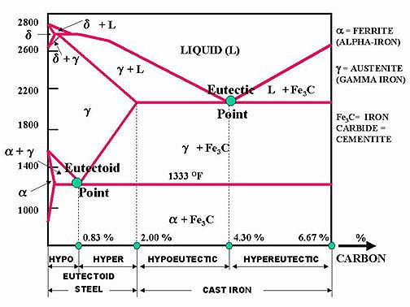

Fig.1.1. Iron-iron carbide diagram.

Fe and C are the main components of Fe - Fe₃C diagram. Fe has polymorphic modification; it’s marked by the initial letters of the Greek alphabet, beginning from low temperatures (Fe_{α}, Fe_{γ} Fe_{δ}).
When iron crystallizes at 1539 ºС it is B.C.C. (δ -iron), at 1392 ºС its structure changes to F.C.C. (γ -iron or austenite), and at 911 ºС it again becomes B.C.C. (α -iron or ferrite).
There are following fathes and structure of Fe - Fe₃C diagram:
CEMENTITE is an iron carbide that has the following chemical formula: Fe₃C. It contains 6.67 % carbon by weight. It is a typical hard and brittle interstitial compound of low tensile strength but high compressive strength. Its crystal structure is orthorhombic.
AUSTENITE ( γ - iron):
It is also known as (γ -) gamma-iron, which is an interstitial solid solution of carbon dissolved in iron with a face centered cubic crystal (F.C.C) structure.
The FCC latice has a larger interstitial site than does the BCC latice and therefore can contain more carbon, up to 2.14 wt% at 1147 ºC and up to 0.8 wt% carbon at 727 ºC. Austenite is normally unstable at room temperature. Under certain conditions it is possible to obtain austenite at room temperature.
FERRITE (α - iron):
It is (α - ) alpha -iron, which is an interstitial solid solution of a small amount of carbon dissolved in iron with a Body Centered Cubic (B.C.C.) crystal structure. It is the softest structure on the iron-iron carbide diagram.
Fig.1.2. BCC iron showing the location of interstitial carbon atoms
This is a relatively weak iron since it only contains a maximum of 0.022 wt% carbon at 727 ºC (eutectoid temperature).
PEARLITE (α - Fe + Fe₃C)
It is the eutectoid mixture containing 0.8 % carbon and is formed at 727ºC on very slow cooling. It is very fine platelike or lamellar mixture of ferrite and cementite. The structure of pearlite includes a white matrix (ferritic background) which includes thin plates of cementite.
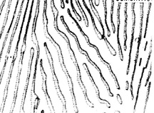

Fig.1.3. Pearlite microstructure (Light background is the ferrite matrix, dark lines are the cementite network)

LEDEBURITE (γ - Fe + Fe₃C)
It is the eutectic mixture of austenite and cementite. It contains 4.3% carbon and represents the eutectic of cast iron. Ledeburite exists when the carbon content is greater than 2.14%, which represents the dividing line on the equilibrium diagram between steel and cast iron.
Plain carbon steel is an alloy of iron and carbon. It has good machineability and malleability. It is different from cast iron as regards the percentage of carbon. It contains carbon from 0.06 to 2% whereas cast iron possesses carbon from 2 to 4.2%.
As the term ‘‘plain carbon steel’’ implies, these are alloys of iron and carbon. These steels were the first developed, are the least expensive, and have the widest range of applications. Steel is used for making camshafts, sheets and srips for fan blades, welded tubing, forgings, chains, stamping, rivets, nails, pipes, angle, channels, case hardening steel, rods, tubes, valves, gears, crankshafts, connecting rods, railway axles, fish plates, etc
The effect of Carbon on the Properties of Steel
In general, as the carbon content increases the hardness of the steel also increases. The tensile strenth and the yield strength also increase to about 0.8% carbon. Thereafter, they level out. This is shown in Figure 1.5
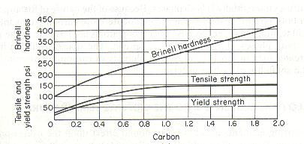
Fig. 1.4. The effect of carbon on the hardness, tensile strength and yield strength of steels.
The tensile strength and hardness are affected as the ratio of ferrite to cementite in the structure of steel changes. As the percentage of pearlite increases in the hypoeutectoid steels, the tensile strength increases. The hypereutectoid steels show only a slight increase in strength as the cementite-to-ferrite ratio increases.
The elongation and the reduction in area represent how ductile or brittle a material is. Fig.5.4. indicates the effect of carbon on the ductility and impact resistance (toughness) of steels. The elongation and the reduction in area drop sharply with increase in carbon content, going almost to zero at about 1.5 % carbon. This indicates that the carbon content of 1.5 % or more will cause high brittleness.
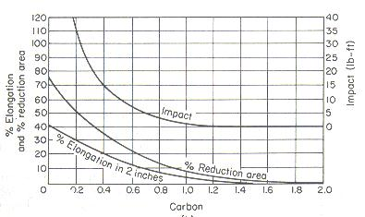
Fig. 1.5. The effect of carbon on the impact resistance and ductility of steels.
The effect of impurities on steel
The effects of impurities like silicon, sulphur, manganese and phosphorus, on steel as discussed under.
Silicon. Silicon content in the finished steel usually ranges from 0.05 to 0.30%. It is added in low carbon steels for preventing them from becoming porous. It helps in removing the gases and oxides. It prevents blow holes there by making steel tougher and harder.
Manganese. It serves as a valuable deoxidizing and purifying agent, in steel. Manganese also combines with sulphur and thereby decreases the harmful effect of this element remaining in the steel. It increases wear resistance, hardness and strength and decreases machineability. When used in ordinary low carbon steels, manganese makes the metal ductile and of good bending quantities. In high speed steels, it is used to tougher the metal and to increase its critical temperature.
Sulphur. It renders free cutting properties in steel. It is found in steel either as iron sulphide or manganese sulphide. Iron sulphide due to its low melting point, produces brittleness whereas manganese sulphide does not affect so much. Therefore, manganese sulphide is less objectionable in steel than iron sulphide.
Phosphorus. It induces brittleness in steel. It also produces cold shortness in steel. In low carbon steels, it raises the yield point and improves the resistance to atmospheric corrosion. The sum of carbon and phosphorus usually does not exceed 0.25%.
Hot-shortness: Brittleness at high temperatures is called hot-shortness which is usually caused by sulfur. When sulfur is present, iron and sulfur form iron sulfide (FeS) that is usually concentrated at the grain boundaries and melts at temperatures below the melting point of steel. Due to the melting of iron sulfide, the cohesion between the grains is destroyed, allowing cracks to develop. This occurs when the steel is forged or rolled at elevated temperatures. In the presence of manganese, sulfur tends to form manganese sulfide (MnS) which prevents hot-shortness.
Cold-shortness: Large quantities of phosphorus (in excess of 0.12% P) reduces the ductility, thereby increasing the tendency of the steel to crack when cold worked. This brittle condition at temperatures below the recrystallization temperature is called cold-shortness.
Classification of Plain Carbon Steels
The steel may be of various kinds and few important types are explained as under.
Classification by structure
There are three kinds of plain carbon steels: hypoeutectoid, eutectoid and hypereutectoid steels.
Eutectoid steel. In the abbreviated iron–iron carbide diagram of Fig. 5.1 the eutectoid point is the lowest temperature and composition at which the austenite phase can exist. It is that point corresponding to a composition of 99.2 wt% Fe 0.8 wt% C. This is the eutectoid point of the iron–iron carbide system.
Euctectoid deals with a solid-to-solid transformation, while the eutectic region begins with a liquid. At the eutectoid point, the eutectoid reaction takes place on cooling a 0.8 wt% C alloy composition slowly through the eutectoid temperature. At this temperature the reaction is
Austenite → Ferrite + Fe₃C
This is a reaction of a solid transforming to two different solids forming a parallel-plate microstructure of the two phases called pearlite.
A plain carbon steel of eutectoid composition is 1080 steel, which has a tensile strength of about 112,0 psi ( pound-force per square inch, lbf/in²) or about 772 MPa.

*Note 1psi = 6.89 MPa; 1 MPa = 0,145 psi
If the austenite contains less than 0.80% carbon (hypoeutectoid steel), free ferrite will first be rejected on slow cooling through the critical temperature until the composition of the remaining austenite reaches 0.80% carbon, when the simultaneous rejection of both ferrite and carbide will again occur, producing pearlite. So a hypoeutectoid steel at room temperature will be composed of areas of free ferrite and areas of pearlite; the higher the carbon percentage, the more pearlite present in the steel. A 1040 steel is typical of a hypoeutectoid steel. It will be somewhat softer than a 1080 steel and have a tensile strength of about 75,0 psi (517 Mpa).
When austenite that contains more than 0.80% carbon (hypereutectoid steel) is slowly cooled, cementite is thrown out at the austenite grain boundaries, forming a cementite network, until the austenite again contains 0.80% carbon, at which time pearlite is again formed. Thus a hypereutectoid steel, when slowly cooled, will have areas of pearlite surrounded by a thin carbide network

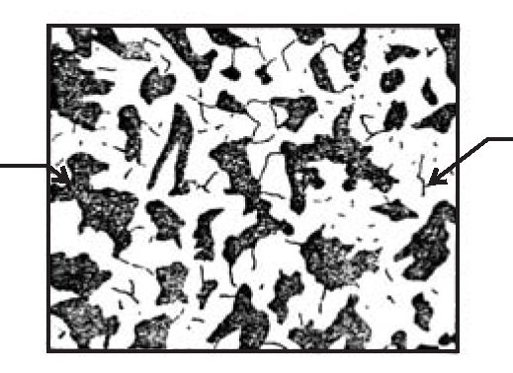 |  | 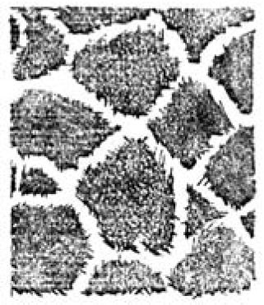
a) | b) | c)
Fig.1.6. Microstructure of mild steel (a), pearlitic eutectoid steel (b),
high carbon steel (c)

Classification of steel by carbon content
Depending upon the carbon content, a plain carbon steels can divided to the following types:

Table 1.1. Classification of steel by carbon content
Dead carbon steel | Up to 0.05% carbon
Low carbon or mild steel | 0.15% to 0.3% carbon
Medium carbon steel | 0.3% to 0.6% carbon
High carbon steel | 0.6% to 1.5% carbon

Dead Carbon Steel
It possesses very low percentage of carbon varying from 0.05 to 0.15%. It has a tensile strength of 390 MPa and a hardness of about 115 BHN. Steel wire, sheets, rivets, screws, pipe, nail and chain are made from this steel. This steel is used for making camshafts, sheets and strips for fan blades, welded tubing, forgings, chains, stamping, rivets, nails, pipes, automobile body etc.

Low Carbon Or Mild Steel
Low carbon steel is sometimes known as mild steel also. It contains 0.20 to 0.30% C which has tensile strength of 555 MPa and hardness of 140 BHN. It possesses bright fibrous structure. It is tough, malleable, ductile and more elastic than wrought iron. It can be easily forged and welded. It can absorb shocks. It rusts easily. Its melting point is about 1410°C. It is used for making angle, channels, case hardening steel, rods, tubes, valves, gears, crankshafts, connecting rods, railway axles, fish plates, small forgings, free cutting steel shaft and forged components etc.
Applications
Mild steel containing 0.15 to 0.20% carbon
It is used in structure steels, universal beams, screws, drop forgings, case hardening steel, bars, rods, tubes, angles and channels etc.
Mild steel containing 0.20-0.30% carbon
It is used in making machine structure, gears, free cutting steels, shafts and forged components etc.
Medium Carbon Steels
Medium carbon steel contains carbon from 0.30 to 0.6%. It possesses having bright fibrous structure when fractured. It is tough and more elastic in comparison to wrought iron. It can be easily forged, welded, elongated due to ductility and beaten into sheets due to its good malleability. It can easily absorb sudden shocks. It is usually produced as killed or semi killed steels and is harden able by treatment. Hardenability is limited to thin sections or to the thin outer layer on thick parts. Its tensile strength is better than cast iron and wrought iron but compressive strength is better than wrought iron but lesser than cast iron. It rusts readily. Its melting point is 1400°C. It can be easily hardened and it possesses good balance of strength and ductility.
It is generally used for making railway coach axles, bolts, connecting rods, key stock, wires and rods, shift and break levers, spring clips, gear shafts, small and medium forgings, railway coach axles, crank pins on heavy machines, spline shafts, crankshafts, forging dies, set screws, die blocks, self tapping screws, clutch discs, valve springs, plate punches, thrust washers etc. The applications of different kinds of medium carbon steel are given as under.
Applications
Plain carbon steels having carbon % 0.30 to 0.45. Axles, special duty shafts, connecting rods, forgings, machinery steel, spring clips, turbine, rotors, gear shafts, key stock, forks and bolts.
Plain carbon steels having carbon % 0.45 to 0.60. Railway coach axles, crank pins, crankshafts, axles, spline shafts, loco tyres.
Plain carbon steels having carbon % 0.60 to 0.80. Drop forging dies, die blocks, bolt heading dies, self-tapping screws, valve spring, lock washers, hammers, cold chisels, hacksaws, jaws for vices etc.

High Carbon Steels
High carbon steels (HCS) contain carbon from 0.6 to 1.5%. Because of their high hardness, these are suitable for wear resistant parts. Spring steel is also high carbon steel. It is available in annealed and pre-tempered strips and wires. High carbon steel loses their hardness at temperature from 200°C to 250°C. They may only be used in the manufacture of cutting tools operating at low cutting speeds. These steels are easy to forge and simple to harden. These steels are of various types which are identified by the carbon percentage, hardness and applications.

Classification by Applications

Free cutting steel
The important features of free cutting steels are their high machinability and high quality surface finish after finishing. These properties are due to higher sulphur and phosphorus. Sulphur exists in the form of manganese sulphide (MnS) which forms inclusions in steel. These inclusions promote the formation of discontinuous chips and also reduce friction on the surface being machined so produces good surface finish easily. Phosphorus is dissolved in the ferrite and increases hardness and brittleness. Lead up to 0.35% can be added to improve the machinability of steel. These have high sulphur content present in form of manganese sulphide inclusions causing the chips to break short on machining. Mn and P make steel hardened and brittle. Lead (0.2% to 0.35%) is sometimes added to steel improving machinability properties of steel. This consists of three Bessemer grades B1111, B1112, B1113 which differ in sulphur content and the sulphurised steels from C1108 to C1151.
The tool life achieved in machining free cutting steels is from 2 to 2.5 times higher than when carbon steels of the same carbon content. However, it must be noted that free cutting steels have lower dynamic strength characteristics and are more susceptible to corrosion. Free cutting steels are frequently supplied in the cold drawn or work hardened form. These cold drawn steels have a high tensile strength and hardness but less ductile when compared to other kind of steels.
Applications of free cutting steel
These steels are used for manufacturing axles, bolts, screws, nuts, special duty shafts, connecting rods, small and medium forgings, cold upset wires and rods, solid turbine rotors, rotor and gear shaft, armature, key stock, forks and anchor bolts screw stock, spring clips, tubing, pipes, light weight rails, concrete reinforcing etc.

Structural steels
Structural steels possess high strength and toughness, resistance to softening at elevated temperatures and enough resistance to corrosion. In addition, they should possess weldability, workability and high hardenability. The principal alloying elements in structural steels are chromium, nickel and manganese.
These steels has various applications. They are used for structural members of bridges, buildings, rail road, cars etc. They are also used for manufacturing components subjected to static and dynamic loads. These components include valves, pins, studs, gears, clutches, bushes, shafts etc.

The Marking of Steel
According to Indian standard ISO 1570-1961, plain carbon steels are designated by the alphabet ‘C’ followed by numerals which indicate the average percentage of carbon in it. For example C40 means a plain carbon steel containing 0.35% to 0.45% C (0.40% on average), although other elements like manganese may be present. In addition to the percentage of carbon, some other specification may include e.g. C55Mn75 means the carbon content lies between 0.50% to 0.60% and the manganese content lies between 0.60 to 0.90%. It may be noted that only average contents are specified in such designation of steelSteel, because of its strength, formability, abundance, and low cost, is the primary metal used for structural applications.
The Society of Automotive Engineers (SAE) has established standards for specific analysis of steels. In the 10XX series, the first digit indicates a plain carbon steel. The second digit indicates a modification in the alloys. 10XX means that it is a plain carbon steel where the second digit (zero) indicates that there is no modification in the alloys. The last two digits denote the carbon content in points. For example SAE 1040 is a carbon steel where 40 points represent 0.40 % Carbon content.
The American Iron and Steel Institute (AISI) numbering system for plain carbon steels also includes 11XX, 12XX, and 15XX. A brief description of each type of alloy is as follows:
10XX Plain carbon, Mn 1.00% max.
11XX Plain carbon, resulfurized
12XX Plain carbon, resulfurized and rephosphorized
15XX Plain carbon, Mn range 1.00–1.65% max.
General representation of steels:
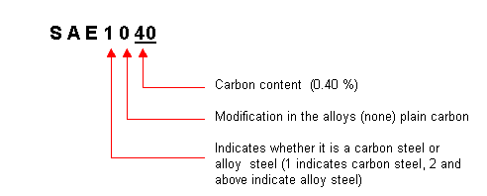
Mechanical and Physical Properties several kinds of steel are in the tables 1.2 –1.4.

TABLE 1.2. Average Mechanical Properties of Cold-Drawn Steel

AISI  no. | Tensile  strength  (psi) | Yield  strength  (psi) | Elongation  (%) | Brinell  hardness | Reduction  of area  (%)
1010 | 67,000 | 55,000 | 25.0 | 137 | 57
1015 | 71,000 | 60,300 | 22.0 | 149 | 55
1020 | 75,000 | 63,700 | 20.0 | 156 | 52
1025 | 80,000 | 68,000 | 18.5 | 163 | 50
1030 | 87,000 | 73,900 | 17.5 | 179 | 48
1035 | 92,000 | 78,200 | 17.0 | 187 | 45
1040 | 97,000 | 82,400 | 16.0 | 197 | 40
1045 | 102,000 | 86,200 | 15.0 | 207 | 35
1120 | 78,000 | 66,300 | 19.5 | 159 | 49
1137 | 105,000 | 89,200 | 16.0 | 217 | 35

TABLE 1.3. Mechanical and Physical Properties of AISI 1020 Steel (Hot Worked)

Modulus of elasticity (psi) | 29–30
Tensile strength (psi) | 75
Yield strength (psi) | 65.7
Elongation (%) | 36
Brinell hardness | 156
Density (g/cm3) | 7.85
Thermal conductivity (Btu/hr ft2 F) | 27
Specific heat (Btu/lb F) | 0.1
Thermal expansion 10 6 (in./in. F) | 8.4

TABLE 1.4. Mechanical Properties of Selected Carbon Steels in Normalized and Annealed Condition

 |  |  | Yield
AISI | Treatment |  | strength | Elongation | Hardness
no. |  | ( C/ F) | (psi) | (%) | (RB)
1020 | N | 870/1600 | 50,000 | 35.8 | 131
 | A | 870/1600 | 43,000 | 36.5 | 111
1040 | N | 900/1650 | 54,000 | 28.0 | 170
 | A | 790/1450 | 51,000 | 30.2 | 149
1060 | N | 900/1650 | 61,000 | 18.0 | 229
 | A | 790/1450 | 54,000 | 22.5 | 179
1080 | N | 900/1650 | 76,000 | 11.0 | 293
 | A | 790/1450 | 56,000 | 24.7 | 174
1095 | N | 900/1650 | 73,000 | 9.5 | 293
 | A | 790/1450 | 55,000 | 13.0 | 192
1137 | N | 900/1650 | 58,000 | 22.5 | 197
 | A | 790/1450 | 50,000 | 26.8 | 174

ªN = normalized; A = annealed; temperature is that to which the piece was heated.
*Notes F = (C x 9/5) + 32; C = (F – 32) x 5/9

Types of cast iron
Cast irons may often be used in place of steel at considerable cost savings. The design and production advantages of cast iron include:
- Low tooling and production cost
- Good machinability without burring
- Ability to cast into complex shapes
- Excellent wear resistance and high hardness (particularly white cats irons)
- High inherent damping capabilities.
The properties of the cast iron are affected by the following factors:
Chemical composition of the iron
Rate of cooling of the casting in the mold (which depends on the section thickness in the casting)
Type of graphite formed (if any)
Major types of cast iron are shown in Figure 1.7.
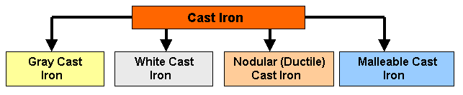
Fig.1.7. Types of Cast Iron
Gray cast iron
Gray iron, named so because of its fracture has a gray appearance. It contains carbon in the form of flake graphite in a matrix which consists of ferrite, pearlite or a mixture of the two. The fluidity of liquid gray iron, and its expansion during solidification due to the formation of graphite, has made this metal ideal for the economical production of shrinkage-free, intricate castings such as motor blocks.
The flake-like shape of graphite in Gray iron, see Fig.1.8 and 1.9, exerts a dominant influence on its mechanical properties. The graphite flakes act as stress raisers which may prematurely cause localized plastic flow at low stresses, and initiate fracture in the matrix at higher stresses. As a result, Gray iron exhibits no elastic behavior but excellent damping characteristics, and fails in tension without significant plastic deformation. The presence of graphite flakes also gives Gray Iron excellent machinability and self-lubricating properties.
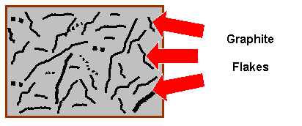 | 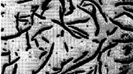
Fig.1.8. Graphite Flakes in Gray  Cast iron | Fig.1.9. Photomicrograph of Gray Cast iron
Advantages of Gray Cast Iron:
- Graphite acts a s a chip breaker and a tool lubricant.
- Very high damping capacity.
- Good dry bearing qualities due to graphite.
- After formation of protective scales, it resists corrosion in many common engineering environments.
Disadvantages:
- Brittle (low impact strength) which severely limits use for critical applications.
- Graphite acts as a void and reduces strength.
- Changes in section size will cause variations in machining characteristics due to variation in microstructure.
- Higher strength gray cast irons are more expensive to produce.
White cast iron
White cast iron is unique in that it is the only member of the cast iron family in which carbon is present only as carbide. Due to the absence of graphite, it has a light appearance. The presence of different carbides, depending on the alloy content, makes white cast irons extremely hard and abrasion resistant but very brittle. An improved form of white cast iron is the chilled cast iron.

Fig.1.10. Photomicrograph of White Cast Iron
Ductile Cast iron (nodular cast)
This structure is developed from the melt. The carbon forms into spheres when cerium, magnesium, sodium, or other elements are added to a melt of iron with very low sulfur content that will inhibit carbon from forming. The control of the heat-treatment process can be pearlitic, ferritic, martensitic matrices into which the carbon spheres are embedded.
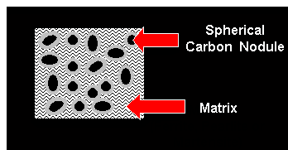 | 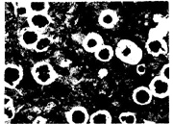
Fig.1.11. Nodular (Ductile) Cast Iron and  the spherical carbon embedded into  the matrix. | Fig.1.12. Photomicrograph  of Nodular Cast iron
Ductile cast iron is used for many structural applications, particularly those requiring strength and toughness combined with good machinability and low cost. The automotive and agricultural industries are the major users of ductile iron castings. Because of economic advantage and high reliability, ductile iron is used for such critical automotive parts as crankshafts, internal combustion engine, engine connecting rods, idler arms, wheel hubs, truck axles, front wheel spindle supports, disk brake calipers, suspension system parts, power transmission yokes, high temperature applications for turbo housing and manifolds, and high security valves for many applications. The cast iron pipe industry is another major user of ductile iron.
Malleable Cast Iron
If cast iron is cooled rapidly, the graphite flakes needed for gray cast iron do not get a chance to form. Instead, white cast iron forms. This white cast iron is reheated to about 950ºC for long periods of time and at the elevated temperatures cementite (Fe₃C) decomposes into ferrite and free carbon. Upon cooling, the combined carbon further decomposes to small compact particles of graphite (instead of flake -like graphite seen in gray cast iron). If the cooling is very slow, more free carbon is released. This free carbon is referred to as temper carbon, and the process is called malleableizing.
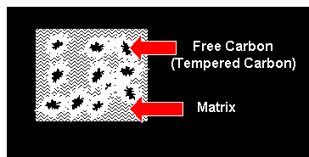 | 
Fig. 1.13. Malleable Cast Iron | Fig.1.14. Ferritic Malleable Cast iron
Malleable cast iron is used for connecting rods and universal joint yokes, transmission gears, differential cases and certain gears, compressor crankshafts and hubs, flanges, pipe fittings and valve parts for railroad, marine and other heavy-duty applications.
Advantages:
- Excellent machinability
- Significant ductility
- Good shock resistance properties
Disadvantages:
The major disadvantage is shrinkage. Malleable cast iron decreases in volume during solidification, and as a result, requires attached reservoirs (feeders and risers) of liquid metal to offset the shrinkage and prevent the formation of internal or external shrinkage defect.
Materials and Equipment:
- Specimen of the hypoeutectoid and hypereutectoid steels.
- Specimen of the gray cast iron, nodular cast iron and malleable cast iron.
- Microscope MM – 4.

Procedure

1. Set specimen of the hypoeutectoid and hypereutectoid steels on a microscope and look at their microstructure.
2. Draw the microstructure of the hypoeutectoid and hypereutectoid steels.
3. Determine the critical temperatures (UCT and LCT) for hypoeutectoid steel with 0.3 %C and hypereutectoid steel with 1.2%C.
4. Set specimen of the gray cast iron, nodular cast iron and malleable cast iron on a microscope and look at their microstructure.
5. Draw the microstructure of the gray cast iron, nodular cast iron and malleable cast iron.
6. Determine the chemical composition of the steels by its SAE-AISI number.

Questions:
- What are the types of iron- carbon alloys?
- What is steel?
- What is cast iron?
- Which polymorphic modifications does the iron have and at what temperatures interval is it stable?
- List phases and structures of the Fe-Fe₃C diagram.
- What is cementite and what properties does it have?
- What is austenite and what properties does it have?
- What is ferrite and what properties does it have?
- What is perlite and what properties does it have?
- What is ledeburite?
- What carbon content does the hypoeutectoid steel have?
- What carbon content does hyperutectoid steel have?
- Discribe the effect of impurities on steel.
- What is hot-shortness and cold shortness?
- Classification of Plain Carbon Steels by structure.
- Classification of steel by carbon content.
- Classification of steel by by applications.
- Discribe the effect of carbon on hardness and tensile strength of steels.
- Discribe the effect of carbon on toughness and ductility of steels.
- What does number SAE 1020 mean?
- What carbon content does medium carbon steels have?
- What are the advantages of cast iron?
- What are the major types of cast iron?
- List forms of the graphite and write what types of cast iron have those forms of graphite.
- What are the advantages of gray cast iron?
- Write an example of used ductile cast iron.
- What carbon content does hypoeutectic cast iron have?
- What carbon content does hypereutectic cast iron have?
LABORATORY WORK № 1
IRON-CARBON ALLOYS
(STEELS and CAST IRON)

PROTOCOL №1

Hypoeutectoid steel Hypereutectoid steel
Carbon content___________% Carbon contain___________%

Critical temperature, ºC
UCT = _________ UCT = _________
LCT = __________ LCT = _________
PROTOCOL № 2

Steel | Carbon content, %  C | Mechanical properties
Steel | Carbon content, %  C | Tensile  strength  (psi/MPa) | Yield  strength  (psi/MPa) | Elongation  (%) | Brinell  hardness | Reduction  of area  (%)
SAE 1010
SAE 1025
SAE 1030
SAE 1045
Conclusions:
____________________________________________________________
______________________________________________________________________________________________________________________________________
PROTOCOL №3

Gray cast iron nodular cast iron malleable cast iron
Graphite form
______________ ______________ _______________

The type of the metallic matrix
______________ ______________ _______________

Conclusions:
_______________________________________________________________
______________________________________________________________________________________________________________________________
Student’s signature Teacher’s signature
“____”___________20___ y. “____”____________20__ y.
LABORATORY WORK 2

HEAT TREATMENT OF STELL
Objectives

1. To learn how to choose temperature of different types of steel heat treatment.
Fundamental concept
Types of heat treatment processes
Various types of heat treatment processes are used to change the following properties or conditions of the steel:
- Improve the toughness, the wear resistanceand the machinability
- Increase the hardness and the ductility
- Refine the grain structure
- Remove the residual stresses.
Figure 2.1 shows major types of heat treatment processes.
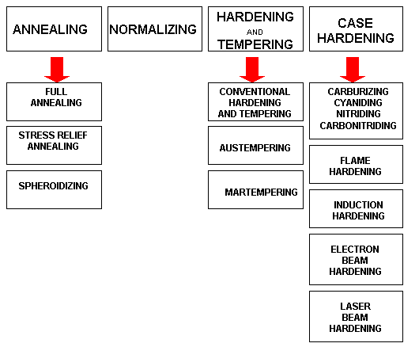
Fig.2.1. The Types of Heat Treatment Processes.
Time-Temperature-Transformation (TTT) Diagram
T(Time) T(Temperature) T(Transformation) diagram is a plot of temperature versus the logarithm of time for a steel alloy of definite composition. It is used to determine when transformations begin and end for an isothermal (constant temperature) heat treatment of a previously austenitized alloy. When austenite is cooled slowly to a temperature below LCT (Lower Critical Temperature), the structure that is formed is Pearlite. As the cooling rate increases, the pearlite transformation temperature gets lower. The microstructure of the material is significantly altered as the cooling rate increases. By heating and cooling a series of samples, the history of the austenite transformation may be recorded. TTT diagram indicates when a specific transformation starts and ends and it also shows what percentage of transformation of austenite at a particular temperature is achieved.
Cooling rates in the order of increasing severity are achieved by quenching from elevated temperatures as follows: furnace cooling, air cooling, oil quenching, liquid salts, water quenching, and brine. If these cooling curves are superimposed on the TTT diagram, the end product structure and the time required to complete the transformation may be found.
In Fig.2.2 the area on the left of the transformation curve represents the austenite region. Austenite is stable at temperatures above LCT but unstable below LCT. Left curve indicates the start of a transformation and right curve represents the finish of a transformation. The area between the two curves indicates the transformation of austenite to different types of crystal structures. (Austenite to pearlite, austenite to martensite, austenite to bainite transformation.)

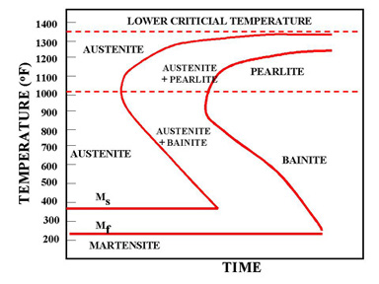
Fig.2.2. TTT Diagram
If the cooling rate is very slow such as annealing process, the cooling curve passes through the entire transformation area and the end product of this the cooling process becomes 100% Pearlite.
In Fig.2.3 the cooling rates A and B indicate two rapid cooling processes. In this case curve A will cause a higher distortion and a higher internal stresses than the cooling rate B. The end product of both cooling rates will be martensite. Cooling rate B is also known as the Critical Cooling Rate, which is represented by a cooling curve that is tangent to the nose of the TTT diagram. Critical Cooling Rate is defined as the lowest cooling rate which produces 100% Martensite while minimizing the internal stresses and distortions.
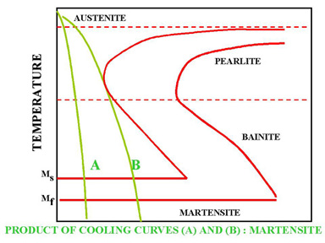
Fig.2.3. Rapid Quench
In Fig.2.4, a rapid quenching process is interrupted (horizontal line represents the interruption) by immersing the material in a molten salt bath and soaking at a constant temperature followed by another cooling process that passes through Bainite region of TTT diagram. The end product is Bainite, which is not as hard as Martensite. As a result of cooling rate D; more dimensional stability, less distortion and less internal stresses are created.
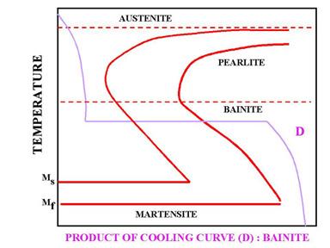

Fig. 2.4. Interrupted Quench
In Fig.2.5 cooling curve C represents a slow cooling process, such as furnace cooling. An example for this type of cooling is annealing process where all the Austenite is allowed to transform to Pearlite as a result of slow cooling.

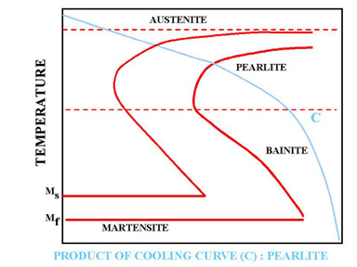
Fig.2.5. Slow cooling process (Annealing)

Processes of Annealing and Spheroidizing
There are two types of Critical Temperature according to the diagram iron- ironcarbide:
LCT (Lower Critical Temperature) - line PSK (constant temperature 727 ºC for all stell);
UCT (Upper Critical Temperature) - line GSE (temperature depends of carbon contain).
Full annealing is accomplished by heating a hypoeutectoid steel to a temperature above the UCT (Upper Critical Temperature). In practice, the steel is heated to about 30-50 ºC above the UCT. It is then cooled in the furnace very slowly to room temperature. The formation of austenite destroys all structures that have existed before heating. Slow cooling yields the original phases of ferrite and pearlite.
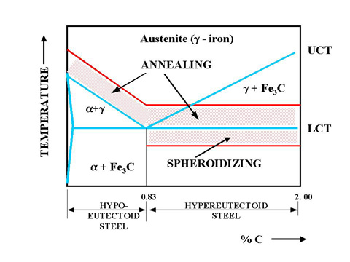
Fig. 2.6. Annealing and Spheroidizing Temperatures
Hypereutectoid steels consist of pearlite and cementite. The cementite forms a brittle network around the pearlite. This presents difficulty in machining the hypereutectoid steels. To improve the machinability of the annealed hypereutectoid steel spheroidize annealing is applied. This process will produce a spheroidal or globular form of a carbide in a ferritic matrix which makes the machining easy. Prolonged time at the elevated temperature will completely break up the pearlitic structure and cementite network. The structure is called spheroidite. This structure is desirable when minimum hardness, maximum ductility and maximum machinability are required.

Stress-Relief Annealing is useful in removing residual stresses due to heavy machining or other cold-working processes. It is usually carried out at temperatures below the LCT, which is usually selected around 600ºC.
Full annealing consists of (1) recovery (stress-relief), (2) recrystallization, (3) grain growth stages. Annealing reduces the hardness, yield strength and tensile strength of the steel.
Process of Normalizing
The normalizing of steel is carried out by heating approximately 30-50 ºC above the UCT (Upper Critical Temperature) followed by cooling in air to room temperature. Normalizing can be applied above the UCT for both hypoeutectoid and hypereutectoid steels. Fig.5.6 shows the normalizing temperatures.

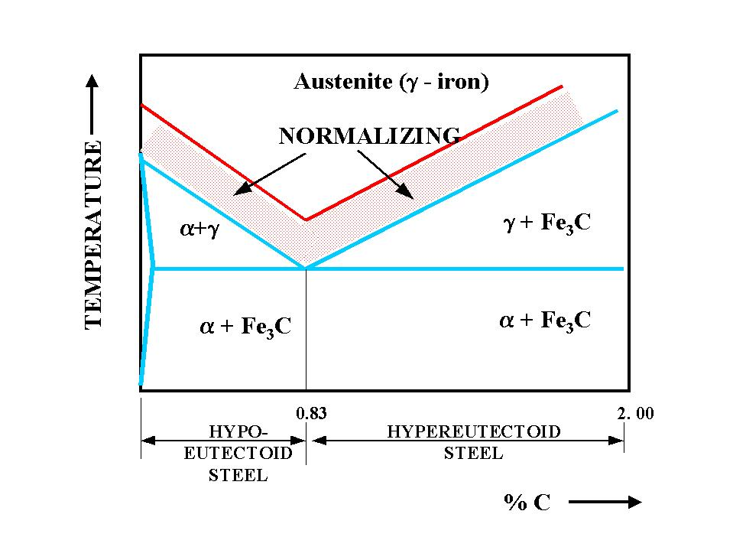
Fig.2.6. Normalizing temperatures for hypoeutectoid and hypereutectoid steels.
The following is the list of the reasons for normalizing the steel :
- To produce a harder and stronger steel than full annealing
- To improve the machinability
- To modify and refine the grain structure
- To obtain a relatively good ductility without reducing the hardness and strength
Annealing and normalizing do not present a significant difference on the ductility of low carbon steels. As the carbon content increases, annealing maintains the % elongation around 20%. On the other hand, the ductility of the normalized high carbon steels drop to 1 to 2 % level.
The tensile strength and the yield point of the normalized steels are higher than the annealed steels. Normalizing and annealing do not show a significant difference on the tensile strength and yield point of the low carbon steels. However, normalized high carbon steels present much higher tensile strength and yield point than those that are annealed.
The medium carbon steels can maintain similar hardness levels when normalized or annealed. However, when high carbon steels are normalized they maintain higher levels of hardness than those that are annealed.
Processes of Hardening and Tempering
Steels can be heat treated to high hardness and strength levels. Structural components subjected to high operating stress need the high strength of a hardened structure. Similarly, tools such as dies, knives, cutting devices, and forming devices need a hardened structure to resist wear and deformation.
Quenched hardened steels are so brittle that even slight impacts may cause fracture. Tempering is a heat treatment that reduces the brittleness of a steel without significantly lowering its hardness and strength. All hardened steels must be tempered before use.

QUENCH AND TEMPERING PROCESSES:
(1) Conventional Heat, Quench and Temper process
(2) Martempering
(3) Austempering
Conventional Heat, Quench and Temper Process:
Quench begins by conventional heating of a hypoeutectoid steel to a temperature to about 30-50ºC above the UCT (Upper Critical Temperature). Quench begins by heating of a hyperoeutectoid steel to a temperature above the LCT (Lower Critical Temperature). Then all steels are soaked and rapidly cooled. In this process, Austenite is transformed to Martensite as a result of rapid quench from furnace to room temperature. Then, martensite is heated to a temperature which gives the desired hardness. As the metal cools, it also contracts and its microstructure occupies less volume. Extreme variations in size of metal parts complicate the work of the heat treater and should be avoided in the designing of metal parts. This means there is a limit to the overall size of parts that can be subjected to such thermal processing. Figure 5.7 shows the conventional hardening, tempering process.
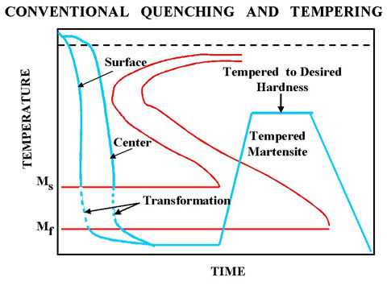

Fig.2.7. Conventional quenching and tempering process.

Martempering (Marquenching):
To overcome the restrictions of conventional quenching and tempering, Martempering process can be used. Martempering or marquenching permits the transformation of Austenite to Martensite to take place at the same time throughout the structure of the metal part. Then cooling is continued through the martensite region, followed by the usual tempering.
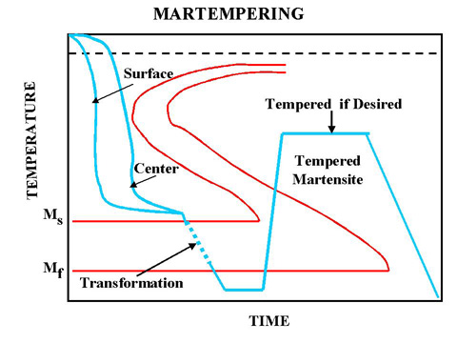
Fig.2.8. Martempering process
Austempering:
This is the second method that can be used to overcome the restrictions of conventional quench and tempering. The quench is interrupted at a higher temperature than for Martempering to allow the metal at the center of the part to reach the same temperature as the surface. By maintaining that temperature, both the center and the surface are allowed to transform to Bainite and are then cooled to room temperature.
Advantages of Austempering:
(1) Less distortion and cracking than martempering,
(2) No need for final tempering (less time consuming and more energy efficient)
(3) Improvement of toughness (impact resistance is higher than the conventional quench and tempering)
(4) Improved ductility
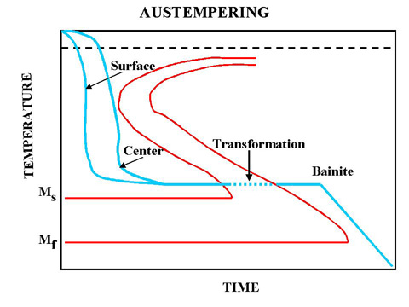
Fig.2.9. Austempering process.
In Austempering process, the end product is 100% bainite. It is accomplished by first heating the part to the properr austenitizing temperature followed by cooling rapidly in a slat bath which is maintained between 400 and 800 oF. The part is left in the bath until the transformation to bainite is complete. The steel is caused to go directly from austenite to bainite.
Materials and Equipment:
- Specimen of the hypoeutectoid steel SAE 1040.
- Microscope MM – 4.
Procedure:
- Determine the carbon content of the steel SAE 1040.
- Choose the temperature of the annealing, normalizing and quanch of this steel.
- Define the major types of heat treatment processes.
- Write conclusions about the difference between these processes.

Questions:
1. What properties or conditions of the steel change during the various types of heat treatment?
2. What are the major types of heat treatment processes?
3. Plot the TTT diagram.
4.What does the TTT diagram indicate?
- What is the critical cooling rate?
- What structure is formed during the slow cooling (annealing process)?
- Show the upper and lower critical temperature on the Fe-Fe₃C diagram.
- What is the purpose of the spheroidizing process?
- How to choose the normalizing temperature for hypo- and hypereutectoid steel?
- What properties does the martensite have?
11.What transformation takes place during quench process?
12.What is the purpose of the tempering process?
LABORATORY WORK № 2
PROCESSES OF HEAT TREATMENT OF STELL

PROTOCOL №1

Define:
Annealing_____________________________________________________________________________________________________________________________________________________________________________________
Normalizing___________________________________________________________________________________________________________________________________________________________________________________
Quenching____________________________________________________________________________________________________________________________________________________________________________________
Tempering____________________________________________________________________________________________________________________________________________________________________________________

PROTOCOL №2

Steel | Carbon content, % | Critical temperature,ºC |  | Temperature of the processes, ºC
SAE 1030 |  | UCT |  | annealing | normalizing | quanch
SAE 1030 |  | LCT

Conclusions:
_______________________________________________________________
_______________________________________________________________
_______________________________________________________________

_______________________ _________________________
Student’s signature Teacher’s signature
“____”___________20___ y. “____”____________20___ y.
LABORATORY WORK № 3
LOW-ALLOY STEELS AND STAINLESS STEELS
Objectives

1. To learn the effect of alloying elements in steel.
2. To learn to determine of the alloy steel chemical composition by its SAE-AISI number.
3. To learn the chemical composition, microstructure and applications low-carbon steels.
4. To learn the chemical composition, microstructure and applications stainless steels.

Scientific principles
To produce needed improvement in properties of plain carbon steel, certain elements in steel are alloyed for specific purposes to increase wearing resistance, electrical and mechanical properties which cannot be obtained in plain carbon steels.
The properties of steel can be tailored for special uses by the addition of other metals to the alloy. For improving the properties of ordinary steel, certain alloying elements are added in it in sufficient amounts. The most common alloying elements added to steel are chromium, nickel, manganese, silicon, vanadium, molybdenum, tungsten, copper, titanium, zirconium, cobalt, and aluminium.
Each of these elements induces certain qualities in steels to which it is added. They may be used separately or in combination to produce desired characteristics in the steel. The main purpose of alloying element in steel is to improve machinability, elasticity, hardness, case hardening, cutting ability, toughness, wear resistance, tensile strength, corrosion resistance, and ability to retain shape at high temperature, ability to resist distortion at elevated temperature and to impart a fine grain size to steel. Like carbon, a number of alloying elements are soluble to produce alloys with improved strength, ductility, and toughness. Also carbon, besides forming an inter-metallic compound with iron, combines with many alloying elements and form alloy carbides. These alloy carbides as well as iron-alloy carbides are usually hard and lack in toughness. Some alloying elements are added to prevent or restrict grain growth. Aluminium is considered the most effective in this respect. Others are zirconium, vanadium, chromium, and titanium. The addition of alloying elements almost always affects the austenite-ferrite transformation mechanism. Some alloying elements lower and some raise the critical temperature. The compositional and structural changes produced by alloying elements change and improve the physical, mechanical and processing properties of steel.
Effect of alloying elements in steel
The chief alloying elements used in steel are nickel, chromium, molybdenum, cobalt, vanadium, manganese, silicon and tungsten. Each of these elements possesses certain qualities upon the steel to which it is added. These elements may be used separately or in combination to produce the desired characteristic in steel. Following are the effects of alloying elements on steel.
Nickel. Steels contain 2 to 5% nickel and from 0.1 to 0.5% carbon increase its strength and toughness. In this range, nickel contributes great tensile strength, yield strength, toughness and forming properties and hardness with high elastic limit, good ductility and good resistance to corrosion. An alloy containing 25% nickel possesses maximum toughness and offers the greatest resistance to rusting, corrosion and burning at high temperature. It has proved beneficial in the manufacture of boiler tubes, valves for use with superheated steam, valves for engines and sparking plugs for petrol engines. A nickel steel alloy containing 36% of nickel is known as invar. It has nearly zero coefficient of expansion. Therefore, it is in great demand for making measuring instruments for everyday use.
Chromium. It improves corrosion resistance (about 12 to 18% addition). It increases tensile strength, hardness, wear resistance and heat resistance. It provides stainless property in steel. It decreases malleability of steel. It is used in steels as an alloying element to combine hardness with high strength and high elastic limit. It also imparts corrosion resisting properties to steel. The most common chrome steels contain from 0.5 to 2% chromium and 0.1 to 1.5% carbon. The chrome steel is used for balls, rollers and races for bearings. A Nickel-Chrome steel containing 3.25% nickel, 1.5% chromium and 0.25% carbon is much used for armour plates. Chrome nickel steel is extensively used for motor car crank shafts, axles and gears requiring great strength and hardness.
Tungsten. It increases hardness, wear resistance, shocks resistance and magnetic reluctance. It increases ability to retain hardness and toughness at high temperature. It prohibits grain growth and the depth of hardening of quenched steel. The principal uses of tungsten steels are for cutting tools, dies, valves, taps and permanent magnets.
Vanadium. It improves tensile strength, elastic limit, ductility, fatigue resistance, shock resistance and response to heat treatment. It aids in obtaining a fine grain structure in tool steel. The addition of a very small amount of vanadium (less than 0.2%) produces a marked increase in tensile strength and elastic limit in low and medium carbon steels without a loss of ductility. The chrome- vanadium steel containing about 0.5 to 1.5% chromium, 15 to 0.3% vanadium and 0.13 to 1.1% carbon have extremely good tensile strength, elastic limit, endurance limit and ductility. These steels are frequently used for parts such as springs, shafts, gears, pins and many drop forged parts.
Molybdenum. A very small quantity (0.15 to 0.30%) of molybdenum is generally used with chromium and manganese (0.5 to 0.8%) to make molybdenum steel. It increases hardness, wear resistance, thermal resistance. When added with nickel, it improves corrosion resistance. It counteracts tendency towards temper brittleness. It makes steel tough at various hardness levels. It acts as a grain growth inhibitor when steels are heated to high temperatures. Molybdenum steels possesses hardness, wear resistance, thermal resistance and extra tensile strength. It is used for airplane fuselage and automobile parts. It can replace tungsten in high speed steels.
Cobalt. When added to steel, it refines the graphite and pearlite and acts as a grain refiner. It improves hardness, toughness, tensile strength and thermal resistance.
Titanium. It acts as a good deoxidizer and promotes grain growth. It prevents formation of austenite in high chromium steels. It is the strongest carbide former. It is used to fix carbon in stainless steels and thus prevents the precipitation of chromium carbide.
Aluminium. It is used as a deoxidizer. If present in an amount of about 1 %, it helps promoting nitriding.
Copper. It improves resistance to corrosion. It increases strength. More than 0.6 % copper for precipitation.
Silicon. It improves magnetic permeability and decreases hysteresis losses. It decreases weldability and forgeability. It is also added as a deoxidizer during casting of ingots. It takes care of oxygen present in steel by forming SiO₂. Silicon steels behave like nickel steels. These steels have a high elastic limit as compared to ordinary carbon steel. Silicon steels containing from 1 to 2% silicon and 0.1 to 0.4% carbon and other alloying elements are used for electrical machinery, valves in engines, springs and corrosion resisting materials.
Manganese. It improves the strength of the steel in both the hot rolled and heat treated condition. The manganese alloy steels containing over 1.5% manganese with a carbon range of 0.40 to 0.55% are used extensively in gears, axles, shafts and other parts where high strength combined with fair ductility is required. The principal use of manganese steel is in machinery parts subjected to severe wear. These steels are all cast and ground to finish.
The effect of alloying elements on the microstructure and properties of steel are given in Table 3.1.

Table 3.1. The effect of alloying elements on the properties of steel

Element | Effect
Aluminum | Ferrite hardener  Graphite former  Deoxidizer
Chromium | Mild ferrite hardener  Moderate effect on hardenability  Graphite former  Resists corrosion  Resists abrasion
Cobalt | High effect on ferrite as a hardener  High red hardness
Molybdenum | Strong effect on hardenability  Strong carbide former  High red hardness  Increases abrasion resistance
Manganese | Strong ferrite hardener
Nickel | Ferrite strengthener  Increases toughness of the hypoeutectoid steel  With chromium, retains austenite  Graphite former
Copper | Austenite stabilizer  Improves resistance to corrosion
Silicon | Ferrite hardener  Increases magnetic properties in steel
Phosphorus | Ferrite hardener  Improves machinability  Increases hardenability

The Marking of Alloy Steel

Alloy steels are indicated by 2XXX, 3XXX, 4XXX, etc. The American Iron and Steel Institute (AISI) in cooperation with the Society of Automotive Engineers (SAE) revised the percentages of the alloys to be used in the making of steel, retained the numbering system (fig. 3.1).

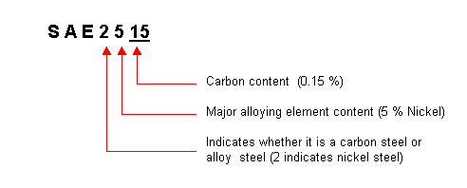
Fig. 3.1. General representation of alloy steels
Table 3.2. Marking and classification of alloy steels.
SAE - AISI Number | Classification
2XXX | Nickel steels  5 % Nickel increases the tensile strength without reducing ductility.  8 to 12 % Nickel increases the resistance to low temperature impact  15 to 25 % Nickel (along with Al, Cu and Co) develop high magnetic properties. (Alnicometals)  25 to 35 % Nickel create resistance to corrosion at elevated temperatures.
3XXX | Nickel-chromium steels  These steels are tough and ductile and exhibit high wear resistance, hardenability and high resistance to corrosion.
4XXX | Molybdenum steels  Molybdenum is a strong carbide former. It has a strong effect on hardenability and high temperature hardness. Molybdenum also increases the tensile strength of low carbon steels.
5XXX | Chromium steels  Chromium is a ferrite strengthener in low carbon steels. It increases the core toughness and the wear resistnace of the case in carburized steels.
86XX  87XX  93XX  94XX  97XX  98XX | Triple Alloy steels which include Nickel (Ni), Chromium (Cr), and Molybdenum (Mo).These steels exhibit high strength and also high strength to weight ratio, good corrosion resistance.
LOW-ALLOY STEELS
Low-alloy carbon steels are those steels containing about 2–8% total alloying element content and manganese, silicon, and copper content greater than that for the carbon steels, which are 1.65% Mn, 0.6% Si, and 0.6% Cu.
It is possible to subdivide these hardenable steels as follows:
Low-carbon quenched and tempered steels having yield strengths in the 50–150 ksi range and total Ni-Cr-Mo content to approximately 4%.
Medium-carbon ultrahigh-strength steels having strengths in the range of 200 ksi. AISI 4130 and 4340 steels are typical examples.
Bearing steels, such as 8620 and 2100.
Chrome-molybdenum heat-resisting steels containing up to 1% Mo and 9% Cr in the AISI 9XXX series.

When relatively large amounts of alloying elements are added to steel, the characteristic behavior of carbon steel is obliterated. Most alloy steel is medium- or high-carbon steel to which various elements have been added to modify its properties to an appreciable extent, but it still owes its distinctive characteristics to the carbon that it contains. The percentage of alloy element required for a given purpose ranges from a few hundredths of 1% to possibly as high as 5%.

When ready for service these steels will usually contain only two constituents, ferrite and carbide. The only way that any alloying element can affect the properties of steel is to change the dispersion of carbide in the ferrite or change the properties of the carbide. The effect on the distribution of carbide is the most important factor. In large sections when carbon steels fail to harden throughout the section, even under a water quench, the har-denability of the steel can be increased by the addition of any alloying element (except possibly cobalt). The elements most effective in increasing the hardenability of steel are manganese, silicon, and chromium.

Elements such as molybdenum, tungsten, and vanadium are effective in increasing the hardenability when dissolved in the austenite, but they are usually present in the austenite in the form of carbides. The main advantage of these carbide-forming elements is that they prevent the agglomeration of carbides in tempered martensite. Tempering relieves the internal stresses in the hardened steel and causes spheroidization of the carbide particles, with resultant loss in hardness and strength. With these stable carbide-forming elements present, higher tempering temperatures may be employed without sacrificing strength. This permits these alloy steels to have a greater ductility for a given strength, or a greater strength for a given ductility, than plain carbon steels.

The third factor that contributes to the strength of alloy steel is the presence of the alloying element in the ferrite. Any element present in solid solution in a metal will increase the strength of the metal. The elements most effective in increasing the strength of the ferrite are phosphorus, sili-con, manganese, nickel, molybdenum, tungsten, and chromium.

A final effect of alloying elements is their influence on the austenitic grain size. Martensite, when formed from coarse-grained austenite, has con-siderably less resistance to shock than that formed from a fine-grained aus-tenite. Aluminum is the most effective element for fine-grained growth inhibitors.
TABLE 3.3. Chemical Composition of Low-Alloy Carbon Steels

 | Alloy
 | no.a | Composition (%)
Manganese steel | 13XX | Mn 1.75
Nickel steels | 23XX | Ni 3.5
 | 25XX | Ni 5.00
Nickel-chromium steels | 31XX | Ni 1.25; Cr 0.65, 0.08
 | 32XX | Ni 1.75; Cr 1.07
 | 33XX | Ni 3.50; Cr 1.50, 1.57
 | 34XX | Ni 3.00; Cr 0.77
Molybdenum steels | 40XX | Mo 0.20, 0.25
 | 44XX | Mo 0.40, 0.52
Chromium-molybdenum | 41XX | Cr 0.50, 0.80, 0.95; Mo 0.12,
steel |  | 0.20, 0.25, 0.30
Nickel-chromium- | 43XX | Ni 1.82; Cr 0.50, Mo 0.25
molybdenum steels |  | Ni 1.82; Cr 0.50; Mo 0.12
 | 47XX | Ni 1.05; Cr 0.45; Mo 0.20,
 | 81XX | Ni 0.30; Cr 0.40; Mo 0.12
 | 86XX | Ni 0.55; Cr 0.50; Mo 0.20
 | 87XX | Ni 0.55; Cr 0.50; Mo 0.25
 | 88XX | Ni 0.55; Cr 0.50; Mo 0.35
 | 93XX | Ni 3.25; Cr 1.20; Mo 0.12
 | 94XX | Ni 0.45; Cr 0.40; Mo 0.12
 | 97XX | Ni 1.00; Cr 0.20; Mo 0.20
 | 98XX | Ni 1.00; Cr 0.80; Mo 0.25
Nickel-molybdenum steels | 46XX | Ni 0.85, 1.82; Mo 0.20, 0.25
 | 48XX | Ni 3.50; Mo 0.25
Chromium steels | 50XX | Cr 0.27, 0.40, 0.50, 0.65
 | 51XX | Cr 0.80, 0.87, 0.92, 0.95, 1.00, 1.05
 | 50XXX | Cr 0.50; C 1.00 min.
 | 51XXX | Cr 1.02; C 1.00 min.
 | 52XXX | Cr 1.45; C 1.00 min.
Chromium-vanadium steel | 61XX | Cr 0.60, 0.80, 0.95; V 0.10, 0.15
Tungsten-chromium steel | 72XX | W 1.75; Cr 0.75
Silicon-manganese steel | 92XX | Si 1.40, 2.00; Mn 0.65, 0.82, 0.85; Cr 0.00, 0.65

aXX or XXX indicates the carbon content in hundredths of a percent
STAINLESS STEEL
TYPES OF CORROSION
Stress Corrosion Cracking
Stress corrosion cracking occurs at points of stress. Usually the metal or alloy is virtually free of corrosion over most of its surface, yet fine cracks penetrate through the surface at the points of stress.
Sulfide Stress Cracking
Many corrosion processes produce hydrogen ions, which combine with electrons from the base metal to form hydrogen atoms. Two such formed hydrogen atoms may combine to form a hydrogen molecule. The majority of such molecules will form hydrogen bubbles and float away harmlessly. However, a percentage of the hydrogen atoms will diffuse into the base metal and embrittle the crystalline structure. Sulfide stress cracking will occur when a critical concentration of hydrogen is reached while a tensile stress exceeding a threshold level is present. Although H₂S does not actively participate in the SSC reaction, sulfides act to promote the entry of the hydrogen atoms into the base metal.
The susceptibility of carbon steels to SSC is directly related to their strength or hardness levels. As carbon or low-alloy carbon steel is heat treated to progressively higher levels of hardness, the time to failure de-creases rapidly for a given stress level.
Temperature is also a factor. Below 7۫ ˚C the diffusion rate is so slow that the crucial concentration is not reached. By carefully monitoring the processing of carbon and low-alloy carbon steels, and keeping the hardness level below 22HRC, these steels will have acceptable resistance to SSC.
Pitting
Carbon and low-alloy carbon steels may pit under low flow or stagnant conditions. The pits are generally shallow.
Corrosion Fatigue
Fatigue failures are the results of prolonged cyclic loading. If corrodents are present, the fatigue problem is worse, sometimes involving corrosion deposits accumulating in the cracks to concentrate the cycling stresses.

Uniform Corrosion
Carbon and low-alloy carbon steels are primarily affected by uniform, or general, corrosion. The most common current corrosive solvent is water, in everything from dilute solutions to concentrated acids and salt solutions. Some organic systems are also capable of causing serious corrosion.
Microbiologically Influenced Corrosion
Stagnant hydrotest water is frequently the cause of this type of corrosion. In water systems there are many bacteria that accumulate and grow on metal surfaces in colonies, changing the localized chemistry to highly corrosive conditions.
Stainless steel contains chromium together with nickel as alloy and rest is iron. Stainless steel contains a minimum of 12% chromium, which stops further oxidation by forming a protective oxide on the surface.
It has been defined as that steel which when correctly heat treated and finished, resists oxidation and corrosive attack from most corrosive media. Stainless steel surface is responsible for corrosion resistance. Minimum chromium content of 12% is required for the film’s formation, and 18% is sufficient to resist the most severe atmospheric corrosive conditions. Their principal alloying element is chromium while some other elements like nickel, manganese etc. can also be present in small amounts. Addition of nickel improves ductility and imparts strength. Corrosion resistance to stainless steels increases with increase in nickel content against neutral chloride solution and weakly oxidizing acids. Addition of molybdenum improves its resistance to sulphuric, sulphurous and organic acids. Addition of manganese increases hot workability of these steels.
Steels having 15 to 20% Ni and about 0.1 % carbon possesses great strength and toughness and extremely good resistance to corrosion. Such steels are called stainless steels. Another type of stainless steel containing 11 to 14% chromium and about 0.35% carbon is used for cutlery, surgical and dental instruments and other purposes where hard edges are required. Maximum resistance to corrosion is obtained when this steel is ground and polished after heat-treating.
A steel containing 18% chromium and 8% nickel is widely used and is commonly referred to as 18/8 steel. Stainless steel is highly resistance to corrosion and oxidation. It can be classified into three major categories according to the type of micro structures.
General Properties of Stainless Steels
It possesses wide range of strength and hardness, high ductility, formability, high corrosion resistance, good creep resistance, good thermal conductivity, good machinability, good weldability, high hot, cold workability, high resistance to scaling and oxidation at elevated temperatures, excellent surface appearance and finish.
Classification of Stainless Steel
On basis of their structure, stainless steels are classified as follow:
– Martensitic stainless steels
– Ferritic stainless steels
– Austenitic stainless steels.
These types of stainless steel are discussed as under.
Martensitic Stainless Steels
These steels contain 12 to 16% chromium and 0.1 to 1.2 % carbon. The structure consists of hard martensite phase after hardening. The general utility chromium stainless steel with 12% chromium and 0.15% carbon are ferromagnetic and air hardening. It is very hard and possesses high strain and high corrosion resistance properties.
Applications
Stainless steels containing 12 to 14% chromium and 0.3% carbon are extensively used for table cutlery, tools and equipments etc. Stainless steels containing 16-18% chromium and 0.2% carbon are used as springs, ball bearing, valves, knife blades and instruments under high temperature and corrosive conditions. These steels are generally used for making utensils, surgical and dental instruments, and springs of high temperature operations, ball valves and toilet seats.

Ferritic Stainless Steels
Ferritic stainless steels are non hardenable and contain 16 to 30% chromium and 0.08 to 0.2 per cent carbon. Structure of these steel consists of ferrite phase which cannot be hardened by heat treatment. They have very low carbon and possess considerable ductility, ability to be worked hot or cold, excellent corrosion resistance and are relatively in expensive. They are always magnetic and retain their basic microstructure up to the melting point.
Applications
These are extensively used for kitchen equipment, diary machinery interior decorative work, automobile trimmings, chemical engineering industry, stainless steel sinks, food containers, refrigerator parts, beer barrels, automobile trimming etc. These are also used as high temperature furnace parts when chromium content is high.
Austenitic Stainless Steel
Addition of substantial quantities of Ni to high Cr alloys gives rise to austenitic steel. It has good resistance to many acids (even hot or cold nitric acid). Slight amount of W and Mo are added in such steels to increase its strength at elevated temperatures. This steel contains 16 to 24% Cr, 8 to 22% Ni and less than 0.2% C. Addition of nickel stabilizes austenite, and hence the structure of these steels consists of austenite at room temperature.
A steel containing 18% Cr and 8% Ni is very widely used and is commonly referred to as 18/ 8 stainless steel. These steels do not harden by heat treatment but can be rolled hard. These steels possess a brilliant luster when polished. These are highly resistant to many acids even nitric acids. The heat conductivity of steel is low, about 5% that of copper. Tungsten and molybdenum are added to increase the strength at elevated temperatures, silicon and aluminium to improve the resistance to scaling and selenium and sulphur are added to improve machinability. This steel is easily weldable.
Applications
It is used for making heat exchangers, conveyors chains, furnaces, spokes, brewery, dairy and chemical industrial components, cutlery parts, surgical and dental instruments, household appliances such as kitchen utensils, sinks and saucepans. These are also used in making components in power stations, especially in nuclear power stations, steam pipes, boiler tubes, radiator and super heater tubes.

Marking of Stainless steel
100 Series—austenitic chromium-nickel-manganese alloys
Type 101—austenitic that is hardenable through cold working for furniture
Type 102—austenitic general purpose stainless steel working for furniture
200 Series—austenitic chromium-nickel-manganese alloys
Type 201—austenitic that is hardenable through cold working
Type 202—austenitic general purpose stainless steel
300 Series—austenitic chromium-nickel alloys
Type 301—highly ductile, for formed products. Also hardens rapidly during mechanical working. Good weldability. Better wear resistance and fatigue strength than 304.
Type 302—same corrosion resistance as 304, with slightly higher strength due to additional carbon.
Type 303—free machining version of 304 via addition of sulfur and phosphorus. Also referred to as "A1" in accordance with ISO 3506.
Type 304—the most common grade; the classic 18/8 stainless steel. Also referred to as "A2" in accordance with ISO 3506.
Type 304L—same as the 304 grade but contains less carbon to increase weldability. Is slightly weaker than 304.
Type 304LN—same as 304L, but also nitrogen is added to obtain a much higher yield and tensile strength than 304L.
Type 308—used as the filler metal when welding 304
Type 309—better temperature resistance than 304, also sometimes used as filler metal when welding dissimilar steels, along with inconel.
Type 316—the second most common grade (after 304); for food and surgical stainless steel uses; alloy addition of molybdenum prevents specific forms of corrosion. It is also known as marine grade stainless steel due to its increased resistance to chloride corrosion compared to type 304. 316 is often used for building nuclear reprocessing plants. 316L is an extra low carbon grade of 316, generally used in stainless steel watches and marine applications, as well exclusively in the fabrication of reactor pressure vessels for boiling water reactors, due to its high resistance to corrosion. Also referred to as "A4" in accordance with ISO 3506. 316Ti includes titanium for heat resistance, therefore it is used in flexible chimney liners.
Type 321—similar to 304 but lower risk of weld decay due to addition of titanium. See also 347 with addition of niobium for desensitization during welding.
400 Series—ferritic and martensitic chromium alloys
Type 405—ferritic for welding applications
Type 408—heat-resistant; poor corrosion resistance; 11% chromium, 8% nickel.
Type 409—cheapest type; used for automobile exhausts; ferritic (iron/chromium only).
Type 410—martensitic (high-strength iron/chromium). Wear-resistant, but less corrosion-resistant.
Type 416—easy to machine due to additional sulfur
Type 420—Cutlery Grade martensitic; similar to the Brearley's original rustless steel. Excellent polishability.
Type 430—decorative, e.g., for automotive trim; ferritic. Good formability, but with reduced temperature and corrosion resistance.
Type 439—ferritic grade, a higher grade version of 409 used for catalytic converter exhaust sections. Increased chromium for improved high temperature corrosion/oxidation resistance.
Type 440—a higher grade of cutlery steel, with more carbon, allowing for much better edge retention when properly heat-treated. It can be hardened to approximately Rockwell 58 hardness, making it one of the hardest stainless steels. Due to its toughness and relatively low cost, most display-only and replica swords or knives are made of 440 stainless. Available in four grades: 440A, 440B, 440C, and the uncommon 440F (free machinable). 440A, having the least amount of carbon in it, is the most stain-resistant; 440C, having the most, is the strongest and is usually considered more desirable in knifemaking than 440A, except for diving or other salt-water applications.
Type 446—For elevated temperature service
500 Series—heat-resisting chromium alloys
600 Series—martensitic precipitation hardening alloys
601 through 604: Martensitic low-alloy steels.
610 through 613: Martensitic secondary hardening steels.
614 through 619: Martensitic chromium steels.
630 through 635: Semiaustenitic and martensitic precipitation-hardening stainless steels.
Type 630 is most common PH stainless, better known as 17-4; 17% chromium, 4% nickel.
650 through 653: Austenitic steels strengthened by hot/cold work.
660 through 665: Austenitic superalloys; all grades except alloy 661 are strengthened by second-phase precipitation.
Type 2205—the most widely used duplex (ferritic/austenitic) stainless steel grade. It has both excellent corrosion resistance and high strength.

Materials and Equipment:
- Specimen of the low-carbon steel and stainless steel.
- Microscope MM – 4.

Procedure
1. Set specimen of the low-carbon steel and stainless steel on a microscope and look at their microstructure.
2. Draw the microstructure of the low-carbon steel and stainless steel
3. Determine the chemical composition of the steels by its SAE-AISI number.
Questions:
- What is alloy steel?
- What is the purpose of the steel alloying?
- List the alloying elements.
- Discribe the effect of alloying elements chromium and nickel in steel.
- Discribe the effect of alloying elements tungsten, vanadium, molybdenum and titanium in steel.
- Discribe the effect of alloying elements cobalt and copper in steel.
- Discribe the effect of alloying elements aluminium, silicon and manganese in steel.
- What does number SAE 2520 mean?
- What does number SAE 3108 mean?
- What is low-alloy carbon steels?
- Classification of is low-alloy carbon steels?
- List types of corrosion.
- Explain stress corrosion cracking and sulfide stress cracking.
- Explain Pitting and Corrosion Fatigue.
- Explain Uniform Corrosion and Microbiologically Influenced Corrosion.
- What is stainless steel?
- Classification of stainless steel by structure.
- Write chemical composition of martensitic stainless steels and their applications.
- Write chemical composition of ferritic stainless steels and their applications.
- Write chemical composition of austenitic stainless steels and their applications.
- Marking of Stainless steel.

LABORATORY WORK № 3
LOW-ALLOY STEELS AND STAINLESS STEELS

PROTOCOL №1

Low-carbon steel Stainless steel

SAE 3108 SAE 304
Carbon content___________% Carbon contain___________%
Alloying elements Cr___%, Ni___% Alloying elements Cr___%, Ni___%
PROTOCOL № 2

Steel | Chemical composition, %
Steel | C | Ni | Mo | Cr | W
SAE 7240
SAE 2412
SAE 4240
SAE 5215

Conclusions:
____________________________________________________________
____________________________________________________________________________________________________________________________________________
_____________________ ___________________
Student’s signature Teacher’s signature
“____”___________20___ y. “____”___________20___ y.
LABORATORY WORK 4
ALUMINIUM, COPPER AND THEIR ALLOYS
Objectives

1. To learn applications and properties of the pure aluminium, pure cooper and their alloys.
2. To explore microstructure of the aluminium and cooper alloys and interrelation between their microstructure and phase diagrams.
Fundamental concept

Pure aluminium has silvery color. It is ductile, malleable and very good conductor of heat and electricity. It has a very high resistance to corrosion than the ordinary steel. Its specific gravity is 2.7 and melting point is 658°C. Its tensile strength varies from 95 to 157 MPa. In proportion to its weight it is quite strong. In its pure state the metal would be weak and soft for most purposes, but when mixed with small amounts of other alloys, it becomes hard and rigid. It may be blanked, formed, drawn, turned, cast, forged and die cast. Its good electrical conductivity is an important property and is broadly used for overhead cables. It forms useful alloys with iron, copper, zinc and other metals.
Applications
It is mainly used in aircraft and automobile parts where saving of weight is an advantage. The high resistance to corrosion and its non-toxicity make it a useful metal for cooking utensils under ordinary conditions. Aluminium metal of high purity has got high reflecting power in the form of sheets and is, therefore, widely used for reflectors, mirrors and telescopes. It is used in making furniture, doors and window components, rail road, trolley cars, automobile bodies and pistons, electrical cables, rivets, kitchen utensils and collapsible tubes for pastes. Aluminium foil is used as silver paper for food packing etc. In a finely divided flake form, aluminium is employed as a pigment in paint. It is a cheap and very important non ferrous metal used for making cooking utensils.
Aluminium alloys
The aluminium may be easily alloyed with other elements like copper, magnesium, zinc, manganese, silicon and nickel to improve various properties. The addition of small quantities of alloying elements into other metals helps to converts the soft and weak metal into hard and strong metal, while still retaining its light weight. Various aluminium alloys are
Duralumin, Y-alloy, Magnalium, Silumina.

Duralumin
It is an important wrought alloy. Its composition contains following chemical contents: Copper = 3.5-4.5%, Manganese = 0.4-0.7%, Magnesium = 0.4-0.7%, Aluminium = 94%.
Phase diagram Al – Cu and Duralumin microstructure are shown in the fig.4.1. and fig.4.2.

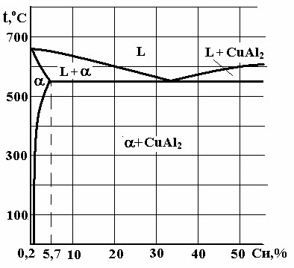 | 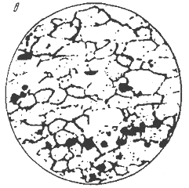
Fig.4.1. Phase diagram Al – Cu | Fig.4.2. Duralumin microstructure, x 200.

Properties
Duralumin can be very easily forged, casted and worked because it possesses low melting point. It has high tensile strength, comparable with mild steel combined with the characteristics lightness of Al. It however possesses low corrosion resistance and high electrical conductivity. This alloy possesses higher strength after heat treatment and age hardening. After working, if this alloy is age hardened for 3 or 4 days. This phenomenon is known as age hardening. It hardens spontaneously when exposed to room temperature. This alloy is soft enough for a workable period after it has been quenched. It is light in weight as compared to its strength in comparison to other metals. It can be easily hot worked at a temperature of 500°C. However after forging and annealing, it can also be cold worked.
Applications
Duralumin is used in the wrought conditions for forging, stamping, bars, sheets, tubes, bolts, and rivets. Due to its higher strength and lighter weight, this alloy is widely used in automobile and aircraft components. To improve the strength of duralumin sheet, a thin film of Al is rolled along with this sheet. Such combined sheets are widely used in air-craft industries. It is also employed in surgical and orthopedic work, non-magnetic work and measuring instrument parts constructing work.

Y -alloy
Y-Alloy is also called copper-aluminium alloy. The addition of copper to pure aluminium increases its strength and machinability. Its composition contains following chemical content: Copper = 3.5-4.5%, Manganese = 1.2-1.7%, Nickel = 1.8-2.3%, Silicon, magnesium, iron = 0.6% each, Aluminium = 92.5%.
Properties
The addition of copper in aluminium increases its strength and machinability. Y-alloy can be easily cast and hot worked. Like duralumin, this alloy is heat treated and age hardened. The age-hardening process of Y-alloy is carried out at room temperature for about five days.
Applications
Y-Alloy is mainly used for cast purposes, but it can also be used for forged components like duralumin. Since Y -alloy has better strength than duralumin at high temperatures, therefore it is much used in aircraft engines for cylinder heads, pistons, cylinder heads, crank cases of internal combustion engines die casting, pump rods etc.
Magnalium
It is made by melting the aluminium with 2-10% magnesium in a vacuum and then cooling it in a vacuum or under a pressure of 100 to 200 atmospheres.
Magnalium is an alloy of aluminium, magnesium, copper, nickel and tin etc. It contains
Al = | 85 to 95%, | Cu = | 0 to 25%, | Mg = | 1 to 5%,
Ni = | 0 to 1.2%, | Sn = | 0 to 3%, | Fe = | 0 to 0.9%,
Mn = | 0 to 0.03%, | Si = | 0.2 to 0.6%.

Properties
Magnalium is light in weight and brittle. This alloy possesses poor castability and good machinability. It can be easily welded.
Applications
Due to its light weight and good mechanical properties, it is mainly used for making aircraft and automobile components.

Silumina
Common casting aluminium alloys are alloys of the Al-Si system (6 ... 13% Si). Diagram of the system Al - Si is of eutectic type (fig.6.3). Adding mixture of 2/3 NaF and 1/3 NaCl or 2/3 KF і 1/3 KCl or 0,05 % Sr improves strength of these alloys. This process called modification.
Alloying Cu, Mg, Zn improves strength, especially after quenching and aging; Ti, Zr, B crush grain and increase the dispersion of the eutectic components; Mn improves corrosion resistance; Ni, Fe increase the heat resistance of casting aluminium alloys.

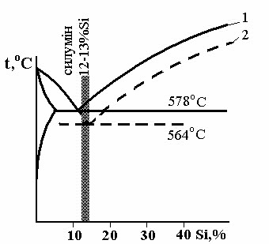 | 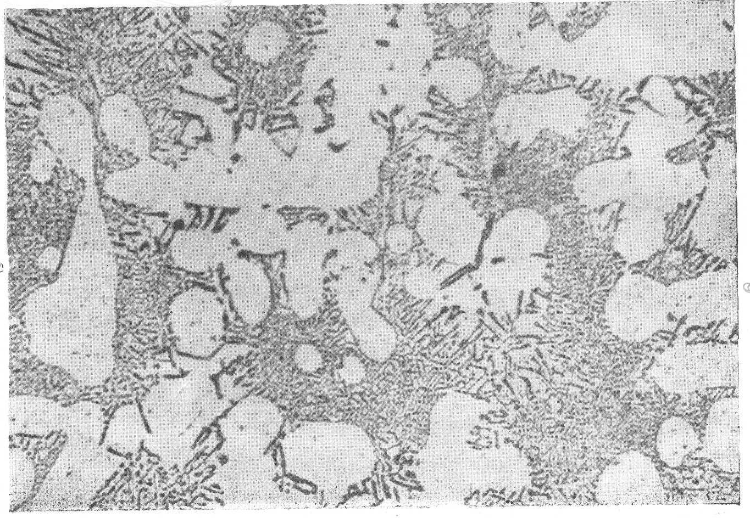
Fig.4.3. Phase diagram Al – Si. | Fig. 4.4. Silumina microstructure, x 200.

Copper

Copper is a very useful material. The remaining copper is approximately 99% pure. This is referred to as blister copper and is further refined to remove other impurities. The final ‘‘tough-pitch’’ copper has a purity of about 99.5%, which is suitable for many alloys. A higher purity of 99.9% can be obtained by electrolytic refinement of the tough-pitch copper.
It has excellent electrical and thermal conductivity properties, is malleable and machinable, but has low mechanical properties. Its tensile strength varies from 300 to 470 MPa and melting point is 1083°C. It is one of the best conductors of heat and it is highly resistant to corrosion. This non ferrous metal can withstand severe bending and forging without failure. If copper is heated to red heat and cooled slowly it becomes brittle, but if cooled rapidly it becomes soft, malleable and ductile. It can be welded at red heat.
The physical properties of copper which are of the most interest are the electrical and thermal conductivities. The recognized standard for metal electrical conductivity is the International Annealed Copper Standard (IACS). The conductivity is reduced by alloying. For example, alloy C71500 has a nickel content of 30% which reduces the conductivity to only 4% IACS.
Copper and its alloys are very easily fabricated; they can be shaped by the common forming processes. They can be cold-rolled, stamped, drawn, bent, and headed as well as being extruded, forged, and rolled at elevated temperatures. Annealing is required for some copper alloys that work-harden during cold working more rapidly than others.
All copper alloys are machinable using standard tooling. All but the hardest alloys can be machined using high-speed tool steels. Free-cutting copper alloys should be used for screw machine production.

A wide choice of means of joining copper alloys is available. They can be joined by soldering, brazing, welding, and mechanical means such as crimping, riveting, and bolting. During welding and brazing operations it is necessary to take into account the high thermal conductivities of copper
All copper alloys are machinable using standard tooling. All but the hardest alloys can be machined using high-speed tool steels. Free-cutting copper alloys should be used for screw machine production.

A wide choice of means of joining copper alloys is available. They can be joined by soldering, brazing, welding, and mechanical means such as crimping, riveting, and bolting. During welding and brazing operations it is necessary to take into account the high thermal conductivities of copper
Properties
The mechanical and physical properties of copper are shown in Table 4.1
TABLE 6.1 Mechanical and Physical Properties of Wrought Copper
Property | Alloy
Property | C11000  spring H08 | hard rod  H04 | C10800  tube H55
Modulus of elasticity 10⁶ (psi) | 17 | 17 | 17
Yield strength 0.5% ext. (ksi) | 500 | 44 | 32
Elongation (%) | 4 | 16 | 25
Rockwell hardness | B-60 | B-47 | B-35
Field strength 10⁸ cycles (ksi) | 14 | — | —
Shear strength (ksi) | — | 27 | 26
Density (lb/in.³) | 0.323 | 0.323 | 0.323
Coefficient of thermal expansion at | 9.8 | 9.8 | 9.8
70–572 F, (10 ⁶/ F)
Thermal conductivity (Btu/ft²/ft/hr/ F) | 226 | 202 | 202
Specific heat | 0.092 | 0.092 | 0.092
Electrical conductivity (% IACS) | 101 | 92 | 92

Applications

Applications such as heat exchangers, condensers, and other heat transfer devices take advantage of the high thermal conductivity of copper and its alloys. As temperatures increase, the thermal conductivity of many copper alloys increases, unlike most metals. Alloying reduces the thermal conductivity.

Copper alloys are used primarily for room temperature applications. Heat transfer apparatus applications are the exception. Most copper alloys can be used to 200 C.
Because of the good electrical properties of copper, it is used primarily in electrical or electronic applications such as bus bars, waveguides, wire, switches, and transfer components. Since copper is a noble metal it also finds many applications in corrosive environments.

Copper Alloys
In order to obtain strength the metal must be cold worked or alloyed. As a result there are hundreds of copper alloys. The Copper Development Association, together with the American Society of Testing and Materials and the Society of Automotive Engineers, has developed a five-digit system to identify these alloys. The system is part of the Unified Numbering System for Metals and Alloys. The numbers C-10000 through C79999 denote the wrought alloys, while the cast copper and copper alloys are numbered C80000 through C99999. This designation system is used throughout North America, Australia, and Brazil. Each number refers to a specific alloy composition. The UNS numbers for specific groups of wrought alloys are given in Table 6. along with applications for each specific group.

There are more than 100 temper designations for copper and copper alloys. These may be found in ASTM B601 ‘Standard Practice for Temper

TABLE 4.2. Unified Numbering System for Wrought Copper and Copper Alloys

UNS no. | Application
Coppers
C10100 to C15999 | General for group; high electrical conductivity requirements
C10100 to C10700 | Highest conductivity coppers
C11000 | Electrical wire and cable
C12200 | Household water tube
C12800 | Refrigerators, air conditioners, and gasoline
C14200, C14300 | Contacts, terminals; resists softening when soldered
C15215 to C16200 | Electrical components, lead frames, integrated circuits
High copper alloys
C16200 to C19199 | General for group; electrical and electronic connectors and
 | contacts
C17000 to C17300 | Highest strength copper-beryllium alloys; bellows, dia-
 | phragms, fasteners, relay parts
C18000 | Switches, circuit breakers, contacts
C18200 to C18300 | Cable connectors, electrodes, arcing and bridging parts
C19400 | Terminals, flexible hose, gaskets, fuse clips
Copper-zinc brasses
C21000 to C28000 | General; sheet for stamping, springs, electrical switches
 | and sockets, plumbing
C23000 | Red brass, condenser and heat exchanger tubes, plumb-
 | ing, architectural trim
C26000 to C26200 | Cartridge brass, radiator cores, hardware, ammunition,
 | plumbing accessories
C26800 | Muntz metal, architectural sheet and trim, large nuts and
 | bolts, brazing rod
Copper-zinc-lead
brasses
C31200 to C38500 | General for group; leaded brasses, high machinability
 | requirements
C34500 | Clock parts, gears, wheels
C36000 | Free-cutting brass, screw machine materials, gears,
 | pinions
C37700 | Forging brass
Copper- zinc-tin
brasses
C40400 to C48600 |  | General; corrosion resistance and higher strength
 |  | requirements
C42500 |  | Supplied as strip for fabricating electrical connectors,
 |  | springs, terminals
C46400 to C46700 |  | Naval brass, marine hardware, propeller shafts, structural
 |  | uses
C48200 to C48500 |  | Free machining, marine hardware, valve stems, screw ma-
 |  | chine products
Copper-aluminum
bronzes
C60800 to C64210 |  | General; combine high strength and excellent corrosion
 |  | resistance
C61000 |  | Marine hardware, pumps, valves, nuts, bolts, shaft tie
 |  | rods, machine parts, condenser tubing
C63000 |  | Nuts, bolts, marine shafts, aircraft parts, forgings
Copper-silicone
bronzes
C64700 to C66100 |  | General; properties similar to aluminum bronzes; excellent
 |  | weldability; hydraulic fluid lines, high strength fasteners,
 |  | wear plates, marine hardware
Copper-nickel
C70100 to C72950 |  | General; excellent corrosion resistance, strength retention
 |  | at high temperatures, condenser tubes, marine products
Copper-zinc-nickel
C73500 to C79800 |  | Good corrosion resistance with moderately high strength,
 |  | silver luster; food and beverage handling equipment,
 |  | decorative hardware, hollow-ware

Designations for Copper and Copper Alloys—Wrought and Cast. Wrought copper and copper alloys can be divided into the following groups:
Coppers Metal which has a minimum copper content of 99.3%copper.
High copper alloys Alloys which contain 96.0 to 99.3% copper.
Brasses
Brasses are alloys which have zinc as the major alloying element.This group contains the copper-zinc alloys, the copper-zinc-lead alloys (leaded brass), and the copper-zinc-tin alloys (tin brasses).
Phase diagram Cu–Zn and properties brasses are in the fig. 6.6.
Alpha Phase
If the copper crystal structure is face centered cubic (FCC), there will be up to 39% of zinc. This solid solution is known as alpha brass. It has good mechanical properties, good corrosion resistance but it possesses lower electrical conductivity than copper.
Beta Phase
If the amount of zinc increases beyond 39%, beta brass will appear in the microstructure of the slowly cooled brass. This has body centered cubic structure (BCC). This phase is hard but quite tough at room temperature.

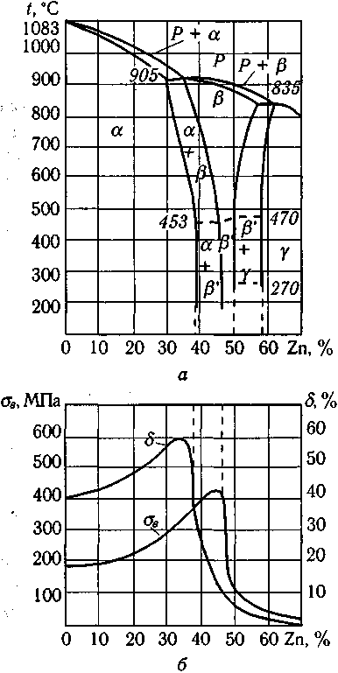

Fig.4.5. Phase diagrame Cu–Zn and properties brasses.
Microstructure of cast and wrought alpha brasses are shown in the fig.4.7.
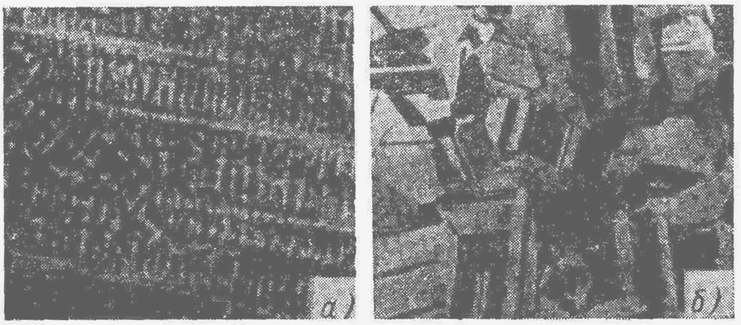
Fig.4.6. Microstructure of cast (a) and wrought (b) alpha brasses brasses.

Bronzes
Bronze is a common alloy of copper and tin. The alloys of copper and tin are generally termed as bronzes. The wide range of composition of these alloys comprise of 75 to 95% copper and 5 to 25% tin.
Four major families of bronze exist: copper-tin-phosphorus (phosphor bronzes), copper-tin-lead-phosphorus (leaded phosphor bronzes), copper-tin-nickel alloys (nickel-tin bronzes), and copper-aluminum alloys (aluminum bronzes).

For the most part copper alloys to a large extent attain their mechanical properties through different amounts of cold work. The main exceptions are the copper-beryllium alloys (the highest strength copper alloys), the aluminum bronzes, and some copper-chromium alloys. The aluminum bronzes are the second highest strength copper alloy group. Their high strengths are achieved by means of heat treatments that produce second phase particles.
Properties

Bronze has higher strength, better corrosion resistance than brasses. It is comparatively hard and resists surface wear and can be shaped or rolled into wire, rods and sheets very easily. It has antifriction or bearing properties. Bronze is costlier than brass. The tensile strength of bronze increases gradually with the amount of tin, reaching a maximum when tin is about 20%. However the percentage of tin content if increases beyond this amount, the tensile strength decreases very rapidly. Bronze is most ductile when it contains about 5% of tin. As the amount of tin increases about 5%, the ductility gradually decreases and practically disappears with about 20% of tin. Whereas presence of zinc in the bronze increases fluidity of molten metal, strength and ductility.
Applications
Phosphorus bronze is used making for bolts, electric contact springs, bearings, bushes, gears, ship sheathing, valve parts, propeller blades, worm wheels, gears, nuts for machine lead screws, pump parts, linings and for many other purposes. It is also suitable for making springs and corrosion resistance mine cables. Silicon bronze is widely used for making boilers, tanks, stoves or where high strength and good corrosion resistance is required. It is used also for making screws, tubing’s, pumps etc. Beryllium bronze is particularly suitable material for making springs, tubes, diaphragms and electrical contacts, heavy duty electrical switches, cams and bushings. This is used for springs, heavy duty electrical switches, cams and bushings. Aluminium bronze is generally used for making fluid connection fittings, gears, propellers, air pumps, bushings, tubes, slide and valves etc. Cams and rollers are commonly produced using this alloy.

Phase diagram Cu–Sn and properties bronze are in the fig. 4.7.

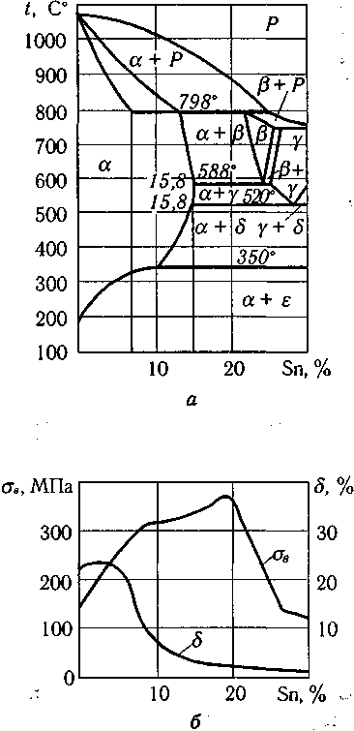
Fig. 4.7. Phase diagrame Cu–Sn and properties bronzes.

Microstructure of the Cu—4 wt.% Sn bronze after cast and anneling show in the fig.4.8.

 | 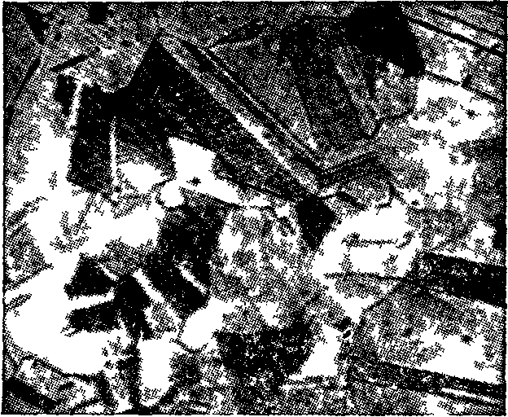
a) | b)
Fig.4.8. Microstructure of the Cu—4 wt.% Sn bronze after cast (a) and anneling (b) , x 200.

Materials and Equipment:
- Specimen of the duralumin, silumina, brass and bronze
- Microscope MM – 4.
Procedure:
1. Set specimen of the duralumin, silumina on a microscope and look at their microstructure.
2. Write chemical composition, according to the literature indicate mechanical properties and applications of the duralumin and silumina.
3. Draw the microstructure of the duralumin and silumina.
4. Draw phase diagrams of the Al - Cu, Al - Si. Describe the phase transformations in alloys.
5. Set specimen of the brass and bronze on a microscope and look at their microstructure.
6. Write chemical composition, according to the literature indicate mechanical properties and applications of the brass and bronze.
7. Draw the microstructure of the brass and bronze.
8. Draw phase state diagram Cu-Zn, Cu-Sn Describe the phase transformations in alloys.
9. Fill the protocol report.

Questions:
  - Describe properties of pure aluminium.
2. Applications of pure aluminium.
- Classification of aluminium alloys.
- Describe properties and applications of the duralumin.
- Explain duralumin heat treatment.
- Describe properties and applications of the silumin.
- What is the silumin modification?
- Describe properties of pure copper.
- Applications of pure copper.
- Classification of copper alloys.
- Describe brasses, their applications, chemical composition and microstructure (using diagrams of Cu-Zn).
- Describe bronzes, their applications, chemical composition and microstructure (using diagrams of (explain using a diagram Cu - Sn).

LABORATORY WORK 4
ALUMINIUM, COPPER AND THEIR ALLOYS

PROTOCOL №1

Wrought aluminium alloy __________duralumin________________________________

Chemical composition, % wt.________________________________________

Manufacturing method______________________________________________________
Mechanical properties:
Tensile strength,σ_{ts}, МPа _______________________________
Elongation,δ, % _______________________________________
Hadness, НВ, МПа _____________________________________

Temperature, ºC | 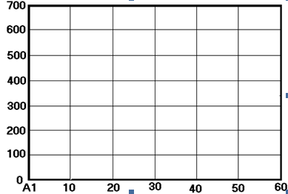

Phase diagram Al – Cu

Describe the phase transformations in alloys
__________________________________________________________________________________________________________________________________________________________________________

Duralumin microstructure, x____

Applications:____________________________________________________________________________________________________________________________________

PROTOCOL №2

Cast aluminium alloy __________silumina________________________________

Chemical composition, % wt.___________________________________________

Manufacturing method______________________________________________________

Mechanical properties:
Tensile strength,σ_{ts}, МPа _______________________________
Elongation,δ, % _______________________________________
Hadness, НВ, МПа _____________________________________

Temperature, ºC | 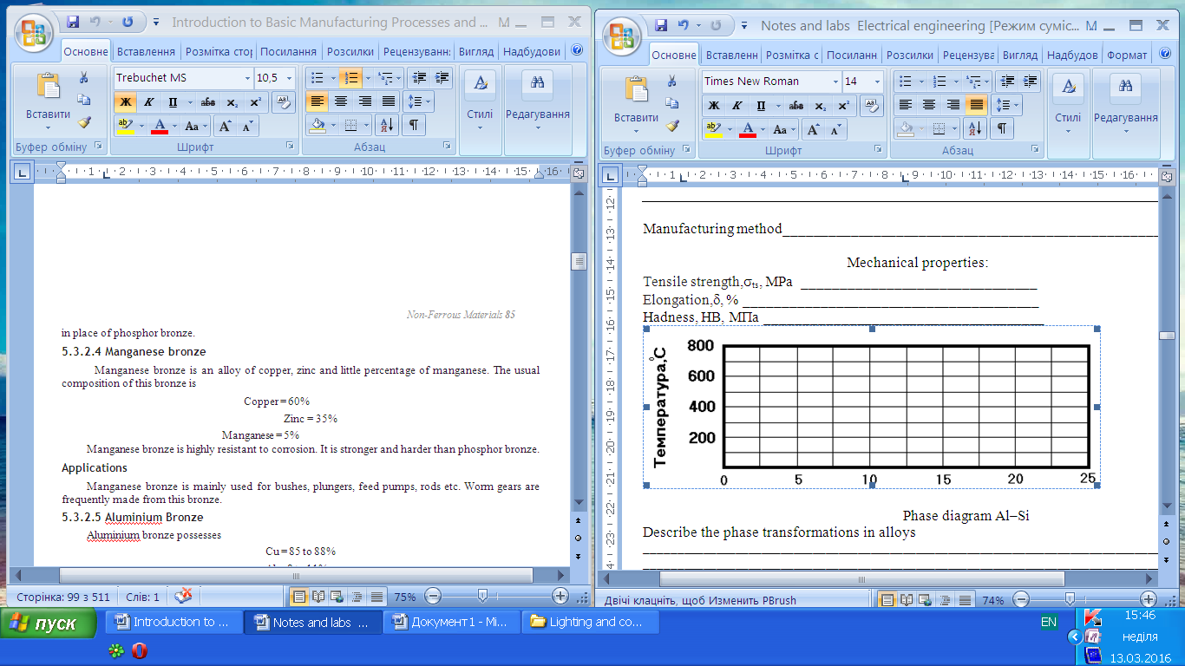

Phase diagram Al–Si

Describe the phase transformations in alloys
__________________________________________________________________________________________________________________________________________________________________________

Silumina microstructure, x____

Applications:_____________________________________________________________________________________________________________________________________

PROTOCOL №3

Wrought copper alloy __________ Alpha Brass _________________________________

Chemical composition, % wt._________________________________________________

Manufacturing method______________________________________________________

Mechanical properties:
Tensile strength,σ_{ts}, МPа _______________________________
Elongation,δ, % _______________________________________
Hadness, НВ, МПа _____________________________________

Temperature, ºC | 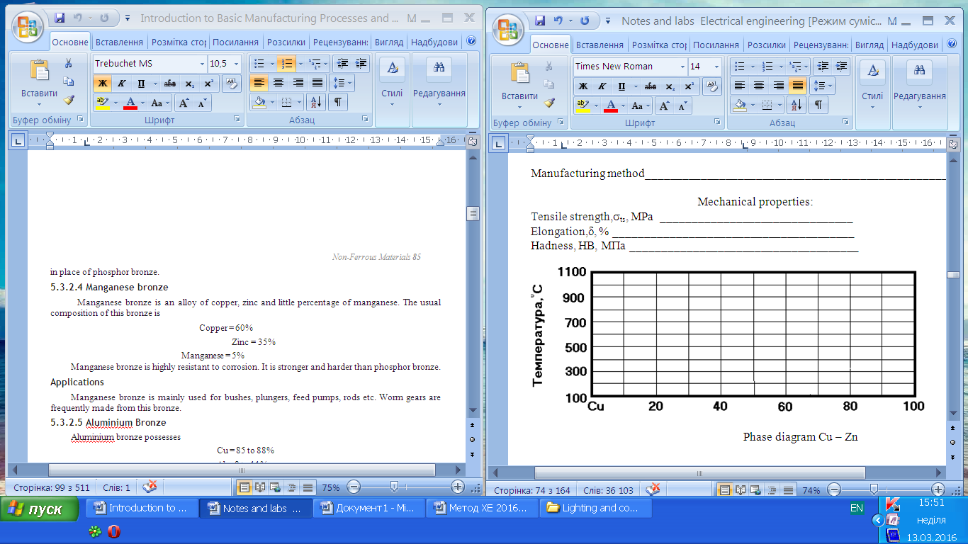

Phase diagram Cu – Zn

Describe the phase transformations in alloys

______________________________________________________________________________________________________________________________

Alpha brass microstructure, x____

Applications:_____________________________________________________________________________________________________________________________________

PROTOCOL №4

Cast cooper alloy __________cooper– tin bronze_________________________

Chemical composition, % wt._________________________________________

Manufacturing method______________________________________________________

Mechanical properties:
Tensile strength,σ_{ts}, МPа _______________________________
Elongation,δ, % _______________________________________
Hadness, НВ, МПа _____________________________________

Temperature, ºC | 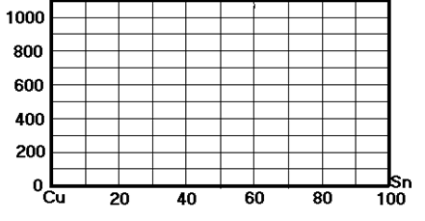

Phase diagram Cu – Sn

Describe the phase transformations in alloys

______________________________________________________________________________________________________________________________

Cooper– tin bronze microstructure, x____

Applications:____________________________________________________________________________________________________________________________________
Conclusion: ________________________________________________________________________________________________________ _________________________
Student’s signature Teacher’s signature
“____”___________20___ y. “____”____________20___ y.
GLOSSARY
Abrasive: A hard material used to grind, cut or wear.
Absorption: The inclusion of the energy of a photon within a substance.
Amorphous: A noncrystalline substance, atoms lack long range order.
Annealing: Heat treatment to alter properties.
Annealing point (glass): Temperature at which stresses are removed.
Atomic vibration: Movement of an atom within a substance.
Band gap energy: Energy difference between the valence and conduction bands.
Brittle fracture: A break that occurs by rapid crack propagation.
Capacitance (C): Charge storing capability.
Cement: A material that binds particles together in a mixture.
Ceramic: A compound of metallic and nonmetallic elements.
Color: Wavelengths of light perceived by the eye.
Component: A part, or device. Conduction band: Carries the excited conduction electrons.
Conductivity: The ability to carry an electric current (electricity) or thermal energy (heat).
Covalent bond: Bonding by sharing electrons.
Crystalline: A solid with a repeating three-dimensional unit cell.
Crystal structure: The orderly arrangement of the atoms or ions within a crystal.
Diamagnetism: Weakly repelled from a magnetic field.
Dielectric: An insulator.
Dielectric constant: Relative electrical permittivity of a material as compared to a perfect vacuum.
Dielectric (breakdown) strength: The amount of electricity needed to start an electric current flow in a dielectric material.
Ductile fracture: Break accompanied by large plastic deformation.
Elastic deformation: Change in shape that returns when a stress is removed.
Elastic Modulus: Ratio of stress to strain in elastic deformation, measure of elasticity.
Electric field: The gradient of voltage.
Electronegativity: The attraction of an atom for shared electrons.
Electron volt (eV): Unit of energy equivalent to the energy gained by an electron when it falls through an electric potential of one volt.
Excited state: An energy state to which an electron may move by the absorption of energy.
Fiber Optics: The technology of transferring information as light pulses through long thin fibers, usually made of glass.
Firing: High temperature processing to increase densification in a product.
Fluorescence: Light that is emitted a short period of time after an electron has been excited.
Fracture toughness (Kc): Measure of a material's resistance to crack propagation.
Glass: An amorphous solid showing characteristic specific volume behavior over a certain temperature range.
Glass - ceramic: Crystalline ceramic material that was formed by heat treating glass.
Glass transition temperature (Tg): Temperature at which a glass changes from a supercooled liquid into a solid.
Grain: Individual crystal in a polycrystalline material.
Grain boundary: The boundary between grains (or crystals) that are misoriented with respect to one another.
Green ceramic body: Ceramic object that is dried but not fired.
Ground state: Lowest electron energy state.
Hardness: Resistance to deformation.
Heat capacity: Heat required to produce a unit increase in temperature per quantity of material.
Imperfection: Flaw, any deviation from perfection, as in a crystal.
Index of refraction: Ratio of the speed of light in a vacuum to the speed of light in a medium.
Insulator: Material that does not conduct electricity (electrical) or heat (thermal).
Ionic bond: Electrostatic force between oppositely charged ions.
Laser: Source of coherent light (Light Amplification by Stimulated Emission of Radiation).
Lattice: The regular arrangement of points in a crystal.
Luminescence: Emission of visible light when an electron returns to the ground state from an excited state.
Magnetic field strength: Intensity of an applied magnetic field.
Microstructure: Structural features that can be observed with a microscope.
Noncrystalline: Amorphous, with no long-range atomic order.
Opaque: Material that does not transmit light.
Phonon: Quantum of vibrational energy.
Phosphorescence: Luminescence that lasts for more than one second.
Photovoltaic cells: A device capable of converting light energy to electricity.
Photoconductivity: Electrical conductivity induced by light.
Photon: Quantum of electromagnetic energy.
Piezoelectric: Material that produces an electrical response to a mechanical force.
Plastic deformation: Permanent deformation, change of shape.
Polycrystalline: Composed of more than one crystal or grain.
Porcelain: A durable ceramic composite made by firing clay, feldspar and quartz together.
Reflection: Deflection of light at the interface between two materials.
Refraction: Bending of light as it passes from one medium into another.
Refractory: Material that can be exposed to high temperature without deterioration.
Resistivity: Measure of resistance to passage of electrical current (reciprocal of conductivity).
Semiconductor: Nonmetallic material that has a relatively narrow energy band gap.
Sintering: Coalescence of individual ceramic particles into a continuous solid phase at a high temperature.
Slip: Mixture of clay with water that can be poured into a mold.
Slip casting: Method of making ceramic objects by pouring slip into a mold.
Softening point (glass): Maximum temperature a glass can be heated before it permanently deforms.
Smart materials: Materials able to detect a change in the environment and react to it.
Specific volume: Volume per unit mass, reciprocal of density.
Strain: Change in length of a sample in the direction of an applied stress.
Stress: Force applied to a sample divided by its cross-sectional area.
Structural clay products: Ceramic objects made mainly of clay and used in structural applications.
Structure: Arrangement of internal components.
Superconductivity: Disappearance of electrical resistivity at low temperatures.
Supercooling: Cooling below the normal temperature for a phase change, without the change occurring.
Tensile strength: Maximum stress without fracture.
Thermal expansion coefficient, linear: Fractional change in length divided by change in temperature, a measure of a materials tendency to expand when heated.
Thermal stress: Residual stress caused by a change in temperature.
Thermal tempering: The introduction of residual compressive stresses to increase the strength of glass.
Toughness: Energy absorbed by a material as it fractures, a measure of its resistance to fracture.
Transgranular fracture: Fracture by crack propagation through the grains.
Translucent: Transmits light diffusely.
Transparent: Transmits light clearly.
Unit cell: The basic repeating unit in a crystal.
Whiteware: Clay-based ceramic that turns white after firing.

Glossary Metals
activity series: also known as the Electromotive Force Series. This is a listing of the
elements according to their potential differences and ability to place other elemental
ions in solution.
alloy: a substance that has metallic properties and is made up of two or more chemical
elements, of which at least one is a metal.
annealing: a heat treatment of a metal designed to produce a soft, ductile condition.
Typically the metal is heated and allowed to cool slowly.
anode: electrode at which electrons are released during corrosion. The half reaction at the anode is called oxidation and the metal is said to be oxidized. The anode is the
electrode that disintegrates during corrosion.
bronze: An alloy composed of tin and copper.
cathode: electrode which accepts electrons during corrosion. The half reaction at the
cathode is called reduction and the metal is said to be reduced. The cathode is not destroyed during corrosion.
cathodic protection: a more active metal is placed next to a less active metal. The more
active metal will serve as an anode and will be corroded instead of the less active metal. The anode is then called a sacrificial anode.
cold-working: a permanent deformation of a metal below its crystallization temperature.
Deforming the metal creates more dislocations which entangle, pinning them and thereby strengthening the metal.
corrosion: oxidation-reduction reaction where electrons are released at the anode and
taken up at the cathode.
dislocations: linear defects in a crystal.
ductile: can be drawn or stretched into wire and other shapes.
elastic deformation: materials return to their original shape after a small load or stress
is applied.
face-centered cubic: crystal arrangement of close-packed layers of particles where three
layers of particles alternate positions. This layering is known as ABCABC.
failure: ultimate separation of metal parts due to applied loads. i.e. it breaks.
fatigue: the application and release of stresses as metal is used which cause small cracks
to grow, during many cycles of application, until they fracture.
grain: a crystal (ordered arrangement of atoms).
grain boundary: the interface between the grains or crystals.

Hall Process: an electrolytic technique to refine aluminum from its ore.
hardening: heating and rapidly cooling steel.
heat treating: modification of properties and structure of alloys by specific heating and
cooling cycles.
hexagon closest packing (HCP): crystal arrangement of layers of particles where
two layers alternate positions. The layering is known as ABAB.
malleable: can be hammered into a sheet.
martensite: a super-saturated solid solution of carbon in ferrite. The carbon atoms
distort the BCC ferrite into a BC-tetragonal structure.
metallic bonding: bond formed by positive ions surrounded by a sea of valence electrons.
ore: a natural mineral deposit that contains enough valuable minerals to make it profitable
to mine at the current technology.
oxide: a compound of oxygen with some other chemical element.
oxidation: the half of an electrochemical reaction where electrons are released. Oxidation
occurs at the electrode called the anode.
pinned: the dislocations in a crystal get tangled or attached to atoms of an alloying agent.
plastic deformation: materials remain deformed after a load is added and then removed.
quenched: cooled rapidly.
reduction: the half of an electrochemical reaction where electrons are taken up. Reduction occurs at the cathode.
reduction of metals: changing a metal ion to a neutral atom by the addition of electrons.

steel: an iron-carbon alloy, malleable in some temperature range as initially cast. Steel
usually contains some other alloying elements such as silicon, manganese, etc. as
well as impurities such as sulfur and phosphorus.
strength: a measure of the ability of a material to support a load.
stress: the internal forces produced by application of an external load, tending to displace
component parts of the stressed material. It is defined as the force (load) divided by
the area on which it acts.
toughness: the ability to aborb energy of deformation without breaking. High toughness requires both high strength and high ductility.
unit cell: The smallest repeating array of atoms in a crystal.

GLOSSARY Ceramic

Abrasive: A hard material used to grind, cut or wear.
Absorption: The inclusion of the energy of a photon within a substance.
Amorphous: A noncrystalline substance, atoms lack long range order.
Annealing: Heat treatment to alter properties.
Annealing point (glass): Temperature at which stresses are removed.
Atomic vibration: Movement of an atom within a substance.
Band gap energy: Energy difference between the valence and conduction bands.
Brittle fracture: A break that occurs by rapid crack propagation.
Capacitance (C): Charge storing capability.
Cement: A material that binds particles together in a mixture.
Ceramic: A compound of metallic and nonmetallic elements.
Color: Wavelengths of light perceived by the eye.
Component: A part, or device.
Conduction band: Carries the excited conduction electrons.
Conductivity: The ability to carry an electric current (electricity) or thermal energy (heat).
Covalent bond: Bonding by sharing electrons.
Crystalline: A solid with a repeating three-dimensional unit cell.
Crystal structure: The orderly arrangement of the atoms or ions within a crystal.
Diamagnetism: Weakly repelled from a magnetic field.
Dielectric: An insulator.
Dielectric constant: Relative electrical permittivity of a material as compared to a perfect vacuum.
Dielectric (breakdown) strength: The amount of electricity needed to start an electric current flow in a dielectric material.
Ductile fracture: Break accompanied by large plastic deformation.
Elastic deformation: Change in shape that returns when a stress is removed.
Elastic Modulus: Ratio of stress to strain in elastic deformation, measure of elasticity.
Electric field: The gradient of voltage.
Electronegativity: The attraction of an atom for shared electrons.
Electron volt (eV): Unit of energy equivalent to the energy gained by an electron when it falls through an electric potential of one volt.
Excited state: An energy state to which an electron may move by the absorption of energy.
Fiber Optics: The technology of transferring information as light pulses through long thin fibers, usually made of glass.
Firing: High temperature processing to increase densification in a product.
Fluorescence: Light that is emitted a short period of time after an electron has been excited.
Fracture toughness (Kc): Measure of a material's resistance to crack propagation.
Glass: An amorphous solid showing characteristic specific volume behavior over a certain temperature range.
Glass - ceramic: Crystalline ceramic material that was formed by heat treating glass.
Glass transition temperature (Tg): Temperature at which a glass changes from a
supercooled liquid into a solid.
Grain: Individual crystal in a polycrystalline material.
Grain boundary: The boundary between grains (or crystals) that are misoriented with respect to one another.
Green ceramic body: Ceramic object that is dried but not fired.
Ground state: Lowest electron energy state.
Hardness: Resistance to deformation.
Heat capacity: Heat required to produce a unit increase in temperature per quantity of material.
Imperfection: Flaw, any deviation from perfection, as in a crystal.
Index of refraction: Ratio of the speed of light in a vacuum to the speed of light in a medium.
Insulator: Material that does not conduct electricity (electrical) or heat (thermal).
Ionic bond: Electrostatic force between oppositely charged ions.
Laser: Source of coherent light (Light Amplification by Stimulated Emission of Radiation).
Lattice: The regular arrangement of points in a crystal.
Luminescence: Emission of visible light when an electron returns to the ground state from an excited state.
Magnetic field strength: Intensity of an applied magnetic field.
Microstructure: Structural features that can be observed with a microscope.
Noncrystalline: Amorphous, with no long-range atomic order.
Opaque: Material that does not transmit light.
Phonon: Quantum of vibrational energy.
Phosphorescence: Luminescence that lasts for more than one second.
Photovoltaic cells: A device capable of converting light energy to electricity.
Photoconductivity: Electrical conductivity induced by light.
Photon: Quantum of electromagnetic energy.
Piezoelectric: Material that produces an electrical response to a mechanical force.
Plastic deformation: Permanent deformation, change of shape.
Polycrystalline: Composed of more than one crystal or grain.
Porcelain: A durable ceramic composite made by firing clay, feldspar and quartz together.
Reflection: Deflection of light at the interface between two materials.
Refraction: Bending of light as it passes from one medium into another.
Refractory: Material that can be exposed to high temperature without deterioration.
Resistivity: Measure of resistance to passage of electrical current (reciprocal of conductivity).
Semiconductor: Nonmetallic material that has a relatively narrow energy band gap.
Sintering: Coalescence of individual ceramic particles into a continuous solid phase at a high temperature.
Slip: Mixture of clay with water that can be poured into a mold.
Slip casting: Method of making ceramic objects by pouring slip into a mold.
Softening point (glass): Maximum temperature a glass can be heated before it permanently deforms.
Smart materials: Materials able to detect a change in the environment and react to it.
Specific volume: Volume per unit mass, reciprocal of density.
Strain: Change in length of a sample in the direction of an applied stress.
Stress: Force applied to a sample divided by its cross-sectional area.
Structural clay products: Ceramic objects made mainly of clay and used in structural applications.
Structure: Arrangement of internal components.
Superconductivity: Disappearance of electrical resistivity at low temperatures.
Supercooling: Cooling below the normal temperature for a phase change, without the change occurring.
Tensile strength: Maximum stress without fracture.
Thermal expansion coefficient, linear: Fractional change in length divided by change in temperature, a measure of a materials tendency to expand when heated.
Thermal stress: Residual stress caused by a change in temperature.
Thermal tempering: The introduction of residual compressive stresses to increase the strength of glass.
Toughness: Energy absorbed by a material as it fractures, a measure of its resistance to fracture.
Transgranular fracture: Fracture by crack propagation through the grains.
Translucent: Transmits light diffusely.
Transparent: Transmits light clearly.
Unit cell: The basic repeating unit in a crystal.
Whiteware: Clay-based ceramic that turns white after firing.
Glossary Polymers

Abbreviations:
HDPE: high density polyethylene
LDPE: low density polyethylene
PET: polyethylene terephthalate
PP: polypropylene
PS: polystyrene
PVA: polyvinyl alcohol
PVC: polyvinyl chloride
addition polymerization: a chemical reaction in which simple molecules are linked together to form long chain molecules.
amorphous: non-crystalline polymer or non-crystalline areas in a polymer.
Bakelite: a polymer produced by the condensation of phenol and formaldehyde.
branched polymer: polymer having smaller chains attached to the polymer backbone.
cellulose: a natural polymer found in wood and other plant material.
composite polymer: a filled or reinforced plastic.
condensation polymer: one in which two or more molecules combine resulting in elimination of water or other simple molecules, with the process being repeated to form a long chain molecule.
configuration: related chemical structure produced by the making and breaking of primary valence bonds.
copolymer: a macromolecule consisting of more than one type of building unit.
creep: cold flow of a polymer.
cross-linking: occurs when primary valence bonds are formed between separate polymer chain molecules.
crystalline polymer: polymer with a regular order or pattern of molecular arrangement and a sharp melting point.
dimer: a polymer containing two monomers.
domains: sequences or regions in block copolymers.
elastomer: a type of polymer that exhibits rubber-like qualities.
Ekonol: a moldable, high temperature polymer.
end group: functional group at the end of a chain in polymers, e.g. carboxylic group.
extrusion: a fabrication process in which a heat-softened polymer is forced continually by a screw through a die.
filler: a relatively inert material used as the discontinuous phase of a polymer composite.
free radical: A chemical component that contains a free electron which covalently bonds with a free electron on another molecule.
homopolymer: a macromolecule consisting of only one type of building unit.
initiation: the start of a chain reaction with a source such as free radicals, peroxides, etc.
kevlar: a high strength polymer which can withstand high temperatures.
linear: polymers made up of one long continuous chain, without any excess
appendages or attachments.
macromolecule: a polymer.
material: a substance useful for structural purposes.
monomer: smallest repeating unit of a polymer.
nylon: a polymer used commonly in the textiles industry.
oligomer: a low molecular weight polymer in which the number of repeating units is approximately between two and ten.
polyethylene: the most extensively produced polymer.
polyester: a polymer with a COOR repeating unit.
polymer: a high molecular weight macromolecule made up of multiple repeating units.
polymerization: the chemical reaction in which high molecular mass molecules are formed from monomers.
polystyrene: a polymer commonly used in packaging.
propagation: the continuous successive chain extension in a polymer chain reaction.
Tg: glass transition temperature below which a polymer is a hard glassy material.
thermoplastic: a polymer which may be softened by heat and hardened by cooling in a reversible physical process.
thermoset: a network polymer obtained by cross-linking a linear polymer to make it infusible or insoluble.
Tm: melting temperature.
Van der Waals forces: intermolecular attractions.
viscosity: the resistance to flow as applied to a solution or a molten solid.
vinyl chloride: the monomer used in PVC production.
vulcanization: cross-linking with heat and sulfur to toughen a polymer.

Appendix 1

Composition and Applications of Few Typical Materials
No | Alloy | Composition | Uses
1 | Duralmin, | 95% Aluminium + 4% Copper+  0.5% Manganese + 0.5% Magnesium | Light structures, extruded sections and sheet
2 | Gun metal | 90% copper + 10% zinc | Small valves, fittings for water services
3 | Monel | 67% Ni + 28% Copper + remaining carbon, iron and Manganese | Valve parts for superheated steam turbine blades
4 | Phosphor bronze | 90% Copper + 9.7% Tin + 0.3% Phosphorus | Bearings, worm wheels, rods sheets
5 | High carbon steel | 0.8% to 1.5% Carbon + remaining iron | Files, dies for wire drawing, clutch disc
6 | Spheroidal CI | 3.2%-4.5% carbon 1-4% Si 0.1-8% Mn 0.1% P 0-3.5% Ni 0.05-0.1% Mn | For high wear resistance
7 | Wrought iron | 99% Pig Iron + 0.12% Carbon + 0.25% Phosphorus + 0.05 % Sulphur | Chains, crane hooks, railway couplings

Appendix 2
Room-Temperature Yield Strength and Plane Strain Fracture Toughness
Data for Selected Engineering Materials
 | Yield Strength |  | K_{lc}
Material | MPa | ksi | MPa | ksi
Aluminum alloy  (7075-T651) | Metals  495 | 72 | 24 | 22
Aluminum alloyª (2024-T3) | 345 | 50 | 44 | 40
Titanium alloyª (Ti-6Al-4V) | 910 | 132 | 55 | 50
Alloy steelª  (4340 tempered 260°C) | 1640 | 238 | 50.0 | 45.8
Alloy steelª (4340 tempered 425°C) | 1420 | 206 | 87.4 | 80.0
Concrete | Ceramics |  | 0.2-1.4 | 0.18-1.27
Soda-lime glass | — | — | 0.7-0.8 | 0.64-0.73
Aluminum oxide | — | — | 2.7-5.0 | 2.5-4.6
Polystyrene (PS) | Polymers  25.0-69.0 | 3.63-10.0 | 0.7-1.1 | 0.64-1.0
Poly(methyl methacrylate) (PMMA) | 53.8-73.1 | 7.8-10.6 | 0.7-1.6 | 0.64-1.5
Polycarbonate (PC) | 62.1 | 9.0 | 2.2 | 2.0
Appendix 3
AISI/SAE and UNS Designation Systems and Composition Ranges for Plain Carbon Steel and Various Low-Alloy Steels
AISI/SAE Designationª | UNS  Designation | Composition Ranges  (wt% of Alloying Elements in Addition to C)^{b}
AISI/SAE Designationª | UNS  Designation | Ni | Cr | Mo | Other
10xx, Plain carbon | G10xx0
11xx, Free machining | G11xx0 |  |  |  | 0.08-0.33 S
12xx, Free machining | G12xx0 |  |  |  | 0.10-0.35 S, 0.04-0.12 P
13xx | G13xx0 |  |  |  | 1.60-1.90 Mn
40xx | G40xx0 |  |  | 0.20-0.30
41xx | G41xx0 |  | 0.80-1.10 | 0.15-0.25
43xx | G43xx0 | 1.65-2.00 | 0.40-0.90 | 0.20-0.30
46xx | G46xx0 | 0.70-2.00 |  | 0.15-0.30
48xx | G48xx0 | 3.25-3.75 |  | 0.20-0.30
51xx | G51xx0 |  | 0.70-1.10
61xx | G61xx0 |  | 0.50-1.10 |  | 0.10-0.15 V
86xx | G86xx0 | 0.40-0.70 | 0.40-0.60 | 0.15-0.25
92xx | G92xx0 |  |  |  | 1.80-2.20 Si
ªThe carbon concentration, in weight percent times 100, is inserted in the place of “xx” for each specific steel.
^{b} Except for 13xx alloys, manganese concentration is less than 1.00 wt%.
Except for 12xx alloys, phosphorus concentration is less than 0.35 wt%.
Except for 11xx and 12xx alloys, sulfur concentration is less than 0.04 wt%.
Except for 92xx alloys, silicon concentration varies between 0.15 and 0.35 wt%.
Appendix 4
Mechanical Characteristics of Hot- Rolled Material and Typical Applications for Various Plain Low-Carbon and High-Strength, Low-Alloy Steels

AISI/SAE or ASTM Number | Tensile Strength [MPa (ksi)] | Yield Strength [MPa (ksi)] | Ductility [%EL in  50 mm (2 in. )] Typical Applications
 | Plain Low-Carbon Steels
1010 | 325 (47) | 180 (26) | 28 | Automobile panels,
 |  |  |  | nails, and wire
1020 | 380 (55) | 210 (30) | 25 | Pipe; structural and
 |  |  |  | sheet steel
A36 | 400 (58) | 220 (32) | 23 | Structural (bridges
 |  |  |  | and buildings)
A516 Grade 70 | 485 (70) | 260 (38) | 21 | Low-temperature
 |  |  |  | pressure vessels
 | High-Strength, Low-Alloy Steels
A440 | 435 (63) | 290 (42) | 21 | Structures that are
 |  |  |  | bolted or riveted
A633 Grade E | 520 (75) | 380 (55) | 23 | Structures used at low
 |  |  |  | ambient temperatures
A656 Grade 1 | 655 (95) | 552 (80) | 15 | Truck frames and
 |  |  |  | railway cars
Appendix 5

Typical Applications and Mechanical Property Ranges for Oil-Quenched and Tempered Plain Carbon and Alloy Steels

AISI  Number | UNS  Number | Tensile Strength [MPa (ksi)] | Yield Strength [MPa (ksi)] | Ductility [%EL in 50 mm (2 in.)] |  | Typical Applications
 |  | Plain Carbon Steels
1040 | G10400 | 605-780 | 430-585 | 33-19 | Crankshafts, bolts
 |  | (88-113) | (62-85)
1080ª | G10800 | 800-1310 | 480-980 | 24-13 | Chisels, hammers
 |  | (116-190) | (70-142)
1095ª | G10950 | 760-1280 | 510-830 | 26-10 | Knives, hacksaw blades
 |  | (110-186) | (74-120)
 |  |  | Alloy Steels
4063 | G40630 | 786-2380 | 710-1770 | 24-4 | Springs, hand tools
 |  | (114-345) | (103-257)
4340 | G43400 | 980-1960 | 895-1570 | 21-11 | Bushings, aircraft tubing
 |  | (142-284) | (130-228)
6150 | G61500 | 815-2170 | 745-1860 | 22-7 | Shafts, pistons, gears
 |  | (118-315) | (108-270)

Appendix 6
Designations, Compositions, and Applications for Tool Steels
AIS  Number | UNS  Number |  |  | Composition (wt%)ª
AIS  Number | UNS  Number | C | Cr | Ni | Mo | W | V | Typical Applications
M1 | T11301 | 0.85 | 3.75 | 0.30 max | 8.70 | 1.75 | 1.20 | Drills, saws; lathe and planer tools
A2 | T30102 | 1.00 | 5.15 | 0.30 max | 1.15 | — | 0.35 | Punches, embossing dies
D2 | T30402 | 1.50 | 12 | 0.30 max | 0.95 | — | 1.10 max | Cutlery, drawing dies
O1 | T31501 | 0.95 | 0.50 | 0.30 max | — | 0.50 | 0.30 max | Shear blades, cutting tools
S1 | T41901 | 0.50 | 1.40 | 0.30 max | 0.50 max | 2.25 | 0.25 | Pipe cutters, concrete drills
W1 | T72301 | 1.10 | 0.15 max | 0.20 max | 0.10 max | 0.15 max | 0.10 max | Blacksmith tools, woodworking tools

ªThe balance of the composition is iron. Manganese concentrations range between 0.10 and 1.4 wt%, depending on the alloy; silicon concentrations between 0.20 and 1.2 wt%, depending on the alloy.
Appendix 7
Designations, Compositions, Mechanical Properties, and Typical Applications for Austenitic, Ferritic, Martensitic, and Precipitation-Hardenable Stainless Steels
````
 |  |  |  | Tensile | Yield | Ductility
AISI | UNS | Composition | Condition^{b} | Strength | Strength | [%EL in 50 | Typical
Number | Number | (wt%)ª | Condition^{b} | [MPa (ksi)] | [MPa (ksi)] | mm (2 in.)] | Applications
 |  |  |  | Ferritic
409 | S40900 | 0.08 C,11.0 Cr, | Annealed | 380 (55) | 205 (30) | 20 | Automotive
 |  | 1.0 Mn, 0.50 |  |  |  |  | exhaust
 |  | Ni, 0.75 Ti |  |  |  |  | components, tanks for
agricultural
sprays
446 | S44600 | 0.20 C, 25 Cr, | Annealed | 515 (75) | 275 (40) | 20 | Valves (high
 |  | 1.5 Mn |  |  |  |  | temperature), glass molds, combustion
 |  |  |  |  |  |  | chambers
 |  |  |  | Austenitic
304 | S30400 | 0.08 C, 19 Cr, 9 | Annealed | 515 (75) | 205 (30) | 40 | Chemical and
 |  | Ni, 2.0 Mn |  |  |  |  | food processing equipment, cryogenic vessels
316L | S31603 | 0.03 C, 17 Cr, | Annealed | 485 (70) | 170 (25) | 40 | Welding
 |  | 12 Ni, 2.5 Mo, 2.0 Mn |  | Martensitic |  |  | construction
410 | S41000 | 0.15 C, 12.5 Cr, | Annealed | 485 (70) | 275 (40) | 20 | Rifle barrels,
 |  | 1.0 Mn | Q & T | 825 (120) | 620 (90) | 12 | cutlery, jet engine parts
440A | S44002 | 0.70 C, 17 Cr, | Annealed | 725 (105) | 415 (60) | 20 | Cutlery, bearings,
 |  | 0.75 Mo, 1.0 Mn | Q & T | 1790 (260) | 1650 (240) | 5 | surgical tools
 |  |  | Precipitation Hardenable
17-7PH | S17700 | 0.09 C, 17 Cr, 7 | Precipitation | 1450 (210) | 1310 (190) | 1-6 | Springs, knives,
 |  | Ni, 1.0 Al, | hardened |  |  |  | pressure vessels
1.0 Mn
ª The balance of the composition is iron. ^{b} Q & T denotes quenched and tempered.

Appendix 8

Designations, Minimum Mechanical Properties, Approximate Compositions, and Typical Applications for Various Gray, Nodular, Malleable, and Compacted Graphite Cast Irons
 |  |  |  | Mechanical Properties
 |  |  |  | Tensile | Yield | Ductility
 | UNS | Composition |  | Strength | Strength | [%EL in 50
Grade | Number | (wt%)ª | Matrix Structure | [MPa (ksi)] | [MPa (ksi)] | mm (2 in.)] |  | Typical Applications
Gray Iron
SAE G1800 | FI0004 | 3.40-3.7 C, | Ferrite + pearlite | 124 (18) | — | — |  | Miscellaneous soft iron
 |  | 2.55 Si, |  |  |  |  |  | castings in which strength is
 |  | 0.7 Mn |  |  |  |  |  | not a primary consideration
SAE G2500 | FI0005 | 3.2-3.5 C, | Ferrite + pearlite | 173(25) | — | — |  | Small cylinder blocks.
 |  | 2.20 Si, |  |  |  |  |  | cylinder heads, pistons, clutch
 |  | 0.8 Mn |  |  |  |  |  | plates, transmission cases
SAE G4000 | FI0008 | 3.0-3.3 C, | Pearlite | 276 (40) | — | — |  | Diesel engine castings, liners.
 |  | 2.0 Si, 0.8 Mn |  |  |  |  |  | cylinders, and pistons
Ductile (Nodular) Iron
ASTMA536
60-40-18 | F32800 s | 3.5-3.8 C, | Ferrite | 414 (60) | 276(40) | 18 |  | Pressure-containing parts such
 |  | 2.0-2.8 Si, |  |  |  |  |  | as valve and pump bodies
100-70-03 | F34800 | \ 0.05 Mg, | Pearlite | 689 (100) | 483 (70) | 3 |  | High-strength gears and
 |  | <0.20 Ni, |  |  |  |  |  | machine components
120-90-02 | F36200 J | 1 <0.10 Mo | Tempered  martensite | 827 (120) | 621 (90) | 2 |  | Pinions, gears, rollers, slides
Malleable Iron
32510 | F22200 | 2.3-2.7 C, 1.0-1.75 Si, <0.55 Mn | Ferrite | 345 (50) | 224 (32) | 10 |  | General engineering service at normal and elevated temperatures
45006 | F23131 | 24-2.7 C, 1.25-1.55 Si, | Ferrite + pearlite | 448 (65) | 310 (45) | 6
 |  | <0.55 Mn
Compacted Graphite Iron
ASTMA842
Grade 250 Л | l - | 3.1-4.0 C, 1.7-3.0 Si, | Ferrite | 250(36) | 175 (25) | ³ |  | Diesel engine blocks, exhaust manifolds.
Grade 450 1 | I - | 0.015-0.035 Mg, | Pearlite | 450(65) | 315 (46) |  |  | brake discs for high-speed trains
 |  | 0.06-0.13 Ті
“The balance of the composition is iron.

Appendix 9

Compositions, Mechanical properties and Applications for Copper Alloys

Alloy  Name | UNS  Number | Composition  (wt%)ª | Condition | Mechanical Properties  Tensile Yield Ductility  Strength Strength [%EL in 50  [MPa (Asi)] [MPa (As/)] mm (2 in.)] |  |  | Typical  Applications
 |  |  |  | Wrought Alloys
Electrolytic  tough  pitch | C11000 | 0.04 O | Annealed | 220 (32) | 69 (10) | 45 | Electrical wire, rivets, screening, gaskets, pans, nails, roofing
Beryllium  copper | C17200 | 1.9 Be, 0.20 Co | Precipitation  hardened | 1140-1310  (165-190) | 965-1205  (140-175) | 4-10 | Springs, bellows, firing pins, bushings, valves, diaphragms
Cartridge  brass | C26000 | 30 Zn | Annealed  Cold-  worked  (H04  hard) | 300 (44) 525 (76) | 75 (11) 435 (63) | 68  8 | Automotive radiator cores, ammunition components, lamp fixtures, flashlight shells, kickplates
Phosphor  bronze,  5%A | C51000 | 5 Sn, 0.2 P | Annealed Cold- worked (H04 hard) | 325 (47) 560 (81) | 130 (19) 515 (75) | 64  10 | Bellows, clutch disks, diaphragms, fuse clips, springs, welding rods
Copper-  nickel,  30% | C71500 | 30 Ni | Annealed Cold- worked (H02 hard) | 380 (55) 515 (75)  Cast Alloys | 125 (18) 485 (70) | 36  15 | Condenser and heat-exchanger components, saltwater piping
Leaded  yellow  brass | C85400 | 29 Zn, 3 Pb, 1 Sn | As cast | 234 (34) | 83(12) | 35 | Furniture hardware, radiator fittings, light fixtures, battery clamps
Tin bronze | C90500 | 10 Sn, 2 Zn | As cast | 310 (45) | 152 (22) | 25 | Bearings, bushings, piston rings, steam fittings, gears
Aluminum  bronze | C95400 | 4 Fe, 11 Al | As cast | 586 (85) | 241 (35) | 18 | Bearings, gears, worms, bushings, valve seats and guards, pickling hooks
ª The balance of the composition is copper.

Appendix 10

Compositions, Mechanical properties and Applications for Aluminum Alloys

Aluminum |  |  | Condition | Tensile | Yield | [%EL in Typical
Association | UNS | Composition | (Temper | Strength | Strength | 50 mm | Applications/
Number | Number | (wt%)ª | Designation) | [MPa (ksi)] | [MPa (ksi)] | (2 in.)] | Characteristics
 |  |  | Wrought, Nonheat-Treatable Alloys
1100 | A91100 | 0.12 Cu | Annealed (O) | 90 | 35 | 35-45 | Food/chemical
 |  |  | Annealed (O) | (13) | (5) |  | handling and storage equipment, heat exchangers, light reflectors
3003 | A93003 | 0.12 Cu, | Annealed (O) | 110 | 40 | 30-40 | Cooking utensils,
 |  | 1.2 Mn, |  | (16) | (6) |  | pressure vessels
 |  | 0.1 Zn |  |  |  |  | and piping
5052 | A95052 | 2.5 Mg, | Strain | 230 | 195 | 12-18 | Aircraft fuel and oil
 |  | 0.25 Cr | hardened | (33) | (28) |  | lines, fuel tanks,
 |  |  | (H32) |  |  |  | appliances, rivets, and wire
 |  |  | Wrought, Heat-Treatable Alloys
2024 | A92024 | 4.4 Cu, | Heat-treated | 470 | 325 | 20 | Aircraft structures,
 |  | 1.5 Mg, | (T4) | (68) | (47) |  | rivets, truck
 |  | 0.6 Mn |  |  |  |  | wheels, screw machine products
6061 | A96061 | 1.0 Mg, | Heat-treated | 240 | 145 | 22-25 | Trucks, canoes,
 |  | 0.6 Si, | (T4) | (35) | (21) |  | railroad cars,
 |  | 0.30 Cu,  0.20 Cr |  |  |  |  | furniture, pipelines
7075 | A97075 | 5.6 Zn, | Heat-treated | 570 | 505 | 11 | Aircraft structural
 |  | 2.5 Mg, | (T6) | (83) | (73) |  | parts and other
 |  | 1.6 Cu, |  |  |  |  | highly stressed
 |  | 0.23 Cr |  |  |  |  | applications
 |  |  | Cast, Heat-Treatable Alloys
295.0 | A02950 | 4.5 Cu, | Heat-treated | 221 | 110 | 8.5 | Flywheel and
 |  | 1.1 Si | (T4) | (32) | (16) |  | rear-axle housings, bus and aircraft
 |  |  |  |  |  |  | wheels, crankcases
356.0 | A03560 | 7.0 Si, | Heat-treated | 228 | 164 | 3.5 | Aircraft pump parts,
 |  | 0.3 Mg | (T6) | (33) | (24) |  | automotive transmission cases, water-cooled cylinder blocks
"The balance of the composition is aluminum.
Appendix 11
Room-Temperature Mechanical Properties (in Tension) for Various Materials
 | Yield Strength |  | Tensile Strength Ductility, %EL
Material | MPa | ksi | MPa | ksi | [in 50 mm (2 in.)]ª
Molybdenum | Metal Alloys^{b}  565 82 |  | 655 | 95 | 35
Titanium | 450 | 65 | 520 | 75 | 25
Steel (1020) | 180 | 26 | 380 | 55 | 25
Nickel | 138 | 20 | 480 | 70 | 40
Iron | 130 | 19 | 262 | 38 | 45
Brass (70 Cu-30 Zn) | 75 | 11 | 300 | 44 | 68
Copper | 69 | 10 | 200 | 29 | 45
Aluminum | 35 | 5 | 90 | 13 | 40
Zirconia (ZrO₂)^{d} | Ceramic Materials^{c} |  | 800-1500 | 115-215
Silicon nitride (Si₃N₄) | — | — | 250-1000 | 35-145 | —
Aluminum oxide (Al₂O₃) | — | — | 275-700 | 40-100 | —
Silicon carbide (SiC) | — | — | 100-820 | 15-120 | —
Glass-ceramic (Pyroceram) | — | — | 247 | 36 | —
Mullite (3Al₂O₃-2SiO₂) | — | — | 185 | 27 | —
Spinel (MgAl₂O₄) | — | — | 110-245 | 16-36 | —
Fused silica (SiO₂) | — | — | 110 | 16 | —
Magnesium oxide (MgO)“ | — | — | 105 | 15 | —
Soda-lime glass | — | — | 69 | 10 | —
Nylon 6,6 | Polymers  44.8-82.8 6.5-12 |  | 75.9-94.5 | 11.0-13.7 | 15-300
Polycarbonate (PC) | 62.1 | 9.0 | 62.8-72.4 | 9.1-10.5 | 110-150
Poly(ethylene terephthalate) (PET) | 59.3 | 8.6 | 48.3-72.4 | 7.0-10.5 | 30-300
Poly(methyl methacrylate) (PMMA) | 53.8-73.1 | 7.8-10.6 | 48.3-72.4 | 7.0-10.5 | 2.0-5.5
Poly(vinyl chloride) (PVC) | 40.7-44.8 | 5.9-6.5 | 40.7-51.7 | 5.9-7.5 | 40-80
Phenol-formaldehyde | — | — | 34.5-62.1 | 5.0-9.0 | 1.5-2.0
Polystyrene (PS) | 25.0-69.0 | 3.63-10.0 | 35.9-51.7 | 5.2-7.5 | 1.2-2.5
Polypropylene (PP) | 31.0-37.2 | 4.5-5.4 | 31.0-41.4 | 4.5-6.0 | 100-600
Polyethylene—high density (HDPE) | 26.2-33.1 | 3.8-4.8 | 22.1-31.0 | 3.2-4.5 | 10-1200
Polytetrafluoroethylene (PTFE) | 13.8-15.2 | 2.0-2.2 | 20.7-34.5 | 3.0-5.0 | 200-400
Polyethylene—low density (LDPE) | 9.0-14.5 | 1.3-2.1 | 8.3-31.4 | 1.2-4.55 | 100-650
For polymers, percent elongation at break.
Property values are for metal alloys in an annealed state.
The tensile strength of ceramic materials is taken as flexural strength. Sintered and containing approximately 5% porosity.
Appendix12
Vickers (and Knoop) Hardnesses for Eight Ceramic Materials

Material | Vickers Hardness (GPa) | Knoop Hardness (GPa) | Comments
Diamond (carbon) | 130 | 103 | Single crystal, (100) face
Boron carbide (B₄C) | 44.2 | — | Polycrystalline, sintered
Aluminum oxide (Al₂O₃) | 26.5 | — | Polycrystalline, sintered, 99.7% pure
Silicon carbide (SiC) | 25.4 | 19.8 | Polycrystalline, reaction bonded, sintered
Tungsten carbide (WC) | 22.1 | — | Fused
Silicon nitride (Si₃N₄) | 16.0 | 17.2 | Polycrystalline, hot pressed
Zirconia (ZrO₂) (partially stabilized) | 11.7 | — | Polycrystalline, 9 mol% Y₂O₃
Soda-lime glass | 6.1 | —

Appendix 13

The densities (in g/ml) of the plastics:
DPE 0.952 to 0.965
LDPE 0.917 to 0.940
PET 1.29 to 1.4
PP 0.900 to 0.910
PS (in solid form) 1.04 to 1.05
PS (in foam form) variable but always less than 1
PVC (rigid) 1.30 to 1.58
PVC (flexible) 1.16 to 1.35

Appendix 14

Dielectric Constants and Strengths for Some Dielectric Materials
Material | Dielectric Constant 60 Hz 1 MHz |  | Dielectric Strength  ( V/mil)ª
 | Ceramics
Titanate ceramics | — | 15-10,000 | 50-300
Mica | — | 5.4-8.7 | 1000-2000
Steatite (MgO-SiO₂) | — | 5.5-7.5 | 200-350
Soda-lime glass | 6.9 | 6.9 | 250
Porcelain | 6.0 | 6.0 | 40-400
Fused silica | 4.0 | 3.8 | 250
 | Polymers
Phenol-formaldehyde | 5.3 | 4.8 | 300-400
Nylon 6,6 | 4.0 | 3.6 | 400
Polystyrene | 2.6 | 2.6 | 500-700
Polyethlene | 2.3 | 2.3 | 450-500
Polytetrafluoroethylene | 2.1 | 2.1 | 400-500
References
- Philip A.Schawetzer. Metallic Materias. Physical, Mechanical, and Corrosion Propertyies. – N.Y., Pensylvania, USA. – 2003. – 702 p.
- Michael F. Ashby, David R.H. Jones. Engineering Materials 2. An Introduction to Microstructures and Processing. – Published by Elsevier Ltd. – 2013. – 545 p.
- Callister, William D., Fundamentals of materials science and engineering : an integrated approach / William D. Callister, David G. Rethwisch.—4th ed. p. cm.
  - Includes index 2011. – 1221 p.
- Schweitzer, P. Metallic materials. Physical, Mechanical, and Corrosion Properties /Philip A. Schweitzer, P. E. –New York, Basel. – 2003. – 704 p.
- Kakani S. Kakani A. Material Science / S. Kakani, A. Kakani. – New age int.Ltd.– 2004. – 639 p.
- Bin Wu. Manufacturing Systems Design and Analysis. 1994.-459p.
- J. Datsko. Material Properties and Manufacturing Processes.
- Katsundo Hitomi. Manufacturing Systems Engineering: a unified approach to manufacturing technology, production management and industrial economics.
- R. Thomas. Wright manufacturing systems.
- J. Beddoes, M. Bibby. Principles of metal manufacturing processes.
- De Garmo, Black and Kosher. Materials and processes in manufacturing.
- Singh R. Introduction to basic manufacturing processes and workshop technology/ Rajender Singh. – New age int.Ltd.– 2006.–483 p.

